Soccer Club Management System

Professor: Dr. Bruen

Contributors:

|  |  |  |
| --- | --- | --- |
| **Student ID** | **Student Name** | **Email** |
| 985869 | Tuyen Ngo | ngotieptuyen@gmail.com |
| 985844 | Quan Doan | Quandt2206@gmail.com |
| 985435 | Duc Nguyen | hoainguyen@mum.edu |

Table of Contents:

**User Requirements** **3**

**List of Features** **4**

**Data Dictionary** **5**

**UML Diagrams** **6**

Class Diagram 6

Sequence Diagrams 7

**Implementation**11

Project Structure 11

Technologies and Development Approach 12

# 

# 

# User Requirements

The National Soccer Club wants to automate their management process, and have delegated the development of the system to a group of students in Maharishi University of Management. Specifically, they want to develop a website allowing their editors to manage all club information and activities. The system needs to be secured, and allows only authorized accesses. The following requirements are provided:

The system needs to support two roles: *editor* and *administrator.*

* The editors are allowed to access all features of the system except that they cannot promote themselves to be the administrator or manage other users.
* The administrator must be able to manage any user and roles, and change their permission.

Other business concerns are defined as following:

The National Soccer Club consists of one or more teams which are selected for regular competition or playing.

The club also has contact information of their fan clubs. A **fan club** is a dedicated group, website, or site to support the teams of the National Soccer Club. It has name, description, address, and information of the club leader.  
A **team** consists of a group of selected players playing together under a common name. At the moment, there are no limitations of number of players and substitutes.  
A recruited **player** is designated to play for a team in one of many different **positions**: Goalkeeper, Defender (*center-back, sweeper, full-back, wing-back*), Midfielder (*center midfield, defensive midfield, attacking midfield, wide midfield*), and Forward (*center forward, second striker, winger*). When being designated, yearly wage and designated position are specified. A player can also be transferred to another team.  
A **manager** is a person involved in the direction, instruction and training of the operations of a team. A team can have many managers, each of whom has a different title.

The The National Soccer Club may have their own **stadiums**. Name, description, location, and capacity are pieces of information of the a stadium that need to be managed.

# List of Features

1. User Management
2. Team Management
3. Manager Management
4. Player Recruitment
5. Stadium Management
6. FanClub Management

# 

# 

# Data Dictionary

|  |  |  |
| --- | --- | --- |
| No. | Domain Class | Description |
| 1 | User | A user is who have access permission to the system. The user can be either an editor or an administrator. |
| 2 | FanClub | A **fan club** is a dedicated group, website, or site to support the teams of the National Soccer Club. |
| 3 | Team | A **team** is a group of selected players playing together. |
| 4 | Player | A **player** is a designated person to play for a team in a specific position.: |
| 5 | PlayerPosition | A player position specifies which specific position the player is responsible for and what are their duties. |
| 6 | Manager | A **manager** is a person involved in the direction, instruction and training of the operations of a team. |
| 7 | Stadium | A stadium is the site where a soccer match or training happens. |
|  |  |  |

# UML Diagrams

## Class Diagram

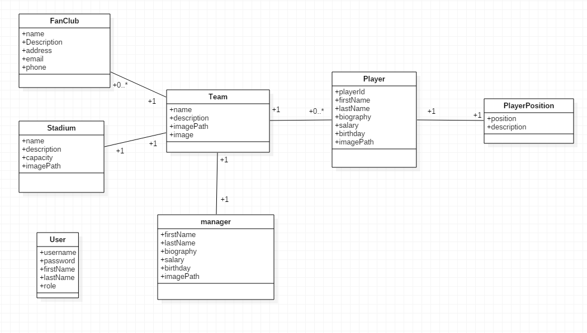

## Sequence Diagrams

**Sign In**

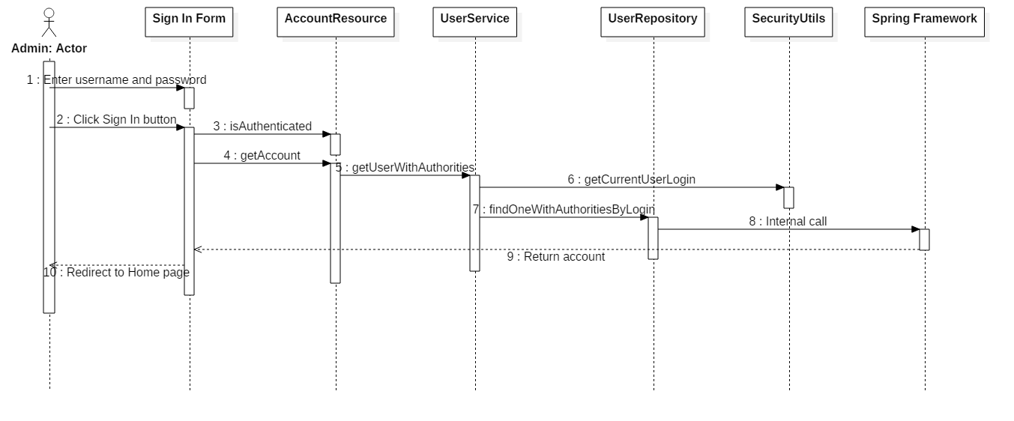

**Create/Edit a User**

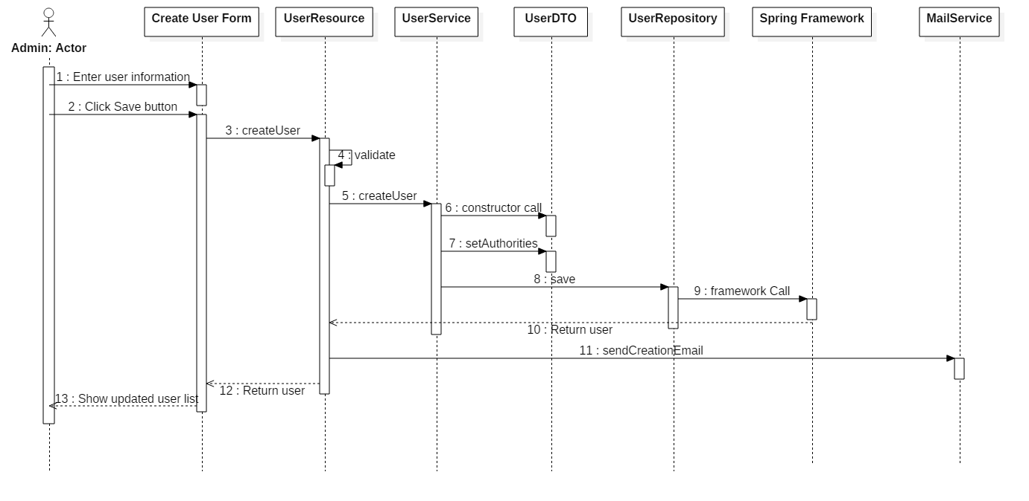

**Create/Edit a Team**

### SequenceDiagram1.png

**Create/Edit a Manager**

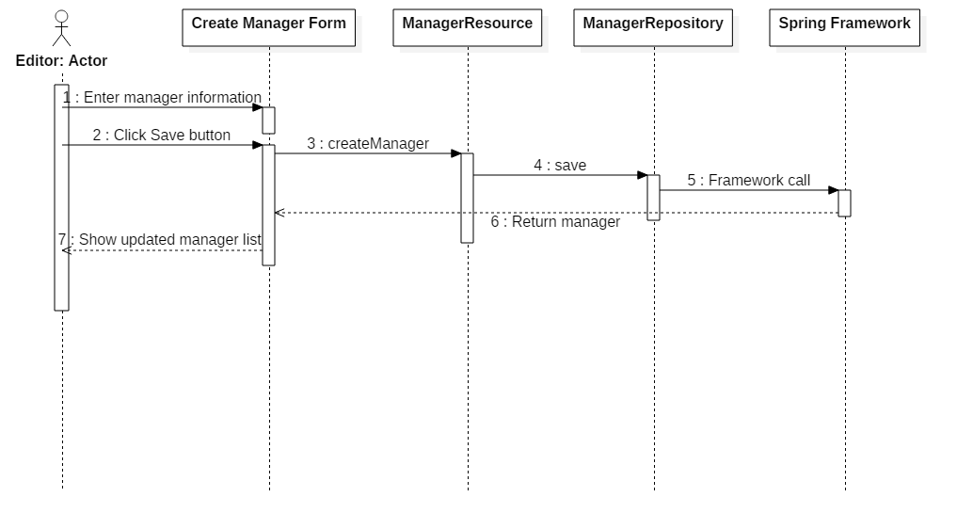

**Create/Edit a Player**

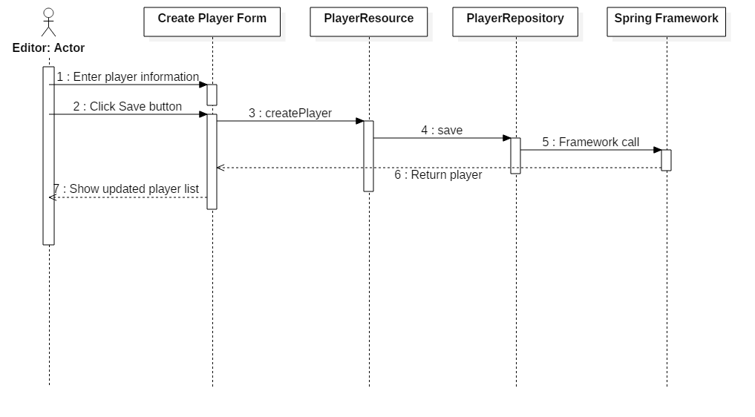

### 

**Create/Edit a Stadium**

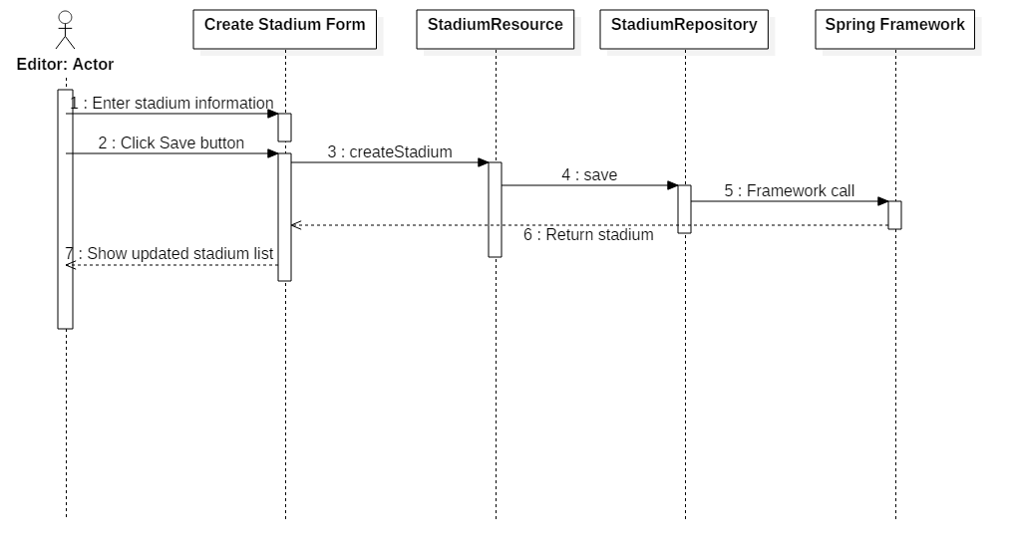

**Create/Edit a Fan Club**

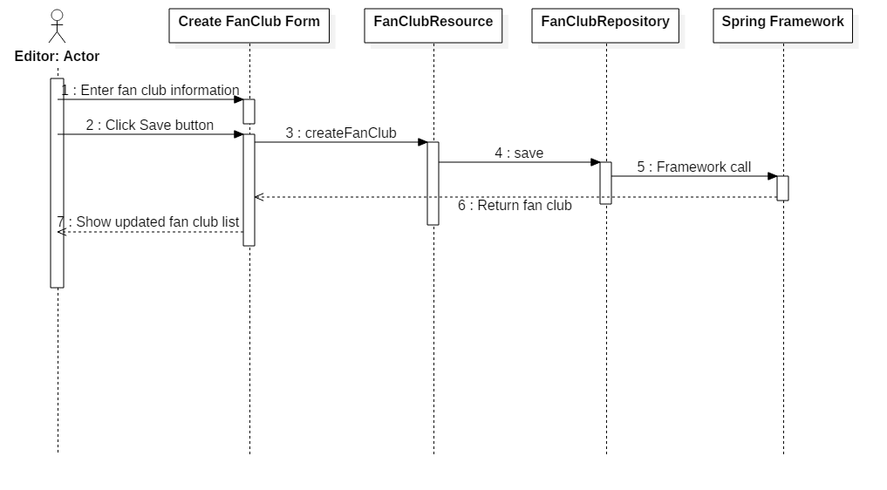

# Implementation

## Technologies and Development Approach

## Project Structure

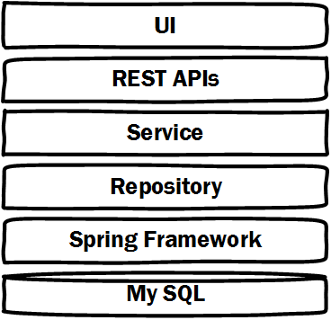

Front-end development

* CSS, HTML

Back-end development

* Java
* Spring framework

Database management system

* My SQL

Spring Technologies:

* Spring validation:
  + Form Validation through Annotation (JSR-303)
  + Custom Validaton
* File Uploading
* Handler Exception Resolver
* Internationalization
* Tile View Resolver Configuration (Wildcards)
* AJAX
* Spring Data Repositories (CRUDRepository)
* JPA ORM Fundamentals (Entity)
* Configurable Parent – Child operations
* Spring Authorization