Mapping Types and Identifiers
Running the same test against a relational database supporting sequences, the following results are being recorded:
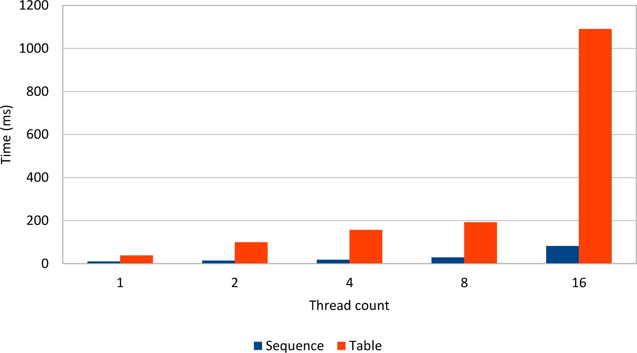

Figure 9.8: Sequence vs. Table
The performance impact of the table generator becomes noticeable in high concurrent environments, where the row-level locking and the database connection switch introduces a serial execution.

Because they use lightweight synchronization mechanisms, database sequences scale better than row-level locking concurrency control mechanisms.
Database sequences are the most efficient Hibernate identifier choice, allowing sequence call optimizers and without compromising JDBC batching.

Relationships
In a relational database, associations are formed by correlating rows belonging to different tables. A relationship is established when a child table defines a foreign key referencing the primary key of its parent table. Every database association is built on top of foreign keys, resulting three table relationship types:
- one-to-many is the most common relationship, and it associates a row from a parent table to multiple rows in a child table.
- one-to-one requires the child table Primary Key to be associated via a Foreign Key with the parent table Primary Key column.
- many-to-many requires a link table containing two Foreign Key columns that reference the two different parent tables.
The following diagram depicts all these three table relationships:
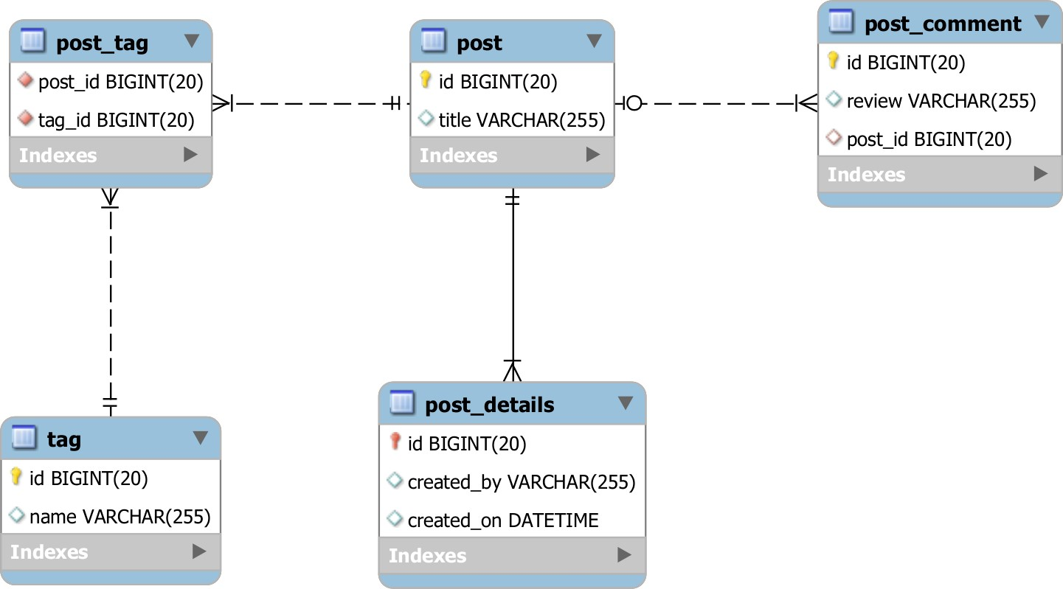

Figure 10.1: Table relationships
The post table has a one-to-many relationship with the post_comment table because a post row might be referenced by multiple comments. The one-to-many relationship is established through the post_id column which has a foreign key referencing the post table primary key. Because a post_comment cannot exist without a post, the post is the parent-side while the post_comment is the child-side.
The post table has a one-to-one relationship with the post_details. Like the one-to-many association, the one-to-one relationship involves two tables and a foreign key. The foreign key has a uniqueness constraint, so only one child row can reference a parent record.
The post and the tag are both independent tables and neither one is a child of the other. A post can feature several tag(s), while a tag can also be associated with multiple post(s). This is a typical many-to-many association, and it requires a junction table to resolve the child-side of these two parent entities. The junction table requires two foreign keys referencing the two parent tables.

The foreign key is, therefore, the most important construct in building a table relationship, and, in a relation database, the child-side controls a table relationship.
In a relational database, the foreign key is associated with the child-side only. For this reason, the parent-side has no knowledge of any associated child relationships, and, from a mapping perspective, table relationships are always unidirectional (the child foreign key references the parent primary key).

Relationship types
When mapping a JPA entity, besides the underlying table columns, the application developer can map entity relationships either in one direction or in a bidirectional way. This is another impedance mismatch between the object-oriented Domain Model and relational database system because, when using an ORM tool, the parent and the child-side can reference each other.
A relationship is unidirectional if only one entity side maps the table relationship and is bidirectional if the table relationship can be navigated in both directions (either from the entity parent-side or the child-side).
To properly represent both sides of an entity relationship, JPA defines four association mapping constructs:
- @ManyToOne represents the child-side (where the foreign key resides) in a database oneto-many table relationship.
- @OneToMany is associated with the parent-side of a one-to-many table relationship.
- @ElementCollection defines a one-to-many association between an entity and multiple value types (basic or embeddable).
- @OneToOne is used for both the child-side and the parent-side in a one-to-one table relationship.
- @ManyToMany mirrors a many-to-many table relationship.

Because the entity relationship choice has a considerable impact on the overall application performance, this chapter analyzes the data access operation efficiency of all these JPA associations.
Mapping collections
In a relational database, all table relationships are constructed using foreign keys and navigated through SQL queries. JPA allows mapping both the foreign key side (the child entity has a reference to its parent), as well as the parent side (the parent entity has one or more child entities).
Although @OneToMany, @ManyToMany or @ElementCollection are convenient from a data access perspective (entity state transitions can be cascaded from parent entities to children), they are definitely not free of cost. The price for reducing data access operations is paid in terms of result set fetching flexibility and performance. A JPA collection, either of entities or value types (basic or embeddables), binds a parent entity to a query that usually fetches all the associated child records. Because of this, the entity mapping becomes sensitive to the number of child entries.
If the children count is relatively small, the performance impact of always retrieving all child entities might be unnoticeable. However, if the number of child records grows too large, fetching the entire children collection may become a performance bottleneck. Unfortunately, the entity mapping is done during the early phases of a project development, and the development team might be unaware of the number of child records a production system exhibits.
Not just the mere size can be problematic, but also the number of attributes of the child entity. Because entities are usually fetched as a whole, the result set is, therefore, proportional to the number of columns the child table contains. Even if a collection is fetched lazily, Hibernate might still require to fully load each entity when the collection is accessed for the first time. Although Hibernate supports extra lazy collection fetching, this is only a workaround and does not address the root problem.
Alternatively, every collection mapping can be replaced by a data access query, which can use a SQL projection that is tailored to the data requirements of each business use case. This way, the query can take business case specific filtering criteria. Although JPA 2.1 does not support dynamic collection filtering, Hibernate offers Persistence Context-bound collection Filters.

When handling large data sets, it is good practice to limit the result set size, both for UI (to increase responsiveness) or batch processing tasks (to avoid long running transactions). Just because JPA offers supports collection mapping, it does not mean they are mandatory for every domain model mapping. Until there is a clear understanding of the number of child records (or if there is even need to fetch child entities entirely), it is better to postpone the collection mapping decision. For high-performance systems, a data access query is often a much more flexible alternative.

@ManyToOne
The @ManyToOne relationship is the most common JPA association, and it maps exactly to the one-to-many table relationship. When using a @ManyToOne association, the underlying foreign key is controlled by the child-side, no matter the association is unidirectional or bidirectional.
This section focuses on unidirectional @ManyToOne relationships only, the bidirectional case being further discussed with the @OneToMany relationship. In the following example, the Post entity represents the parent-side, while the PostComment is the child-side.
As already mentioned, the JPA entity relationship diagram matches exactly the one-to-many table relationship.
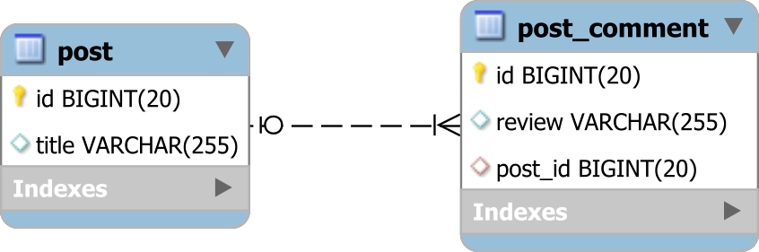

Figure 10.2: The one-to-many table relationship
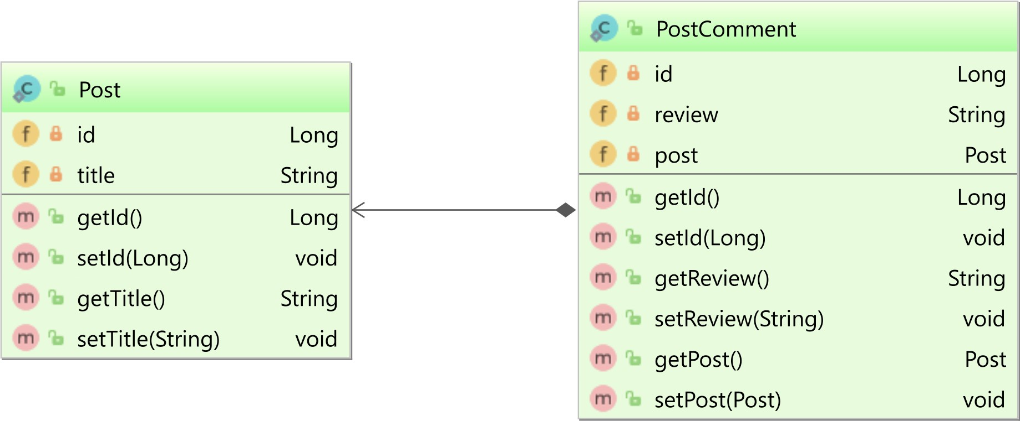

Figure 10.3: @ManyToOne relationship
Instead of mapping the post_id foreign key column, the PostComment uses a @ManyToOne relationship to the parent Post entity. The PostComment can be associated with an existing Post object reference, and the PostComment can also be fetched along with the Post entity.
@ManyToOne
@JoinColumn(name = "post_id") private Post post;
Hibernate translates the internal state of the @ManyToOne Post object reference to the post_id foreign key column value.
If the @ManyToOne attribute is set to a valid Post entity reference:
Post post = entityManager.find(Post.class, 1L); PostComment comment = new PostComment("My review"); comment.setPost(post); entityManager.persist(comment);
Hibernate will generate an insert statement populating the post_id column with the identifier of the associated Post entity.
INSERT INTO post_comment (post_id, review, id) VALUES (1, 'My review', 2) If the Post attribute is later set to null: comment.setPost(null);
The post_id column will also be updated with a NULL value:
UPDATE post_comment SET post_id = NULL, review = 'My review' WHERE id = 2

Because the @ManyToOne association controls the foreign key directly, the automatically generated DML statements are very efficient.
Actually, the best-performing JPA associations always rely on the child-side to translate the JPA state to the foreign key column value.
This is one of the most important rules in JPA relationship mapping, and it will be further emphasized for @OneToMany, @OneToOne and even @ManyToMany associations.

@OneToMany
While the @ManyToOne association is the most natural mapping of the one-to-many table relationship, the @OneToMany association can also mirror this database relationship, but only when being used as a bidirectional mapping. A unidirectional @OneToMany association uses an additional junction table, which no longer fits the one-to-many table relationship semantics.

Bidirectional @OneToMany
The bidirectional @OneToMany association has a matching @ManyToOne child-side mapping that controls the underlying one-to-many table relationship. The parent-side is mapped as a collection of child entities.
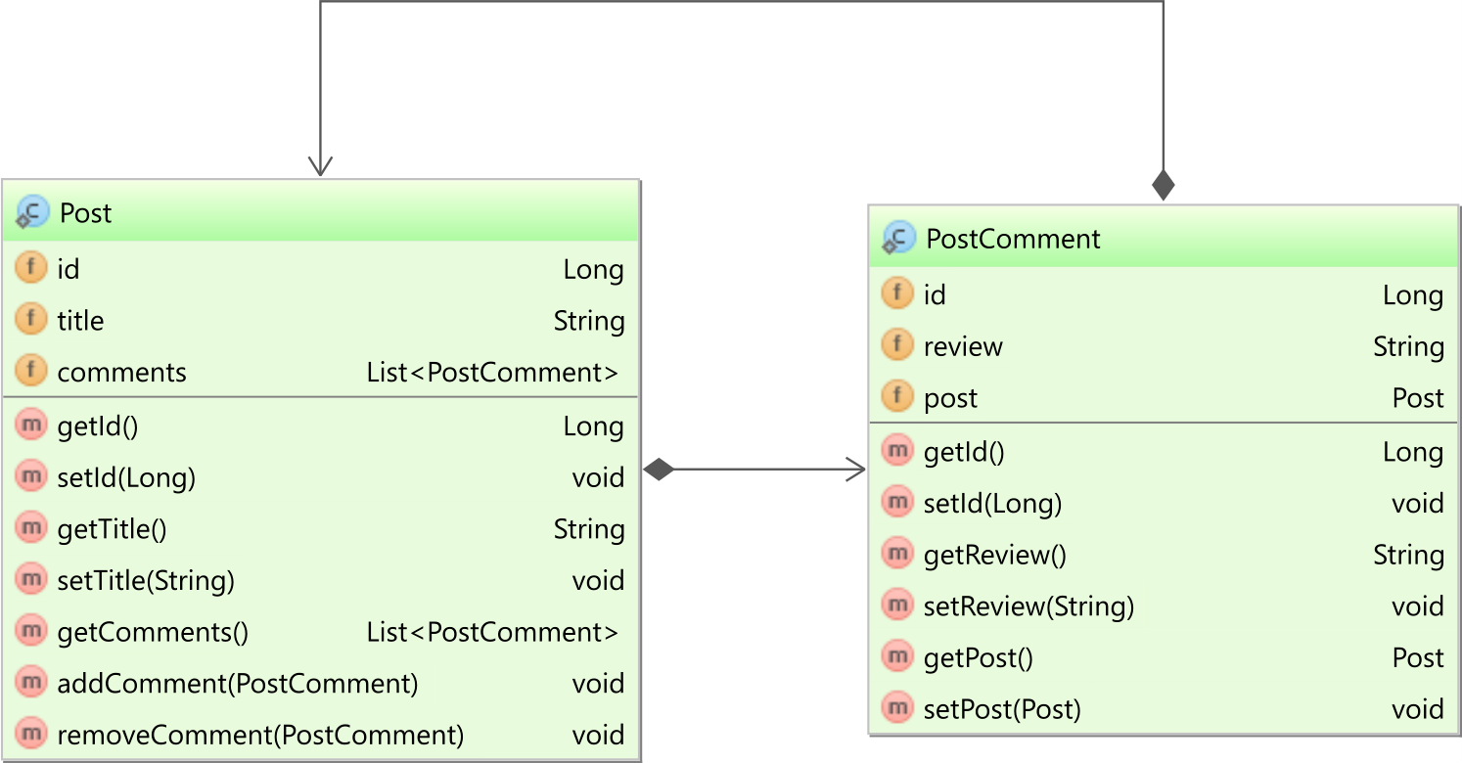

Figure 10.4: Bidirectional @OneToMany relationship
In a bidirectional association, only one side can control the underlying table relationship. For the bidirectional @OneToMany mapping, it is the child-side @ManyToOne association in charge of keeping the foreign key column value in sync with the in-memory Persistence Context. This is the reason why the bidirectional @OneToMany relationship must define the mappedBy attribute, indicating that it only mirrors the @ManyToOne child-side mapping.
@OneToMany(mappedBy = "post", cascade = CascadeType.ALL, orphanRemoval = true) private List<PostComment> comments = new ArrayList<>();

Even if the child-side is in charge of synchronizing the entity state changes with the database foreign key column value, a bidirectional association must always have both the parent-side and the child-side in sync.
To synchronize both ends, it is practical to provide parent-side helper methods that add/remove child entities.
public void addComment(PostComment comment) { comments.add(comment); comment.setPost(this);
}
public void removeComment(PostComment comment) { comments.remove(comment); comment.setPost(null);
}
One of the major advantages of using a bidirectional association is that entity state transitions can be cascaded from the parent entity to its children. In the following example, when persisting the parent Post entity, all the PostComment child entities are persisted as well.
Post post = new Post("First post");
PostComment comment1 = new PostComment("My first review"); post.addComment(comment1);
PostComment comment2 = new PostComment("My second review"); post.addComment(comment2); entityManager.persist(post);
INSERT INTO post (title, id) VALUES ('First post', 1)
INSERT INTO post_comment (post_id, review, id) VALUES (1, 'My first review', 2) INSERT INTO post_comment (post_id, review, id) VALUES (1, 'My second review', 3) When removing a comment from the parent-side collection: post.removeComment(comment1);
The orphan removal attribute instructs Hibernate to generate a delete DML statement on the targeted child entity:
DELETE FROM post_comment WHERE id = 2

Equality-based entity removal
The helper method for the child entity removal relies on the underlying child object equality for matching the collection entry that needs to be removed.
If the application developer does not choose to override the default equals and hashCode methods, the java.lang.Object identity-based equality is going to be used. The problem with this approach is that the application developer must supply a child entity object reference that is contained in the current child collection.
Sometimes child entities are loaded in one web request and saved in a HttpSession or a Stateful Enterprise Java Bean. Once the Persistence Context, which loaded the child entity is closed, the entity becomes detached. If the child entity is sent for removal into a new web request, the child entity must be reattached or merged into the current Persistence Context. This way, if the parent entity is loaded along with its child entities, the removal operation will work properly since the removing child entity is already managed and contained in the children collection.
If the entity has not changed, reattaching this child entity will be redundant and so the equals and the hashCode methods must be overridden to express equality in terms of a unique business key. In case the child entity has a @NaturalId or a unique attribute set, the equals and the hashCode methods can be implemented on top of that. Assuming the PostComment entity has the following two columns whose combination render a unique business key, the equality contract can be implemented as follows:
private String createdBy;
@Temporal(TemporalType.TIMESTAMP) private Date createdOn = new Date();
@Override public boolean equals(Object o) { if (this == o) return true;
if (o == null || getClass() != o.getClass()) return false; PostComment that = (PostComment) o;
return Objects.equals(createdBy, that.createdBy) && Objects.equals(createdOn, that.createdOn);
}
@Override public int hashCode() { return Objects.hash(createdBy, createdOn);
}

Identifier-based equality
The java.lang.Object.equalsª method Javadoc demands the strategy be reflexive, symmetric, transitive, and consistent.
While the first three equality properties (reflexive, symmetric, transitive) are easier to achieve, especially with the java.util.Objects^{b} equals and hashCode utilities, consistency requires more diligence.

For a JPA or Hibernate entity, consistency means that the equality result is reflexive, symmetric and transitive across all entity state transitions (e.g. new/transient, managed, detached, removed).
If the entity has a @NaturalId attribute, then ensuring consistency is simple since the natural key is assigned even from the transient state, and this attribute never changes afterward. However, not all entities have a natural key to use for equality checks, so another table column must be used instead.
Luckily, most database tables have a primary key, which uniquely identifies each row of a particular table. The only caveat is to ensure consistency across all entity state transitions.
A naive implementation would look like this:
@Entity public class Post {
@Id @GeneratedValue private Long id;
//Getters and setters omitted for brevity
@Override public boolean equals(Object o) { if (this == o) return true; if (!(o instanceof Post)) return false; return Objects.equals(id, ((Post) o).getId());
}
@Override public int hashCode() { return Objects.hash(id);
}
}

ªhttps://docs.oracle.com/javase/8/docs/api/java/lang/Object.html#equals-java.lang.Object-
^{b}https://docs.oracle.com/javase/7/docs/api/java/util/Objects.html

Now, when running the following test case:
Set<Post> tuples = new HashSet<>(); tuples.add(entity); assertTrue(tuples.contains(entity));
doInJPA(entityManager -> { entityManager.persist(entity); entityManager.flush(); assertTrue(tuples.contains(entity));
});
The final assertion will fail because the entity can no longer be found in the Set collection since the new identifier value is associated with a different Set bucket than the one where the entity got stored in.
To fix it, the equals and hashCode methods must be changed as follows:
@Override public boolean equals(Object o) { if (this == o) return true; if (!(o instanceof Post)) return false;
return id != null && id.equals(((Post) o).getId());
}
@Override public int hashCode() { return 31;
}
When the entity identifier is null, equality can only be guaranteed for the same object references. Otherwise, no transient object is equal to any other transient or persisted object. That’s why the equals method above skips the identifier check if the current object has a null identifier value.
Using a constant hashCode value solves the previous bucket-related problem associated with Set(s) or Map(s) because, this time, only a single bucket is going to be used. Although in general, using a single Set bucket is not very efficient for large collection of objects, in this particular use case, this workaround is valid since managed collections should be rather small to be efficient. Otherwise, fetching a @OneToManySet with thousands of entities is orders of magnitude more costly than the one-bucket search penalty.
When using List(s), the constant hashCode value is not an issue at all, and, for bidirectional collections, the Hibernate-internal PersistentList(s) are more efficient than PersistentSet(s).

The bidirectional @OneToMany association generates efficient DML statements because the @ManyToOne mapping is in charge of the table relationship. Because it simplifies data access operations as well, the bidirectional @OneToMany association is worth considering when the size of the child records is relatively low.

Unidirectional @OneToMany
The unidirectional @OneToMany association is very tempting because the mapping is simpler than its bidirectional counterpart. Because there is only one side to take into consideration, there is no need for helper methods and the mapping does not feature a mappedBy attribute either.
@OneToMany(cascade = CascadeType.ALL, orphanRemoval = true) private List<PostComment> comments = new ArrayList<>();
Unfortunately, in spite its simplicity, the unidirectional @OneToMany association is less efficient than the unidirectional @ManyToOne mapping or the bidirectional @OneToMany association.
Against any intuition, the unidirectional @OneToMany association does not map to a one-to-many table relationship. Because there is no @ManyToOne side to control this relationship, Hibernate uses a separate junction table to manage the association between a parent row and its child records.
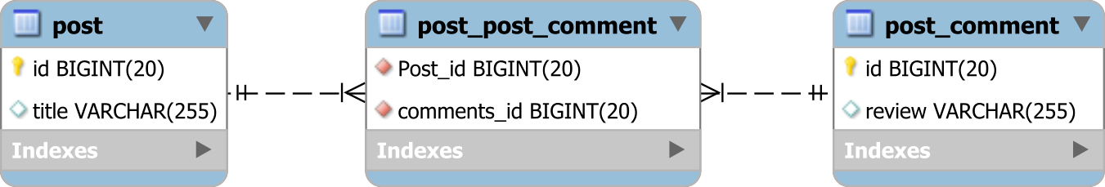

Figure 10.5: The @OneToMany table relationship
The table post_post_comment has two foreign key columns, which reference both the parentside row (the Post_id column is a foreign key to the post table primary key) and the child-side entity (the comments_id references the primary key of the post_comment table).
Without going into analyzing the associated data access operations, it is obvious that joining three tables is less efficient than joining just two. Because there are two foreign keys, there need to be two indexes (instead of one), so the index memory footprint increases. However, since this is a regular table mapping for a many-to-many relationship, the extra table and the increased memory footprint are not even the biggest performance issue. The algorithm for managing the collection state is what makes any unidirectional @OneToMany association less attractive.
Considering there is a Post entity with two PostComment child records, obtained by running the following example:
Post post = new Post("First post");
post.getComments().add(new PostComment("My first review")); post.getComments().add(new PostComment("My second review")); post.getComments().add(new PostComment("My third review")); entityManager.persist(post);
While for a bidirectional @OneToMany association there were three child rows being added, the unidirectional association requires three additional inserts for the junction table records.
INSERT INTO post (title, id) VALUES ('First post', 1)
INSERT INTO post_comment (review, id) VALUES ('My first review', 2)
INSERT INTO post_comment (review, id) VALUES ('My second review', 3)
INSERT INTO post_comment (review, id) VALUES ('My third review', 4)
INSERT INTO post_post_comment (Post_id, comments_id) VALUES (1, 2)
INSERT INTO post_post_comment (Post_id, comments_id) VALUES (1, 3)
INSERT INTO post_post_comment (Post_id, comments_id) VALUES (1, 4) When removing the first element of the collection: post.getComments().remove(0);
Hibernate generates the following DML statements:
DELETE FROM post_post_comment WHERE Post_id = 1
INSERT INTO post_post_comment (Post_id, comments_id) VALUES (1, 3)
INSERT INTO post_post_comment (Post_id, comments_id) VALUES (1, 4)
DELETE FROM post_comment WHERE id = 2
First, all junction table rows associated with the parent entity are deleted, and then the remaining in-memory records are added back again. The problem with this approach is that instead of a single junction table remove operation, the database has way more DML statements to execute.
Another problem is related to indexes. If there is an index on each foreign key column (which is the default for many relational databases), the database engine must delete the associated index entries only to add back the remaining ones. The more elements a collection has, the less efficient a remove operation gets.

The unidirectional @OneToMany relationship is less efficient both for reading data (three joins are required instead of two), as for adding (two tables must be written instead of one) or removing (entries are removed and added back again) child entries.

Ordered unidirectional @OneToMany
If the collection can store the index of every collection element, the unidirectional @OneToMany relationship may benefit for some element removal operations. First, an @OrderColumn annotation must be defined along the @OneToMany relationship mapping:
@OneToMany(cascade = CascadeType.ALL, orphanRemoval = true)
@OrderColumn(name = "entry")
private List<PostComment> comments = new ArrayList<>();
At the database level, the entry column is included in the junction table.
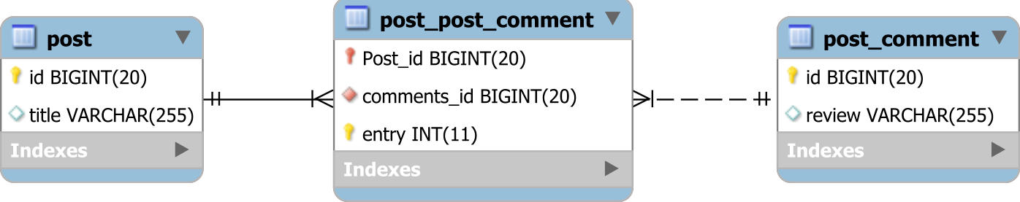

Figure 10.6: The unidirectional @OneToMany with an @OrderColumn

It is better not to mistake the @OrderColumn with the @OrderBy JPA annotation. While the former allows the JPA provider to materialize the element index into a dedicated database column so that the collection is sorted using an ORDER BY clause, the latter does the sorting at runtime based on the ordering criteria provided by the @OrderBy annotation.
Considering there are three PostComment entities added for a given Post parent entity:
post.getComments().add(new PostComment("My first review")); post.getComments().add(new PostComment("My second review")); post.getComments().add(new PostComment("My third review"));
The index of every collection element is going to be stored in the entry column of the junction table:
INSERT INTO post_comment (review, id) VALUES ('My first review', 2)
INSERT INTO post_comment (review, id) VALUES ('My second review', 3)
INSERT INTO post_comment (review, id) VALUES ('My third review', 4)
INSERT INTO post_post_comment (Post_id, entry, comments_id) VALUES (1, 0, 2)
INSERT INTO post_post_comment (Post_id, entry, comments_id) VALUES (1, 1, 3)
INSERT INTO post_post_comment (Post_id, entry, comments_id) VALUES (1, 2, 4) When removing elements from the tail of the collection: post.getComments().remove(2);
Hibernate only requires a single junction table delete statement:
DELETE FROM post_post_comment WHERE Post_id = 1 AND entry = 2
DELETE FROM post_comment WHERE id = 4
Unfortunately, this optimization does not hold for entries that are located towards the head of the collection. So, if we remove the first element: post.getComments().remove(0);
Hibernate deletes the last entry associated with the parent row from the junction table, and then it updates the remaining entries to preserve the same element ordering as the inmemory collection snapshot:
DELETE FROM post_post_comment WHERE Post_id = 1 AND entry = 2
UPDATE post_post_comment SET comments_id = 4 WHERE Post_id = 1 AND entry = 1
UPDATE post_post_comment SET comments_id = 3 WHERE Post_id = 1 AND entry = 0
DELETE FROM post_comment WHERE id = 2

If the unidirectional @OneToMany collection is used like a stack and elements are always removed from the collection tail, the remove operations will be more efficient when using an @OrderColumn. But the closer an element is to the head of the list, the more update statements must be issued, and the additional updates have an associated performance overhead.

@OneToMany with @JoinColumn
JPA 2.0 added support for mapping the @OneToMany association with a @JoinColumn so that it can map the one-to-many table relationship. With the @JoinColumn, the @OneToMany association controls the child table foreign key, so there is no need for a junction table.
On the JPA side, the class diagram is identical to the aforementioned unidirectional @OneToMany relationship, and the only difference is the JPA mapping which takes the additional @JoinColumn:
@OneToMany(cascade = CascadeType.ALL, orphanRemoval = true)
@JoinColumn(name = "post_id")
private List<PostComment> comments = new ArrayList<>();
When adding three PostComment entities, Hibernate generates the following SQL statements:
post.getComments().add(new PostComment("My first review")); post.getComments().add(new PostComment("My second review")); post.getComments().add(new PostComment("My third review"));
INSERT INTO post_comment (review, id) VALUES ('My first review', 2)
INSERT INTO post_comment (review, id) VALUES ('My second review', 3)
INSERT INTO post_comment (review, id) VALUES ('My third review', 4)
UPDATE post_comment SET post_id = 1 WHERE id = 2
UPDATE post_comment SET post_id = 1 WHERE id = 3
UPDATE post_comment SET post_id = 1 WHERE id = 4
Besides the regular insert statements, Hibernate issues three update statements for setting the post_id column on the newly inserted child records. The update statements are generated by the Hibernate-internal CollectionRecreateAction which tries to preserve the element order whenever the collection state changes. In this particular case, the CollectionRecreateAction should not be scheduled for execution, however, as of writing (Hibernate 5.2.3), this issue still replicates.
When deleting the last element of the collection: post.getComments().remove(2);
Hibernate generates the following SQL statements:
UPDATE post_comment SET post_id = null WHERE post_id = 1 AND id = 4
DELETE from post_comment WHERE id = 4
Again, there is an additional update statement associated with the child removal operation. When a child entity is removed from the parent-side collection, Hibernate sets the child table foreign key column to null. Afterward, the orphan removal logic kicks in, and it triggers a delete statement against the disassociated child entity.
Unlike the regular @OneToMany association, the @JoinColumn alternative is consistent in regard to the collection entry position that is being removed. So, when removing the first element of the collection: post.getComments().remove(0);
Hibernate still generates an additional update statement:
UPDATE post_comment SET post_id = null WHERE post_id = 1 AND id = 2
DELETE from post_comment WHERE id = 2
Bidirectional @OneToMany with @JoinColumn relationship
The @OneToMany with @JoinColumn association can also be turned into a bidirectional relationship, but it requires instructing the child-side to avoid any insert and update synchronization:
@ManyToOne
@JoinColumn(name = "post_id", insertable = false, updatable = false) private Post post;

The redundant update statements are generated for both the unidirectional and the bidirectional association, so the most efficient foreign key mapping is the @ManyToOne association.

Unidirectional @OneToMany Set
All the previous examples were using List(s), but Hibernate supports Set(s) as well. For the next exercise, the PostComment entity uses the following mapping:
@Entity(name = "PostComment") @Table(name = "post_comment") public class PostComment {
@Id @GeneratedValue private Long id; private String slug; private String review;
public PostComment() { byte[] bytes = new byte[8];
ByteBuffer.wrap(bytes).putDouble(Math.random()); slug = Base64.getEncoder().encodeToString(bytes);
}
public PostComment(String review) { this();
this.review = review;
}
//Getters and setters omitted for brevity
@Override public boolean equals(Object o) { if (this == o) return true;
if (o == null || getClass() != o.getClass()) return false; PostComment comment = (PostComment) o; return Objects.equals(slug, comment.getSlug());
}
@Override public int hashCode() { return Objects.hash(slug);
}
}
This time, the PostComment entity uses a slug attribute which provide a way to uniquely identify each comment belonging to a given Post entity.
Because the PostComment references are going to be stored in a java.util.Set, it is best to override the equals and hashCode Object methods according to the entity business key. In this particular example, the PostComment does not have any meaningful business key, so the slug attribute is used for the equality checks.
The parent Post entity has a unidirectional @OneToMany association that uses a java.util.Set:
@OneToMany(cascade = CascadeType.ALL, orphanRemoval = true) private Set<PostComment> comments = new HashSet<>(); When adding three PostComment entities:
post.getComments().add(new PostComment("My first review")); post.getComments().add(new PostComment("My second review")); post.getComments().add(new PostComment("My third review")); Hibernate generates the following SQL statements:
INSERT INTO post_comment (review, slug, id)
VALUES ('My second review', 'P+HLCF25scI=', 2)
INSERT INTO post_comment (review, slug, id)
VALUES ('My first review', 'P9y8OGLTCyg=', 3) INSERT INTO post_comment (review, slug, id)
VALUES ('My third review', 'P+fWF+Ck/LY=', 4)
INSERT INTO post_post_comment (Post_id, comments_id) VALUES (1, 2)
INSERT INTO post_post_comment (Post_id, comments_id) VALUES (1, 3)
INSERT INTO post_post_comment (Post_id, comments_id) VALUES (1, 4)
The remove operation is much more effective this time because the collection element order needs not be enforced anymore.
When removing the PostComment child entities:
for(PostComment comment: new ArrayList<>(post.getComments())) { post.getComments().remove(comment);
}
Hibernate generates one statement for removing the junction table entries and three delete statements for the associated post_comment records.
DELETE FROM post_post_comment WHERE Post_id = 1
DELETE FROM post_comment WHERE id = 2
DELETE FROM post_comment WHERE id = 3
DELETE FROM post_comment WHERE id = 4
To avoid using a secondary table, the @OneToMany mapping can use the @JoinColumn annotation.
@OneToMany(cascade = CascadeType.ALL, orphanRemoval = true)
@JoinColumn(name = "post_id")
private Set<PostComment> comments = new HashSet<>();
Upon inserting three PostComment entities, Hibernate generates the following statements:
INSERT INTO post_comment (review, slug, id)
VALUES ('My third review', 'P8pcnLprqcQ=', 2)
INSERT INTO post_comment (review, slug, id)
VALUES ('My second review', 'P+Gau1+Hhxs=', 3)
INSERT INTO post_comment (review, slug, id)
VALUES ('My first review', 'P+kr9LOQTK0=', 4)
UPDATE post_comment SET post_id = 1 WHERE id = 2
UPDATE post_comment SET post_id = 1 WHERE id = 3
UPDATE post_comment SET post_id = 1 WHERE id = 4
When deleting all three PostComment entities, the generated statements look like this:
UPDATE post_comment SET post_id = null WHERE post_id = 1
DELETE FROM post_comment WHERE id = 2
DELETE FROM post_comment WHERE id = 3
DELETE FROM post_comment WHERE id = 4

Although it is an improvement over the unidirectional unordered or ordered List, the unidirectional Set is still less efficient than the bidirectional @OneToMany association.

