
The schema ownership goes to the database, and the data access layer must assist the Domain Model to communicate with the underlying data.

7.4 Entity state transitions
JPA shifts the developer mindset from SQL statements to entity state transitions. An entity can be in one of the following states:
State | Description
New (Transient) | A newly created entity which is not mapped to any database row is considered to be in the New or Transient state. Once it becomes managed, the Persistence Context issues an insert statement at flush time.
Managed (Persistent) | A Persistent entity is associated with a database row, and it is being managed by the currently running Persistence Context. State changes are detected by the dirty checking mechanism and propagated to the database as update statements at flush time.
Detached | Once the currently running Persistence Context is closed, all the previously managed entities become detached. Successive changes are no longer tracked, and no automatic database synchronization is going to happen.
Removed | A removed entity is only scheduled for deletion, and the actual database delete statement is executed during Persistence Context flushing.

Table 7.1: JPA entity states
The Persistence Context captures entity state changes, and, during flushing, it translates them into SQL statements. The JPA EntityManager and the Hibernate Session⁵ (which includes additional methods for moving an entity from one state to the other) interfaces are gateways towards the underlying Persistence Context, and they define all the entity state transition operations.
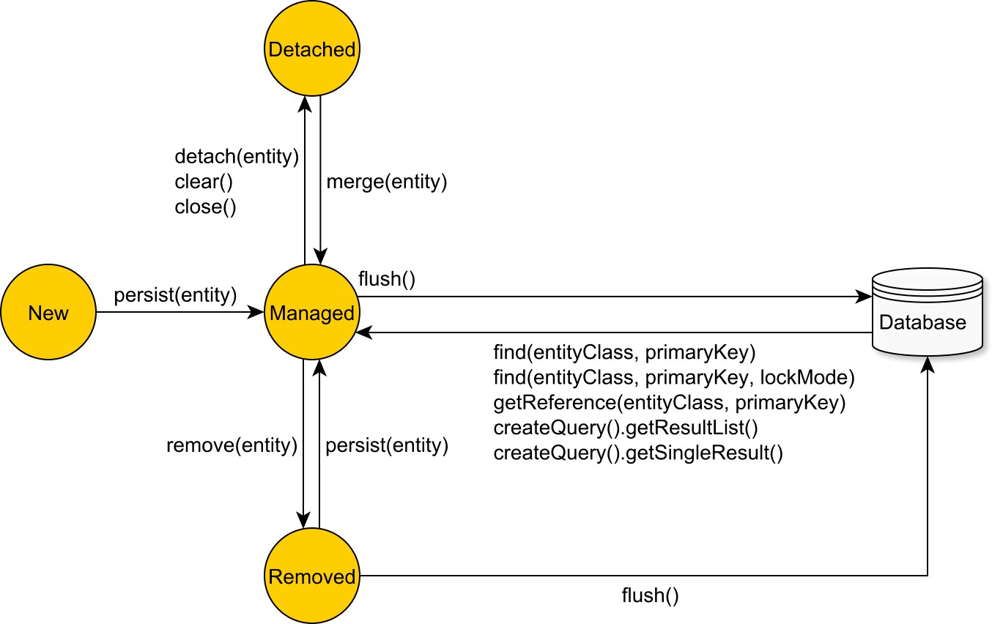

Figure 7.4: JPA entity state transitions
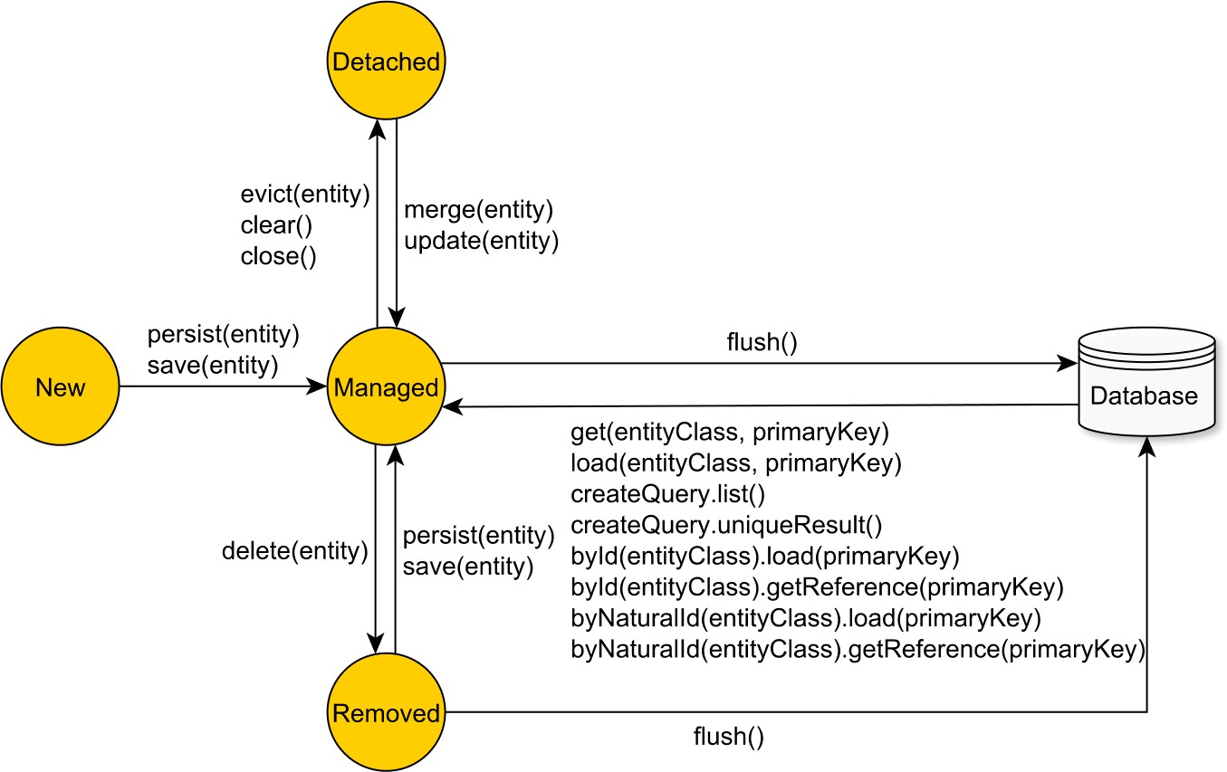
Figure 7.5: Hibernate entity state transitions

7.5 Write-based optimizations
SQL injection prevention
By managing the SQL statement generation, the JPA tool can assist in minimizing the risk of SQL injection attacks. The less the chance of manipulating SQL String statements, the safer the application can get. The risk is not completely eliminated because the application developer can still recur to concatenating SQL or JPQL fragments, so rigor is advised.

Hibernate uses PreparedStatement(s) exclusively, so not only it protects against SQL injection, but the data access layer can better take advantage of server-side and clientside statement caching as well.
Auto-generated DML statements
The enterprise system database schema evolves with time, and the data access layer must mirror all these modifications as well.
Because the JPA provider auto-generates insert and update statements, the data access layer can easily accommodate database table structure modifications. By updating the entity model schema, Hibernate can automatically adjust the modifying statements accordingly.
This applies to changing database column types as well. If the database schema needs to migrate a postal code from an INT database type to a VARCHAR(6), the data access layer will need only to change the associated Domain Model attribute type from an Integer to a String, and all statements are going to be automatically updated. Hibernate defines a highly customizable JDBC-to-database type mapping system, and the application developer can override a default type association, or even add support for new database types (that are not currently supported by Hibernate).
The entity fetching process is automatically managed by the JPA implementation, which autogenerates the select statements of the associated database tables. This way, JPA can free the application developer from maintaining entity selection queries as well.
Hibernate allows customizing all the CRUD statements, in which case the application developer is responsible for maintaining the associated DML statements.
Although it takes care of the entity selection process, most enterprise systems need to take advantage of the underlying database querying capabilities. For this reason, whenever the database schema changes, all the native SQL queries need to be updated manually (according to their associated business logic requirements).
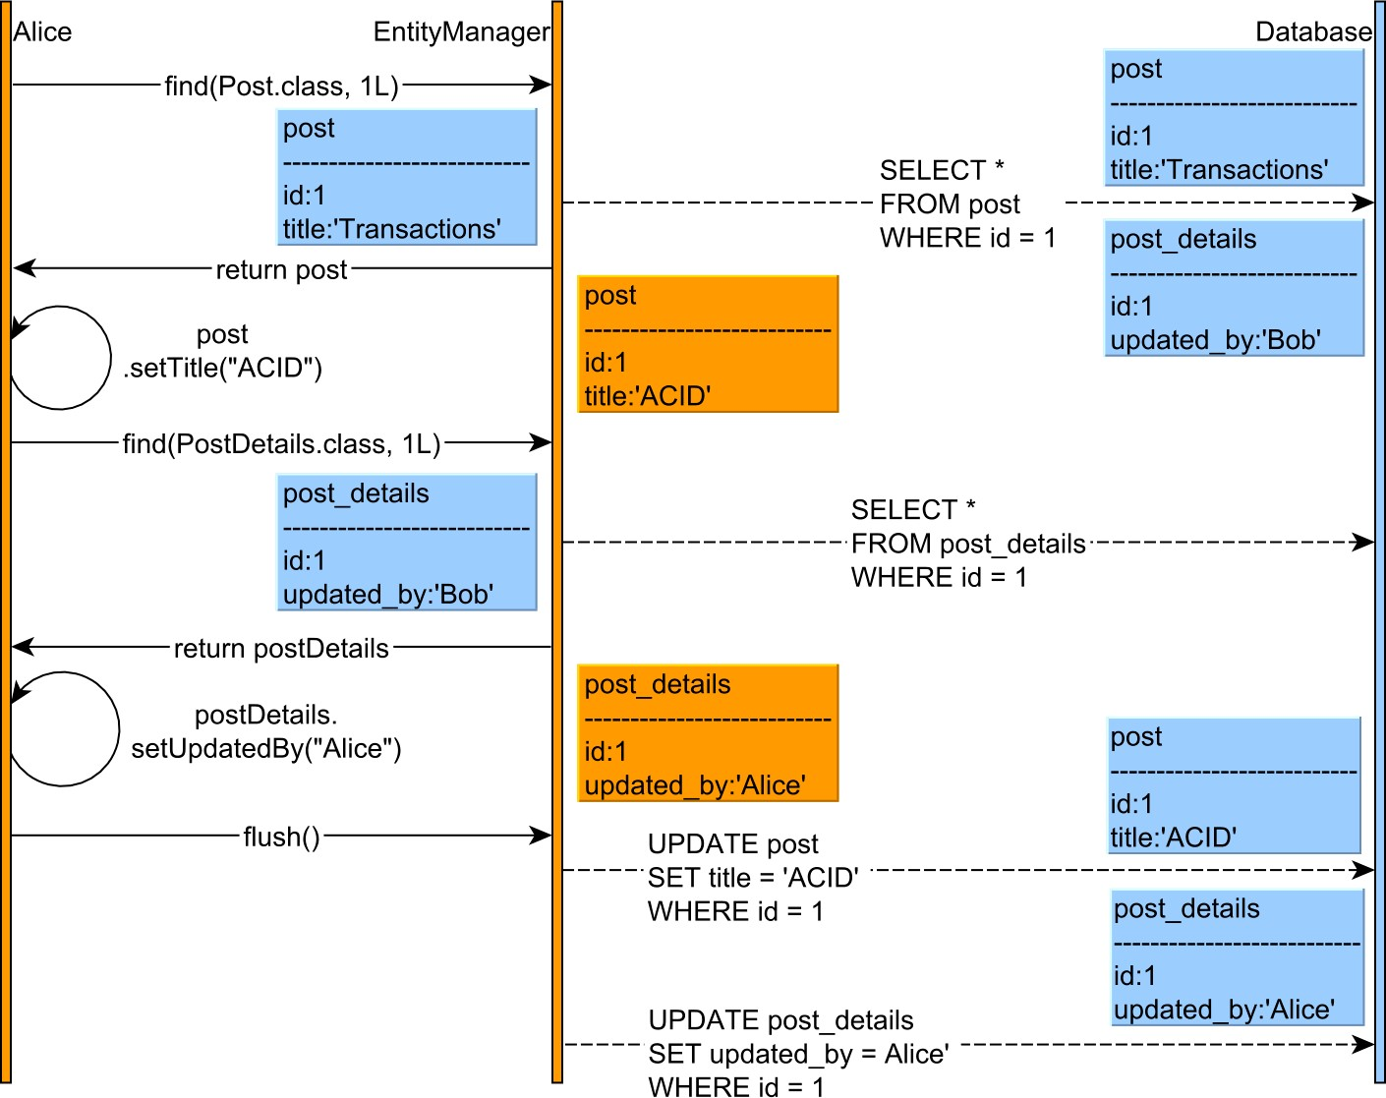
Write-behind cache
The Persistence Context acts as a transactional write-behind cache, deferring entity state
flushing up until the last possible moment.
Figure 7.6: Persistence Context
Because every modifying DML statement requires locking (to prevent dirty writes), the
write behind cache can reduce the database lock acquisition interval, therefore increasing
concurrency.
However,
caches
introduce
consistency
challenges,
and
the
Persistence
Context
requires a flush prior to executing any JPQL or native SQL query, as otherwise it might
break the read-your-own-write consistency guarantee.
As detailed in the following chapters, Hibernate does not automatically flush pending
changes when a native query is about to be executed, and the application developer
must explicitly instruct what database tables are needed to be synchronized.

Transparent statement batching
Since all changes are being flushed at once, Hibernate may benefit from batching JDBC statements. Batch updates can be enabled transparently, even after the data access logic has been implemented. Most often, performance tuning is postponed until the system is already running in production, and switching to batching statements should not require a considerable development effort.

With just one configuration, Hibernate can execute all prepared statements in batches.
Application-level concurrency control
As previously explained, no database isolation level can protect against losing updates when executing a multi-request long conversation. JPA supports both optimistic and pessimistic locking.
The JPA optimistic locking mechanism allows preventing lost updates because it imposes a happens-before event ordering. However, in multi-request conversations, optimistic locking requires maintaining old entity snapshots, and JPA makes it possible through Extended Persistence Contexts or detached entities.

A Java EE application server can preserve a given Persistence Context across several web requests, therefore providing application-level repeatable reads. However, this strategy is not free since the application developer must make sure the Persistence Context is not bloated with too many entities, which, apart from consuming memory, it can also affect the performance of the Hibernate default dirty checking mechanism.
Even when not using Java EE, the same goal can be achieved using detached entities, which provide fine-grained control over the amount of data needed to be preserved from one web request to the other. JPA allows merging detached entities, which rebecome managed and automatically synchronized with the underlying database system.
JPA also supports a pessimistic locking query abstraction, which comes in handy when using lower-level transaction isolation modes.

Hibernate has a native pessimistic locking API, which brings support for timing out lock acquisition requests or skipping already acquired locks.

7.6 Read-based optimizations
Following the SQL standard, the JDBC ResultSet is a tabular representation of the underlying fetched data. The Domain Model being constructed as an entity graph, the data access layer must transform the flat ResultSet into a hierarchical structure.
Although the goal of the ORM tool is to reduce the gap between the object-oriented Domain Model and its relational counterpart, it is very important to remember that the source of data is not an in-memory repository, and the fetching behavior influences the overall data access efficiency.

The database cannot be abstracted out of this context, and pretending that entities can be manipulated just like any other plain objects is very detrimental to application performance. When it comes to reading data, the impedance mismatch becomes even more apparent, and, for performance reasons, it is mandatory to keep in mind the SQL statements associated with every fetching operation.
In the following example, the posts records are fetched along with all their associated comments. Using JDBC, this task can be accomplished using the following code snippet:
doInJDBC(connection -> { try (PreparedStatement statement = connection.prepareStatement(
"SELECT * " +
"FROM post AS p " +
"JOIN post_comment AS pc ON p.id = pc.post_id " +
"WHERE " +
" p.id BETWEEN ? AND ? + 1"
)) {
statement.setInt(1, id); statement.setInt(2, id);
try (ResultSet resultSet = statement.executeQuery()) { List<Post> posts = toPosts(resultSet); assertEquals(expectedCount, posts.size()); }
} catch (SQLException e) { throw new DataAccessException(e);
}
});
When joining many-to-one or one-to-one associations, each ResultSet record corresponds to a pair of entities, so both the parent and the child can be resolved in each iteration. For oneto-many or many-to-many relationships, because of how the SQL join works, the ResultSet contains a duplicated parent record for each associated child.
Constructing the hierarchical entity structure requires manual ResultSet transformation, and, to resolve duplicates, the parent entity references are stored in a Map structure.
List<Post> toPosts(ResultSet resultSet) throws SQLException { Map<Long, Post> postMap = new LinkedHashMap<>(); while (resultSet.next()) {
Long postId = resultSet.getLong(1); Post post = postMap.get(postId); if(post == null) { post = new Post(postId); postMap.put(postId, post); post.setTitle(resultSet.getString(2)); post.setVersion(resultSet.getInt(3));
}
PostComment comment = new PostComment(); comment.setId(resultSet.getLong(4)); comment.setReview(resultSet.getString(5)); comment.setVersion(resultSet.getInt(6)); post.addComment(comment);
} return new ArrayList<>(postMap.values());
}
The JDBC 4.2 PreparedStatement supports only positional parameters, and the first ordinal starts from 1. JPA allows named parameters as well, which are especially useful when a parameter needs to be referenced multiple times, so the previous example can be rewritten as follows:
doInJPA(entityManager -> {
List<Post> posts = entityManager.createQuery(
"select distinct p " +
"from Post p " +
"join fetch p.comments " +
"where " +
" p.id BETWEEN :id AND :id + 1", Post.class)
.setParameter("id", id) .getResultList(); assertEquals(expectedCount, posts.size());
});
In both examples, the object-relation transformation takes place either implicitly or explicitly. In the JDBC use case, the associations must be manually resolved, while JPA does it automatically (based on the entity schema).
The fetching responsibility
Besides mapping database columns to entity attributes, the entity associations can also be represented in terms of object relationships. More, the fetching behavior can be hard-wired to the entity schema itself, which is most often a terrible thing to do.
Fetching multiple one-to-many or many-to-many associations is even more problematic because they might require a Cartesian Product, therefore affecting performance. Controlling the hard-wired schema fetching policy is cumbersome as it prevents overriding an eager retrieval with a lazy loading mechanism.

Each business use case has different data access requirements, and one policy cannot anticipate all possible use cases, so the fetching strategy should always be set up on a query basis.
Prefer projections for read-only views
Although it is very convenient to fetch entities along with all their associated relationships, it is better to take into consideration the performance impact as well. As previously explained, fetching too much data is not suitable because it increases the transaction response time.
In reality, not all use cases require loading entities, and not all read operations need to be served by the same fetching mechanism. Sometimes a custom projection (selecting only a few columns from an entity) is much more suitable, and the data access logic can even take advantage of database-specific SQL constructs that might not be supported by the JPA query abstraction.

As a rule of thumb, fetching entities is suitable when the logical transaction requires modifying them, even if that only happens in a successive web request. With this is mind, it is much easier to reason on which fetching mechanism to employ for a given business logic use case.
The second-level cache
If the Persistence Context acts as a transactional write-behind cache, its lifetime will be bound to that of a logical transaction. For this reason, the Persistence Context is also known as the first-level cache, and so it cannot be shared by multiple concurrent transactions.
On the other hand, the second-level cache is associated with an EntityManagerFactory, and all Persistence Contexts have access to it. The second-level cache can store entities as well as entity associations (one-to-many and many-to-many relationships) and even entity query results. Because JPA does not make it mandatory, each provider takes a different approach to caching (as opposed to EclipseLink, by default, Hibernate disables the second-level cache).
Most often, caching is a trade-off between consistency and performance. Because the cache becomes another source of truth, inconsistencies might occur, and they can be prevented only when all database modifications happen through a single EntityManagerFactory or a synchronized distributed caching solution. In reality, this is not practical since the application might be clustered on multiple nodes (each one with its own EntityManagerFactory) and the database might be accessed by multiple applications.

Although the second-level cache can mitigate the entity fetching performance issues, it requires a distributed caching implementation, which might not elude the networking penalties anyway.

7.7 Wrap-up
Bridging two highly-specific technologies is always a difficult problem to solve. When the enterprise system is built on top of an object-oriented language, the object-relational impedance mismatch becomes inevitable. The ORM pattern aims to close this gap although it cannot completely abstract it out.
In the end, all the communication flows through JDBC and every execution happens in the database engine itself. A high-performance enterprise application must resonate with the underlying database system, and the ORM tool must not disrupt this relationship.
Just like the problem it tries to solve, Hibernate is a very complex framework with many subtleties that require a thorough knowledge of both database systems, JDBC, and the framework itself. This chapter is only a summary, meant to present JPA and Hibernate into a different perspective that prepares the reader for high-performance object-relational mapping. There is no need to worry if some topics are not entirely clear because the upcoming chapters analyze all these concepts in greater detail.

8. Connection Management and Monitoring
As previously explained in the JDBC Connection Management chapter, for performance reasons, database connections are better off reused. Because JPA providers generate SQL statements on behalf of users, it is very important to monitor this process and acknowledge its outcome. This chapter explains the Hibernate connection provider mechanism and ways to monitor statement execution.

8.1 JPA connection management
Like the whole Java EE suite, the JPA 1.0 specification was very much tied to enterprise application servers. In a Java EE container, all database connections are managed by the application server which provides connection pooling, monitoring, and JTA capabilities.
Once configured, the Java EE DataSource can be located through JNDI. In the persistence.xml configuration file, the application developer must supply the JNDI name of the associated JTA or RESOURCE_LOCAL DataSource. The transaction-type attribute must also match the data source transaction capabilities.
<persistence-unit name="persistenceUnit" transaction-type="JTA">
<provider>org.hibernate.jpa.HibernatePersistenceProvider</provider>

<jta-data-source>java:global/jdbc/flexypool</jta-data-source> </persistence-unit>
A RESOURCE_LOCAL transaction must use a non-jta-data-sourceDataSource.
<persistence-unit name="persistenceUnit" transaction-type="RESOURCE_LOCAL">
<provider>org.hibernate.jpa.HibernatePersistenceProvider</provider>

<non-jta-data-source>java:/comp/env/jdbc/hsqldb</non-jta-data-source> </persistence-unit>
While for a Java EE application it is perfectly fine to rely on the application server for providing a full-featured DataSource reference, stand-alone applications are usually configured using dependency injection rather than JNDI.
From the JPA implementation perspective, the DataSource can be either configured externally or by the JPA provider itself. Most often, configuring an external DataSource is still the preferred alternative as it gives more flexibility in decorating the connection providing mechanism (e.g. logging, monitoring).
JPA providers can fetch connections through the underlying JDBC Driver since JPA 2.0 has standardized the database connection configuration properties:

Table 8.1: JPA connection properties
Property | Description
javax.persistence.jdbc.driver | Driver full class name (e.g. org.hsqldb.jdbc.JDBCDriver )
javax.persistence.jdbc.url | Driver Url (e.g. jdbc:hsqldb:mem:test )
javax.persistence.jdbc.user | Database user’s name
javax.persistence.jdbc.password | Database user’s password
Unfortunately, these properties alone are not sufficient because most enterprise applications need connection pooling and monitoring capabilities anyway. For this reason, JPA connection management is still an implementation-specific topic, and the upcoming sections dive into the connection provider mechanism employed by Hibernate.

8.2 Hibernate connection providers
Hibernate needs to operate both in Java EE and stand-alone environments, and the database connectivity configuration can be done either declaratively or programmatically. To accommodate JDBC Driver connections as well as RESOURCE_LOCAL and JTA DataSource configurations, Hibernate defines its own connection factory abstraction, represented by the org.hibernate.engine.jdbc.connections.spi.ConnectionProvider interface:
public interface ConnectionProvider extends Service, Wrapped { public Connection getConnection() throws SQLException; public void closeConnection(Connection connection) throws SQLException;
public boolean supportsAggressiveRelease();
}
Because the connection provider might influence transaction response time, each provider is analyzed from a high-performance OLTP system perspective.

8.2.1 DriverManagerConnectionProvider
Hibernate picks this provider when being given the aforementioned JPA 2.0 connection properties or the Hibernate-specific configuration counterpart:
- hibernate.connection.driver_class
- hibernate.connection.url
- hibernate.connection.username • hibernate.connection.password.

Although it fetches database connections through the underlying DriverManager, this provider tries to avoid the connection acquisition overhead by using a trivial pooling implementation. The Hibernate documentation does not recommend using the DriverManagerConnectionProvider in a production setup.

8.2.2 C3P0ConnectionProvider
C3p0 is a mature connection pooling solution that has proven itself in many production environments, and, using the underlying JDBC connection properties, Hibernate can replace the built-in connection pool with a c3p0 DataSource. To activate this provider, the application developer must supply at least one configuration property starting with the hibernate.c3p0 prefix:
<property name="hibernate.c3p0.max_size" value="5"/>
C3p0 (released in 2001) and Apache DBCP (released in 2002) are the oldest and the most deployed stand-alone Java connection pooling solutions. Later in 2010, BoneCP emerged as a high-performance alternative for c3p0 and Apache DBCP.
Nowadays, the BoneCP GitHub page says it is been deprecated in favor of HikariCP.
As of writing, the most attractive Java connection pools are HikariCP, Vibur DBCP, and Apache DBCP2. HikariCP and Vibur DBCP offer built-in Hibernate connection providers.

8.2.3 HikariCPConnectionProvider
Hibernate 5 supports HikariCP (one of the fastest connection pools) via the following dependency:
<dependency> <groupId>org.hibernate</groupId> <artifactId>hibernate-hikaricp</artifactId>
<version>${hibernate.version}</version>

</dependency>
By specifying the hibernate.connection.provider_class property, the application developer can override the default connection provider mechanism:
<property name="hibernate.connection.provider_class" value="org.hibernate.hikaricp.internal.HikariCPConnectionProvider"/>
Unlike DriverManagerConnectionProvider or C3P0ConnectionProvider, HikariCP requires specific configuration properties:
Property | Description
hibernate.hikari.dataSourceClassName | Driver full class name
hibernate.hikari.dataSource.url | Driver Url
hibernate.hikari.dataSource.user | Database user’s name
hibernate.hikari.dataSource.password | Database user’s password
hibernate.hikari.maximumPoolSize | Maximum pool size

Table 8.2: HikariCP connection properties

8.2.4 DatasourceConnectionProvider
This provider is chosen when the JPA configuration file defines a non-jta-data-source or a jta-data-source element, or when supplying a hibernate.connection.datasource configuration property.

Unlike other providers, this one is compatible with JTA transactions, which are mandatory in Java EE.
Spring works with both stand-alone JTA transaction managers (e.g. Bitronix or Atomikos) and Java EE DataSource(s), and, because it offers the best control over the actual DataSource configuration, the DatasourceConnectionProvider is the preferred choice (even for HikariCP).

8.2.5 Connection release modes
Hibernate defers the database connection acquisition until the current transaction has to execute its first SQL statement (either triggered by a read or a write operation). This optimization allows Hibernate to reduce the physical transaction interval, therefore increasing the chance of getting a connection from the pool.
The connection release strategy is controlled through the hibernate.connection.release_mode property which can take the following values:

Table 8.3: Connection release modes
Value | Description
after_transaction | Once acquired, the database connection is released only after the current transaction either commits or rolls back.
after_statement | The connection is released after each statement execution and reacquired prior to running the next statement. Although not required by either JDBC or JTA specifications, this strategy is meant to prevent application servers from mistakenly detecting a connection leak between successive EJB (Enterprise Java Beans) calls
auto | This is the default value, and for RESOURCE_LOCAL transactions, it uses the after_transaction mode, while for JTA transactions it falls back to after_statement.
For JTA transactions, the default mode might be too strict since not all Java EE application servers exhibit the same behavior for managing transactional resources. This way, it is important to check if database connections can be closed outside of the EJB component that triggered the connection acquisition event. Spring-based enterprise systems do not use Enterprise Java Beans, and, even when using a stand-alone JTA transaction manager, the after_transaction connection release mode might be just fine.
It is somehow intuitive that the after_statement mode incurs some performance penalty associated with the frequent acquisition/releasing connection cycles. For this reason, the following test measures the connection acquisition overhead when using Bitronix in a Spring application context. Each transaction executes the same statement (fetching the current timestamp) for a given number of times (represented on the x-axis). The y-axis captures the recorded transaction response times for both after_statement and after_transaction connection release modes.
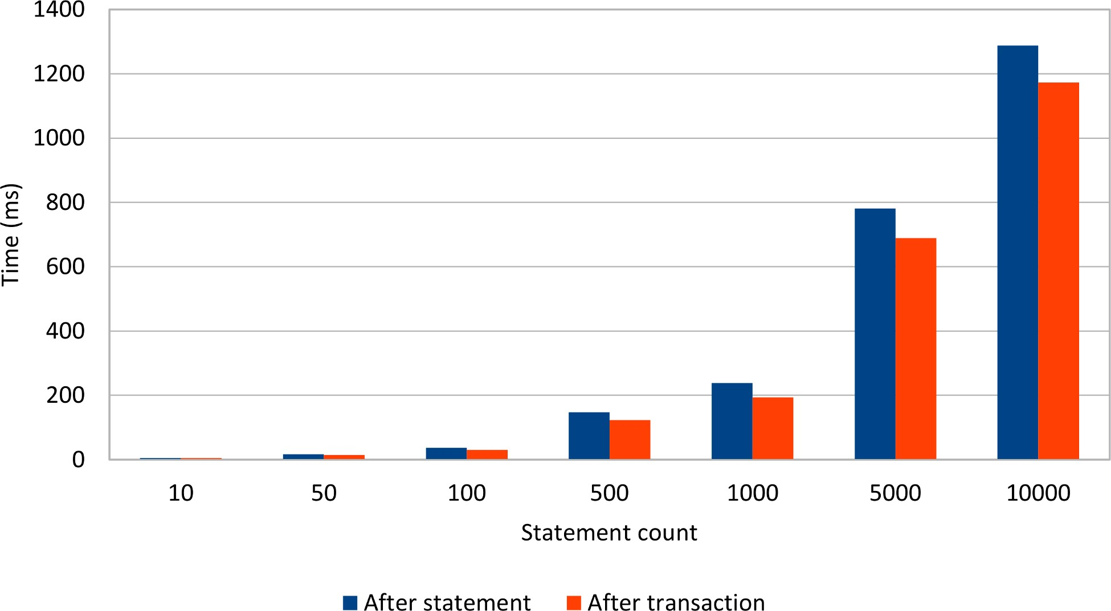

Figure 8.1: Connection release mode
The more statements a transaction executes, the greater the penalty of reacquiring the associated database connection from the underlying connection pool. To better visualize the connection acquisition overhead, the test runs up to 10 000 statements, even if this number is probably too high for the typical OLTP transaction.
Ideally, database transactions should be as short as possible, and the number of statements should not be too high either. This requirement stems from the fact that the number of pooled connections is limited and locks are better released sooner than later.

The after_transaction connection release mode is more efficient than the default JTA after_statement strategy, and so it should be used if the JTA transaction resource management logic does not interfere with this connection releasing strategy.

8.3 Monitoring connections
As previously concluded, using an externally configured DataSource is preferred because the actual DataSource can be decorated with connection pooling, monitoring and logging capabilities. Because that is exactly how FlexyPool works too, the following diagram captures the DataSource proxying mechanism:
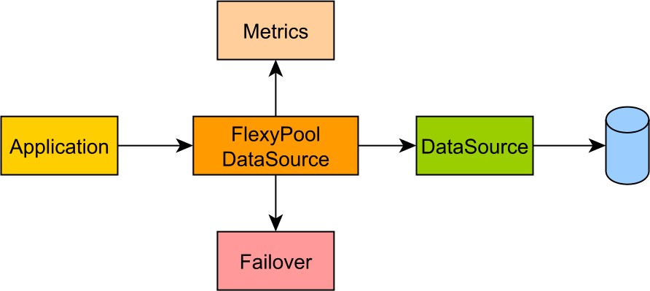

Figure 8.2: FlexyPool architecture
Instead of getting the actual DataSource instance, the data access layer gets a proxy reference. The proxy intercepts connection acquisition and releasing requests, and, this way, it can monitor its usage.
When using Spring, setting up FlexyPool is fairly easy because the application has total control over the DataSource configuration.
In Java EE, database connections should always be fetched from a managed DataSource, and one simple way of integrating FlexyPool is to extend the default DatasourceConnectionProviderImpl and substitute the original DataSource with the FlexyPoolDataSource.
For this reason, FlexyPool comes with the following Hibernate connection provider:
public class FlexyPoolHibernateConnectionProvider extends DatasourceConnectionProviderImpl { private transient FlexyPoolDataSource<DataSource> flexyPoolDataSource;
@Override public void configure(Map props) { super.configure(props); flexyPoolDataSource = new FlexyPoolDataSource<>(getDataSource());
}
@Override public Connection getConnection() throws SQLException { return flexyPoolDataSource.getConnection();
}
@Override public boolean isUnwrappableAs(Class unwrapType) { return super.isUnwrappableAs(unwrapType) || getClass().isAssignableFrom(unwrapType);
}
@Override public void stop() { flexyPoolDataSource.stop(); super.stop();
}
}
To use the FlexyPoolHibernateConnectionProvider, the application must configure the hibernate.connection.provider_class property:
<property name="hibernate.connection.provider_class"
value="com.vladmihalcea.flexypool.adaptor.FlexyPoolHibernateConnectionProvider"
/>

8.3.1 Hibernate statistics
Hibernate has a built-in statistics collector which gathers notifications related to database connections, Session transactions and even second-level caching usage. The StatisticsImplementor interface defines the contract for intercepting various Hibernate internal events:
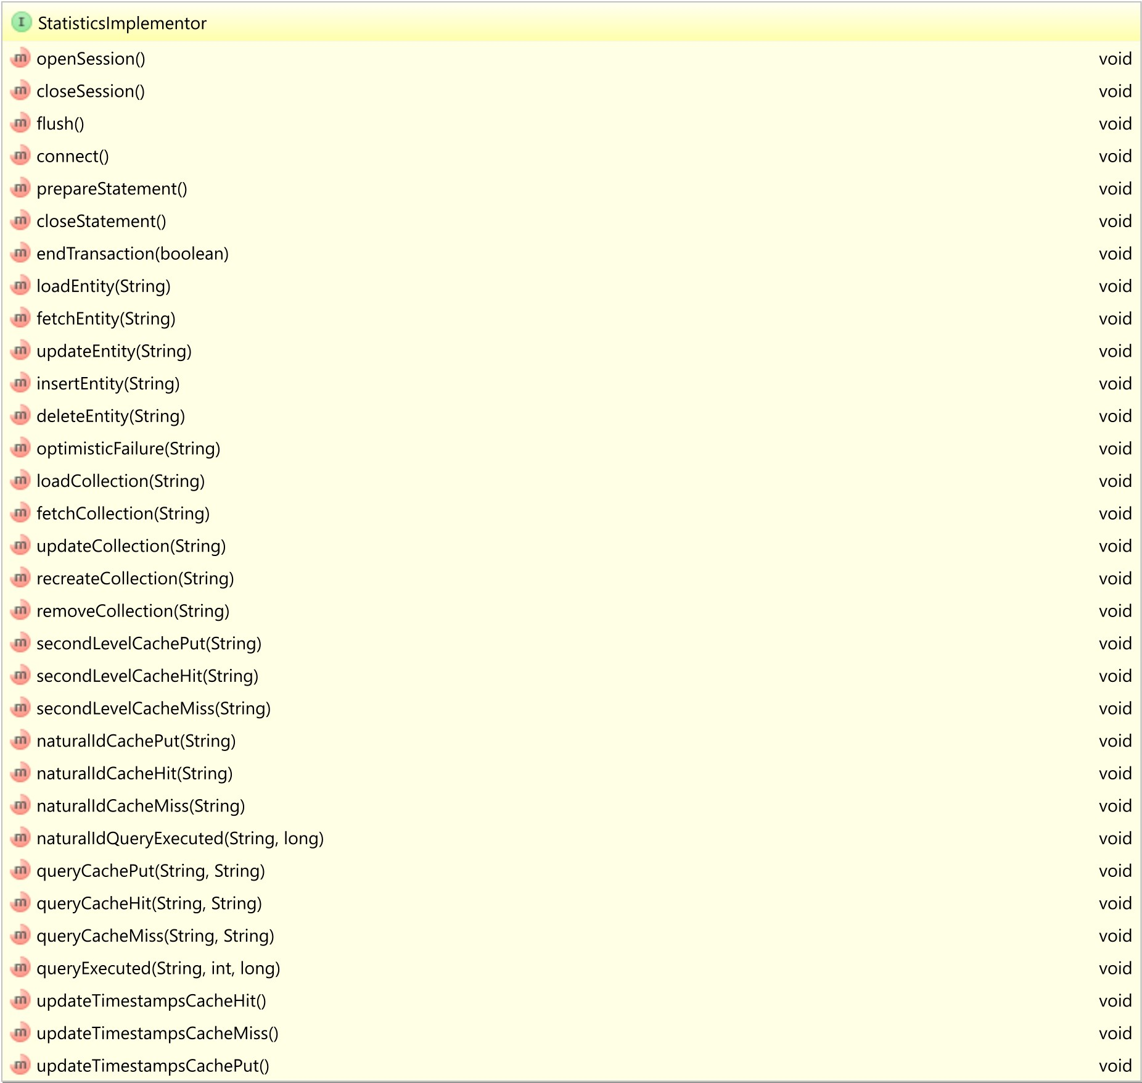

Figure 8.3: Hibernate StatisticsImplementor interface
There is a great variety of metrics Hibernate can collect on user’s behalf, but, for performance reasons, the statistics mechanism is disabled by default.
To enable the statistics gathering mechanism, the following property must be configured first:
<property name="hibernate.generate_statistics" value="true"/>
Once statistics are being collected, in order to print them into the current application log, the following logger configuration must be set up:
<logger name="org.hibernate.engine.internal.StatisticalLoggingSessionEventListener" level="info" />
With these two settings in place, whenever a Hibernate Session (Persistence Context) ends, the following report is displayed in the currently running log.
37125102 nanoseconds spent acquiring 10000 JDBC connections;
25521714 nanoseconds spent releasing 10000 JDBC connections; 95242323 nanoseconds spent preparing 10000 JDBC statements;
923615040 nanoseconds spent executing 10000 JDBC statements;
The default statistics collector just counts the number of times a certain callback method was called, and, if that is not satisfactory, the application developer can supply its own custom StatisticsImplementor implementation.
Dropwizard Metrics
In a high-throughput transaction system, the amount of metric data needed to be recorded can be overwhelming, so storing all these values into memory is not practical at all.
To reduce the memory footprint, the Dropwizard Metricsª project uses various reservoir sampling^{b} strategies, which either employ a fixed-size sampler or a time-based sampling window.
Not only it supports a great variety of metrics (e.g. timers, histograms, gauges), but Dropwizard Metrics can use multiple reporting channels as well (e.g. SLF4J, JMX, Ganglia, Graphite).

For all these reasons, it is better to use a mature framework such as Dropwizard Metrics instead of building a custom implementation from scratch.
ªhttps://github.com/dropwizard/metrics
^{b}https://en.wikipedia.org/wiki/Reservoir_sampling
8.3.1.1 Customizing statistics
Although the built-in metrics are rather informative, Hibernate is not limited to the default statistics collector mechanism which can be completely customized.
In the upcoming example, the statistics collector also provides the following metrics:
- the distribution of physical transaction time (the interval between the moment a connection is first acquired and when it gets released)
- a histogram of the number of connections acquisition requests during the lifespan of any given transaction (due to the after_statement release mode).
The StatisticsReport class provides metric storage and report generation features on top of Dropwizard Metrics:
public class StatisticsReport { private final Logger LOGGER = LoggerFactory.getLogger(getClass()); private MetricRegistry metricRegistry = new MetricRegistry();
private Histogram connectionCountHistogram = metricRegistry.
histogram("connectionCountHistogram");
private Timer transactionTimer = metricRegistry. timer("transactionTimer");
private Slf4jReporter logReporter = Slf4jReporter
.forRegistry(metricRegistry)
.outputTo(LOGGER) .build();
public void transactionTime(long nanos) { transactionTimer.update(nanos, TimeUnit.NANOSECONDS);
}
public void connectionsCount(long count) { connectionCountHistogram.update(count);
}
public void generate() { logReporter.report();
}
}

http://docs.oracle.com/javaee/7/api/javax/persistence/EntityManager.html#persist-java.lang.Object⁵https://docs.jboss.org/hibernate/orm/current/javadocs/org/hibernate/Session.html
http://www.mchange.com/projects/c3p0/
https://commons.apache.org/proper/commons-dbcp/
https://github.com/wwadge/bonecp
https://github.com/brettwooldridge/HikariCP
https://github.com/vibur/vibur-dbcp
https://github.com/brettwooldridge/HikariCP
http://lists.jboss.org/pipermail/hibernate-dev/2006-December/000903.html
https://github.com/vladmihalcea/flexy-pool

