Table of Contents

PRD â€“ Há»‡ thá»‘ng VinhKhanhStreet (VKFoodTour)
Product Requirements Document Dá»± Ã¡n: Ná»n táº£ng Food Tour thÃ´ng minh vá»›i audio guide Ä‘a ngÃ´n ngá»¯ cho phá»‘ áº©m thá»±c PhiÃªn báº£n: 1.1 NgÃ y cáºp nháºt: 27/04/2026
PhiÃªn báº£n cÃ³ áº£nh sÆ¡ Ä‘á»“ Ä‘Ã£ render: xem docs/diagrams/PRD.Rendered.md (Ä‘Ã£ thay táº¥t cáº£ khá»‘i Mermaid báº±ng PNG/SVG). Render láº¡i khi sá»a file nÃ y: cháº¡y pwsh -File docs/render-prd.ps1 tá»« thÆ° má»¥c gá»‘c.

1. Tá»•ng quan Ä‘á»“ Ã¡n

1.1. Bá»‘i cáº£nh
Phá»‘ áº©m thá»±c táº¡i Viá»‡t Nam ngÃ y cÃ ng phÃ¡t triá»ƒn vÃ thu hÃºt lÆ°á»£ng lá»›n du khÃ¡ch trong vÃ ngoÃ i nÆ°á»›c. Tuy nhiÃªn, du khÃ¡ch thÆ°á»ng gáº·p cÃ¡c váº¥n Ä‘á»:
- KhÃ´ng hiá»ƒu Ä‘Æ°á»£c cÃ¢u chuyá»‡n, vÄƒn hÃ³a, lá»‹ch sá» cá»§a tá»«ng quÃ¡n.
- RÃ o cáº£n ngÃ´n ngá»¯ khi Ä‘á»c menu, biá»ƒn hiá»‡u, há»i thÃ´ng tin.
- KhÃ³ lá»±a chá»n quÃ¡n phÃ¹ há»£p do thiáº¿u thÃ´ng tin thá»‘ng nháº¥t.
- Tráº£i nghiá»‡m rá»i ráº¡c, khÃ´ng cÃ³ "sá»£i dÃ¢y" dáº«n dáº¯t xuyÃªn suá»‘t tour.
CÃ¡c giáº£i phÃ¡p hiá»‡n cÃ³ nhÆ° Google Maps, TripAdvisor chá»‰ cung cáº¥p thÃ´ng tin tÄ©nh, khÃ´ng cÃ³ tráº£i nghiá»‡m audio theo vá»‹ trÃ (location-based audio guide) vÃ khÃ´ng há»— trá»£ Ä‘a ngÃ´n ngá»¯ tá»± Ä‘á»™ng cho tá»«ng quÃ¡n nhá» láº».

1.2. Má»¥c tiÃªu sáº£n pháº©m
VinhKhanhStreet (VKFoodTour) lÃ há»‡ thá»‘ng tráº£i nghiá»‡m áº©m thá»±c thÃ´ng minh, bao gá»“m:
- Web Admin: nÆ¡i quáº£n trá»‹ viÃªn váºn hÃ nh toÃ n bá»™ phá»‘ áº©m thá»±c (POI, ngÃ´n ngá»¯, audio, QR, thá»‘ng kÃª).
- Web Vendor: nÆ¡i chá»§ quÃ¡n tá»± quáº£n lÃ½ gian hÃ ng, thá»±c Ä‘Æ¡n, media.
- Mobile App: á»©ng dá»¥ng dÃ nh cho du khÃ¡ch, quÃ©t QR Ä‘áº§u phá»‘ Ä‘á»ƒ báº¯t Ä‘áº§u tour audio Ä‘a ngÃ´n ngá»¯, tá»± Ä‘á»™ng thuyáº¿t minh theo vá»‹ trÃ GPS.
Má»¥c tiÃªu cá»‘t lÃµi:
- Táº¡o tráº£i nghiá»‡m audio tour tá»± Ä‘á»™ng theo geofence cho du khÃ¡ch.
- Há»— trá»£ Ä‘a ngÃ´n ngá»¯ (i18n) vá»›i dá»‹ch + TTS (Text-to-Speech) hÃ ng loáº¡t.
- Há»‡ thá»‘ng QR-first: má»™t QR Ä‘áº§u phá»‘ khá»Ÿi táº¡o toÃ n bá»™ tour, tá»«ng QR quÃ¡n Ä‘á»ƒ xem chi tiáº¿t nhanh.
- Cung cáº¥p dashboard thá»‘ng kÃª realtime phá»¥c vá»¥ quáº£n lÃ½ vÃ quyáº¿t Ä‘á»‹nh kinh doanh.

1.3. Pháº¡m vi & Ä‘á»‘i tÆ°á»£ng sá» dá»¥ng
Äá»‘i tÆ°á»£ng | Ná»n táº£ng | Vai trÃ² chÃnh
Admin | Web Admin (Blazor Server) | Quáº£n trá»‹ toÃ n há»‡ thá»‘ng, duyá»‡t POI, cáº¥u hÃ¬nh ngÃ´n ngá»¯, táº¡o audio, quáº£n lÃ½ QR, dá»‹ch ná»™i dung
Vendor (chá»§ quÃ¡n) | Web Vendor (cÃ¹ng app Blazor, role Vendor) | Cáºp nháºt thÃ´ng tin quÃ¡n, quáº£n lÃ½ thá»±c Ä‘Æ¡n, xem thá»‘ng kÃª
Du khÃ¡ch (End-user) | Mobile App (.NET MAUI) | QuÃ©t QR, chá»n ngÃ´n ngá»¯, nghe audio theo vá»‹ trÃ, Ä‘Ã¡nh giÃ¡

1.4. Kiáº¿n trÃºc tá»•ng thá»ƒ
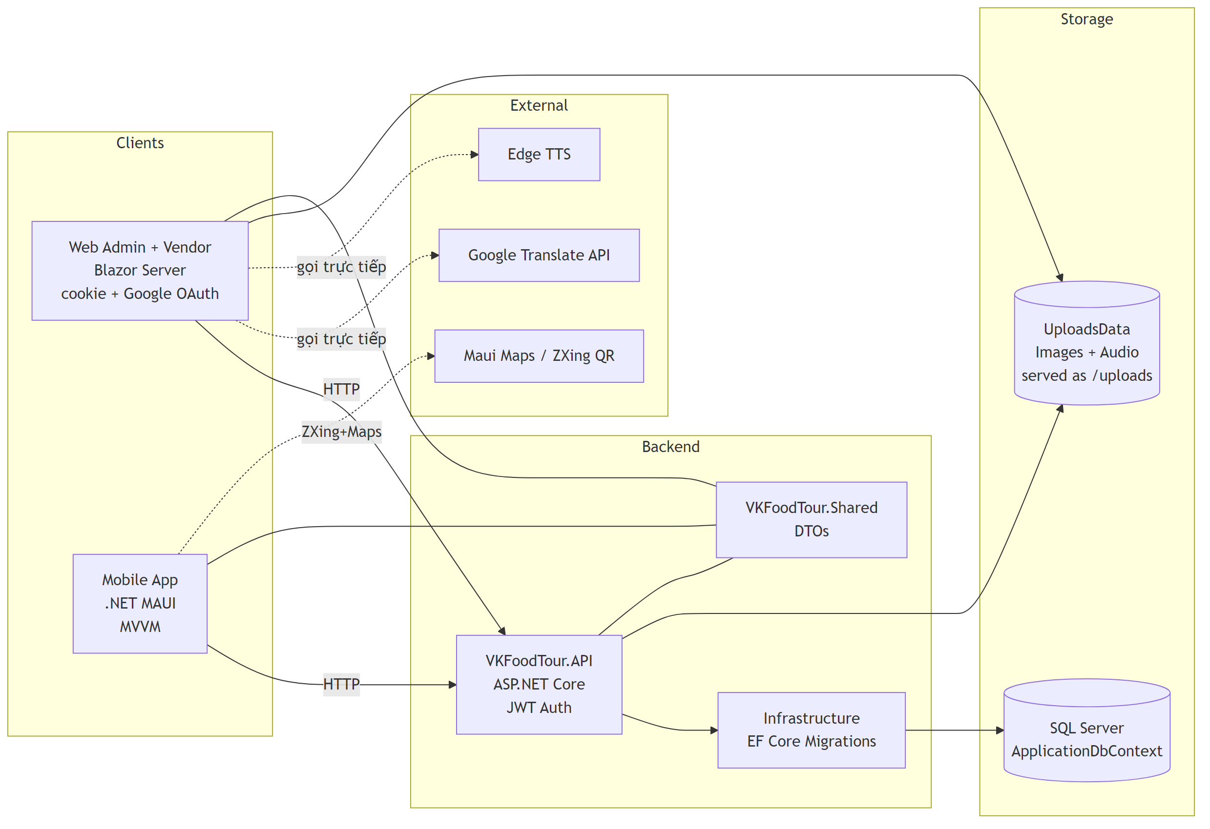
Ghi chÃº kiáº¿n trÃºc thá»±c táº¿
- Nghiá»‡p vá»¥ Ä‘Æ°á»£c Ä‘áº·t trá»±c tiáº¿p trong Controller cá»§a API vÃ trong Admin/Services/ (khÃ´ng dÃ¹ng CQRS/MediatR).
- Google Translate vÃ Edge TTS Ä‘Æ°á»£c gá»i tá»« Web Admin (khi Admin soáº¡n ná»™i dung), khÃ´ng pháº£i tá»« API runtime.
- KhÃ´ng cÃ³ SignalR hub nghiá»‡p vá»¥ â€“ dashboard realtime dá»±a trÃªn polling tracking log.

2. Use-case tá»•ng quan
MÃ´ táº£: SÆ¡ Ä‘á»“ use-case gom toÃ n bá»™ chá»©c nÄƒng cá»§a há»‡ thá»‘ng theo 3 actor chÃnh: Admin, Vendor, Du khÃ¡ch. ÄÃ¢y lÃ cÃ¡i nhÃ¬n tá»•ng quan vá» pháº¡m vi Ä‘á»“ Ã¡n trÆ°á»›c khi Ä‘i vÃ o chi tiáº¿t tá»«ng module.
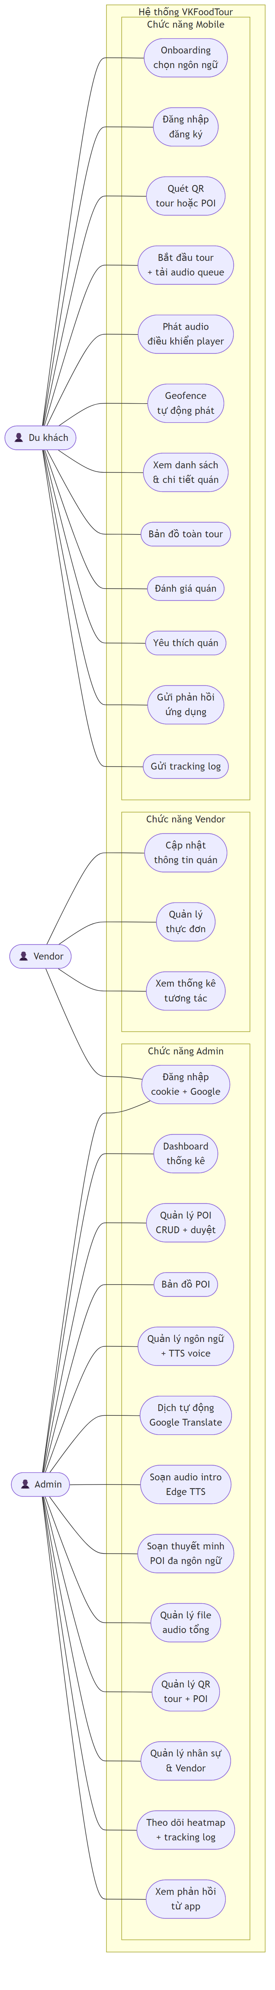
Ghi chÃº:
- Admin vÃ Vendor dÃ¹ng chung há»‡ thá»‘ng Ä‘Äƒng nháºp (UA1) â€“ phÃ¢n quyá»n theo role.
- Chá»©c nÄƒng "Quáº£n lÃ½ POI" (UA3) include use-case "Duyá»‡t POI" (Pending â†’ Approved/Rejected) â€“ chi tiáº¿t tráº¡ng thÃ¡i xem á»Ÿ sÆ¡ Ä‘á»“ State Lifecycle (STATE-01).
- CÃ¡c use-case dáº¡ng CRUD (UA3, UA8, UA11, UV1, UV2) Ä‘á»u tuÃ¢n theo pattern chung â€“ xem sÆ¡ Ä‘á»“ SEQ-08 (CRUD generic).

3. Chá»©c nÄƒng ná»•i báºt
Má»—i má»¥c dÆ°á»›i Ä‘Ã¢y liá»‡t kÃª route, file Razor / Service, vÃ danh sÃ¡ch phÆ°Æ¡ng thá»©c thá»±c sá»± Ä‘Æ°á»£c gá»i khi váºn hÃ nh tab. Phá»¥c vá»¥ tra cá»©u nhanh khi maintain.

3.1. Web Admin (role Admin)

A1 â€” Dashboard tá»•ng quan / (Pages/Home.razor)
Khu vá»±c | MÃ´ táº£ | PhÆ°Æ¡ng thá»©c / nguá»“n dá»¯ liá»‡u
Realtime thiáº¿t bá»‹ | Äáº¿m device Ä‘ang dÃ¹ng app trong cá»a sá»• vÃ i chá»¥c giÃ¢y | ActiveDevicesWidget.LoadAsync() â†’ Ä‘á»c Db.TrackingLogs (poll má»—i 3s)
Thá»‘ng kÃª há»‡ thá»‘ng | Tá»•ng POI / POI Ä‘ang hoáº¡t Ä‘á»™ng / tá»•ng thuyáº¿t minh / sá»‘ ngÃ´n ngá»¯ active / tá»•ng user / sá»‘ vendor / lÆ°á»£t QR hÃ´m nay | Home.LoadAdminStats()
HÃ nh vi ngÆ°á»i dÃ¹ng | Tá»•ng tÆ°Æ¡ng tÃ¡c hÃ´m nay (loáº¡i trá»« heartbeat move), thá»i gian nghe TB, tá»•ng Ä‘Ã¡nh giÃ¡ | Home.LoadAdminStats()
Top gian hÃ ng | Top 5 POI cÃ³ nhiá»u lÆ°á»£t enter + qr_scan | Group TrackingLogs theo PoiId
Top thuyáº¿t minh | Top 5 POI cÃ³ tá»•ng phÃºt nghe lá»›n nháº¥t (listen_end) | Sum ListenedDurationSec
NgÃ´n ngá»¯ sá» dá»¥ng | Äáº¿m sá»‘ thiáº¿t bá»‹ duy nháº¥t theo ngÃ´n ngá»¯ Má»šI NHáº¤T cá»§a há» trong 30 ngÃ y, chuáº©n hoÃ¡ bá» anon: / region | Home.LoadAdminStats() + NormalizeLangCode()
PhÃ¢n bá»• Ä‘Ã¡nh giÃ¡ | Histogram 1-5 sao | Db.Reviews.GroupBy(Rating)

A2 â€” Quáº£n lÃ½ gian hÃ ng /admin/pois (Pages/PoiList.razor + Services/PoiService.cs)
TÃ¡c vá»¥ | PhÆ°Æ¡ng thá»©c
TÃ¬m kiáº¿m theo tÃªn + lá»c tráº¡ng thÃ¡i + lá»c phÃª duyá»‡t | FilteredPois (LINQ in-memory)
Táº£i danh sÃ¡ch POI vÃ Vendor | PoiService.GetAllAsync(), AuthService.GetAllUsersAsync()
Má»Ÿ modal sá»a / lÆ°u | ShowEditModal(), SavePoi() â†’ PoiService.UpdateAsync(Poi) (radius bá»‹ Ã©p vá» DefaultRadius=20 máº·c Ä‘á»‹nh, runtime cá»™ng theo gÃ³i)
Duyá»‡t POI | ApprovePoiAction() â†’ PoiService.ApprovePoiAsync(poiId)
Tá»« chá»‘i POI | RejectPoiAction() â†’ PoiService.RejectPoiAsync(poiId, note)
KhoÃ¡ / má»Ÿ khoÃ¡ gian hÃ ng | HidePoiAsync() â†’ PoiService.HideStallAsync(id) ; ToggleActive() â†’ ToggleActiveAsync(id)
Hiá»ƒn thá»‹ geofence hiá»‡u dá»¥ng theo gÃ³i | GetOwnerTier(ownerId) + GetTierBonus(tier) (+0/+5/+10/+15)

A3 â€” Báº£n Ä‘á»“ POI + Heatmap /admin/ban-do (Pages/Admin/BanDoPoi.razor)
TÃ¡c vá»¥ | PhÆ°Æ¡ng thá»©c
Khá»Ÿi táº¡o Leaflet + render markers | InitMapAsync() â†’ JS interop initAdminMap
Báºt/táº¯t heatmap | OnToggleHeatmap(), ReloadHeatmapAsync()
Heatmap data | API GET /api/Tracking/heatmap?hours=...

A4 â€” Quáº£n lÃ½ ngÃ´n ngá»¯ & dá»‹ch /quan-ly-ngon-ngu (Pages/Admin/QuanLyNgonNgu.razor + LanguageProvisionJobService, GoogleTranslateService, EdgeTtsService)
TÃ¡c vá»¥ | PhÆ°Æ¡ng thá»©c
Táº£i danh sÃ¡ch ngÃ´n ngá»¯ + voice gá»£i Ã½ | LoadData()
Kiá»ƒm tra mÃ£ ngÃ´n ngá»¯ Google há»— trá»£ | CheckLanguageCode() â†’ GoogleTranslateService.IsLanguageSupportedAsync()
ThÃªm ngÃ´n ngá»¯ + cháº¡y auto-provision audio cho má»i POI Approved | AddLanguage() â†’ LanguageProvisionJobService.StartAsync() (job ná»n)
Theo dÃµi tiáº¿n Ä‘á»™ job | RefreshCurrentJob(), StartJobPolling()
Audit dá»‹ch â€” phÃ¡t hiá»‡n POI thiáº¿u hoáº·c lá»‡ch ná»™i dung | RunTranslationAudit() â†’ so sÃ¡nh Narrations theo LanguageId
Sá»a lá»—i tá»«ng POI | RetryIssue(issue) â†’ PoiService.SyncPoiLanguageAsync(poiId, languageId)
Äá»“ng bá»™ láº¡i toÃ n ngÃ´n ngá»¯ | StartResyncForLanguage(id)
Báºt/táº¯t ngÃ´n ngá»¯ | ToggleLanguage(row)

A5 â€” Audio Intro Phá»‘ /admin/intro-audio (Pages/Admin/IntroAudio.razor)
TÃ¡c vá»¥ | PhÆ°Æ¡ng thá»©c
Táº£i ná»™i dung intro hiá»‡n táº¡i theo ngÃ´n ngá»¯ | LoadCurrentSettingAsync() (Ä‘á»c báº£ng APP_SETTINGS)
Äá»•i ngÃ´n ngá»¯ Ä‘ang sá»a | SelectLang(code)
Tá»± Ä‘á»™ng dá»‹ch intro tá»« tiáº¿ng Viá»‡t | AutoTranslateIntroAsync() â†’ GoogleTranslateService.TranslateAsync()
Sinh audio Edge TTS | GenerateIntroTtsAsync() â†’ EdgeTtsService.SynthesizeAsync(text, voice) (output UploadsData/intro/intro_{lang}.mp3)
XoÃ¡ audio intro | DeleteIntroAudioAsync()
LÆ°u setting | UpsertSettingAsync(key, value)

A6 â€” Quáº£n lÃ½ thuyáº¿t minh POI /thuyet-minh (Pages/Admin/ThuyetMinh.razor) vÃ Audio tá»•ng /admin/audio-management (Pages/Admin/AudioManagement.razor)
TÃ¡c vá»¥ | PhÆ°Æ¡ng thá»©c
Táº£i POI + tÃ¬nh tráº¡ng audio Ä‘a ngÃ´n ngá»¯ | LoadDataAsync() (group Narrations theo LanguageId & IsActive)
Sinh audio Edge TTS cho 1 POI | GenerateTtsForPoiAsync(poi) â†’ PoiService.UpdateMultilingualNarrationsAsync(poiId, forceRefresh)
Sinh audio cho toÃ n bá»™ POI | GenerateAllTtsAsync()
Táº¡o QR cho POI | CreateQrForPoiAsync(poi) â†’ PoiService.EnsurePrimaryQrForVendorAsync()
Nghe thá» audio trÃªn trÃ¬nh duyá»‡t | PlayAudio(url) / StopAudio() (JS interop <audio>)

A7 â€” Quáº£n lÃ½ QR /ma-qr (Pages/Admin/MaQR.razor)
TÃ¡c vá»¥ | PhÆ°Æ¡ng thá»©c
Táº£i danh sÃ¡ch QR (POI + master tour) | LoadData()
Táº¡o/Ä‘áº£m báº£o QR master cho phá»‘ | CreateMasterQrAsync() â†’ PoiService.EnsureMasterTourQrAsync()
Báºt/táº¯t 1 QR | ToggleQr(qrId)
TÃ¡i táº¡o QR theo ná»™i dung quÃ¡n | RegenerateByDescription(qr) â†’ PoiService.RegenerateQrFromDescriptionAsync()
Táº£i PNG QR | DownloadQr(token) â†’ JS endpoint sinh PNG
XoÃ¡ táº¥t cáº£ QR | DeleteAllQrAsync() â†’ PoiService.DeleteAllQrAsync()
Resolve token (mobile) | API GET /api/Qr/resolve/{token}

A8 â€” Quáº£n lÃ½ gian hÃ ng (ná»™i bá»™) /gian-hang (Pages/Admin/GianHang.razor)
TÃ¡c vá»¥ | PhÆ°Æ¡ng thá»©c
Tá»•ng há»£p POI + chá»§ + email + áº£nh + ngÃ´n ngá»¯ TM + sá»‘ mÃ³n | OnInitializedAsync() (join Pois, Users, Narrations, Foods, Images)
Má»Ÿ quick-edit (chá»‰ priority â€” radius láº¥y máº·c Ä‘á»‹nh + bonus theo gÃ³i) | OpenQuickEdit(row)
LÆ°u priority | SaveQuickEditAsync() (Ã©p poi.Radius = DefaultRadius)

A9 â€” Quáº£n lÃ½ nhÃ¢n sá»± & vendor /nguoi-dung (Pages/Admin/NguoiDung.razor)
TÃ¡c vá»¥ | PhÆ°Æ¡ng thá»©c
Táº£i danh sÃ¡ch user (Admin + Vendor) | LoadUsers() â†’ AuthService.GetAllUsersAsync()
Báºt/khoÃ¡ tÃ i khoáº£n | ToggleUserAsync(user) â†’ AuthService.ToggleActiveAsync(userId)
Táº¡o / sá»a user (má»Ÿ modal) | ShowModal(), SaveUser() â†’ AuthService.RegisterAdminAsync() / RegisterVendorAsync() (auto-táº¡o POI placeholder cho vendor)

A10 â€” Pháº£n há»“i App /admin/phan-hoi-app (Pages/Admin/AppFeedback.razor)
TÃ¡c vá»¥ | PhÆ°Æ¡ng thá»©c
Táº£i feedback + lá»c / phÃ¢n trang | LoadDataAsync(), SetRatingFilter(star), ApplyFilter(), PrevPage(), NextPage()
XoÃ¡ pháº£n há»“i | DeleteFeedbackAsync(id)

A11 â€” Auth /login, /logout
TÃ¡c vá»¥ | PhÆ°Æ¡ng thá»©c
ÄÄƒng nháºp | Login.HandleLogin() â†’ AuthService.AuthenticateAsync(email, password) (BCrypt verify) â†’ SignInAsync cookie scheme
ÄÄƒng xuáº¥t | Logout.OnInitializedAsync() â†’ SignOutAsync

3.2. Web Vendor (cÃ¹ng app Blazor, role Vendor)

V1 â€” Dashboard quÃ¡n / (Pages/Home.razor â€” branch Vendor)
Khu vá»±c | PhÆ°Æ¡ng thá»©c
Tá»•ng quan KPI (QR scan hÃ´m nay, audio play hÃ´m nay, Ä‘Ã¡nh giÃ¡ TB, gÃ³i thÃ nh viÃªn) | Home.LoadVendorStats() â†’ DashboardMetricsService.GetVendorMetricsAsync(userId)
Checklist váºn hÃ nh (mÃ´ táº£ / Ä‘á»‹a chá»‰-báº£n Ä‘á»“ / áº£nh bÃ¬a / audio / mÃ³n) | flag tá»« VendorMetrics (HasDescription, HasAddress, HasValidMap, HasCover, HasAudio, MenuCount)
Quick action | link sang /vendor/thong-tin, /vendor/thuc-don, /vendor/goi-thanh-vien

V2 â€” ThÃ´ng tin gian hÃ ng /vendor/thong-tin (Pages/Vendor/ThongTinQuan.razor)
TÃ¡c vá»¥ | PhÆ°Æ¡ng thá»©c
Táº£i POI cá»§a vendor (auto-táº¡o náº¿u chÆ°a cÃ³) | LoadDataAsync() â†’ PoiService.GetPoiByOwnerIdAsync(userId) / EnsureVendorPoiAsync()
Khá»Ÿi táº¡o báº£n Ä‘á»“ tÆ°Æ¡ng tÃ¡c + Ã´ tÃ¬m Ä‘á»‹a chá»‰ | JS initMapPicker(...) (callback OnMapLocationChanged, OnAddressSearchSelected)
TÃ¬m kiáº¿m Ä‘á»‹a chá»‰ | HandleSearchClick() / HandleSearchKeyUp(e) â†’ JS triggerMapSearch
LÆ°u thÃ´ng tin chung (tÃªn / mÃ´ táº£ / Ä‘á»‹a chá»‰ / toáº¡ Ä‘á»™ / áº£nh) | SaveChanges() â†’ PoiService.UpdateStallInfoAsync(...) + sau Ä‘Ã³ UpdateMultilingualNarrationsAsync Ä‘á»ƒ re-sinh audio
Gá»i yÃªu cáº§u duyá»‡t | RequestApproval() â†’ PoiService.RequestApprovalAsync(poiId)
Upload áº£nh bÃ¬a / gallery | HandleCoverUpload(e), HandleGalleryUpload(e) â†’ ghi UploadsData/poi/... + PoiService.AddStallGalleryImageAsync
XoÃ¡ áº£nh gallery | RemoveGalleryAsync(id) â†’ PoiService.RemoveStallGalleryImageAsync
LÃ m má»›i audio Ä‘a ngÃ´n ngá»¯ | SyncAudioAsync() â†’ PoiService.UpdateMultilingualNarrationsAsync(poiId, forceRefresh: true)

V3 â€” Thá»±c Ä‘Æ¡n /vendor/thuc-don (Pages/Vendor/ThucDon.razor + MenuService)
TÃ¡c vá»¥ | PhÆ°Æ¡ng thá»©c
Táº£i mÃ³n cá»§a POI | OnInitializedAsync() â†’ MenuService.GetByPoiAsync(poiId)
Má»Ÿ modal thÃªm / sá»a mÃ³n | ShowAddModal(), ShowEditModal(item), HideModal()
Upload áº£nh mÃ³n | HandleMenuImageUpload(e) (lÆ°u vÃ o UploadsData/menu/...)
LÆ°u mÃ³n (insert/update) | SaveItem() â†’ MenuService.UpsertAsync(MenuItem)
Báºt/táº¯t mÃ³n (sold-out / available) | ToggleStatus(item) â†’ MenuService.ToggleAvailabilityAsync(id)

V4 â€” GÃ³i thÃ nh viÃªn /vendor/goi-thanh-vien (Pages/Vendor/GoiThanhVien.razor) â má»›i khÃ´i phá»¥c
TÃ¡c vá»¥ | PhÆ°Æ¡ng thá»©c
Táº£i gÃ³i hiá»‡n táº¡i | OnInitializedAsync() â†’ AuthService.GetUserByIdAsync(userId) Ä‘á»c User.MembershipTier
ÄÄƒng kÃ½ gÃ³i (Standard / Silver / Gold / Diamond) | RegisterTierAsync(newTier) â†’ AuthService.UpdateMembershipTierAsync(userId, newTier)
Quyá»n lá»£i theo gÃ³i | bonus geofence +0/+5/+10/+15, Æ°u tiÃªn audio trong queue, huy hiá»‡u trÃªn map mobile (gáº¯n vÃ o Poi.MembershipTier qua join Owner)

V5 â€” Trang doanh thu redirect /vendor/thu-nhap (Pages/Vendor/ThuNhap.razor)
Trang chá»‰ Ä‘iá»u hÆ°á»›ng vá» Home Dashboard tá»•ng há»£p (Ä‘Ã£ merge sá»‘ liá»‡u doanh thu/Ä‘Ã¡nh giÃ¡ vÃ o Home Vendor Ä‘á»ƒ gá»n UI).

3.3. Mobile App (.NET MAUI) â€” VKFoodTour.Mobile/

M1 â€” Onboarding & chá»n ngÃ´n ngá»¯
- Views/WelcomePage.xaml.cs â€” landing cÃ³ nÃºt "Báº¯t Ä‘áº§u", ghi event move lÃºc khá»Ÿi Ä‘á»™ng qua IDataService.TrackEventAsync().
- Views/LanguagePickerPage.xaml.cs â€” OnLanguageSelected() â†’ ILocalizationService.SetLanguageCode(code) â†’ ghi ISettingsService.SelectedLanguageCode + HasPickedLanguage = true.

M2 â€” ÄÄƒng nháºp / Ä‘Äƒng kÃ½ / khÃ¡ch vÃ£ng lai
- Views/LoginPage.xaml.cs:
  - OnSubmit() â†’ IDataService.LoginAsync(email,pwd) hoáº·c RegisterAsync(name,email,pwd) â†’ IAuthSessionService.SetUser(...).
  - OnContinueAsGuest() â†’ IAuthSessionService.EnterAnonymous() + log event move kÃ¨m languageCode thuáº§n (khÃ´ng cÃ²n prefix anon:).

M3 â€” QuÃ©t QR
- Views/QrScanPage.xaml.cs (ZXing) â†’ OnQrDetected(token) â†’ IDataService.ResolveQrAsync(token, lang) (GET /api/Qr/resolve/{token}).
- Náº¿u káº¿t quáº£ type = tour â†’ má»Ÿ TourPlayerPage. Náº¿u poi â†’ má»Ÿ StallDetailPage(poiId).

M4 â€” Tour player / audio queue
- Views/TourPlayerPage.xaml.cs + ViewModels/TourPlayerViewModel:
  - StartAsync() â†’ TourService.StartTourAsync(tourId, lang) (POST /api/Tour/start).
  - LoadQueueAsync() â†’ TourService.GetAudioQueueAsync(tourId, lang) (GET /api/Tour/audio-queue).
  - Push tá»«ng item vÃ o AudioQueueService.

M5 â€” PhÃ¡t audio
- Services/AudioPlaybackService.cs (Plugin.Maui.Audio): PlayAsync(url), Pause(), Resume(), Stop(), SeekTo(sec), sá»± kiá»‡n PlaybackEnded.
- Services/AudioQueueService.cs â€” orchestrator chÃnh:
  - EnqueueAsync(item), HandlePoiEnteredAsync(poi), PlayNextFromQueueAsync(), InsertNext(item), InterruptAndPlay(item).
  - Quy táº¯c 60% (TierValue so sÃ¡nh gÃ³i + tiáº¿n Ä‘á»™ _player.PositionRatio) Ä‘á»ƒ quyáº¿t Ä‘á»‹nh InsertNext vs InterruptAndPlay.
  - MarkPoiPlayed(poi) bÃ¡o cho GeofenceMonitorService khÃ´ng re-trigger.

M6 â€” Geofence
- Services/GeofenceMonitorService.cs:
  - StartAsync() poll Geolocation.Default.GetLastKnownLocationAsync() má»—i 3s.
  - EvaluateAsync(lat,lng) tÃnh khoáº£ng cÃ¡ch tá»›i má»i POI: threshold = clamp(PoiRadiusMeters,5,200) + TierBonusMeters + GpsBufferMeters(10m).
  - Dwell 8s: _pendingEnter[poiId] = now, sau 8s á»Ÿ trong vÃ¹ng â†’ _confirmedIn.Add(poiId) + báº¯n event PoiEntered.
  - Exit debounce 10s: pháº£i ngoÃ i vÃ¹ng Ä‘á»§ 10s má»›i PoiExited.
  - Heartbeat move má»—i MoveHeartbeatSeconds qua IDataService.TrackEventAsync(eventType:"move", lat, lng).

M7 â€” Danh sÃ¡ch / chi tiáº¿t quÃ¡n
- Views/StallListPage.xaml.cs + ViewModels/HomeViewModel.cs: LoadAsync() â†’ IDataService.GetPoisAsync(lang) (GET /api/Poi). Sort theo MembershipTier rá»“i Name.
- Views/StallDetailPage.xaml.cs + ViewModels/StallDetailViewModel: LoadAsync(poiId) â†’ IDataService.GetPoiDetailAsync(poiId, lang) (GET /api/Poi/{id}/detail).
- Views/FullMapPage.xaml.cs LoadPoisAsync() â€” váº½ pin + vÃ²ng trÃ²n geofence (base + tierBonus + 10m) + popup chi tiáº¿t khi tap pin.

M8 â€” ÄÃ¡nh giÃ¡ quÃ¡n
- ViewModels/StallDetailViewModel.SubmitReviewAsync() â†’ IDataService.PostReviewAsync(CreateReviewDto { PoiId, Rating, Comment, LanguageCode }) (POST /api/Reviews).

M9 â€” YÃªu thÃch (offline-only)
- Services/FavoriteService.cs: Toggle(poiId), IsFavorite(poiId), GetAll() lÆ°u trong Preferences cá»§a MAUI.

M10 â€” Tracking log + offline queue
- Services/DataService.TrackEventAsync(poiId, eventType, listenedDurationSec?, languageCode?, lat?, lng?):
  - Tá»± gáº¯n LanguageCode tá»« SettingsService.SelectedLanguageCode náº¿u caller khÃ´ng truyá»n.
  - NormalizeLanguageCode() bá» prefix xxx:, lower-case.
  - Náº¿u API lá»—i â†’ EnqueueTrackingAsync() lÆ°u vÃ o SQLite (ILocalStore.EnqueueEventAsync).
  - FlushPendingEventsAsync() xáº£ queue khi máº¡ng quay láº¡i.

M11 â€” Äá»“ng bá»™ offline (má»›i thÃªm)
- Services/Offline/SyncService.cs: SyncAsync() gá»i GET /api/Sync/bootstrap â†’ ghi LocalStore (POI, áº£nh, audio URL, ngÃ´n ngá»¯).
- Services/Offline/MediaCacheService.cs: EnsureCachedAsync(url) táº£i áº£nh/audio vá» FileSystem.AppDataDirectory â†’ tráº£ file:// cho UI.
- Cháº¡y má»—i láº§n App.Resumed Ä‘á»ƒ cáºp nháºt ngáº§m.

M12 â€” Äa ngÃ´n ngá»¯ giao diá»‡n
- Services/LocalizationService.cs: SetLanguageCode(code), sá»± kiá»‡n LanguageChanged.
- Localization/TranslationStrings.cs chá»©a map vi/en/ja/ko/zh + helper NormalizeCultureCode(code) (cáº¯t region: zh-CN â†’ zh).

M13 â€” Gá»i feedback app
- IDataService.SendAppFeedbackAsync(rating, comment) â†’ POST /api/Feedback/app.

M14 â€” Cache áº£nh
- Services/HttpImageService.cs: GetImageStreamAsync(url) cache trong MemoryCache vá»›i TTL 10 phÃºt, fallback nguá»“n gá»‘c khi miss.

3.4. Äiá»ƒm ná»•i báºt cá»§a Ä‘á»“ Ã¡n
- Location-based audio guide: audio thuyáº¿t minh tá»± Ä‘á»™ng phÃ¡t theo GPS/geofence, khÃ¡c biá»‡t vá»›i cÃ¡c app du lá»‹ch báº¥m-má»›i-nghe.
- Pipeline dá»‹ch + TTS khÃ©p kÃn trÃªn Web Admin: admin nháºp tiáº¿ng Viá»‡t â†’ Google Translate sang ngÃ´n ngá»¯ Ä‘Ãch â†’ Edge TTS sinh audio â†’ lÆ°u vÃ o UploadsData vÃ liÃªn káº¿t vá»›i POI.
- Smart Audio Queue (AudioQueueService): xá» lÃ½ hÃ ng Ä‘á»£i audio khi Ä‘i qua nhiá»u POI hoáº·c Ä‘á»©ng giá»¯a cÃ¡c vÃ¹ng geofence chá»“ng láº¥n â€“ Æ°u tiÃªn theo tiáº¿n Ä‘á»™ track (60%) thay vÃ¬ khoáº£ng cÃ¡ch, káº¿t há»£p dwell 8s + exit debounce 10s á»Ÿ GeofenceMonitorService Ä‘á»ƒ trÃ¡nh "nhÃ¡y" do GPS nhiá»…u.
- QR-first onboarding: má»™t QR Ä‘áº§u phá»‘ Ä‘á»§ Ä‘á»ƒ khá»Ÿi táº¡o toÃ n bá»™ tour, khÃ´ng cáº§n Ä‘Äƒng kÃ½ trÆ°á»›c.
- Tracking Ä‘áº§y Ä‘á»§ hÃ nh vi (Tracking/log) phá»¥c vá»¥ heatmap, Ä‘áº¿m thiáº¿t bá»‹ online, thá»‘ng kÃª tá»‰ lá»‡ hoÃ n thÃ nh tour.

4. SÆ¡ Ä‘á»“ Sequence (tuáº§n tá»±)

4.1. SEQ-01 â€“ Du khÃ¡ch quÃ©t QR vÃ báº¯t Ä‘áº§u tour
MÃ´ táº£: MÃ´ táº£ luá»“ng tá»« khi du khÃ¡ch quÃ©t QR táº¡i cá»•ng phá»‘ áº©m thá»±c Ä‘áº¿n khi audio intro Ä‘Æ°á»£c phÃ¡t. ÄÃ¢y lÃ luá»“ng "onboarding" quan trá»ng nháº¥t quyáº¿t Ä‘á»‹nh tráº£i nghiá»‡m Ä‘áº§u tiÃªn.
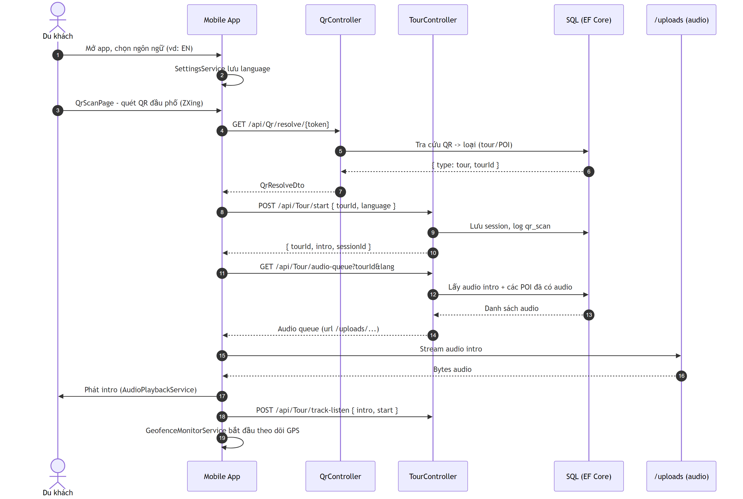
Äiá»ƒm quan trá»ng:
- QR token luÃ´n Ä‘i qua Qr/resolve Ä‘á»ƒ trÃ¡nh lá»™ dá»¯ liá»‡u POI.
- Audio url lÃ Ä‘Æ°á»ng dáº«n tÄ©nh /uploads/... (ASP.NET UseStaticFiles).
- Tour/track-listen ghi láº¡i viá»‡c báº¯t Ä‘áº§u phÃ¡t intro.

4.2. SEQ-02 â€“ Tá»± Ä‘á»™ng phÃ¡t audio khi vÃ o vÃ¹ng geofence POI
MÃ´ táº£: CÆ¡ cháº¿ geofence trigger tá»± Ä‘á»™ng â€“ mobile poll GPS má»—i 3s, pháº£i á»Ÿ trong vÃ¹ng POI liÃªn tá»¥c 8 giÃ¢y (dwell) má»›i phÃ¡t audio Ä‘á»ƒ trÃ¡nh giáºt do GPS nhiá»…u. Khi káº¿t thÃºc tá»± nhiÃªn, audio káº¿ tiáº¿p Ä‘Æ°á»£c láº¥y tá»« queue.
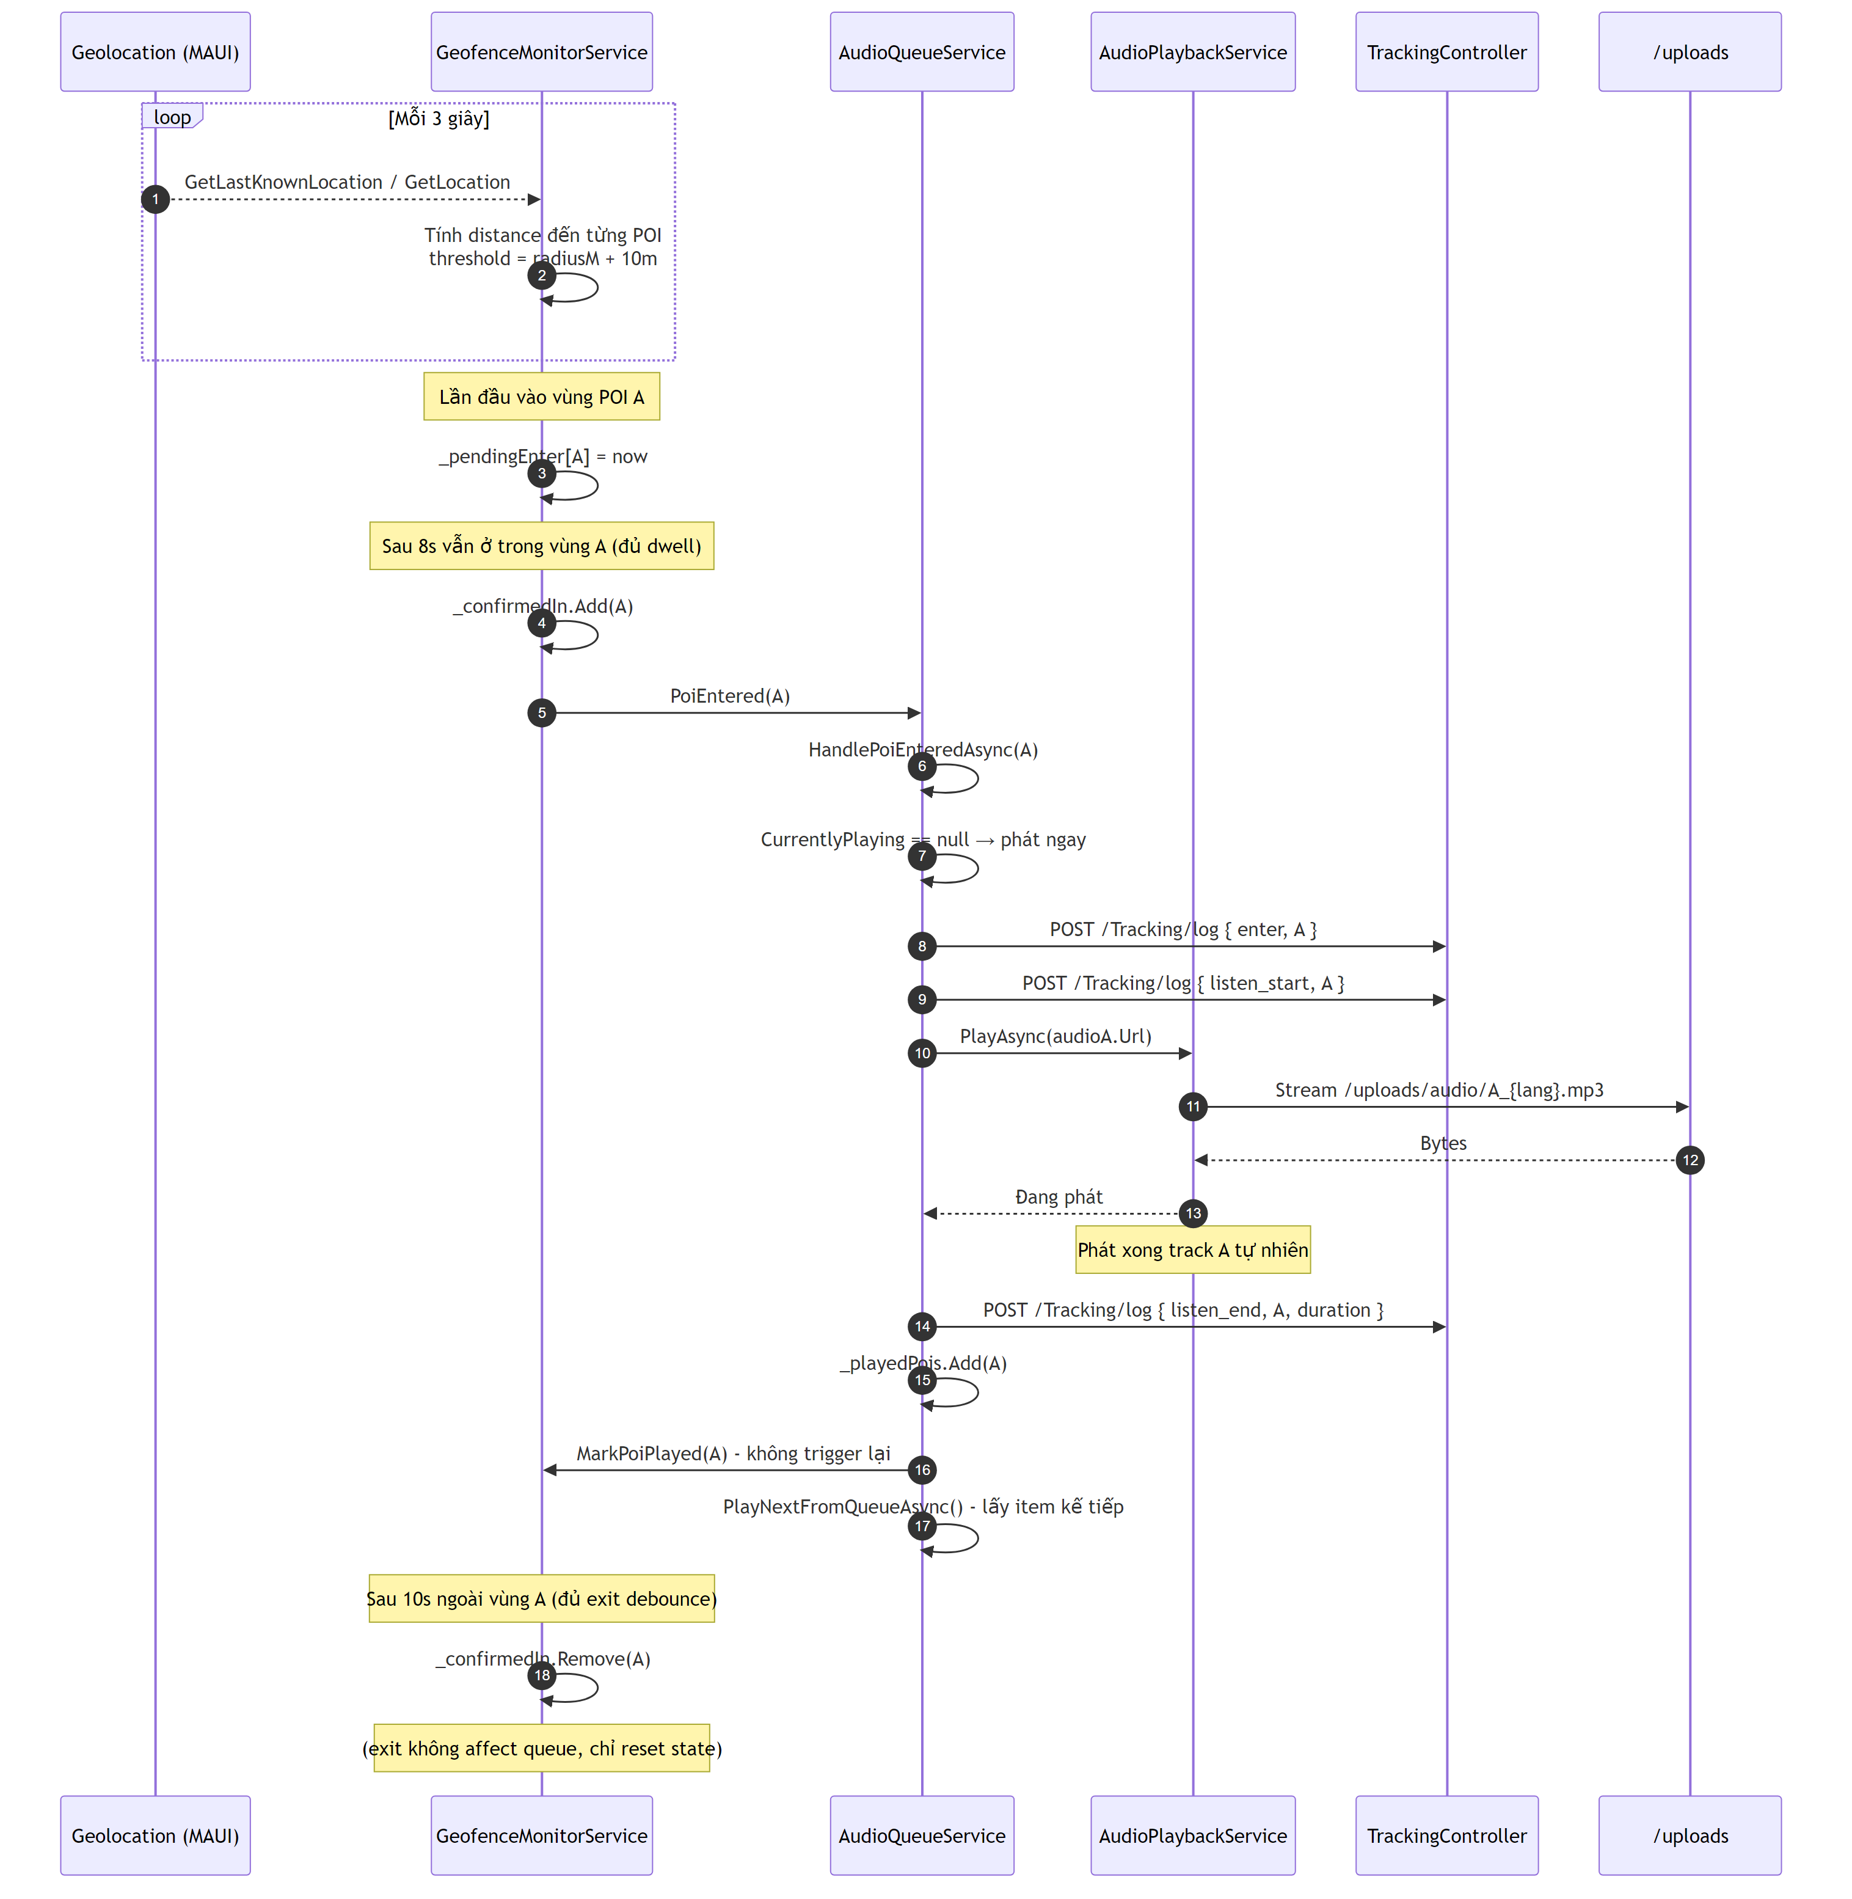
Äiá»ƒm quan trá»ng:
- Dwell 8s ngÄƒn false-positive khi du khÃ¡ch Ä‘i ngang qua quÃ¡n mÃ khÃ´ng dá»«ng.
- POI Ä‘Ã£ phÃ¡t xong Ä‘Æ°á»£c Ä‘Ã¡nh dáº¥u _playedPois â†’ khÃ´ng re-trigger dÃ¹ du khÃ¡ch quay láº¡i.
- TrÆ°á»ng há»£p Ä‘á»©ng giá»¯a 2 geofence Ä‘Æ°á»£c mÃ´ táº£ riÃªng á»Ÿ SEQ-07.

4.3. SEQ-03 â€“ Admin dá»‹ch ná»™i dung POI + sinh audio báº±ng Edge TTS
MÃ´ táº£: TrÃªn Web Admin, tá»« trang ThuyetMinh.razor, admin soáº¡n ná»™i dung tiáº¿ng Viá»‡t cá»§a 1 POI, dá»‹ch sang cÃ¡c ngÃ´n ngá»¯ Ä‘Ãch (Google Translate), sau Ä‘Ã³ sinh audio (Edge TTS) vÃ lÆ°u file vÃ o thÆ° má»¥c UploadsData/ Ä‘á»ƒ API phá»¥c vá»¥ qua /uploads.
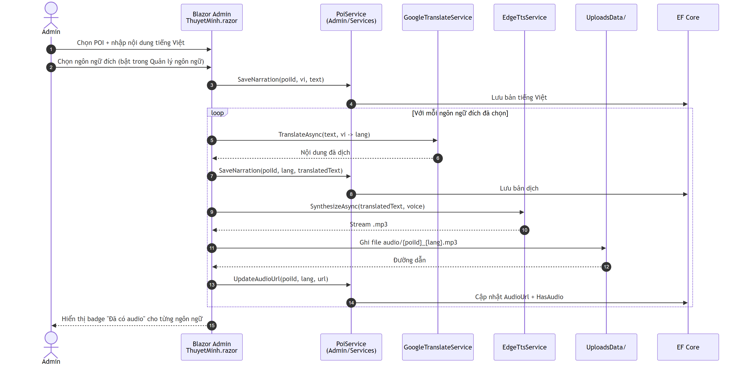
Äiá»ƒm quan trá»ng:
- Hoáº¡t Ä‘á»™ng trong Blazor Server (khÃ´ng qua API runtime) â€“ táºn dá»¥ng server-side Ä‘á»ƒ gá»i Google Translate vÃ Edge TTS.
- Má»—i ngÃ´n ngá»¯ tÆ°Æ¡ng á»©ng má»™t voice Ä‘Æ°á»£c cáº¥u hÃ¬nh á»Ÿ QuanLyNgonNgu.razor.
- File audio lÆ°u vÃ o UploadsData/ (shared vá»›i API Ä‘á»ƒ phá»¥c vá»¥ qua /uploads).

4.4. SEQ-04 â€“ Vendor cáºp nháºt gian hÃ ng & Admin duyá»‡t
MÃ´ táº£: Vendor Ä‘Äƒng nháºp cÃ¹ng Blazor app, sá»a thÃ´ng tin quÃ¡n vÃ thá»±c Ä‘Æ¡n. Admin duyá»‡t trong PoiList.razor. Mobile app chá»‰ nháºn POI á»Ÿ tráº¡ng thÃ¡i Approved qua Poi API.
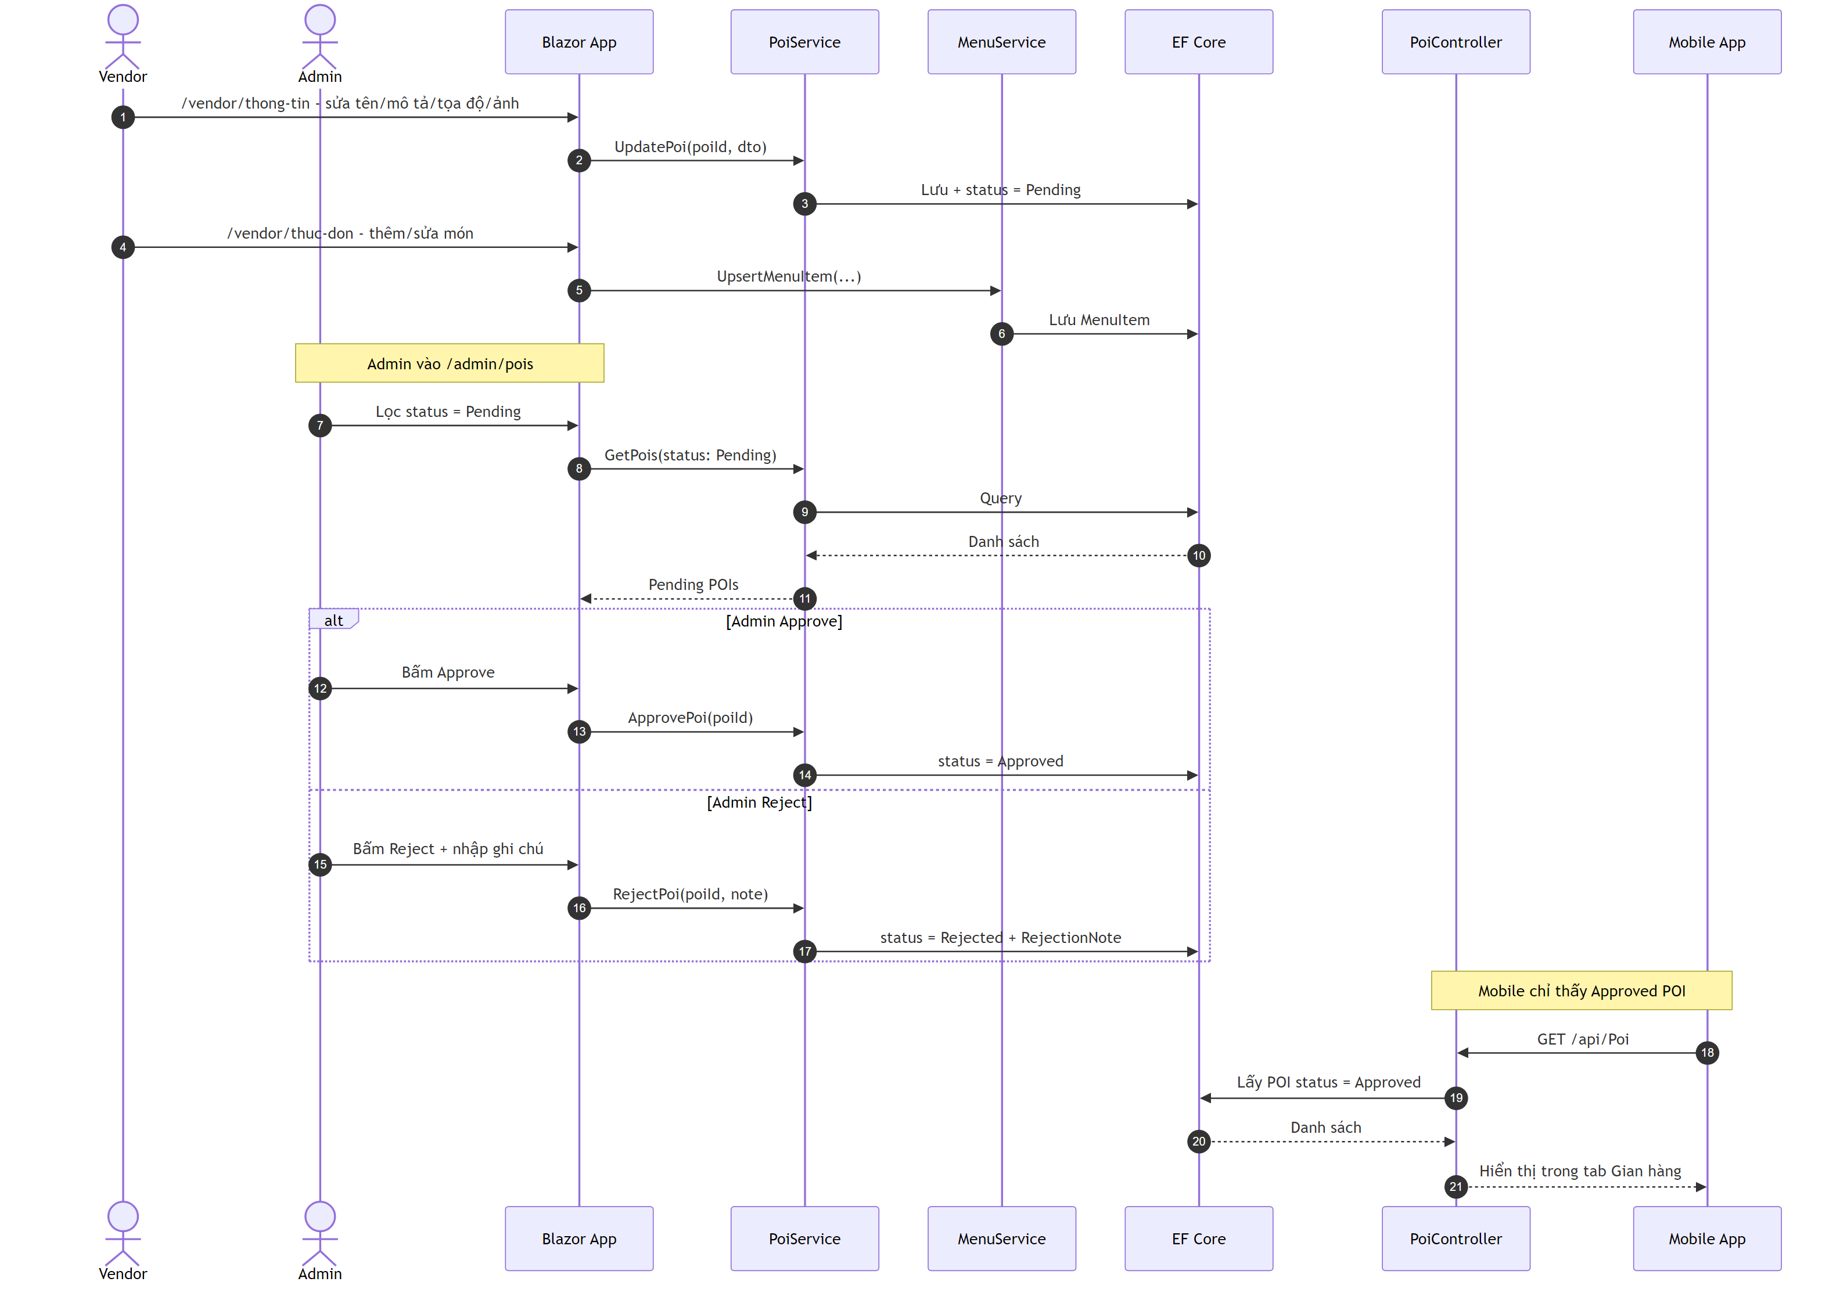

4.5. SEQ-05 â€“ Mobile ghi log & Dashboard Ä‘á»c cÃ¹ng database
MÃ´ táº£: Du khÃ¡ch gá»i sá»± kiá»‡n qua VKFoodTour.API (TrackingController). Trang Dashboard (Home.razor, Blazor Server) khÃ´ng gá»i HTTP ná»™i bá»™ tá»›i API Ä‘á»ƒ láº¥y thá»‘ng kÃª: nÃ³ vÃ cÃ¡c widget con dÃ¹ng EF Core (ApplicationDbContext / IDbContextFactory) truy váº¥n trá»±c tiáº¿p cÃ¹ng SQL Server mÃ API ghi vÃ o. LÃ m tÆ°Æ¡i â€œrealtimeâ€ nhá» Timer trong widget (khÃ´ng dÃ¹ng SignalR nghiá»‡p vá»¥).
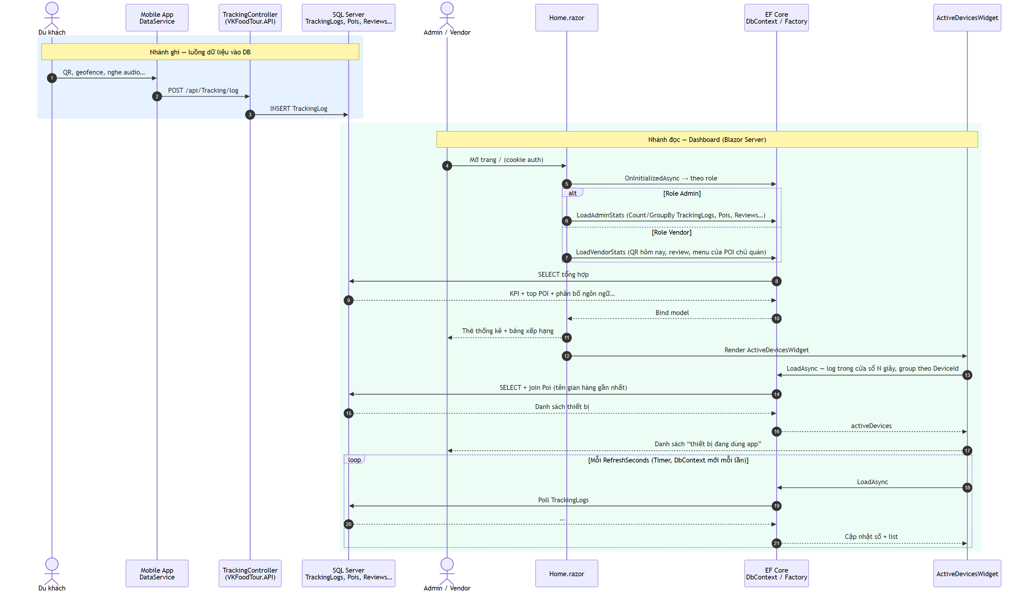
Ghi chÃº:
- Heatmap trÃªn báº£n Ä‘á»“ tá»•ng quan náº±m á»Ÿ /admin/ban-do (BanDoPoi.razor): cÅ©ng Ä‘á»c TrackingLogs qua EF + Ä‘áº©y JSON sang JS (updateOverviewHeatmap), khÃ´ng Ä‘i qua GET /api/Tracking/heatmap tá»« Blazor.
- Component OnlineUsersWidget cÃ¹ng pattern (Timer + IDbContextFactory) nhÆ°ng chÆ°a Ä‘Æ°á»£c nhÃºng vÃ o Home.razor; trang chá»§ admin hiá»‡n dÃ¹ng ActiveDevicesWidget (WindowSeconds=45, RefreshSeconds=3).

4.5.1. SEQ-05a â€“ Admin Dashboard: phÆ°Æ¡ng thá»©c trong Home.razor & ActiveDevicesWidget
MÃ´ táº£: Chuá»—i gá»i theo code thá»±c táº¿ khi user role Admin má»Ÿ /. File: Admin/Components/Pages/Home.razor, widget: Admin/Components/Pages/Admin/ActiveDevicesWidget.razor.
A) Home.razor â€” OnInitializedAsync â†’ LoadAdminStats (inject ApplicationDbContext Db)
Thá»© tá»± | PhÆ°Æ¡ng thá»©c / truy váº¥n
1 | AuthenticationStateProvider.GetAuthenticationStateAsync()
2 | LoadAdminStats()
3 | Db.Pois.CountAsync()
4 | Db.Pois.CountAsync(p => p.IsActive)
5 | Db.Narrations.CountAsync()
6 | Db.Languages.CountAsync(l => l.IsActive)
7 | Db.Users.CountAsync()
8 | Db.Users.CountAsync(u => u.Role == "Vendor")
9 | Db.TrackingLogs.CountAsync(t => t.EventType == "qr_scan" && t.CreatedAt >= today)
10 | Db.TrackingLogs.CountAsync(t => t.CreatedAt >= today && t.EventType != "move")
11 | listenLogs.AnyAsync() rá»“i listenLogs.AverageAsync(t => t.ListenedDurationSec!.Value) (listenLogs = TrackingLogs lá»c listen_end)
12 | Db.TrackingLogs â€¦ GroupBy/OrderByDescending/Take(5) â†’ ToListAsync() (top POI)
13 | Db.Pois.Where(...).ToDictionaryAsync(p => p.PoiId, p => p.Name)
14 | VÃ²ng foreach gÃ¡n TopPoiItem.PoiName
15 | Db.TrackingLogs â€¦ GroupBy POI listen_end â†’ ToListAsync() (top audio)
16 | foreach gÃ¡n TopAudioItem.PoiName (dÃ¹ng poiNames)
17 | Db.TrackingLogs group theo LanguageCode â†’ ToListAsync()
18 | Db.Languages.ToDictionaryAsync(l => l.Code, l => l.Name)
19 | Build languageStats (LINQ trÃªn bá»™ nhá»›)
20 | Db.Reviews.CountAsync()
21 | Db.Reviews.GroupBy(r => (int)r.Rating).ToDictionaryAsync(...) â†’ ratingDistribution
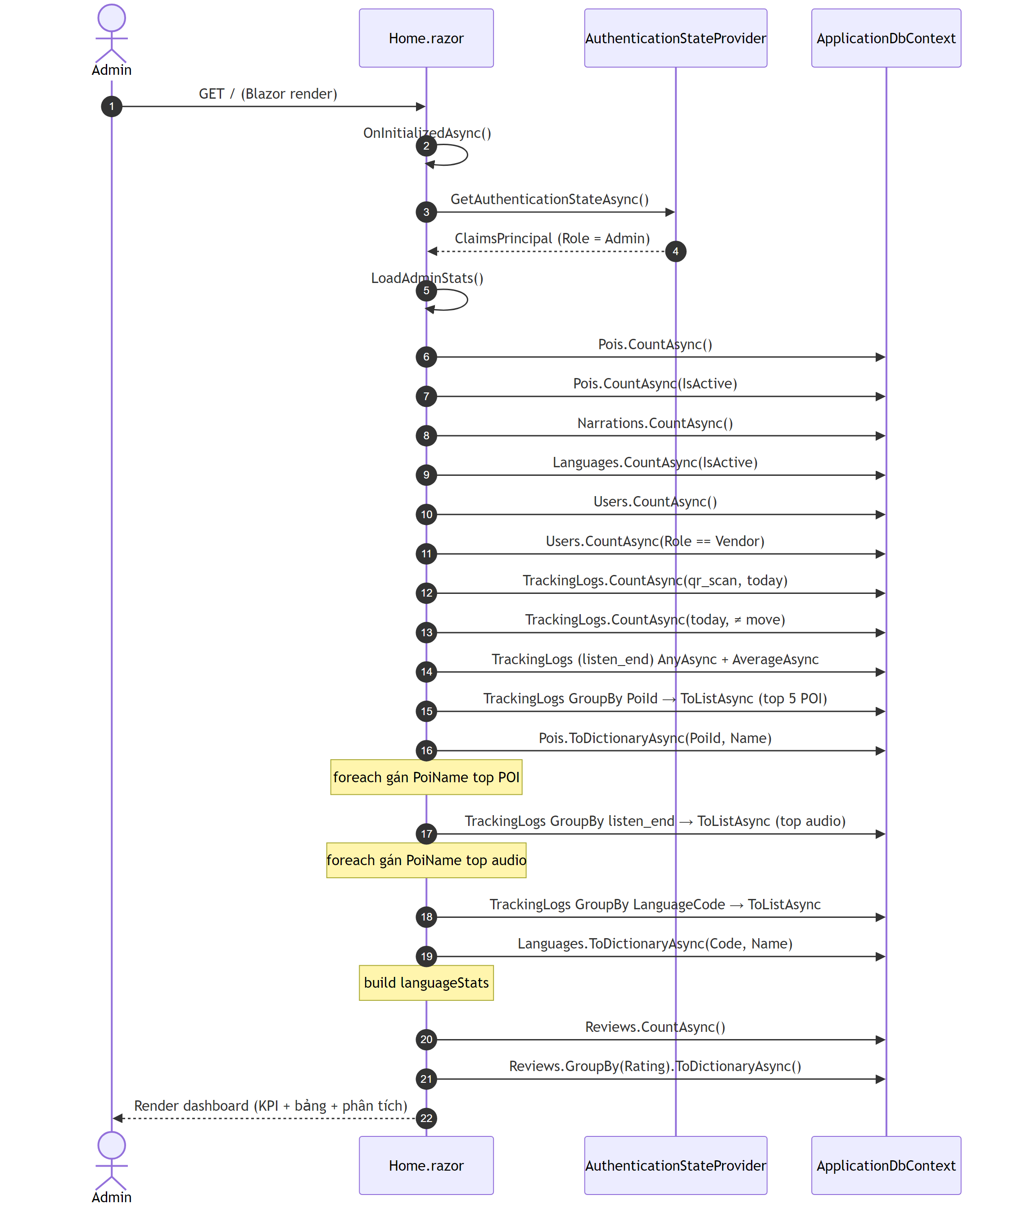
B) ActiveDevicesWidget â€” inject IDbContextFactory<ApplicationDbContext> DbFactory
Thá»© tá»± | PhÆ°Æ¡ng thá»©c
1 | OnInitializedAsync()
2 | Math.Clamp(WindowSeconds, 15, 300)
3 | LoadAsync()
4 | DbFactory.CreateDbContextAsync()
5 | db.TrackingLogs.AsNoTracking()â€¦GroupBy(DeviceId)â€¦ToListAsync()
6 | db.Pois.AsNoTracking()â€¦ToDictionaryAsync(PoiId, Name) (náº¿u cÃ³ poiIds)
7 | GÃ¡n activeDevices (LINQ trÃªn bá»™ nhá»›)
8 | new Timer(...) â€” refresh má»—i RefreshSeconds (3s): gá»i láº¡i LoadAsync() + InvokeAsync(StateHasChanged)
9 | new Timer(...) â€” má»—i 1s: cáºp nháºt secondsAgo + StateHasChanged
10 | DisposeAsync() â€” há»§y hai timer
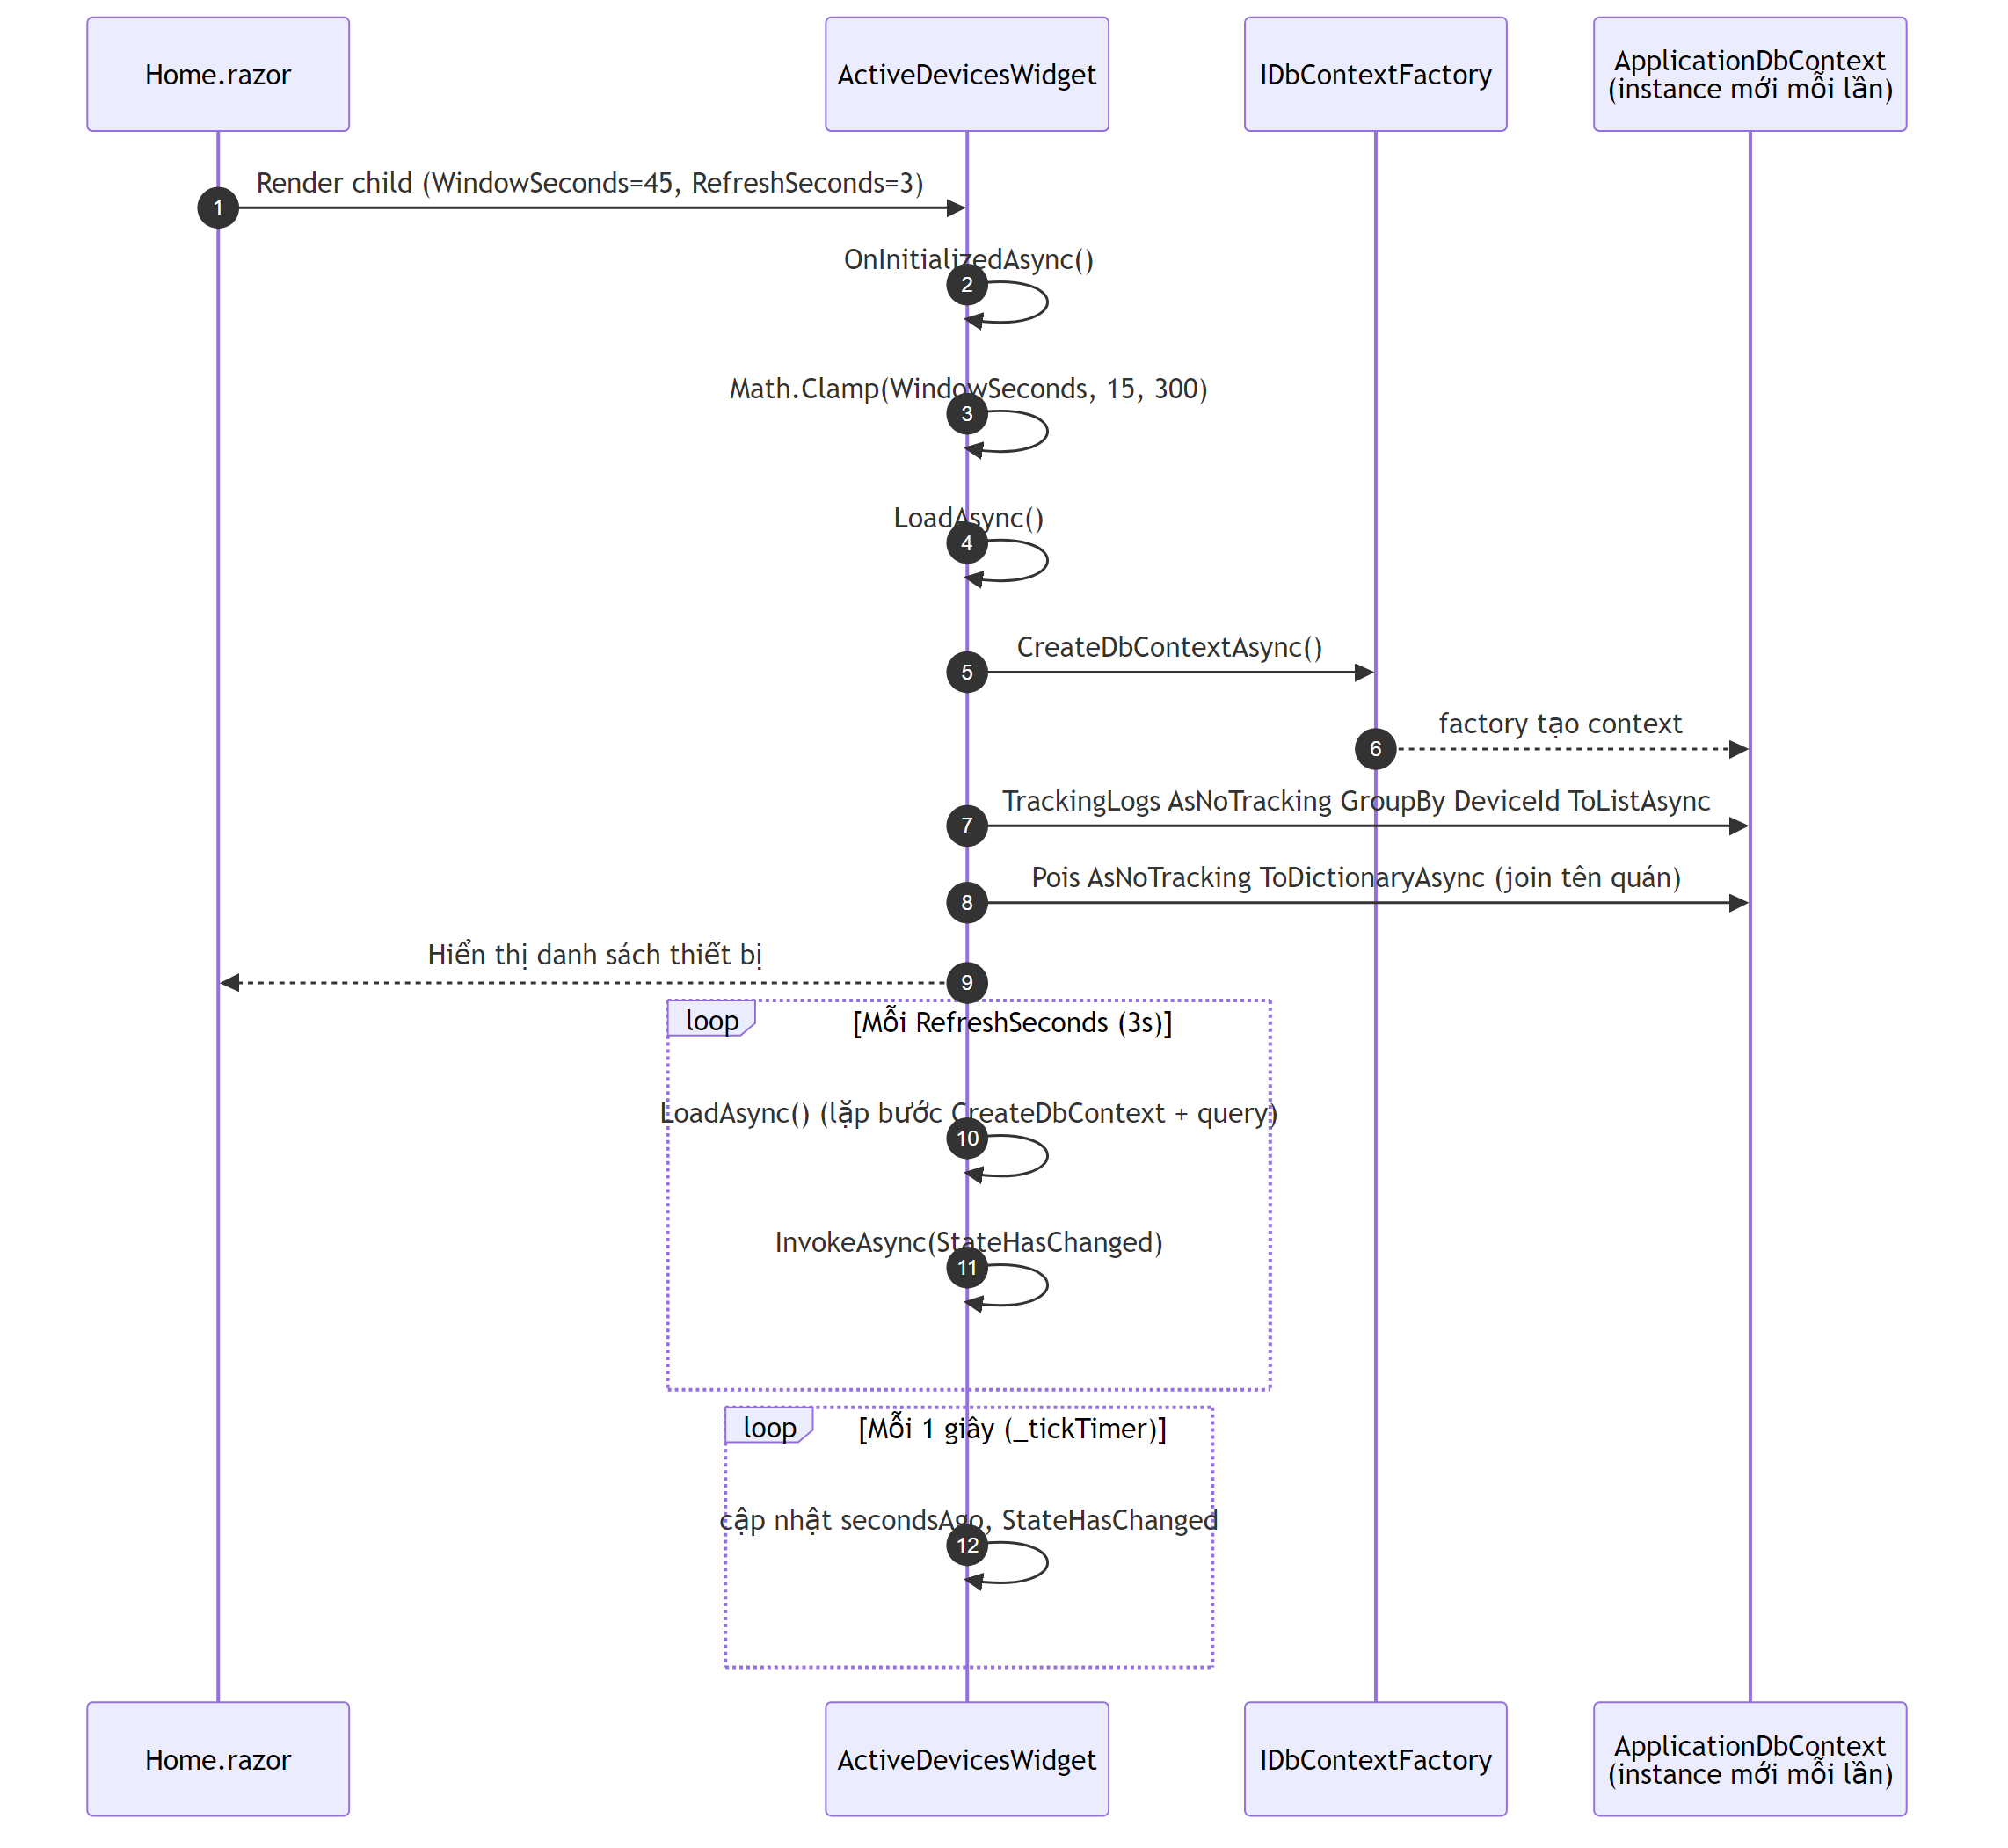
Ghi chÃº thá»© tá»± Blazor: Home.OnInitializedAsync (gá»“m LoadAdminStats) cháº¡y trÆ°á»›c khi subtree render xong; ActiveDevicesWidget khá»Ÿi táº¡o sau (lifecycle con), nÃªn block A hoÃ n táº¥t trÆ°á»›c B trong cÃ¹ng láº§n táº£i trang Ä‘áº§u.

4.6. SEQ-06 â€“ Du khÃ¡ch Ä‘Ã¡nh giÃ¡ quÃ¡n
MÃ´ táº£: Sau khi nghe audio vÃ xem chi tiáº¿t quÃ¡n, du khÃ¡ch cÃ³ thá»ƒ gá»i rating + bÃ¬nh luáºn vá» quÃ¡n.
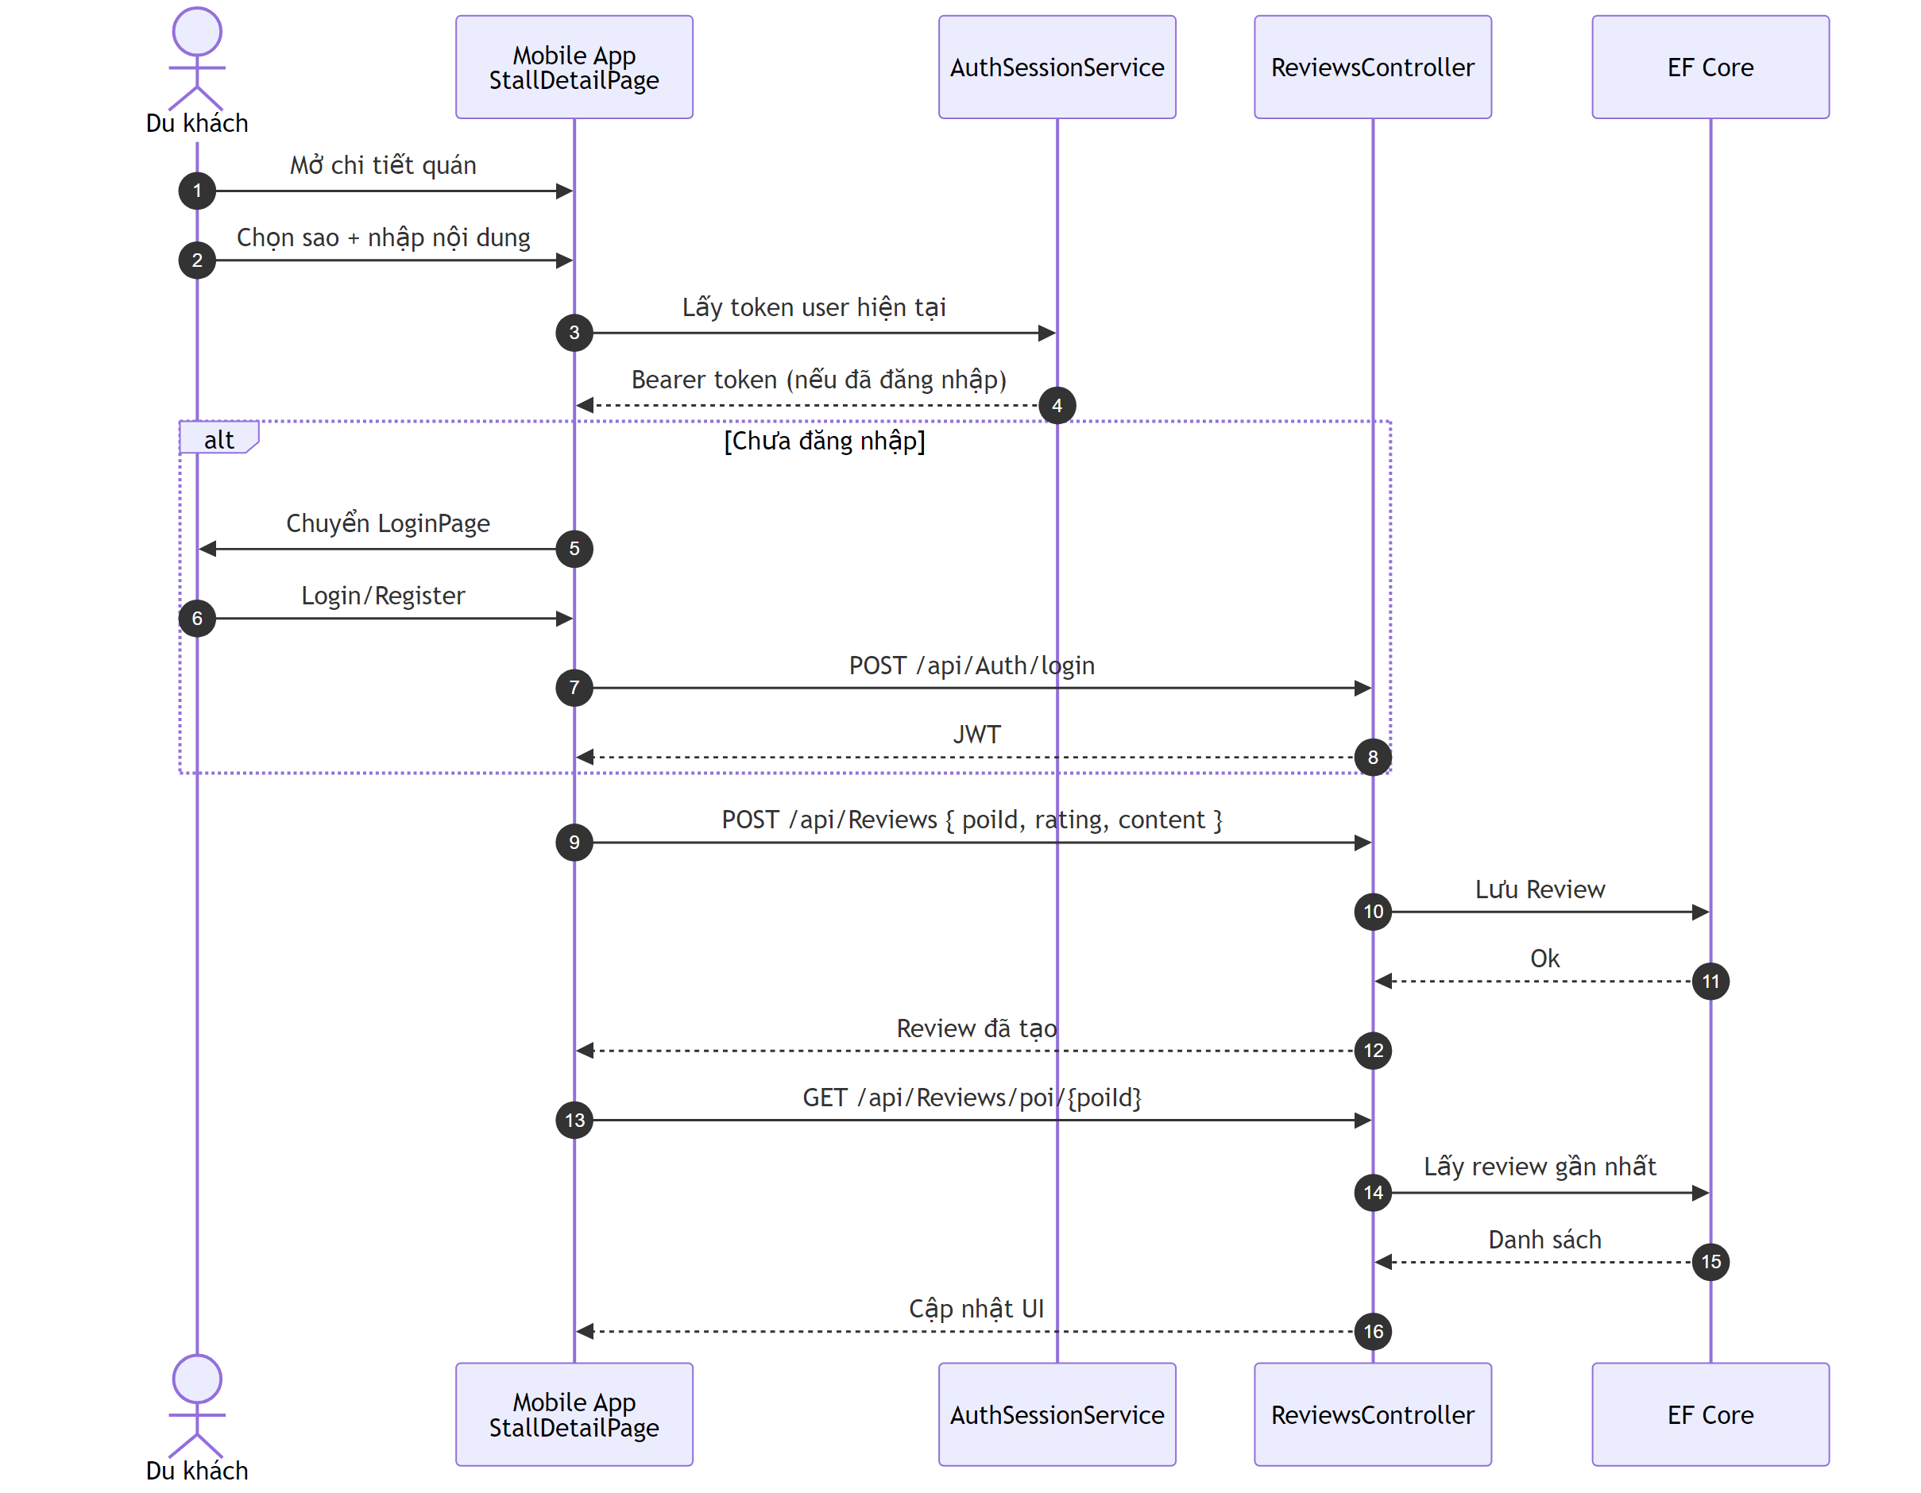

4.7. SEQ-07 â€“ Æ¯u tiÃªn audio khi Ä‘á»©ng giá»¯a 2 geofence chá»“ng láº¥n
MÃ´ táº£: Ká»‹ch báº£n du khÃ¡ch Ä‘ang nghe audio cá»§a POI A thÃ¬ bÆ°á»›c vÃ o vÃ¹ng geofence cá»§a POI B (2 vÃ¹ng chá»“ng láº¥n, hoáº·c 2 quÃ¡n cáº¡nh nhau). AudioQueueService quyáº¿t Ä‘á»‹nh xá» lÃ½ dá»±a trÃªn tiáº¿n Ä‘á»™ track A Ä‘ang phÃ¡t so vá»›i ngÆ°á»¡ng 60%.
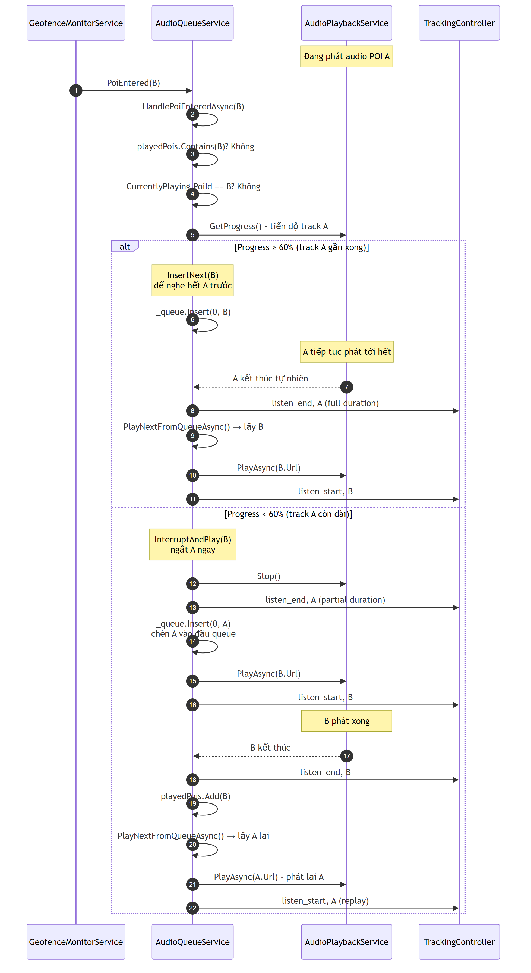
Giáº£i thÃch Ã½ nghÄ©a ngÆ°á»¡ng 60%:
- Vá»›i ngÆ°á»¡ng â‰¥ 60%: track Ä‘ang phÃ¡t Ä‘Ã£ gáº§n xong â†’ cho nghe trá»n váº¹n Ä‘á»ƒ giá»¯ tráº£i nghiá»‡m liá»n máº¡ch, POI má»›i xáº¿p káº¿ tiáº¿p.
- Vá»›i ngÆ°á»¡ng < 60%: du khÃ¡ch vá»«a má»›i bÆ°á»›c vÃ o quÃ¡n cÅ© vÃ chÆ°a nghe Ä‘Æ°á»£c bao nhiÃªu, giá» Ä‘Ã£ á»Ÿ gáº§n quÃ¡n má»›i â€“ Æ°u tiÃªn thÃ´ng tin vá» vá»‹ trÃ hiá»‡n táº¡i, ngáº¯t track cÅ©, phÃ¡t track má»›i, vÃ phÃ¡t láº¡i track cÅ© sau khi track má»›i káº¿t thÃºc.
- Háº±ng sá»‘ InterruptThreshold = 0.60 Ä‘Æ°á»£c Ä‘á»‹nh nghÄ©a trong AudioQueueService.cs â€“ cÃ³ thá»ƒ tune Ä‘á»ƒ thay Ä‘á»•i hÃ nh vi.
CÃ¡c nhÃ¡nh an toÃ n khÃ¡c (code thá»±c táº¿):
- Náº¿u POI B Ä‘Ã£ cÃ³ trong _playedPois â†’ bá» qua (khÃ´ng phÃ¡t láº¡i).
- Náº¿u POI B chÃnh lÃ track Ä‘ang phÃ¡t (CurrentlyPlaying.PoiId == B) â†’ bá» qua (trÃ¡nh double-trigger do GPS jitter).
- Náº¿u CurrentlyPlaying != null nhÆ°ng IsPlaying == false (bootstrap/loading) â†’ InsertNext Ä‘á»ƒ trÃ¡nh race condition.

4.8. SEQ-08 â€“ Pattern CRUD cÃ³ duyá»‡t (generic)
MÃ´ táº£: SÆ¡ Ä‘á»“ chung cho táº¥t cáº£ chá»©c nÄƒng CRUD cÃ³ luá»“ng duyá»‡t trong há»‡ thá»‘ng â€“ Ã¡p dá»¥ng cho: quáº£n lÃ½ POI, thá»±c Ä‘Æ¡n, ngÆ°á»i dÃ¹ng, ngÃ´n ngá»¯, QR code, review, feedback, audioâ€¦ Khi xem má»™t chá»©c nÄƒng CRUD trong báº£ng liá»‡t kÃª (má»¥c 3), tham chiáº¿u sÆ¡ Ä‘á»“ nÃ y thay vÃ¬ váº½ láº¡i tá»«ng cÃ¡i.
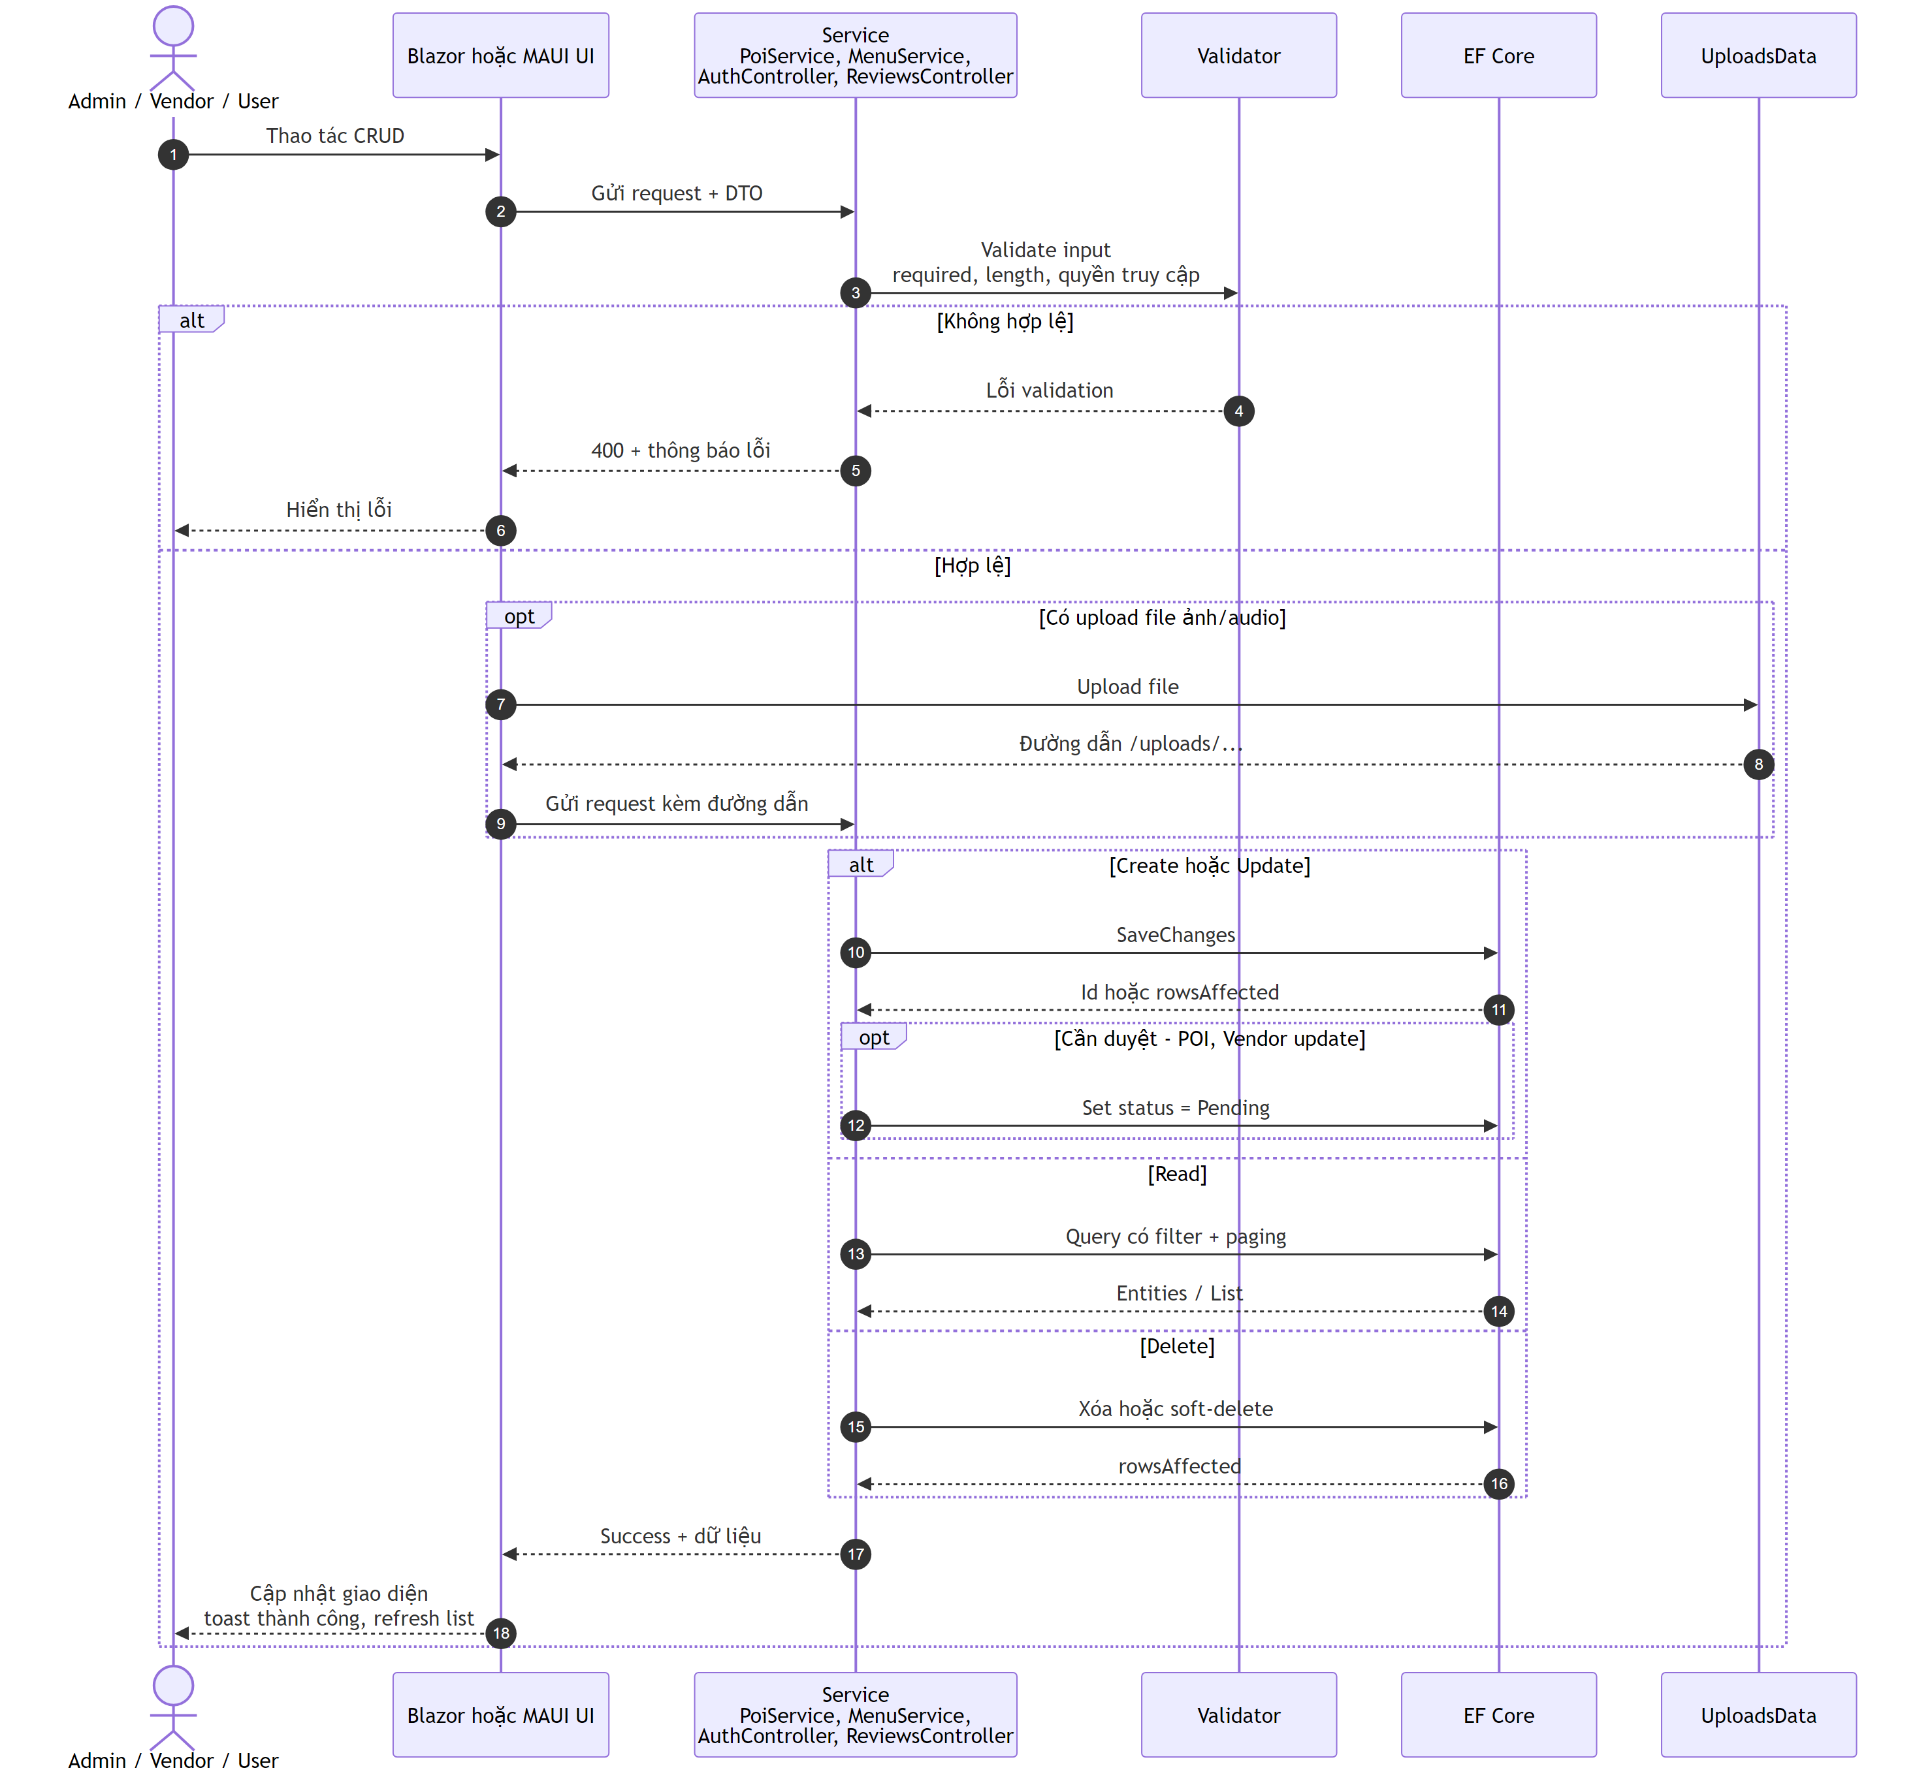
Ãp dá»¥ng cho cÃ¡c chá»©c nÄƒng:
Chá»©c nÄƒng | Actor | Service/Controller | File?
Quáº£n lÃ½ POI | Admin / Vendor | PoiService | CÃ³ áº£nh
Quáº£n lÃ½ thá»±c Ä‘Æ¡n | Vendor | MenuService | CÃ³ áº£nh
Quáº£n lÃ½ ngÃ´n ngá»¯ | Admin | (Blazor page) | KhÃ´ng
Quáº£n lÃ½ QR | Admin | (QrController resolve) | KhÃ´ng
Quáº£n lÃ½ ngÆ°á»i dÃ¹ng | Admin | NguoiDung.razor | KhÃ´ng
Gá»i review | User | ReviewsController | KhÃ´ng
Gá»i feedback app | User | FeedbackController | KhÃ´ng
Upload audio | Admin | EdgeTtsService + file write | CÃ³ file

4.9. SEQ-09 â€“ Hiá»ƒn thá»‹ Heatmap tracking trÃªn Web Admin
MÃ´ táº£: Luá»“ng táº£i vÃ hiá»ƒn thá»‹ heatmap thá»±c táº¿ trÃªn trang BanDoPoi.razor. Admin báºt switch heatmap, chá»n má»‘c thá»i gian, UI gá»i API Tracking/heatmap, sau Ä‘Ã³ Ä‘áº©y dá»¯ liá»‡u sang JS interop Ä‘á»ƒ cáºp nháºt lá»›p heatmap trÃªn báº£n Ä‘á»“.
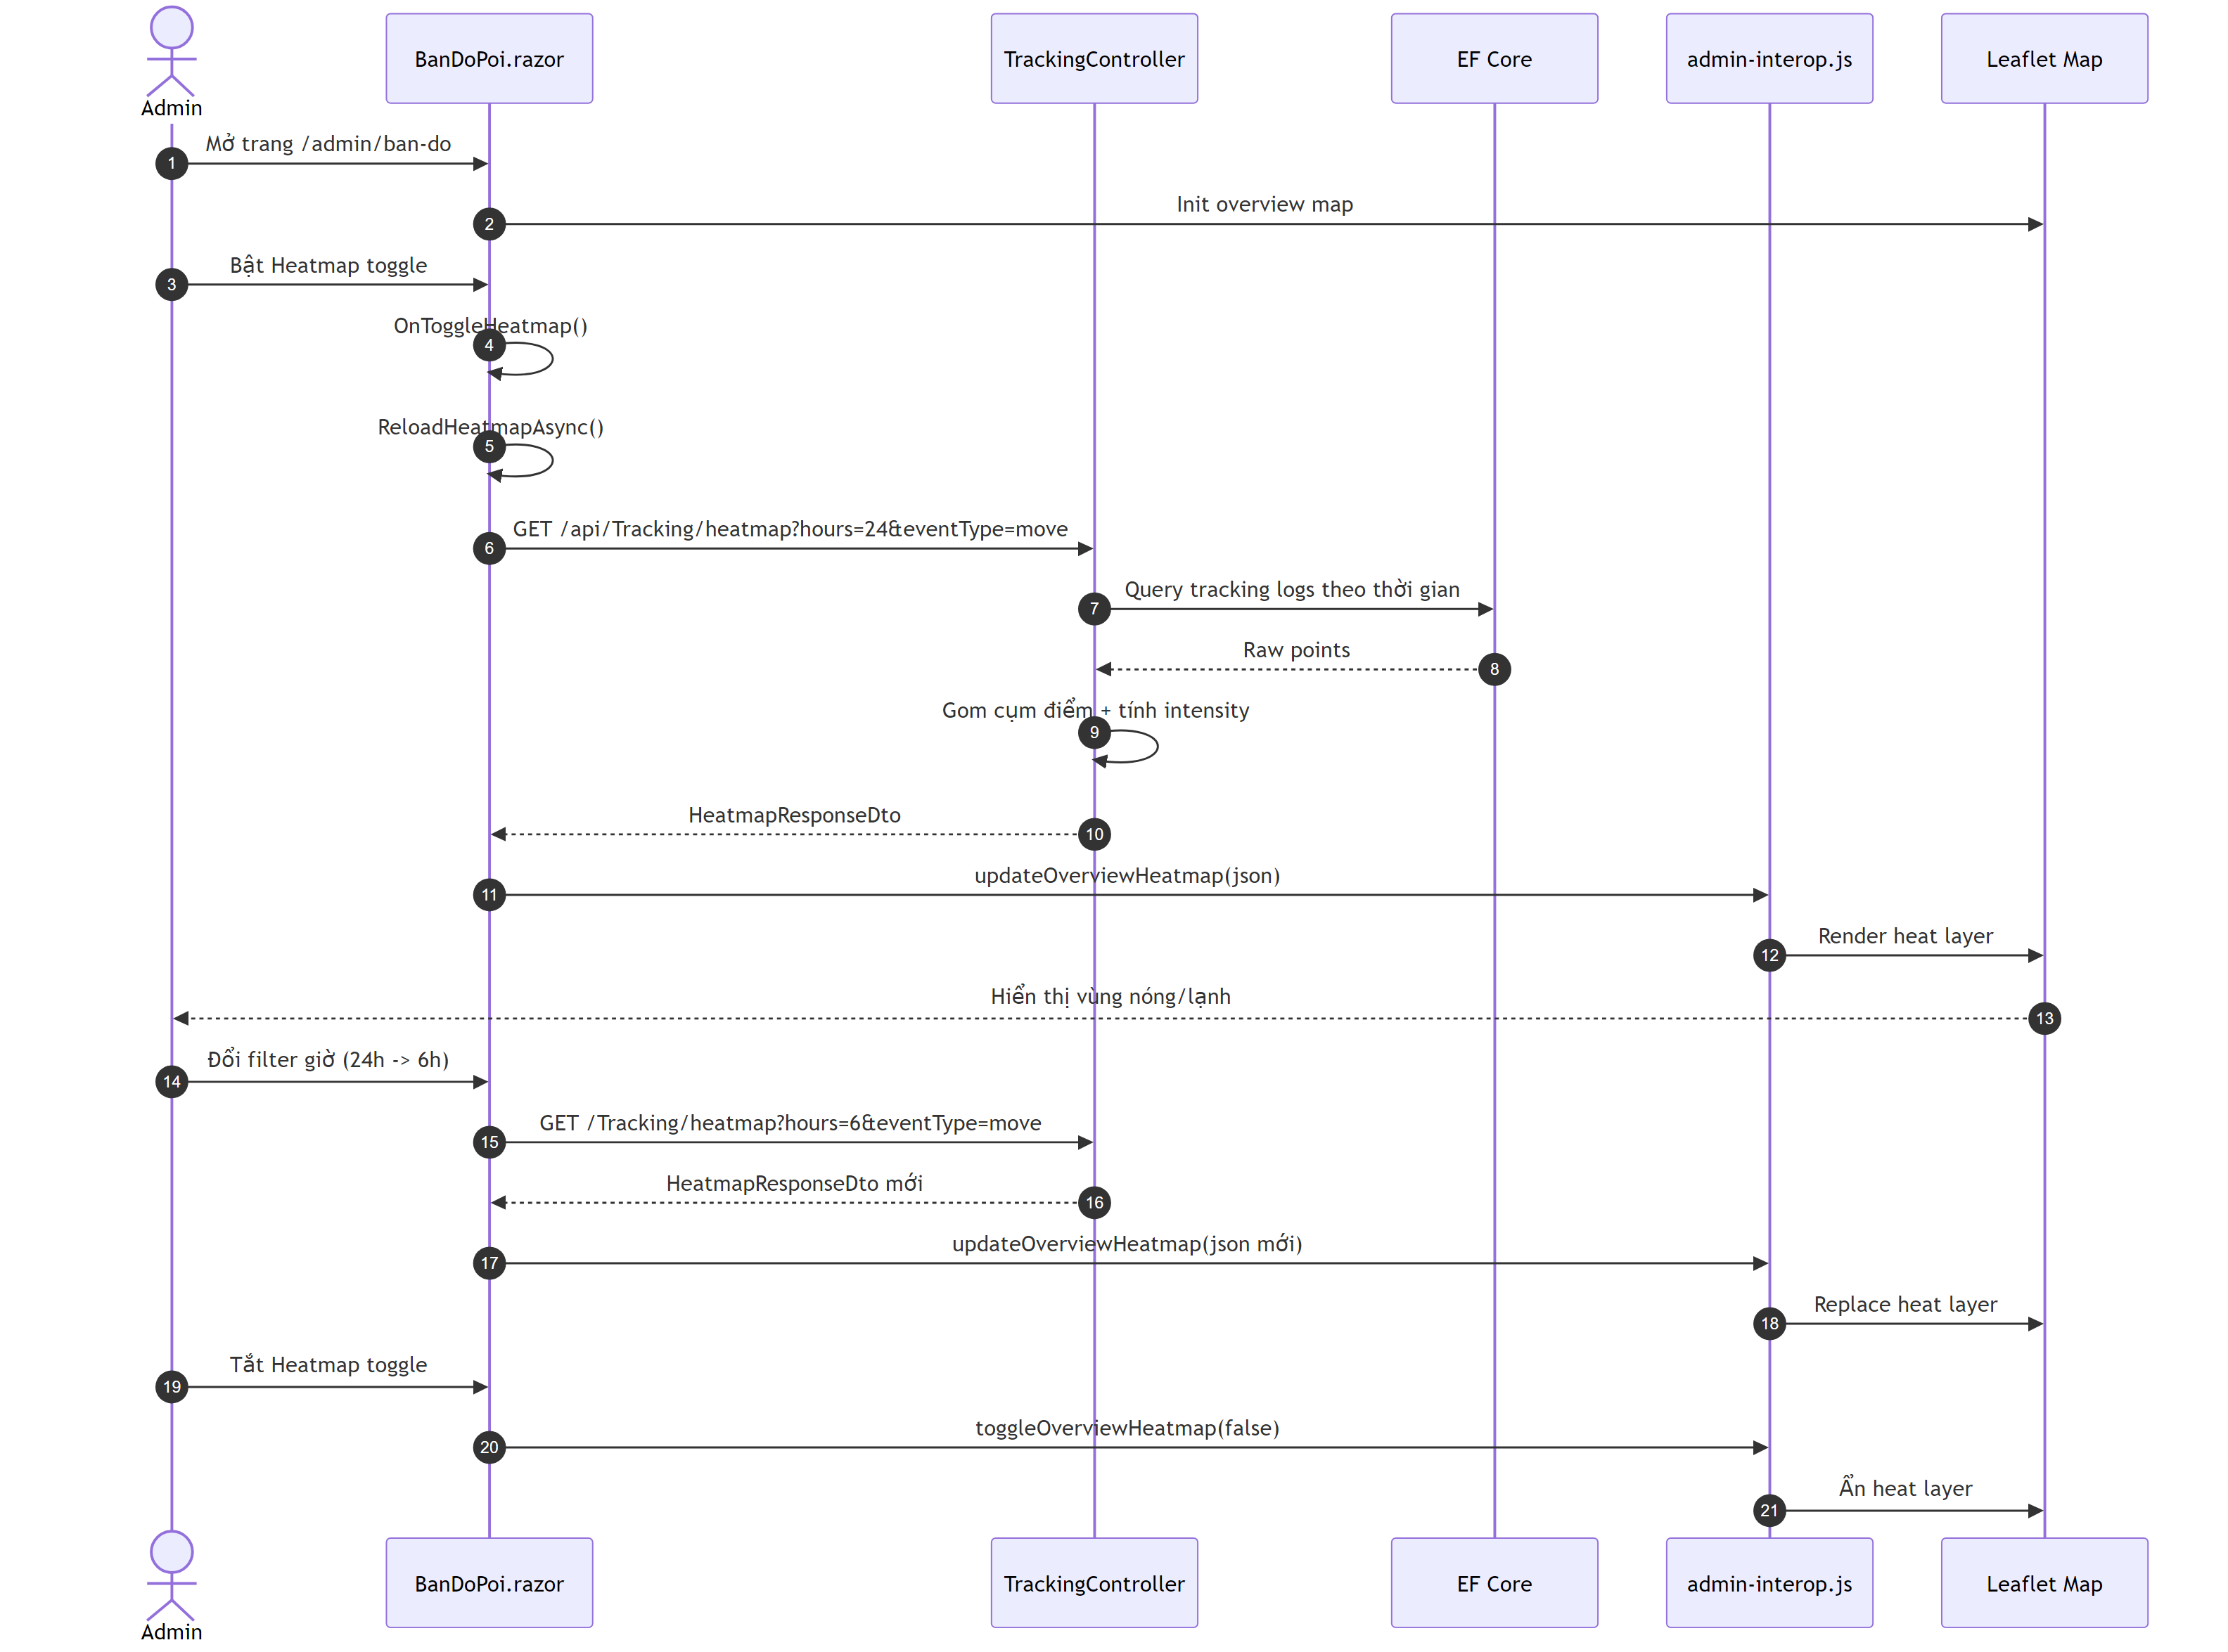
Äiá»ƒm ká»¹ thuáºt chÃnh (Ä‘Ãºng code hiá»‡n táº¡i):
- API endpoint: GET /api/Tracking/heatmap trong TrackingController.
- UI xá» lÃ½ á»Ÿ BanDoPoi.razor vá»›i cÃ¡c hÃ m OnToggleHeatmap() vÃ ReloadHeatmapAsync().
- JS interop: updateOverviewHeatmap() vÃ toggleOverviewHeatmap() trong admin-interop.js.

4.10. SEQ-10 â€“ Quáº£n lÃ½ ngÃ´n ngá»¯ vÃ Ã¡nh xáº¡ TTS voice
MÃ´ táº£: Luá»“ng quáº£n lÃ½ ngÃ´n ngá»¯ trÃªn trang QuanLyNgonNgu.razor: Admin thÃªm ngÃ´n ngá»¯ má»›i, cáº¥u hÃ¬nh mÃ£ ngÃ´n ngá»¯ + voice, báºt/táº¯t tráº¡ng thÃ¡i hoáº¡t Ä‘á»™ng. Cáº¥u hÃ¬nh nÃ y Ä‘Æ°á»£c dÃ¹ng láº¡i khi dá»‹ch ná»™i dung vÃ sinh audio thuyáº¿t minh.
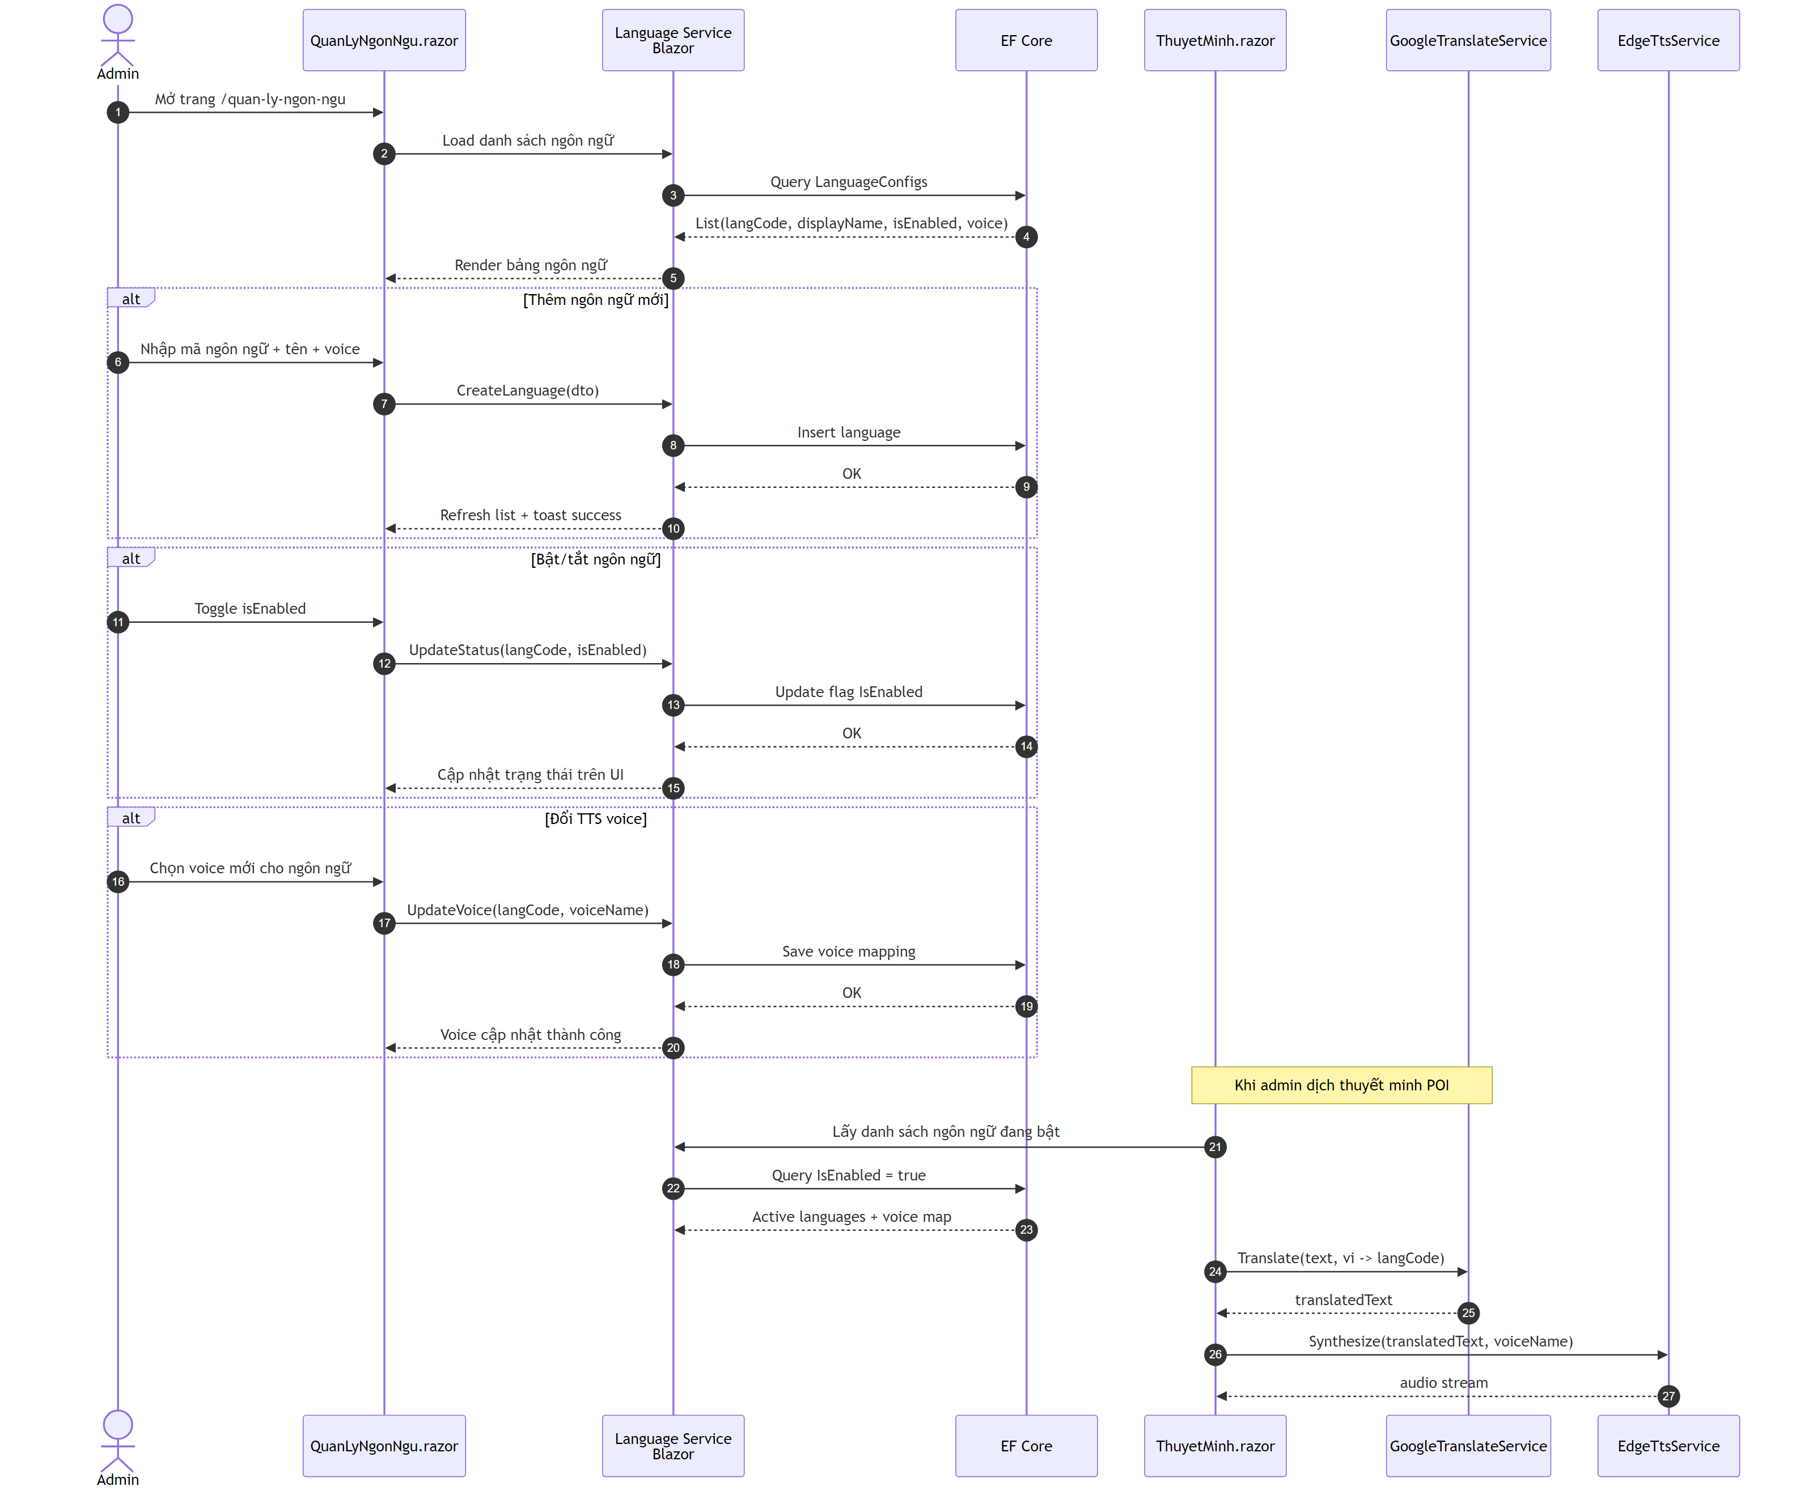
Äiá»ƒm ká»¹ thuáºt chÃnh:
- Trang quáº£n lÃ½: QuanLyNgonNgu.razor.
- NgÃ´n ngá»¯ báºt (isEnabled=true) lÃ nguá»“n dá»¯ liá»‡u cho luá»“ng dá»‹ch/sinh audio á»Ÿ ThuyetMinh.razor.
- TTS sá» dá»¥ng voice Ä‘Ã£ Ã¡nh xáº¡ theo tá»«ng ngÃ´n ngá»¯ Ä‘á»ƒ Ä‘áº£m báº£o phÃ¡t Ã¢m Ä‘Ãºng.

5. SÆ¡ Ä‘á»“ Activity & State

5.1. ACT-01 â€“ HÃ nh trÃ¬nh du khÃ¡ch end-to-end trÃªn Mobile App
MÃ´ táº£: ToÃ n bá»™ luá»“ng cá»§a Mobile App tá»« khi má»Ÿ app (WelcomePage) Ä‘áº¿n khi káº¿t thÃºc tour.
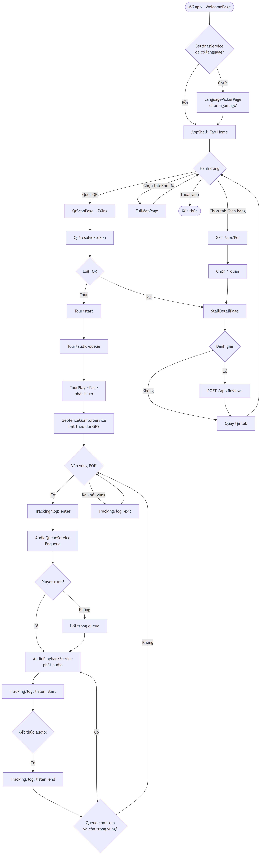

5.2. ACT-02 â€“ Duyá»‡t POI cá»§a Admin trong PoiList.razor
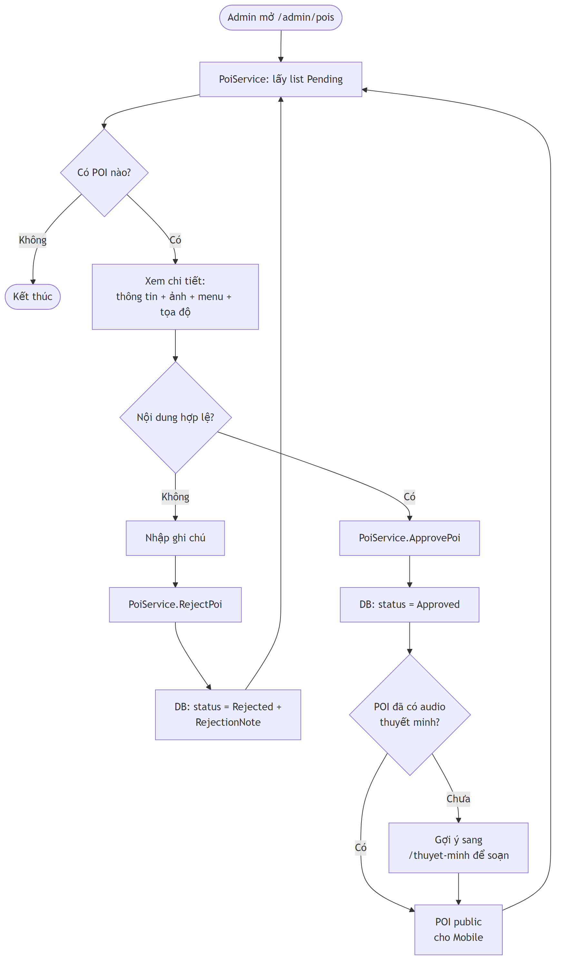

5.3. ACT-03 â€“ Vendor cáºp nháºt gian hÃ ng
MÃ´ táº£: Vendor dÃ¹ng chung Blazor app, chá»‰ tháº¥y cÃ¡c trang /vendor/* theo role.
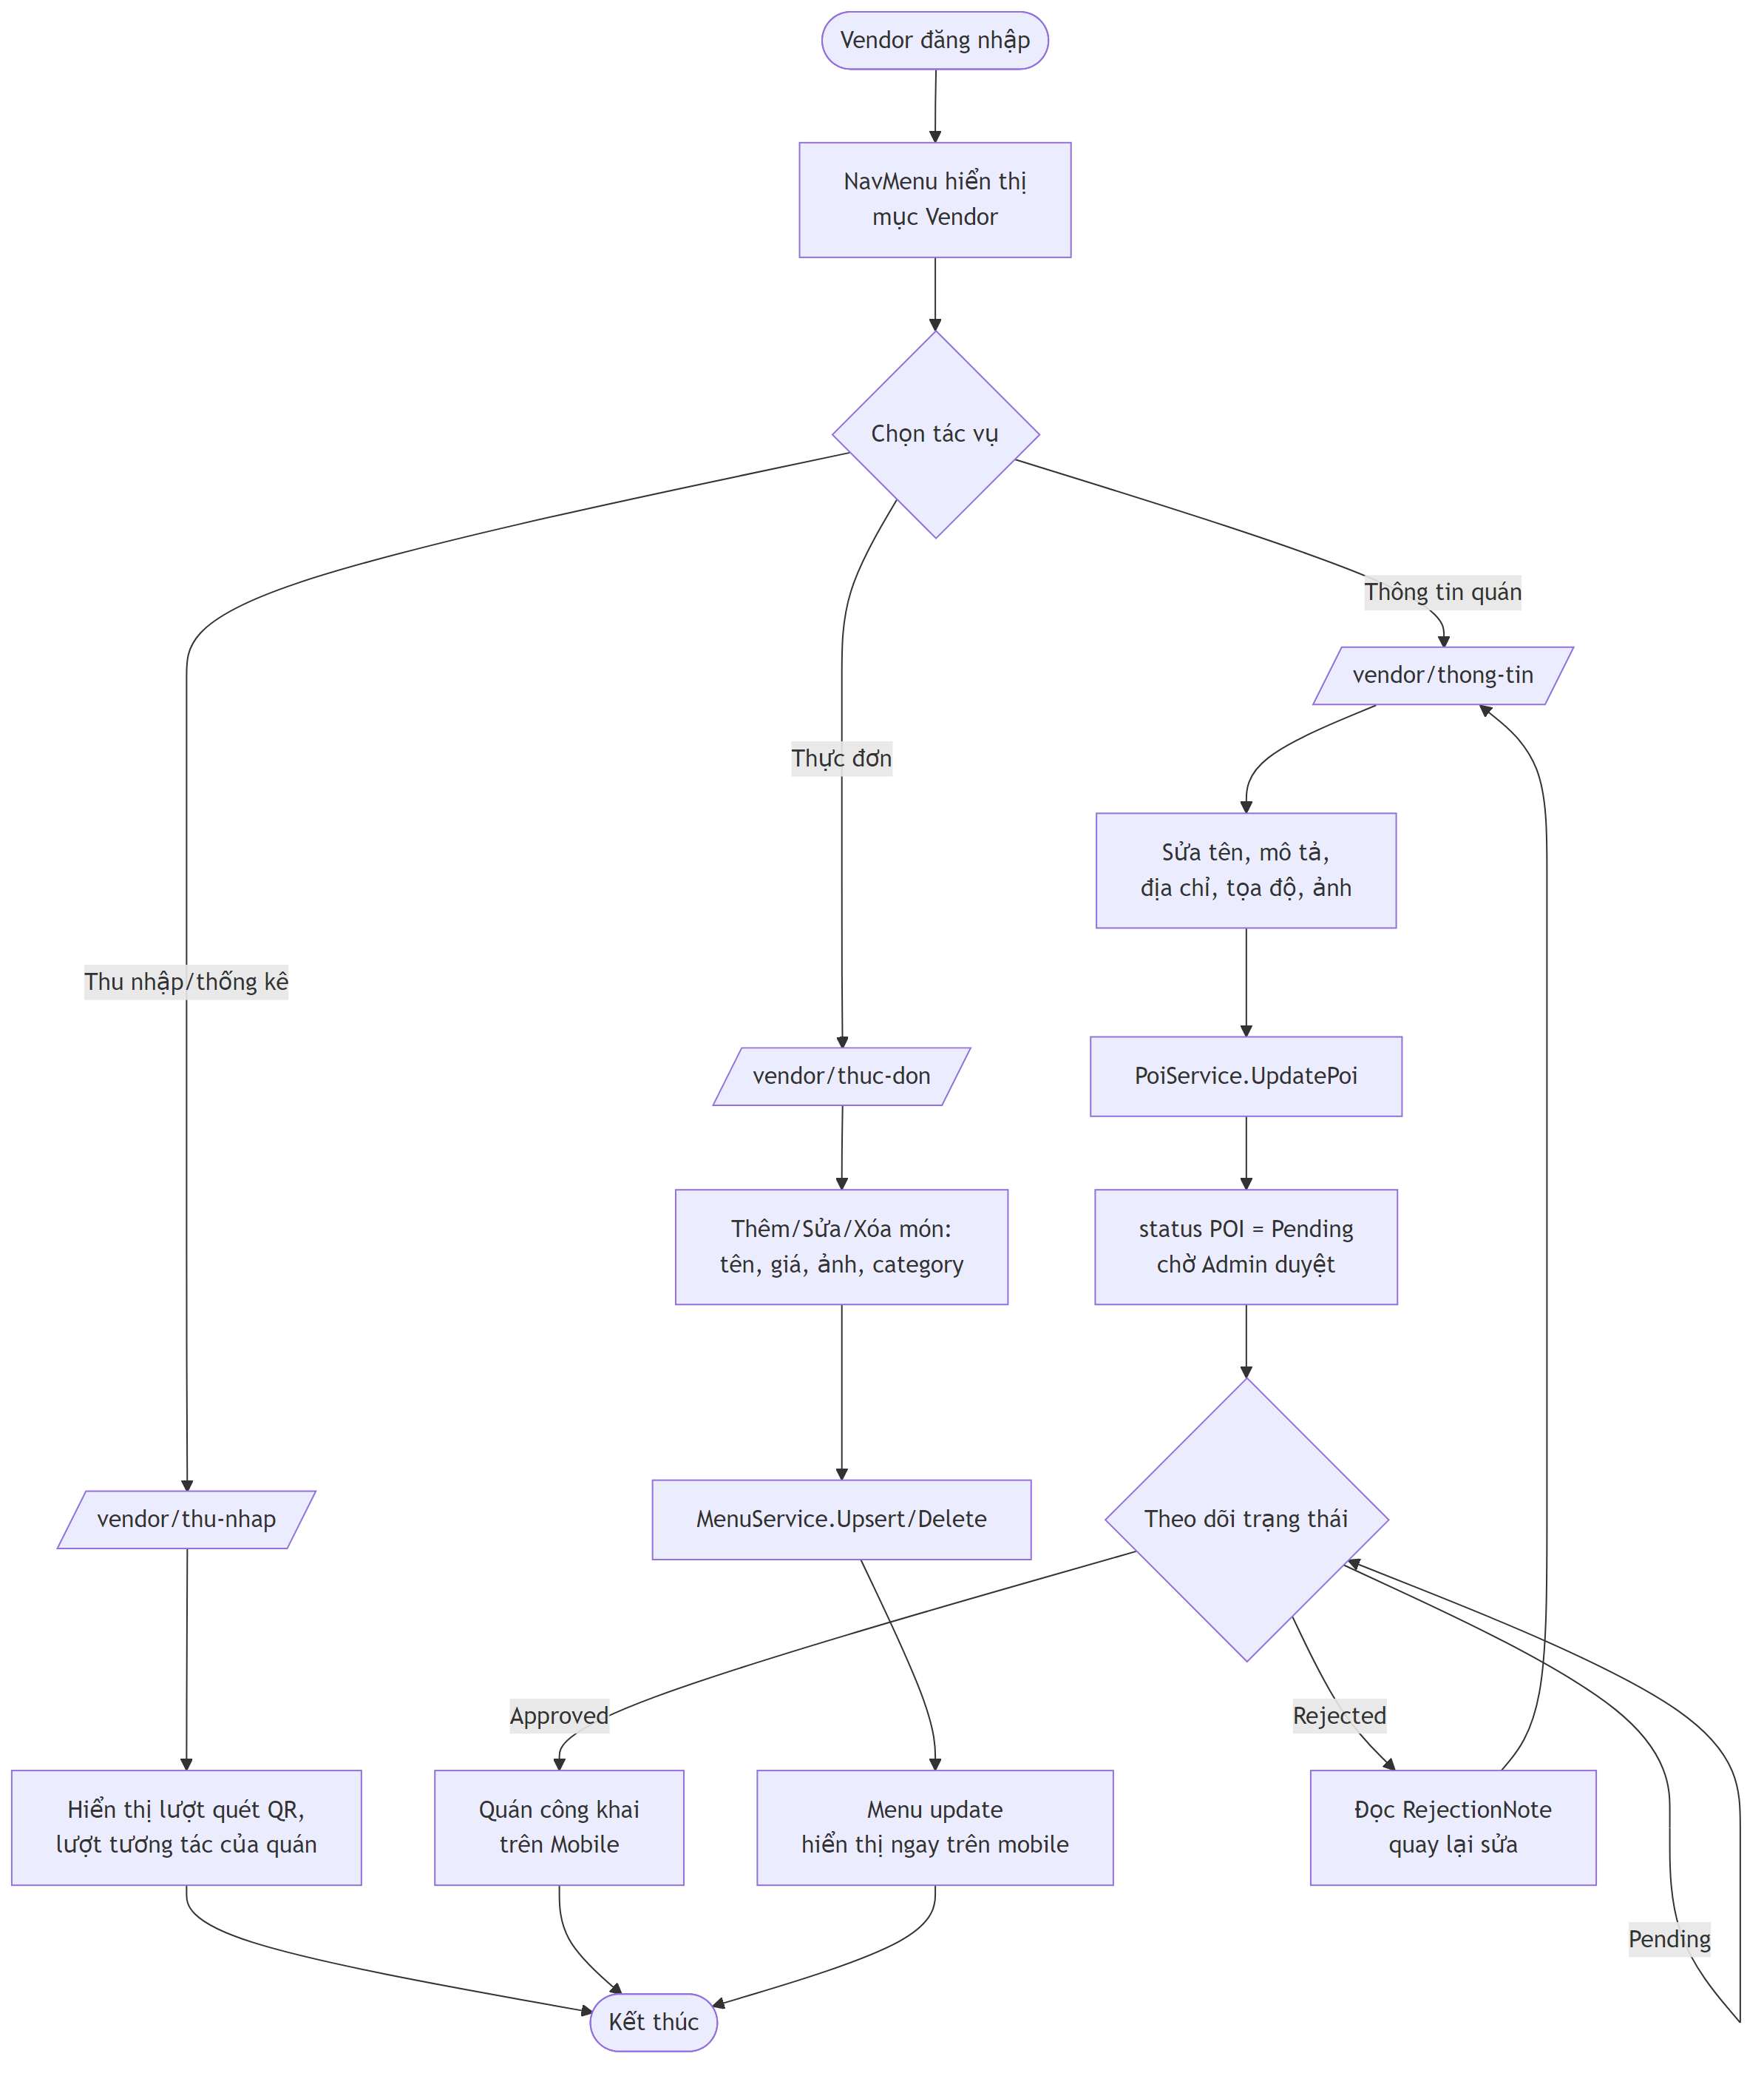

5.4. ACT-04 â€“ Dá»‹ch & sinh audio thuyáº¿t minh trong ThuyetMinh.razor
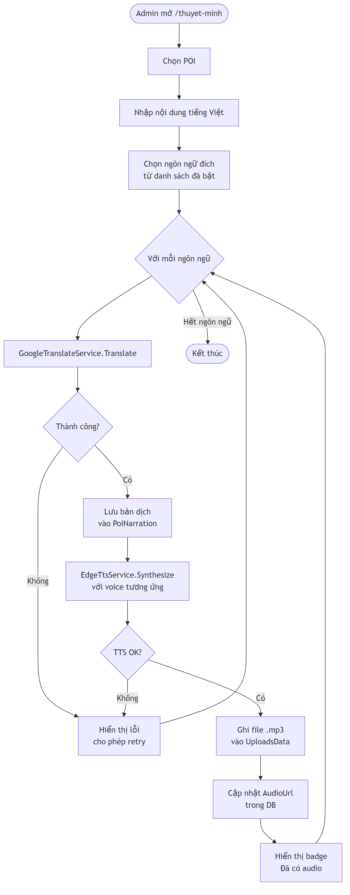

5.5. ACT-05 â€“ Logic Audio Queue vá»›i ngÆ°á»¡ng Æ°u tiÃªn 60%
MÃ´ táº£: Logic tháºt cá»§a HandlePoiEnteredAsync trong AudioQueueService.cs khi nháºn sá»± kiá»‡n PoiEntered tá»« GeofenceMonitorService.
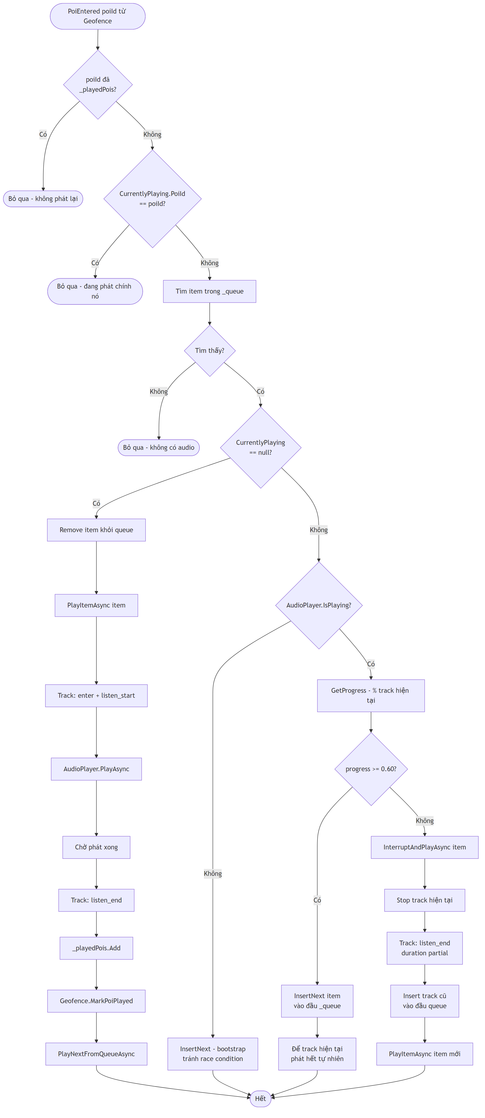
CÃ¡c háº±ng sá»‘ tham chiáº¿u trong code:
- GeofenceMonitorService.DwellThresholdSec = 8 â€“ pháº£i á»Ÿ trong zone 8 giÃ¢y má»›i trigger.
- GeofenceMonitorService.ExitDebounceMs = 10_000 â€“ 10 giÃ¢y ngoÃ i zone má»›i confirm exit.
- GeofenceMonitorService.GpsBufferMeters = 10 â€“ ná»›i bÃ¡n kÃnh thÃªm 10m Ä‘á»ƒ bÃ¹ GPS drift.
- GeofenceMonitorService.PollIntervalMs = 3_000 â€“ polling 3 giÃ¢y.
- AudioQueueService.InterruptThreshold = 0.60 â€“ ngÆ°á»¡ng quyáº¿t Ä‘á»‹nh InsertNext vs Interrupt.

5.6. STATE-01 â€“ VÃ²ng Ä‘á»i (lifecycle) cá»§a POI
MÃ´ táº£: SÆ¡ Ä‘á»“ state diagram thá»ƒ hiá»‡n cÃ¡c tráº¡ng thÃ¡i vÃ chuyá»ƒn Ä‘á»•i cá»§a má»™t POI tá»« lÃºc Vendor táº¡o Ä‘áº¿n khi xuáº¥t hiá»‡n trÃªn Mobile App.
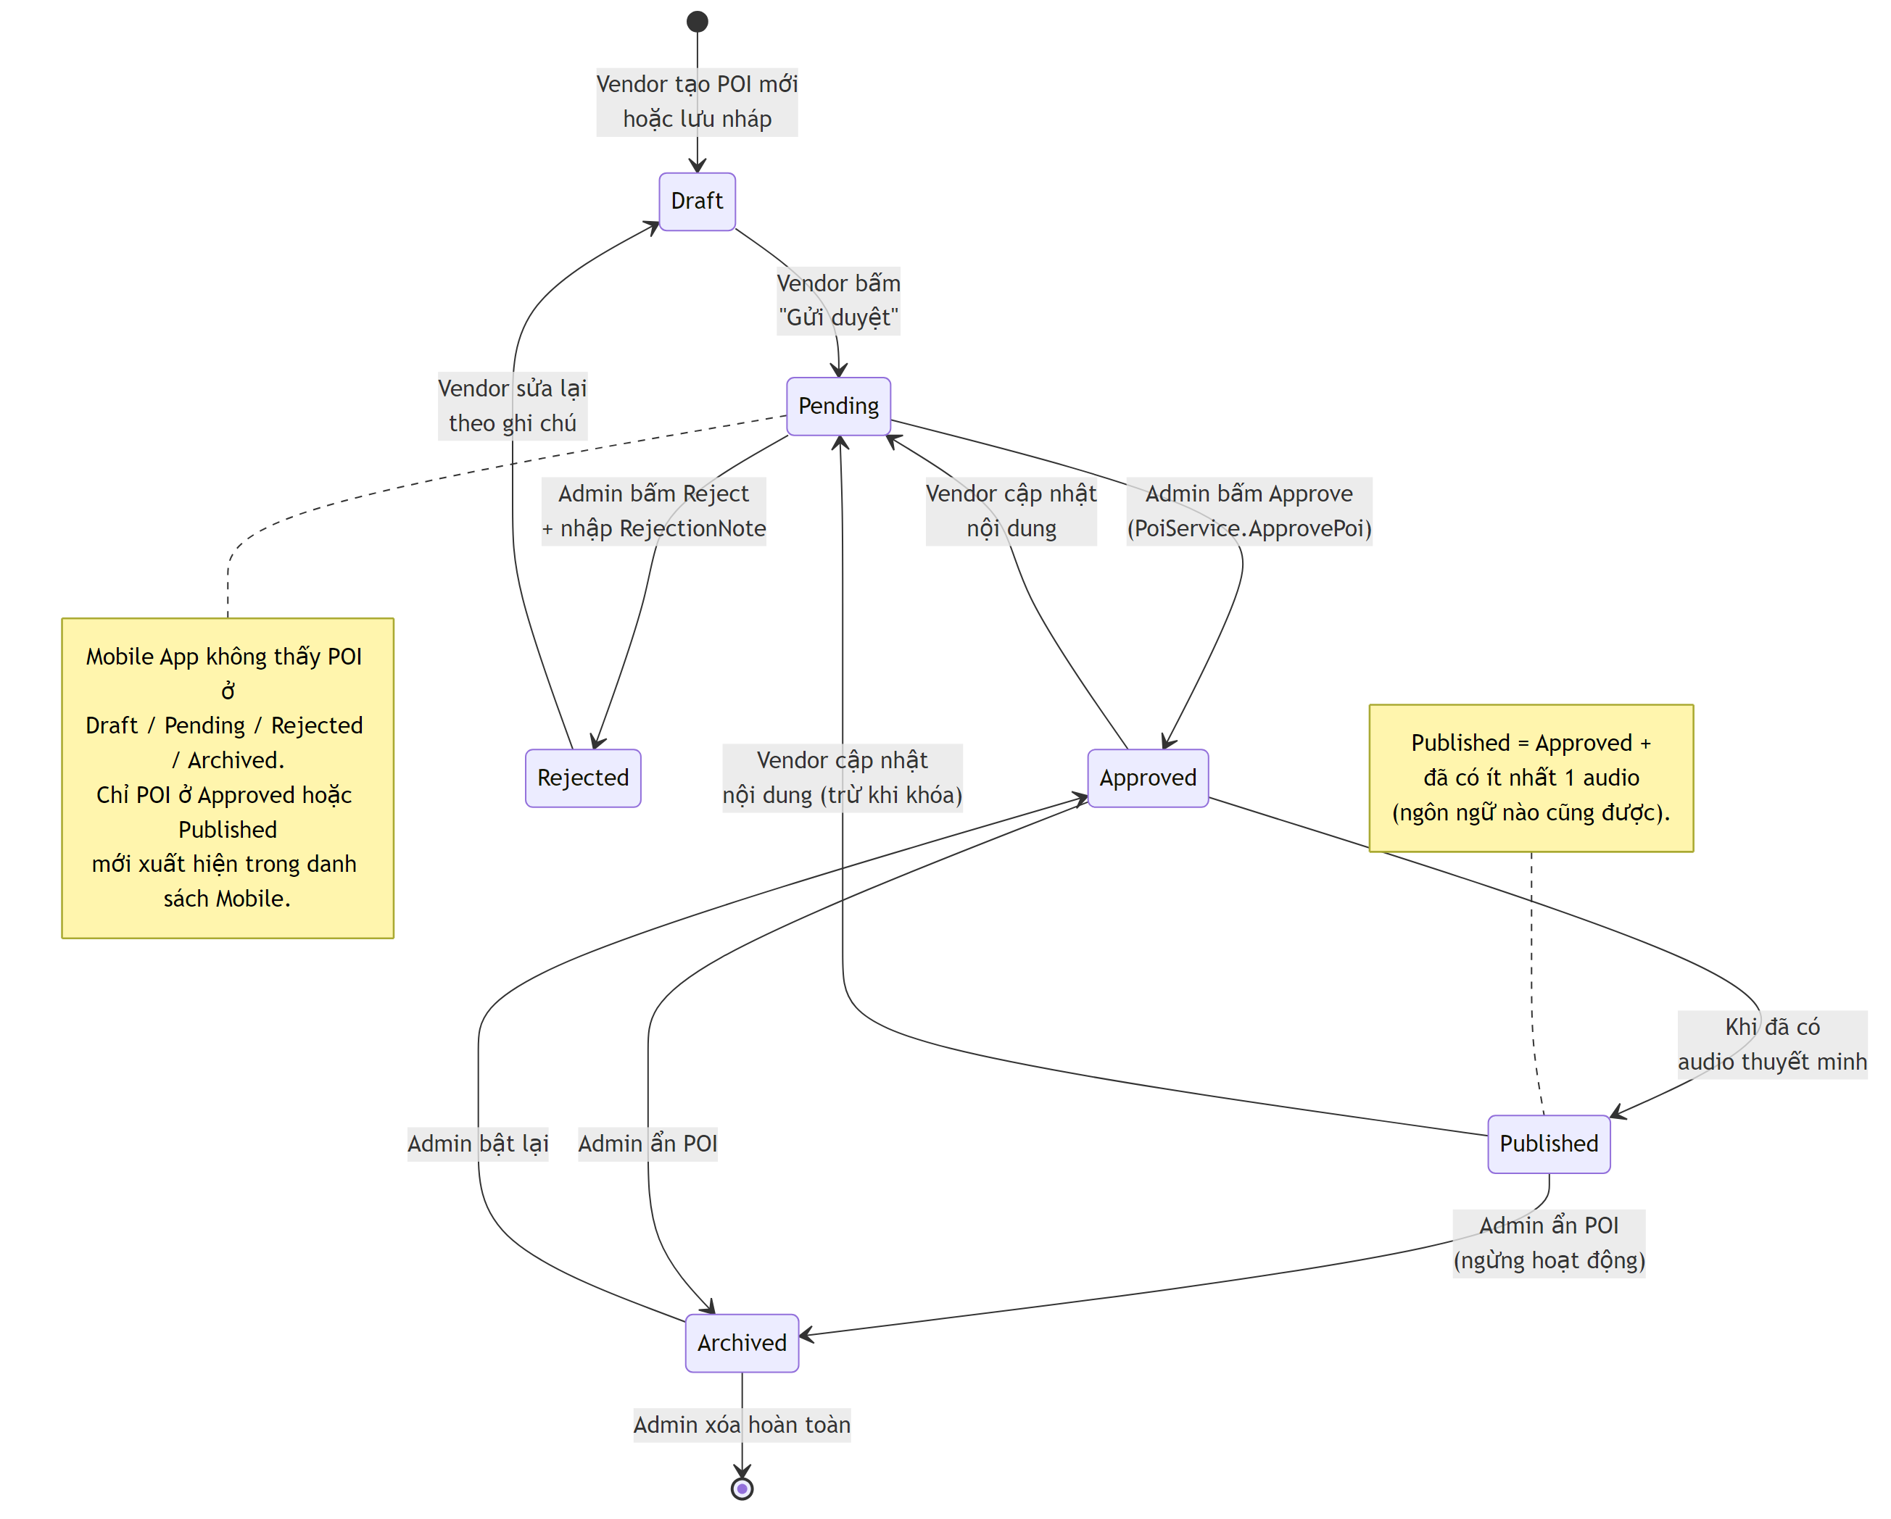
RÃ ng buá»™c chuyá»ƒn tráº¡ng thÃ¡i:
- Má»i thay Ä‘á»•i ná»™i dung quan trá»ng cá»§a Vendor Ä‘á»u reset vá» Pending Ä‘á»ƒ Admin xem láº¡i.
- POI chá»‰ hiá»ƒn thá»‹ cÃ´ng khai trÃªn Mobile khi á»Ÿ tráº¡ng thÃ¡i Approved hoáº·c Published.
- Chuyá»ƒn sang Archived lÃ soft-delete â€“ váº«n giá»¯ log tracking lá»‹ch sá».

6. YÃªu cáº§u phi chá»©c nÄƒng
Háº¡ng má»¥c | YÃªu cáº§u
Hiá»‡u nÄƒng | API < 500ms cho cÃ¡c request chÃnh; audio trigger theo geofence trong vÃ i giÃ¢y. CÃ³ sáºµn load_test.js vÃ stress_test.js Ä‘á»ƒ kiá»ƒm thá» táº£i.
Báº£o máºt | Cookie auth + Google OAuth cho Admin/Vendor; JWT cho Mobile (AuthController); máºt kháº©u hash; static files phá»¥c vá»¥ qua /uploads.
Kháº£ dá»¥ng | App khÃ´ng crash khi API lá»—i â€“ DataService cÃ³ FallbackDemo() Ä‘á»ƒ hiá»ƒn thá»‹ dá»¯ liá»‡u tá»‘i thiá»ƒu.
Äa ngÃ´n ngá»¯ | ThÃªm ngÃ´n ngá»¯ trong QuanLyNgonNgu.razor â†’ sinh audio lÃ cÃ³ thá»ƒ sá» dá»¥ng, khÃ´ng cáº§n build láº¡i app.
Tracking | Má»i hÃ nh vi chÃnh (qr_scan, enter, exit, listen_start, listen_end) Ä‘á»u Ä‘Æ°á»£c ghi qua Tracking/log cho heatmap vÃ thá»‘ng kÃª.

7. Phá»¥ lá»¥c

7.1. Danh sÃ¡ch event tracking (Mobile â†’ Tracking/log)
- qr_scan â€“ quÃ©t QR Ä‘áº§u phá»‘ hoáº·c QR quÃ¡n.
- enter / exit â€“ vÃ o / rá»i vÃ¹ng geofence POI (sau dwell 8s / debounce 10s).
- listen_start / listen_end â€“ báº¯t Ä‘áº§u / káº¿t thÃºc phÃ¡t audio (kÃ¨m ListenedDurationSec).
- move â€“ heartbeat vá»‹ trÃ (phá»¥c vá»¥ heatmap & Ä‘áº¿m thiáº¿t bá»‹ online); luÃ´n kÃ¨m LanguageCode Ä‘Ã£ chuáº©n hoÃ¡.

7.2. Danh sÃ¡ch API chÃnh
Controller | Endpoint | Má»¥c Ä‘Ãch
AuthController | POST /api/Auth/login, /register | ÄÄƒng nháºp/Ä‘Äƒng kÃ½ du khÃ¡ch (role User), tráº£ token + user info
PoiController | GET /api/Poi?lang=, GET /api/Poi/{id}?lang=, GET /api/Poi/{id}/detail?lang= | Danh sÃ¡ch / chi tiáº¿t POI Ä‘Ã£ localize theo ngÃ´n ngá»¯; chi tiáº¿t kÃ¨m menu, áº£nh, narration, audio URL
LanguagesController | GET /api/Languages | Danh sÃ¡ch ngÃ´n ngá»¯ active Ä‘Ã£ cÃ³ TTS voice
QrController | GET /api/Qr/resolve/{token}?lang= | Resolve token QR sang tour hoáº·c POI
TourController | POST /api/Tour/start, GET /api/Tour/audio-queue?tourId&lang, POST /api/Tour/track-listen | Báº¯t Ä‘áº§u tour, táº£i audio queue, log start/end nghe audio
TrackingController | POST /api/Tracking/log, GET /api/Tracking/online-count?minutes=, GET /api/Tracking/heatmap?hours= | Ghi log (server normalize LanguageCode), Ä‘áº¿m thiáº¿t bá»‹ online, heatmap dáº¡ng bucket toáº¡ Ä‘á»™
ReviewsController | GET /api/Reviews/recent?take=, GET /api/Reviews/poi/{poiId}, POST /api/Reviews | Danh sÃ¡ch review + táº¡o review
FeedbackController | POST /api/Feedback/app | Gá»i feedback á»©ng dá»¥ng
SyncController â | GET /api/Sync/bootstrap?since= | Snapshot offline: ngÃ´n ngá»¯ active + POI Approved + áº£nh + audio URL cho mobile cache

7.3. ThÃ nh pháº§n dá»± Ã¡n
- Admin/ â€“ Web Admin + Vendor (ASP.NET Core Blazor Server), phÃ¢n quyá»n theo role Admin / Vendor.
- VKFoodTour.API/ â€“ ASP.NET Core Web API (JWT), phá»¥c vá»¥ static files UploadsData/ qua /uploads.
- VKFoodTour.Application/ â€“ project dá»± phÃ²ng cho layer Application (hiá»‡n táº¡i gáº§n nhÆ° trá»‘ng, logic Ä‘áº·t trá»±c tiáº¿p trong API controller vÃ Admin/Services).
- VKFoodTour.Infrastructure/ â€“ ApplicationDbContext, Entities, Migrations (EF Core).
- VKFoodTour.Shared/ â€“ DTO dÃ¹ng chung: PoiDto, PoiDetailDto, TourDtos, AuthDtos, ReviewDtos, TrackingDtos, QrResolveDto, LanguageListItemDto, AppFeedbackDtos.
- VKFoodTour.Mobile/ â€“ App .NET MAUI (ZXing QR, Maui Maps, Plugin.Maui.Audio) vá»›i DataService, AuthSessionService, SettingsService, LocalizationService, FavoriteService, HttpImageService, AudioPlaybackService, AudioQueueService, GeofenceMonitorService.
- VKFoodTour.Mobile.Core/ â€“ Core library dÃ¹ng chung (chá»©a PoiApiService nhÆ° báº£n thay tháº¿ tÆ°Æ¡ng lai).
- Database/VKFoodTour.sql â€“ script DDL + seed.
- UploadsData/ â€“ chá»©a file áº£nh vÃ audio sinh ra tá»« Edge TTS.

TÃ i liá»‡u nÃ y lÃ báº£n Ä‘áº·c táº£ yÃªu cáº§u sáº£n pháº©m (PRD) cho há»‡ thá»‘ng VKFoodTour, phá»¥c vá»¥ má»¥c Ä‘Ãch phÃ¡t triá»ƒn, nghiá»‡m thu vÃ bÃ¡o cÃ¡o Ä‘á»“ Ã¡n.

