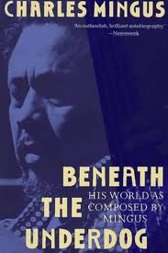
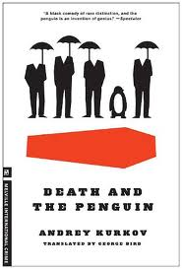
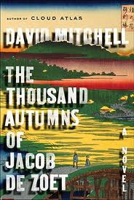
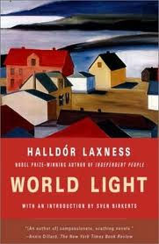
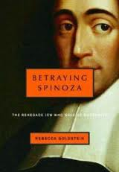
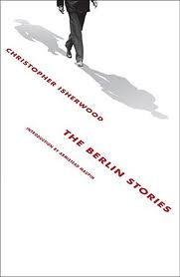
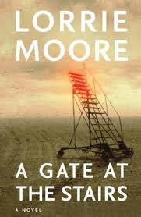
2012 Faculty Book Recommendations for FWT Reading

Barbara Alfano
- The Shape of Water by Andrea Camilleri
- The Terracotta Dog by Andrea Camilleri
Camilleri's novels --detective novels whose protagonist, inspector Montalbano, loves to cook. He lives and works in Sicily.

Doug Bauer
- Master of Disguises by Charles Simic
- Touch by Henri Cole

Megan Mayhew Bergman
- Monster of God by David Quammen
- Death Comes for the Archbishop by Willa Cather
- Veronica by Mary Gaitskill
- The Collected Stories of Leonard Michaels
- Oscar Wilde by Richard Ellman

Michael Bisio
- Beneath the Underdog by Charles Mingus

John Bullock
- Charles Dickens: A Life by Claire Tomalin

Ron Cohen
- Braintrust: What Neuroscience Tells Us about Morality by Patricia S. Churchland
- Liquid Times: Living in an Age of Uncertainty by Zygmunt Bauman
- The Death of an Adversary by Hans Keilson
- Toilet: Public Restrooms and the Politics of Sharing edited by Harvey Molotch and Laura Noren
- Alone Together: Why We Expect More from Technology and Less from Each Other by Sherry Turkle

Annabel Davis-Goff
  - Afternoon Men by Anthony Powell
  - Flaubert’s Parrot by Julian Barnes

Liz Deschenes
- Speaker Receiver by Moyra Davey

Kathleen Dimmick
- Lord of Misrule by Jaimy Gordon

Marguerite Feitlowitz
- Things on Which I've Stumbled by Peter Cole
- The Gate of Angels by Penelope Fitzgerald
- The Beginning of Spring by Penelope Fitzgerald
- A Change of Climate by Hilary Mantel
- Eight Months on Ghazzah Street by Hilary Mantel
- Ship Fever by Andrea Barrett
- Servants of the Map by Andrea Barrett
- Joan Mitchell: Lady Painter by Patricia Albers

Becky Godwin
- A Visit from the Good Squad by Jennifer Egan
- The Thousand Autumns of Jacob de Zoet by David Mitchell

Camille Guthrie
Poetry
- Skin Inc.: Identity Repair Poems by Thomas Sayers Ellis
- Dear Darkness by Kevin Young
- One with Others by C.D. Wright
Fiction
- The Beginners by Rebecca Wolff
- And Yet They Were Happy by Helen Phillips

Jon Isherwood
- The Hero's Journey Joseph Campbell on His Life and Work edited by Philip Cousineau
- A Fable of Modern Art by Dore Ashton
- The Letters of Vincent Van Gogh edited and introduced by Mark Roskill
- Conversations with Cezanne edited by Michael Doran
- Life by Keith Richards
- The Berlin Stories by Christopher Isherwood
- A Natural History of the Senses by Diane Ackerman

Jonathan Kline
- With Liberty & Justice for Some: How the Law is Used to Destroy Equality and Protect the Powerful by Glen Greenwald
- Overlook: Exploring the Internal Fringes of America with the Center of Land Use Interpretation by Matthew Coolidge
- Upriver: Manmade Sites of Interest on the Hudson from the Battery to Troy by Matthew Coolidge
- The Cruel Radiance: Photography and Political Violence by Susie Linfield

Scott Lehrer
- Travels with Myself and Another by Martha Gellhorn wonderful travel writing by the great war journalist.
- Motherless Brooklyn by Jonathan Lethem It's detective novel, but the main character has Tourette's. Not good for meeting with mafia Dons!
- Bill Graham Presents by Bill Graham and Robert Greenfield This is a great American story. His life reads like a mashup of The Tin Drum, The Adventures of Augie March and Spinal Tap.
- The Big Short: Inside the Doomsday Machine by Michael Lewis Ohhh, so that's what happened on Wall Street in the fall of 2008...a common sense explanation of some serious financial voodoo.

Mary Lum
- The Influencing Machine by Brooke Gladstone
- The Collected Stories of Lydia Davis
- Asterios Polyp by David Mazzucchelli
- We Need To Talk About Kevin by Lionel Shriver
- BLAST by Marshall McLuhan

Amie McClellan
- I suggest spending some snow days snuggling up with the entire series of Kurt Wallender police detective novels by Henning Mankell. I never thought I liked police detective novels but I can't get enough of these!

Andrew McIntyre
- The Character of Physical Law by Richard Feynman
- Euler's Gem: The Polyhedron Formula and the Birth of Topology by David Richeson
- Betraying Spinoza: The Renegade Jew Who Gave Us Modernity by Rebecca Goldstein

Carol Meyer
- The Book Thief by Markus Zusak I enjoyed the characters, which makes the book worth reading, and the fact that death was the narrator even though the concept didn't completely work but I appreciate the experiment.
- Mr. Pip by Llyod Jones Exotic, familiar, and tragic all in one novel. Also, how can you go wrong with a nod to Dickens.

Mirka Prazak
- One Day I Will Write About This Place by Binyavang'a Wainaina

Jean Randich
- Twilight of the Superheroes by Deborah Eisenberg
- Death and the Penguin by Andrey Kurkov
- Let the Great World Spin by Colum McCann
- Our Daily Bread by Lauren B. Davis
- Salvage the Bones by Jesmyn Ward

Isabel Roche
- Dexterity by Doug Bauer
- A Gate at the Stairs by Laurie Moore

Donald Sherefkin
- The Poor Mouth by Flann O'Brien
- Discovering the Vernacular Landscape by J. B. Jackson
- The Conscience of the Eye: The Design and Social Life of Cities by Richard Sennett

Betsy Sherman
- The Thousand Autumns of Jacob de Zoet by David Mitchell
- The Maytrees by Annie Dillard

Jim Voorhies
- The Nightmare of Participation by Markus Miessen
- The Rings of Saturn by W.G. Sebald

Mark Wunderlich
- The Emigrants Trilogy by Vilhelm Moberg
- Every Man Dies Alone by Hans Fallada
- World Light by Halldor Laxness
- The Quickening Maze by Adam Foulds
- Bring Down the Little Birds by Carmen Gimenez Smith

Kerry Woods
- Neal Stephenson's Baroque Cycle trilogy -- three books totaling nearly 2300 pages -- should keep you busy for a good chunk of FWT. Individual titles are 'Quicksilver', 'The Confusion', and 'The System of the World'. I suppose this would be classified as historical fiction; it's also nerd-fiction, and has a bit of magical realism to it as well (there's a guy who appears to be literally ageless – he turns up in another Stephenson novel set in 21st century). The sweep is pretty broad; Cromwell through the Restoration Stuarts in England, Court of Louis xiv in France, Mustafa Pasha's Ottoman Army at the gates of Vienna, various German principalities, Massachusetts (at animagined proto-MIT in still-Puritan New England). Characters include a number of kings and queens and other nobility (mostly historical, with a fictional 'vagabond-kind' as an important character), everybody involved in the English Enlightenment (Newton, Hooke, etc.), W. G. Liebniz, Jean Bart (a real French privateer) -- and a couple of fictional protagonists who turn out to have been indirectly responsible for much of what happened during a very lively European generation. Stephenson seems to have mastered the history in intimate detail (except where he doesn't mean to be factual). One reviewer called his treatment of the intellectual discourse of the tim 'magisterial', and I can't argue. AND he's very funny. Great dialogue (given what a lot of it's about -- development of calculus, enlightenment philosophical debates, and so on -- it seems like it ought to feel really didactic, but it doesn't) and just generally delightful narrative writing.

All of Stephenson's novels are good reading. They share style, but not genre. Snow Crash has been described as 'postcyberpunk' science fiction. Cryptonomicon is more nerd stuff -- Stephenson's obsession with cryptography running from WWII to near future -- but full of implausible adventures. I just read Anathem -- a 1000-pager that combines speculative/scifi, some swashbuckling, a lot of nimble philosophical/cultural/linguistic ruminations, AND a good dose of quantum physics. It involves FIVE alternate universes (ours is one of them). I liked it almost as much as the last book of the Baroque Cycle.

