MASTER'S THESIS
RESEARCH PLAN
A Hierarchical ReAct Multi-Agent Pipeline for Residential Appliance Load Scheduling Under Dynamic Electricity Pricing
Hoan Le
University of Oulu | Information Processing Science | 2026
Methodology: Design Science Research (DSR) | Duration: 5 months

1. Background and Motivation
The research journey toward optimizing residential energy consumption is shifting from rigid heuristic algorithms to autonomous, reasoning-capable AI architectures. Gartner reported a 1,445% surge in multi-agent system inquiries between Q1 2024 and Q2 2025, reflecting a fundamental transition from single all-purpose agents to orchestrated teams of specialized agents — each fine-tuned for a distinct capability. With the volatility of dynamic electricity spot prices, and Finland's adoption of 15-minute pricing intervals since October 2025, conventional smart home setups often struggle to balance cost efficiency with the practical reality of overlapping appliance usage.
Existing single-agent LLM-based Home Energy Management Systems (HEMS) have demonstrated initial promise but carry three documented limitations: multi-appliance coordination failures in some model configurations, one-dimensional optimization signals based solely on wholesale price, and evaluations confined to single-day scenarios that leave robustness across price-volatility regimes untested (Jonah et al., 2026, arXiv:2607.04569). This thesis addresses these gaps by designing and evaluating a hierarchical ReAct multi-agent pipeline — an architecture aligned with the dominant 2026 agentic AI trend of specialized agent orchestration.
The work is grounded in the practical context of the Low Carbon Alert trainee project, which provides direct domain exposure to energy data pipelines and demand-side flexibility challenges. A secondary evaluation axis comparing a large commercial model (GPT-4o-mini) against a small open-source model (Llama-3.3-70B) contributes to the emerging research agenda on sustainable agentic AI — NVIDIA's position paper demonstrates that a 7B SLM consumes 10 to 30 times less energy per inference than a large frontier model while maintaining competitive task quality.

2. Research Questions
The study is guided by one main research question and two sub-questions. The main RQ is non-binary — it asks how much and under which conditions, producing a richer, more nuanced answer than a yes/no finding. Together the three questions cover performance magnitude (RQ), design rationale (SQ1), and domain insight (SQ2).

Main Research Question
RQ: To what extent does a hierarchical ReAct multi-agent pipeline reduce residential appliance scheduling cost compared to a single-agent baseline, and under which price-volatility conditions is the improvement most pronounced?

How it is answered: The optimality gap — percentage cost deviation from MILP mathematical optimum — is computed for both systems across 48 evaluation scenarios. A Wilcoxon signed-rank test determines statistical significance and effect size r quantifies practical significance. Results are broken down by scenario type (stable, moderate, volatile, spike, negative price, conflict) to identify the price-volatility conditions where the multi-agent design adds the most value.
Answered in: Chapter 5 — Results (optimality gap table, Wilcoxon output, per-scenario breakdown); Chapter 7 — Conclusion.

Sub-Question 1 — Design
SQ1: How should the pipeline be designed to handle multiple simultaneous appliance scheduling requests without redundant reasoning across agents?

How it is answered: Chapter 4 presents the three-agent architecture and justifies each design decision — why the Appliance Profiler, Price-Aware Scheduler, and Conflict Resolver separation handles simultaneous requests better than a single agent processing all tasks in one context window. The conflict resolution success rate in Chapter 5 provides empirical validation.
Answered in: Chapter 4 — System Design and Implementation; Chapter 5 — conflict resolution metric.

Sub-Question 2 — Appliance Types
SQ2: Which appliance types benefit most from multi-agent scheduling, and what appliance characteristics drive the largest cost reduction?

How it is answered: Chapter 5 breaks results down per appliance type: washing machine, dishwasher, and tumble dryer. Mean cost saving and optimality gap are computed separately for each. Chapter 6 interprets which appliance characteristics — cycle duration, power draw, constraint window width — drive the largest benefit from intelligent scheduling.
Answered in: Chapter 5 — per-appliance breakdown table; Chapter 6 — Discussion interpretation.

Question | Type | Primary metric | Chapter
RQ — Extent and conditions of cost reduction | Empirical | Optimality gap %; Wilcoxon p-value + effect size r; per-scenario-type breakdown | Ch. 5 + Ch. 7
SQ1 — Pipeline design for simultaneous requests | Design | Architecture diagram; conflict resolution success rate | Ch. 4 + Ch. 5
SQ2 — Appliances and characteristics driving benefit | Analytical | Cost saving per appliance type; optimality gap per type; characteristic analysis | Ch. 5 + Ch. 6

3. Methodology
The methodology driving this thesis is Design Science Research (DSR), as defined by Peffers et al. (2007). DSR is appropriate because the central activity is the iterative construction and empirical validation of a software artifact — the hierarchical ReAct multi-agent pipeline — rather than the observation of a pre-existing phenomenon. A Systematic Literature Review (SLR) constitutes DSR Phase 1: it confirms the research gap and grounds all architectural decisions in prior work. The SLR becomes Chapter 2 of the thesis.

Phase | DSR step | Activity in this thesis | Output
1 | Problem | SLR across ACM, IEEE, Scopus, arXiv confirming no multi-agent ReAct HEMS addresses multi-appliance coordination across multiple price-volatility regimes | Gap statement; confirmed RQs
2 | Objectives | Define measurable success criteria: optimality gap target, conflict resolution rate, latency and token cost budget | Objective specification in Ch. 3
3 | Design | Design LangGraph state graph; implement Appliance Profiler, Price-Aware Scheduler, Conflict Resolver; build single-agent baseline and MILP solver | Working pipeline artifact (Ch. 4)
4 | Demonstration | Run pipeline on five representative scenarios; confirm it produces valid cost-reducing schedules before full evaluation | Demonstration results in Ch. 5
5 | Evaluation | Run 48 scenarios through multi-agent pipeline, single-agent baseline, and MILP solver; apply Wilcoxon test; break results down per scenario type and appliance type | Quantitative results in Ch. 5
6 | Communication | Write findings, design guidelines, limitations, and future work; answer RQ, SQ1, and SQ2 explicitly in Ch. 7 | Complete thesis submitted

4. The Research Journey
The research journey maps each DSR phase to a concrete weekly activity and deliverable across five months. Each phase must produce its deliverable before the next begins.

Month | Weeks | DSR phase | Activity | Deliverable
1 | 1–2 | Phase 1 Problem | Read arXiv:2607.04569 and arXiv:2510.26603 in full. Annotate three gap statements. Confirm RQ, SQ1, SQ2 with supervisor. Download smart home consumption dataset and dynamic spot price data. | Gap statement; RQs signed off; datasets ready
1 | 3–4 | Phase 2 Objectives | Execute SLR. Screen papers. Write Ch. 2 outline. Define evaluation success criteria. Write Introduction and Methodology drafts. | Ch. 2 outline; annotated bibliography; Ch. 3 draft
2 | 5–6 | Phase 3a Design | Design three-agent LangGraph architecture. Implement and validate single-agent ReAct baseline on five pilot scenarios. Confirm baseline produces suboptimal but plausible schedules. | Working single-agent baseline; pilot validation
2 | 7–8 | Phase 3b Design | Implement MILP ground truth solver in PuLP. Validate on same five pilot scenarios. Confirm provably optimal schedules — evaluation benchmark for all 48 scenarios. | Validated MILP solver; Ch. 4 draft begun
3 | 9–10 | Phase 3c Build | Implement Appliance Profiler and Price-Aware Scheduler agents independently. Test each on pilot scenarios before integration. | Two validated specialist agents
3 | 11–12 | Phase 3d Build | Implement Conflict Resolver and Orchestrator. Integrate full pipeline. Stress-test on multi-appliance conflict scenarios — the case type most likely to reveal single-agent failure. | Complete pipeline end-to-end
4 | 13–14 | Phase 4 Demo | Run demonstration on five representative scenarios. Instrument with LangSmith for full trace capture. Confirm pipeline produces valid output before full evaluation. | Demonstration results; LangSmith traces
4 | 15–16 | Phase 5 Evaluate | Run all 48 scenarios through all three systems. Collect optimality gap, conflict resolution rate, latency, token cost. Apply Wilcoxon test. Break results down by scenario type and appliance type. Write Ch. 5. | Raw results CSV; Ch. 5 draft
5 | 17–18 | Phase 6a Write | Write Chapters 2 and 6: full Literature Review and Discussion. Interpret results against RQ, SQ1, SQ2. Address limitations and future work. | Chapters 2 and 6 complete
5 | 19–20 | Phase 6b Submit | Write Ch. 7 Conclusion answering RQ, SQ1, SQ2 explicitly. Write Abstract. Compile APA reference list. Apply Oulu IPS formatting. Supervisor review. Submit. | Complete thesis submitted

5. System Architecture
The artifact is a LangGraph-based hierarchical pipeline that divides scheduling responsibilities across three specialized ReAct agents coordinated by an Orchestrator. Each agent runs its own Thought-Action-Observation loop with access only to the tools relevant to its role. Outputs pass between agents through a shared LangGraph state object. Figure 1 below presents the complete pipeline architecture.

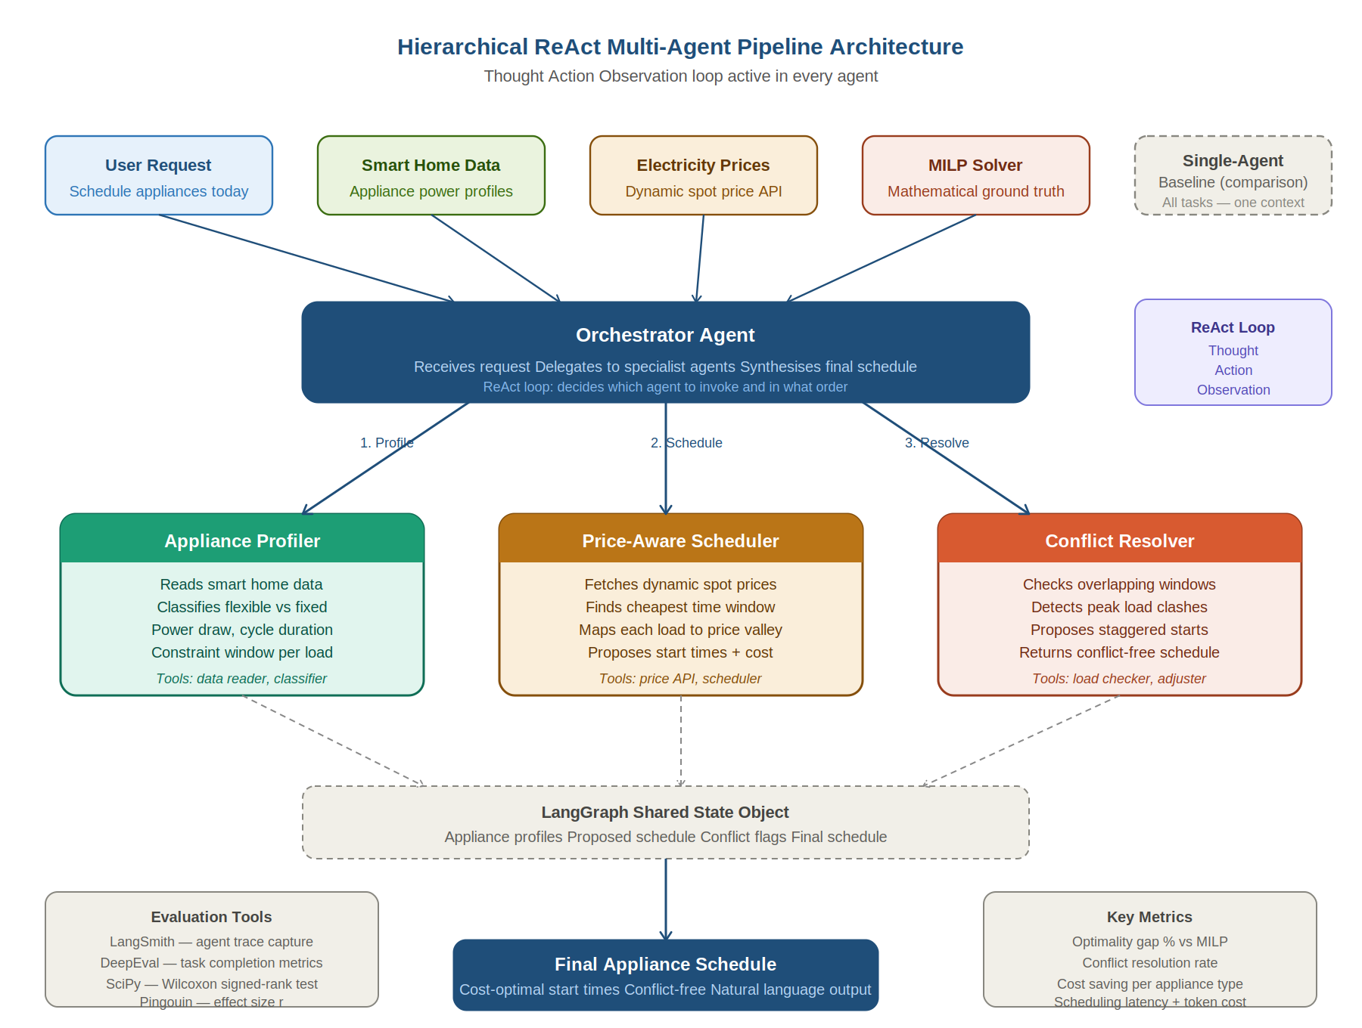
Figure 1. Hierarchical ReAct Multi-Agent Pipeline Architecture. Solid arrows indicate primary data flow; dashed arrows indicate state updates to the shared LangGraph state object. The single-agent baseline (dashed box, top right) receives identical inputs and is evaluated in parallel for comparison.

Agent specifications
Agent | Role | Tools | Output
Orchestrator | Receives household scheduling request; delegates sub-tasks to three specialist agents in sequence; synthesises outputs into a final daily schedule in natural language | Message passing to specialist agents | Final schedule with per-appliance start times and total cost estimate
Appliance Profiler | Reads smart home consumption data and classifies each appliance by shiftability — flexible loads have long cycles and user-defined completion windows; fixed loads (fridge, microwave) are excluded | Data reader, appliance classifier | Structured appliance profile: power draw, cycle duration, constraint window per flexible load
Price-Aware Scheduler | Integrates with dynamic spot price API to identify the cheapest available window for each flexible appliance within its constraint envelope; reasons over the daily price curve to minimise total cost | Spot price tool, schedule calculator, cheapest window finder | Proposed schedule with per-appliance start times and cost estimate
Conflict Resolver | Evaluates the proposed schedule for overlapping high-draw windows that would exceed the household peak threshold; proposes staggered start time adjustments; returns a conflict-free schedule | Load summation tool, conflict detector, schedule adjuster | Revised conflict-free schedule

Technology stack
Component | Tool | Cost
Orchestration | LangGraph v1.0+ (stable, October 2025) | Free — open source
LLM primary evaluation | GPT-4o-mini via OpenAI API | Under $3 for all 48 scenarios
LLM secondary evaluation | Llama-3.3-70B via Ollama or Groq free tier | Free — sustainable AI comparison axis
Ground truth | PuLP MILP solver | Free — open source
Tracing | LangSmith free tier | Free — native LangGraph integration
Evaluation | DeepEval open source | Free — task completion and tool call metrics
Statistics | SciPy + Pingouin (Python) | Free — Wilcoxon test and effect size r

6. Dataset and Evaluation Strategy
The empirical validation relies entirely on real-world, open-access data. Smart home appliance consumption profiles are drawn from a publicly available household electricity dataset providing granular power measurements at 8-second intervals from 20 residential homes monitored continuously over two years. This eliminates the need for theoretical load simulations while grounding all 48 evaluation scenarios in real household behaviour. Dynamic electricity prices are sourced from the Finnish spot price market, providing the pricing signal the scheduling agents reason over.

Source | Link | Notes
Consumption data (cleaned) | zenodo.org/records/5063428 | Individual house CSV files, appliances labelled, free, no registration. Recommended starting point.
Consumption data (official) | refitsmarthomes.org/datasets | Official project page with all dataset variants and full documentation.
Consumption data (paper) | doi.org/10.1038/sdata.2015.7 | Cite as Murray et al. (2017) when referencing dataset in thesis.
Finnish spot prices | parassahko.fi/en/statistics | Free historical Finnish spot price CSV, CC BY 4.0, 15-min resolution from June 2026.
nordpool Python library | pypi.org/project/nordpool | pip install nordpool — fetches FI prices in two lines of code.

Scenario design — 48 evaluation scenarios
Type | Price regime | Appliances | Instances | Answers
A | Stable — low volatility | 2 appliances: dishwasher + washing machine | 8 | RQ baseline — both systems should perform well
B | Stable — low volatility | 3 appliances: dishwasher + washing machine + tumble dryer | 8 | SQ1 — three-way conflict resolution test
C | Moderate volatility | 3 to 5 appliances mixed | 8 | RQ — price-signal responsiveness
D | High volatility — winter peak | 5 appliances with overlapping constraint windows | 8 | RQ — most financially consequential condition
E | Price spike — crisis event | 3 appliances with tight constraint windows | 8 | RQ — extreme price event robustness
F | Negative spot price — summer surplus | 4 appliances with flexible windows | 8 | RQ — identifies whether agents exploit zero-cost windows

Evaluation metrics
Metric | Definition | Research question answered
Optimality gap % | (Agent cost minus MILP cost) / MILP cost x 100 | RQ — how much improvement; lower gap = better performance
Per-scenario-type gap | Mean optimality gap grouped by scenario type A through F | RQ — under which conditions is improvement most pronounced
Conflict resolution rate | % of multi-appliance scenarios correctly resolved | SQ1 — does pipeline handle simultaneous requests?
Cost saving per appliance | Mean cost reduction vs no-scheduling baseline per appliance type | SQ2 — which appliances benefit most
Wilcoxon W + p-value | Non-parametric paired test across 48 scenario pairs | RQ — is the difference statistically significant?
Effect size r | r = Z / sqrt(N) | RQ — is the difference practically significant?
Scheduling latency | Wall-clock seconds from request to final schedule | Practical deployability
API token cost | Total tokens x price per token (USD) | Sustainable AI axis — SLM vs LLM cost comparison

7. Expected Outcomes
The conclusion of this thesis will establish the extent to which distributing reasoning tasks across specialized ReAct agents reduces residential appliance scheduling cost compared to a monolithic single-agent baseline, and identify the price-volatility conditions under which the improvement is most pronounced. The three research questions are answered sequentially and explicitly in Chapter 7:

- RQ: Quantified finding — the mean optimality gap reduction achieved by the multi-agent pipeline relative to the single-agent baseline, supported by the Wilcoxon test result (W, p-value, effect size r) and a breakdown by scenario type identifying which price-volatility conditions produce the largest improvement.
- SQ1: Architectural finding — which design decisions (role separation, sequential delegation, dedicated conflict resolution) are necessary for handling simultaneous scheduling requests without redundant reasoning, supported by the conflict resolution success rate metric.
- SQ2: Domain finding — ranked list of appliance types by cost saving magnitude and an explanation of which appliance characteristics (cycle duration, power draw, constraint window width) drive the largest benefit from multi-agent scheduling.

A secondary sustainable AI finding compares GPT-4o-mini against Llama-3.3-70B on scheduling quality and token cost, contributing to the research agenda on energy-efficient agentic AI deployment — directly relevant to the Low Carbon Alert trainee project context.
Deliverables include the evaluated LangGraph pipeline, full benchmark results across 48 scenarios, LangSmith trace data, DeepEval evaluation output, statistical analysis results, and an extensible architectural blueprint for hierarchical multi-agent deployment in dynamic pricing environments.

8. Key References

Jonah, N., et al. (2026). LLMs for agentic home energy management. arXiv:2607.04569.
Primary gap reference — three documented limitations this thesis directly addresses
El Makroum, M., et al. (2026). Agentic AI home energy management system: A large language model framework for residential load scheduling. arXiv:2510.26603.
Hierarchical multi-agent HEMS baseline — closest existing work; architecture replicated as single-agent reference
Yao, S., Zhao, J., Yu, D., Du, N., Shafran, I., Narasimhan, K., & Cao, Y. (2023). ReAct: Synergizing reasoning and acting in language models. ICLR 2023. arXiv:2210.03629.
Foundational paper for the Thought-Action-Observation loop used in all agents
Murray, D., Stankovic, L., & Stankovic, V. (2017). An electrical load measurements dataset of United Kingdom households from a two-year longitudinal study. Scientific Data, 4, 160122.
Primary consumption dataset citation
Peffers, K., Tuunanen, T., Rothenberger, M. A., & Chatterjee, S. (2007). A design science research methodology for information systems research. Journal of Management Information Systems, 24(3), 45–77.
DSR methodology — six-phase process model applied throughout this thesis
Han, S., et al. (2024). LLM multi-agent systems: Challenges and open problems. arXiv:2402.03578.
Multi-agent systems survey — justifies role-specialization and orchestration design
NVIDIA Corporation. (2025). Efficient inference with small language models. NVIDIA Technical Position Paper.
Evidence that SLMs consume 10 to 30x less energy per inference — sustainable AI secondary evaluation axis

