

Template for Theses (Arial 20pt bold)

University of Oulu
Information Processing Science
Bachelor / Master’s Thesis
First name Last name
Year

Abstract (Heading 1 Arial 18pt)
Times New Roman 12pt Line spacing 1

Keywords (Arial 12pt italic)
first keyword, second keyword, other keywords

Supervisor (Arial 12pt italic)
Title, position First name Last name

Foreword (Heading 1 Arial 18pt)
Times New Roman 12pt line spacing 1

Contents
Abstract (Heading 1 Arial 18pt) 2
Foreword (Heading 1 Arial 18pt) 3
Contents 4
1. Introduction (Heading 1 Arial 18pt numbered) 5
1.1 Title page (Heading 2 Arial 14pt numbered) 5
1.2 Text and headings 5
1.3 Tables, figures and lists 5
1.4 Emphasis and citations 7
1.5 Examples of codes and formulas 8
1.6 Footnotes 8
1.7 Page numbers 8
1.8 Contents 8
2. Use of References 10
2.1 Reference style 10
2.2 References 11
References 13
Appendix A. The styles used in the document 14

Introduction (Heading 1 Arial 18pt numbered)
This is a template for bachelor theses and master’s theses in Information Processing Science. This template outlines the required formatting and referencing used in theses.
Every chapter starts with text. The text acts as a short introductory part for the following sections.

Title page (Heading 2 Arial 14pt numbered)
The name of the thesis is written positioned 13 cm from the upper edge of the title page by the font Arial and size 20. A potential sub title is written by Arial size 16. On the right bottom of the page starting from 9 cm the name of the university, department, type of thesis, the author and date are written. If this template is used for exercise assignment, the student number is needed to ease crediting the performance. The student number is not included in bachelor or master’s thesis.

Text and headings
The thesis is written with Times New Roman (or similar) with single line spacing. The font is 12 points. The paragraphs are written without indentation and are separated by one empty line (12 p). Except the main headings, the headings are written by small alphabets. The main heading is in Arial font size 18 and sub headings Arial font size 14. The main headings start new pages. The heading is positioned after 48 point empty space and after the heading there is 24 point empty space. The subheadings are preceded by two empty lines (24 p) between the subheading and the following text there is empty space of one line. On the left there is 4 cm margin to ease stapling. All other margins are 2 cm
According to generally adopted style, there may not be consecutive headlines. Therefore introductory text is needed after headlines before following headlines. The headlines may not remain alone without the actual text on the same page. Instead, the headlines must be tied with the following paragraph.

Tables, figures and lists
Tables should be centred and the size of a table should correspond to its content. Tables must be numbered and named by a caption. The numbering is running from the beginning of the thesis. The captions are positioned above the tables. Above the caption there is space for one empty line (12 p) and below 6 points. The table must be referred according to its number. Referring to a table by “see below” or “in the next table” is not sufficient. Table 1 summarizes the font styles that are used in the theses.

Table 1. The heading styles in the theses.
 | Font Style | Size | NB
Heading0 | Arial | 18 | No numbering
Heading1 | Arial | 18
Heading2 | Arial | 14
Heading3 | Arial | 14
Heading4 | Arial, italics | 12 | No numbering, not recommended
Body text | Times Roman | 12
Table title | Arial | 10 | Note the bolding
Figure title | Arial | 10 | Note the bolding
A table should not be divided on two or more pages, if possible. Instead of having a too long table it is recommended to build several smaller tables or to consider if there are more suitable formats to present the information such as appendices. If the table is a direct copy from another publication, you must get a permission from author or publisher to use the table in your work and the table must be cited properly (Author, year, with permission). If the table is adapted from an existing table in another publication, the table must be cited properly (adapted from Author, year). See the referencing guide.
Pictures must be numbered and named by a caption. The numbering is running from the beginning of the thesis. The title is placed below the picture. Below the title is an empty space of one line (12 p). Above the picture is an empty space of 6 p. The picture is referred by its number in the text. If the picture is narrower as the body text, it is centred (see Fig. 1).
A good hint to insert a picture is to add a table (Table – Insert – Table - 1 column, 1 row, Autofit to contents) first, and then paste the picture into the cell. Thus the picture does not float over the text and margins when editing the document. Remember to remove the table borders. Always keep the titles near the tables and pictures.
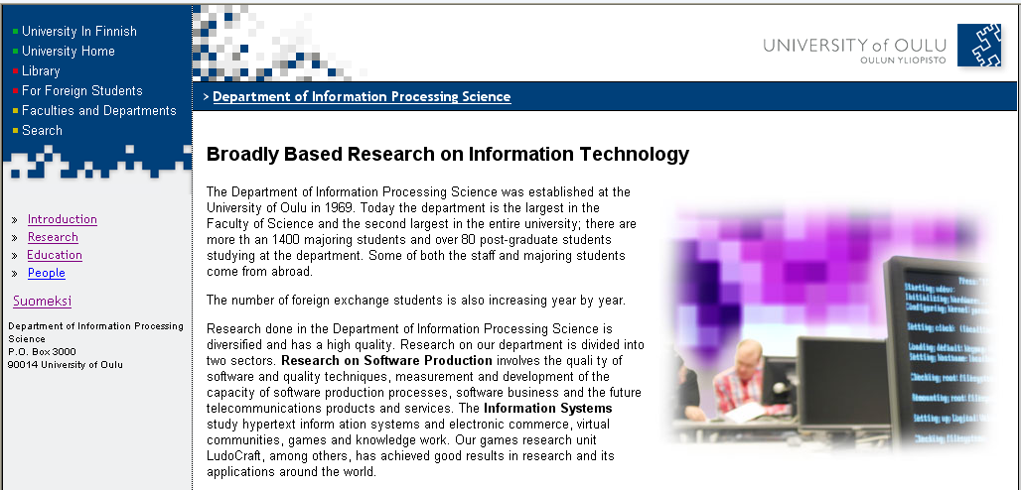
Figure 1. Example of a screen capture. In case of a long caption it is indented by 1.7 cm from the left margin.
According to Finnish Laws, pictures are under legal protection. They must not be copied without permission. There are exceptions such as pictures that consist of statistical information or are produced only from numerical data. If the picture (diagram, photo, screenshot, etc.) is a direct copy from another publication, you must get a permission from author or publisher to use the picture in your work and the picture must be cited properly (Author, year, with permission). If the picture is licensed with copyright licence allowing free distribution of it (e.g. Creative Commons license), you may still have to cite the original author or work. Giving the credit to the original author by citing them is always a good and ethical practice, even if it would not be otherwise required. If for example a diagram is adapted (redrawn and changed) from an existing diagram in another publication, the picture must be cited properly (adapted from Author, year). See the referencing guide.
Again, proper referencing must be followed (see the APA referencing style).
Lists are used when summing issues. In academic writing the use of lists should be minimised. The lists are indented. Also lists must be discussed in the text. Similar to tables and pictures, the interpretation must be given by the author regarding lists, too.
- A list is indented.
- The topics are talked in the body text.
A chapter must not be ended with a list.
A list may also be numbered. In the next list you can see the styles utilised in the guideline.
- ListItem.
- ListItemLast.
- ListItemNumbered.
Every picture and table must be referred in the text. There must be body text both before a picture and after a picture. A chapter may not begin or end with a picture, table or list. Furthermore, there must always be body text between two headings.

Emphasis and citations
Emphasis may be used in case the topic is really significant or it must be separated from the surrounding text. For emphasising, there is a style of Emphasized. It is done by italics.
Direct citations must be made carefully. “Short direct citations can be presented in the body text between quotation marks and including the reference.” (Reference, year, page number). Longer citations (more than two rows of text) are separated by making them as a paragraph and indenting it. It is important to add full references as instructed in the APA style (American Psychological Association, 2019).
“Direct quotes longer than two rows of text are separated by making them as a paragraph and indenting it using Quote style. Remember to also add full reference.” (Author, year, page number)
Direct quotes from interviews should use Quote style regardless of the length of the quote.

Examples of codes and formulas
Code is presented by Courier New with size 10. The code must be numbered and explained in the body text. The number is placed on the right side. Long lists of code should be avoided.
public class B extends A { (1)
public void setProp(String s) {
this.prop = s;
}
private String prop;
}

The style CodeSample is defined for the examples.
Formulas are presented in the body text centred. If possible, general fonts are used. The following is a classic example of a formula.
E = mc² | (1)
The formulas are numbered similar to tables, pictures and code. The number is placed on the right side. The chapter may not begin or end with a formula or code.

Footnotes
Footnotes may be used if they bring true additional value into the text. The references must be listed in the list of references, not in the footnotes. The footnotes may extend the discussion of concepts, for example.
The footnotes are seldom really necessary. Therefore their use should be avoided. Every footnote is numbered and it is presented in the footer of the page it is referred to.

Page numbers
Every page from title page to last appendix is numbered. However, the title page may not show the number. The number is placed 1 cm from upper edge and 2 cm from outer edge.

Contents
The table of contents includes all sections of the thesis from the abstract to the last appendices. The headings are indented so that the left column of the next level is even with previous column (Fig. 2). In the table of contents the line spacing is 1.
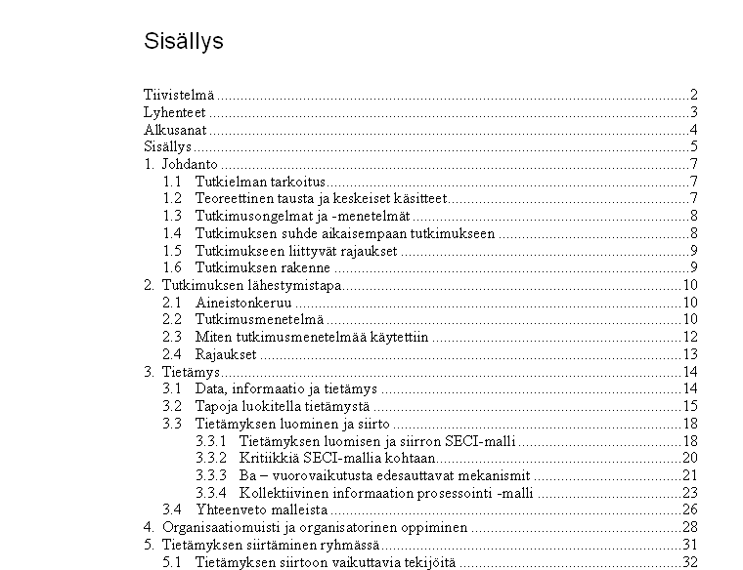
Figure 2. Example of the list of contents.
The table of contents should show only three levels of titles, in maximum. This is valid even if the thesis contains four heading levels. The table is titled by Contents.

Use of References
In the thesis we follow the style introduced by The American Psychological Association (APA). The latest APA style can be found easily in the Internet and some sites provide guides on using APA style, too. See, e.g. https://libguides.murdoch.edu.au/APA and https://owl.purdue.edu/owl/research_and_citation/apa_style/apa_formatting_and_style_guide/general_format.html
As the guideline is written according to the instructions, it enables the students to copy their text (without format) on the document and thus get their text into the right format. The format is to be used in the Bachelor Theses and in the Master’s Theses. In case of other theses, essays or reports it is recommended that the students inquire their teachers if the guideline is to be followed or not.
The use of references includes both referring and building the list of references. In the thesis, the style of references and referencing follows the American Psychological Association version 7. The APA style can be found easily in the Internet and some sites provide a quick guide, too.
Useful APA guides:
https://libguides.murdoch.edu.au/APA
https://owl.purdue.edu/owl/research_and_citation/apa_style/apa_formatting_and_style_guide/general_format.html

Reference style
The APA reference guides how to make different kinds of references. The guide is versatile and if offers guidance about style and grammar matters, as well. Some guidance is available also on APA website.
For example, the instructions guide how to place a reference that refers to a single sentence or to several consecutive sentences. A general rule is that a reference after a paragraph refers to the whole paragraph while a reference at the end of a sentence refers to the one sentence only. In other words, the paragraph is based on the reference that is mentioned at the end of it. It is important to note the place of full stop when referring as it differs according to the usage of reference. The most important rule is that the reader must be aware of where the thought comes from - whether it is from prior literature or from the current study.

The next two examples are equal:
Charness and Boot (2009) mark how bad design in technology is a potential reason to cause fear.
Bad design in technology is a potential reason to cause fear (Charness & Boot, 2009).
Both of the sentences root from one origin that is shown differently in the sentences. Mark the place of the full stop after the parenthesis.
In case of the original paper with its interesting results is not available it is referred as follows “As Lewin (1945) reported in his study on work practices (as cited in Rapoport, 1970), the tasks ...” and the article of Rapoport is listed in the references.
The next paragraph shows how several sentences are referred to in the end of a paragraph. Mark the omission of the full stop in the reference in the end of the paragraph:
Avison et al. (1999) classify action research as a distinct qualitative research method because it links research and practice. Action research is argued to be ideal for studying information systems in practice because it serves different interests and it offers good means to improve practice in general. While action research combines theory and practice, it combines also researchers and practitioners through change and reflection. (Avison et al., 1999)
In case of a specific section (table, picture, list) it is necessary to enter the page number in the reference, for example (Lewis & Loftus, 2000, p. 185). In addition, if the section in the original source being cited is difficult to find, the page number is recommended in the reference.
If you want to cite multiple references for the same
Table 2 clarifies how to use ‘et al.’ in the thesis when citing references with many authors:
Table 2. Use of ‘et al.’ in the body text (Lee, n.d.).
Number of authors | Citations in parenthesis | Citations as part of text
Two | (Palmer & Roy, 2008) | Palmer and Roy (2008)
Three or more | (Sharp et al., 2007) | Sharp et al. (2007)

As shown in Table 2, two authors are always listed. If there are more than six authors, only the first author is informed in the citations. A special note regarding the list of references: if there are more than six authors only the first six authors are listed followed by three full stops …; and then the name of the last author is listed. (See the examples in the next chapter.)

References
The list of references is presented alphabetically according to the latest APA reference style. Line spacing is 1. The chapter is one of the main chapters (style Heading0) but it is not numbered.
It is wise to generate the list of references with the help of reference management tool, such as RefWorks. However, it is not uncommon that some items in the reference list generated by such tool need further editing to meet the required APA standard.
As described in the APA reference style, the article types influence the formatting of the reference. You can find good practical guides on how to apply the APA reference style from the Internet, e.g. https://libguides.murdoch.edu.au/APA is a nice short guide. Always use the latest version of the APA reference style. Next, some examples are given:
Book:
Gamma, E., Helm, R., Johnson, R., & Vlissides, J. (1995). Design patterns: Elements of reusable object-oriented software. Boston, MA, USA: Addison-Wesley Longman Publishing.
Halonen, R. (2012). Online discussion forum as a means of peer support. In N. Wickramasinghe, R. Bali, R. Suomi, & S. Kirn, S. (Eds.), Critical issues for the development of sustainable E-health solutions (pp. 149-161). New York, USA: Springer.
Journal article:
May, D., & Taylor, P. (2003). Knowledge management with patterns. Communications of the ACM, 46(7), 94-99.
Eerola, T., Lensu, L., Kalviainen, H., Kamarainen, J.-K., Leisti, T., Nyman, G., ... Oittinen, P. (2010). Full reference printed image quality: Measurement framework and statistical evaluation. Journal of Imaging Science and Technology 54(1), 1-13.
Conference article:
Beck, K., Coplien, J. O., Crocker, R., Dominick, L., Meszaros, G., Paulisch, F., & Vlissides, J. (1996). Industrial experience with design patterns, Proceedings of the 18th International Conference on Software Engineering, 103-114.
Suhonen, K., Vaataja Heli, Virtanen, T., & Raisamo, R. (2008). Seriously fun: Exploring how to combine promoting health awareness and engaging gameplay. Proceedings of the 12th International Conference on Entertainment and Media in the Ubiquitous Era, Tampere, Finland. 18-22. doi: 10.1145/1457199.1457204
Internet article:
Farah, J. (2006). CM: The Next Generation - Agile Configuration Management. Retrieved January 5, 2007, from http://www.cmcrossroads.com/content/view/ 6761/202/
Specifically, no full stop is needed after the entry in case of Internet address.
Please note that even if the examples were given separately divided by the publication type (book, article, etc.) the total list of references must appear alphabetically as guided earlier.

References
American Psychological Association. (2019). Publication manual of the American Psychological Association (7th ed.). Washington, DC: American Psychological Association.
Borrego, M., Douglas, E. P., & Amelink, C. T. (2009). Quantitative, qualitative, and mixed research methods in engineering education. Journal of Engineering Education, 98(1), 53-66.
Hirsjärvi, S., Remes, P., & Sajavaara, P. (2004). Tutki ja kirjoita (10. osin uud. laitos). Helsinki: Tammi. (In Finnish)
Järvinen, P. (2001). On research methods. Tampere: Opinpajan kirja.
Kinnunen, M., & Löytty, O. (2002). Tieteellinen kirjoittaminen. Tampere: Vastapaino. (In Finnish)
Klein, H. K., & Myers, M. D. (1999). A set of principles for conducting and evaluating interpretive field studies in information systems. MIS Quarterly, 23(1), 67-94.
Kitchenham, B. (2004). Procedures for performing systematic reviews. Technical Report.TK/SE-0401, Keele University, and Technical Report 0400011T.1, NICTA.
Lee, C. (n.d.). The proper use of et al. in APA style. Retrieved June 19, 2014 from http://blog.apastyle.org/apastyle/2011/11/the-proper-use-of-et-al-in-apa-style.html
Peffers, K., Tuunanen, T., Rothenberger, M. A., & Chatterjee, S. (2007). A design science research methodology for information systems research. Journal of management information systems, 24(3), 45-77.
Swales, J.M., & Feak, C.B. (1996). Academic writing for graduate students. Essential tasks and skills. Michigan: University of Michigan Press.
Viljanen, E. (1986). Tutkielman tekeminen. Helsinki: Otava. (In Finnish)

Appendix A. The styles used in the document
Style | Font | Usage | Note
Title | Arial 20 | The main title. | Bold
Subtitle | Arial 18 | The sub title (if needed).
AuthorInformation | Times New Roman 12 | Author details on the cover sheet.
Keywords | Arial 12, Italics | Title for keywords.
Heading0 | Arial 18 | Title for foreword, abstract, contents, abbreviations, references and appendices. | No numbering
Heading1 | Arial 18 | Main chapter. Begins on a new page.
Heading2 | Arial 14 | Second level title.
Heading3 | Arial 14 | Third level title.
Heading4 | Arial 12, Italics | Fourth level title. | No numbering,  not recommended.
Normal | Times New Roman 12 | Body text.
Emphasized | Times New Roman 12, Italics | Emphasised text in Italics.
FigureCaption | Arial 10 | Title for picture.
TableCaption | Arial 10 | Title for table.
TableHeader | Arial 10, Bold | Title cells in table.
TableText | Times New Roman 10 | Text cells in table.
ListItem | Times New Roman 12 | List item.
ListItemLast | Times New Roman 12 | Last item in a list.
ListItemNumbered | Times New Roman 12 | Numbered item in a list.
CodeSample | Courier New 10 | Example of code.
Quote | Times New Roman 12, Italics, Indented | Direct quotation longer than two rows

http://apastyle.apa.org/

