Contents

1. Create database 1

Create database by using statement. 1

Create database by graphic tool 2

Create database by using a template 3

2. Rename a database 6

Rename database by using statement 6

Rename database by graphic tool 6

3. Drop a database 7

Drop database by using statement 7

Drop database by using graphic tool. 7

# Create database

We can create a database by one of following way:

## Create database by using statement.

- In the SSMS enters following statement and clicks **Execute.** A database named CMC_TRAINING will be created.

USE master

IF EXISTS(SELECT * from sys.databases WHERE name='CMC_TRAINING')

DROP DATABASE CMC_TRAINING

CREATE DATABASE CMC_TRAINING

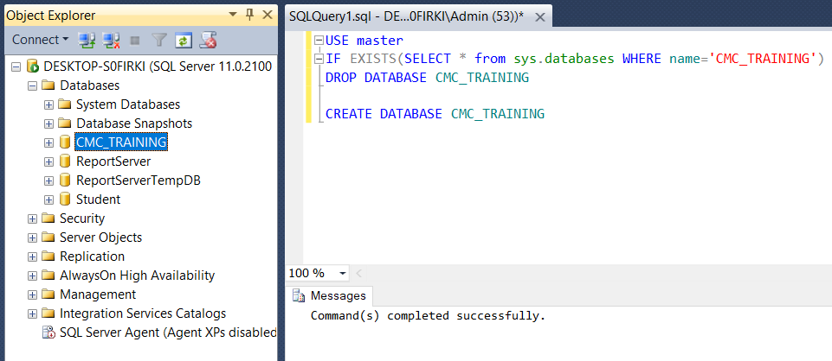

## Create database by graphic tool

- In **Object Explorer**, right clicks on **Database** and choose **New Database...**

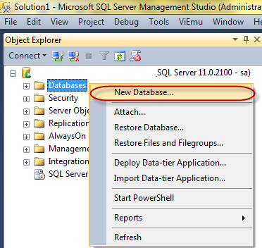

- In the **New Database** dialog, enter CMC_Training in the **Database name** textbox.

We can change location for mdf and ldf file in **database files**

Each database has at least one mdf file

ldf file is a transaction log file. In real world, we should store mdf and ldf in the separate hard disk drive.

Click **OK** button to create the database

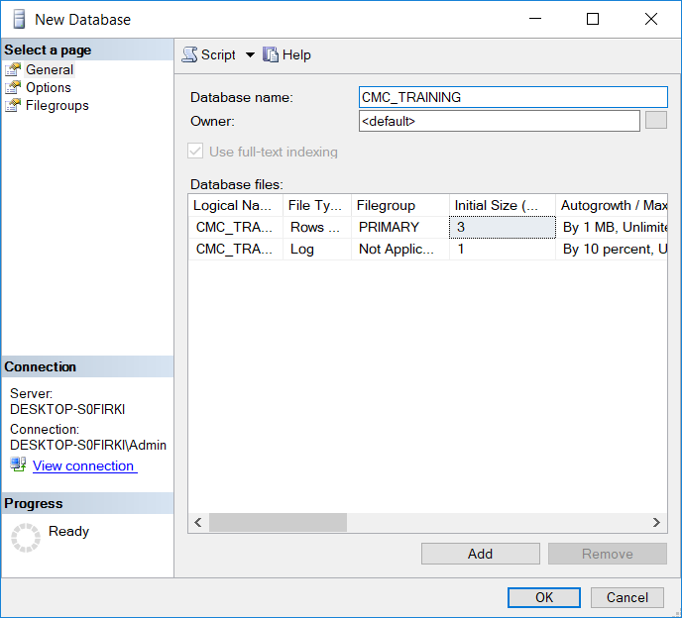

## Create database by using a template

- Choose **Template Explorer** in the **View** menu

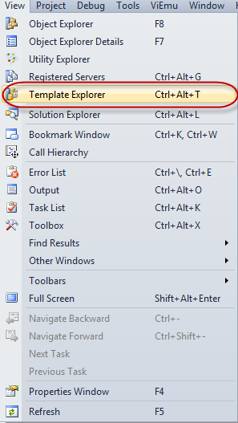

- Double click on **Create Database** under **Database** folder

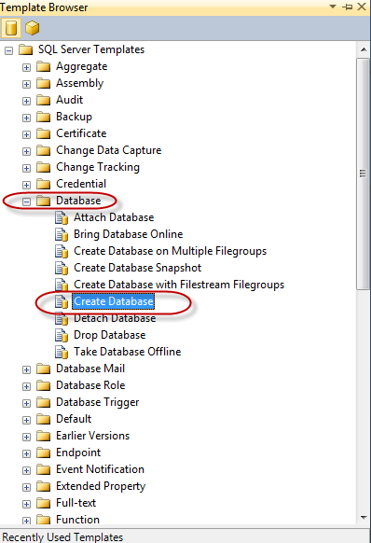

- Just enter database name in the script and run **Execute** as below

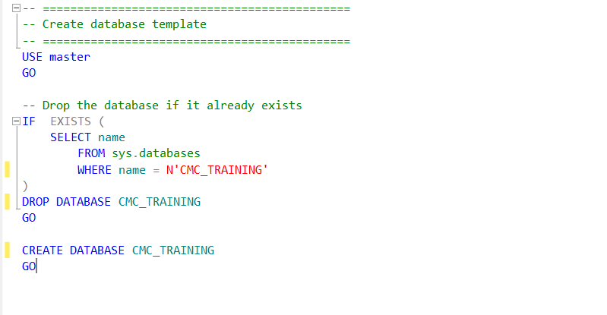

# 2. Rename a database

## Rename database by using statement

- Use the below statement in order to rename the database.

USE master;

GO

ALTER DATABASE CMC_Training

Modify Name = CMC_Training2 ;

GO

## Rename database by graphic tool

- In the **Object Explorer**, right click on the database and choose **Rename**

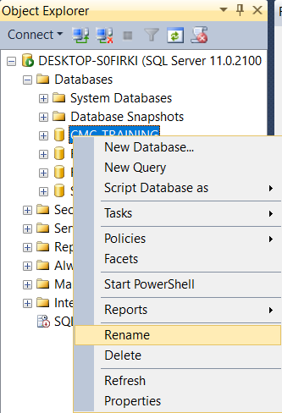

# 3. Drop a database

## Drop database by using statement

- Copy and Paste below statement and click **Execute**

USE master

GO

DROP DATABASE CMC_TRAINING

GO

## Drop database by using graphic tool.

- Right click on the database and choose **Delete**

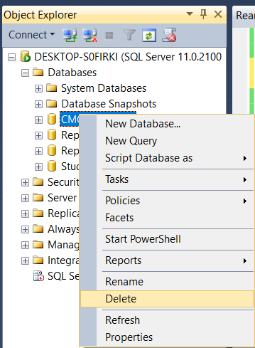

- In the **Delete Object** dialog, make sure **Close existing connections** is checked and then click **OK**

