# This demo will create 2 schema called GDP1 and Instore

1. Step1: Right click on **Schemas** in **Security** of CMC_Training database and choose **New Schema...**

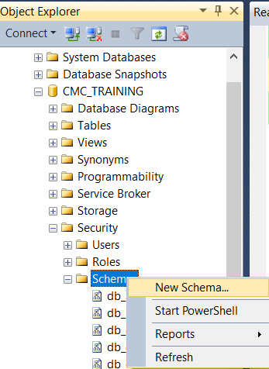

1. In **Schema** dialog enter GDP1 in **Schema** name textbox and click **OK**

