Contents

1. Create basic table 1

Create a table by using statement 1

Create a table by using a template 2

Create a table by using graphic tool 2

2. Table Constraints 3

Table Level 3

Using graphic tool 3

Using statement 10

Column Level 11

3. Table Indexes 11

4. Identity demo 12

Using Graphic tool 12

Using statement 13

Code Sample 13

5. Truncate Demo 14

# Create basic table

This demostrates creating a table (without constraints, index...) by using statement or template or graphic tool.

## Create a table by using statement

- Enter below statement in query editor and click **Execute**

CREATE TABLE Employee(

EmployeeID int

, FirstName nvarchar(100)

, LastName nvarchar(100)

, NationalIDNumber nvarchar(15)

, ManagerID int

, Title nvarchar(50)

, BirthDate datetime

, MaritalStatus nchar(1)

, Gender nchar(1)

, IsDeletedFlag bit

)

## Create a table by using a template

- Double click **Create Table** under **Table** folder in **Template Browser**

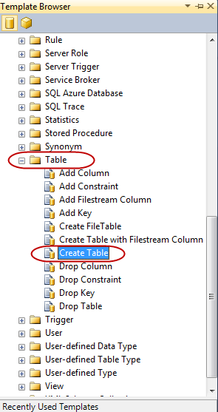

- In the template we can write statement to create a table

## Create a table by using graphic tool

- Right click on **Tables** and choose **New Table...**  
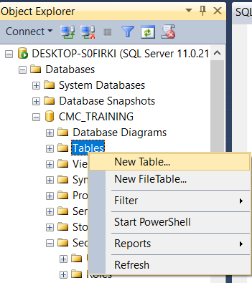

- In the designer, enter table columns in **Column Name**, choose **Data Type** from combobox as below

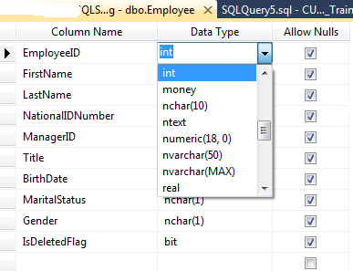

# Table Constraints

This demo show you the way create constraints as NOT NULL, CHECK, UNIQUE, PRIMARY KEY, DEFAULT, FOREIGN KEY.

## Table Level

### Using graphic tool

* Create **NOT NULL** constraint

- Right click on Employee table that created in the previous demo and choose **Design**

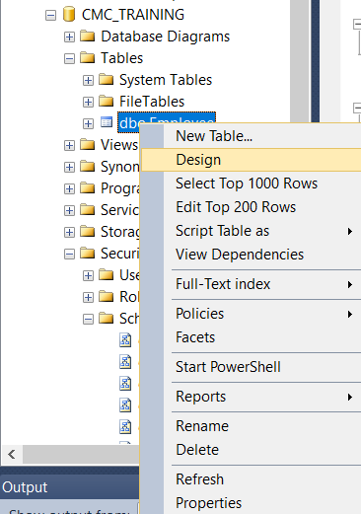

- In the Designer uncheck **Allow Nulls** for EmployeeID, FirstName, LastNAme, NationalIDNumber, BirthDate, Gender and IsDeletedFlag. This means these columns are not null. Then click **Save**

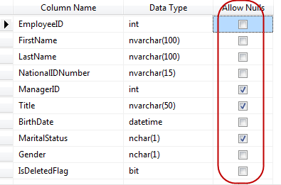

- If we try to insert a NULL value into one of these columns we will get error as below

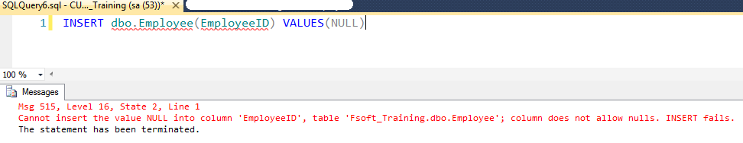

* Create **CHECK** constraint

We enforce MaritalStatus is 'S' (Single) or 'M' (Married)

- Right click on MartialStatus and choose **Check Constraints...**

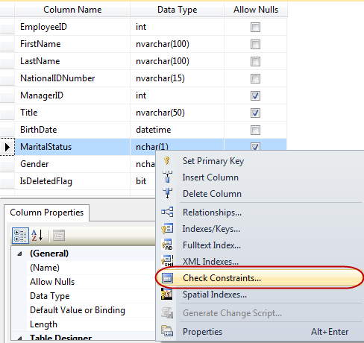

- In Check Constraints dialog, click **Add** buton then enter CK_MaritalStatus as constraint **Name**, and enter MaritalStatus = 'M' OR MaritalStatus = 'S' into **Expression**. click **Close** and then **Save** button

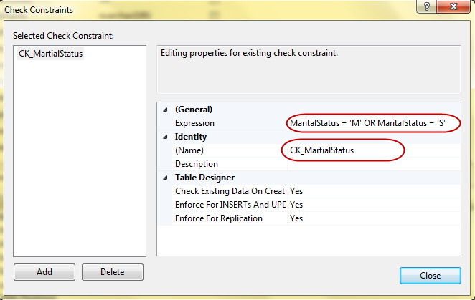

* Create **UNIQUE** constraint

We are going to make NationalIDNumber as unique column.

- Right click on NationalIDNumber and choose **Indexes/Keys...**

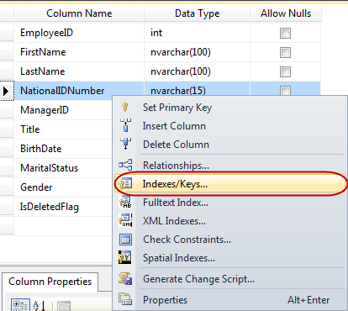

- In **Selected Primary/ Unique Key or Index** dialog, click **Add** button and then choose Unique Key as **Type** and enter IX_Employee_NationalIDNumber as **Name.** Click **Close** button and choose **Save**

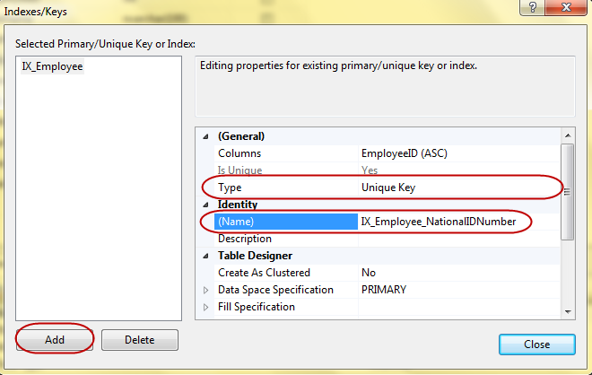

* Primary Key

We will set EmployeeID as primary key for this table.

- Right click on EmployeID and choose **Set Primary Key**, then click **Save**

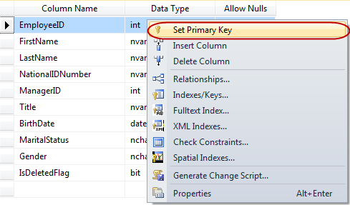

* Create **Default Value** constraints

We'll set 0 as default value for IsDeletedFlag

- Click on IsDeletedFlag column, in the **Column Properties**, enter 0 into **Default Value or Binding**. Click **Save** button

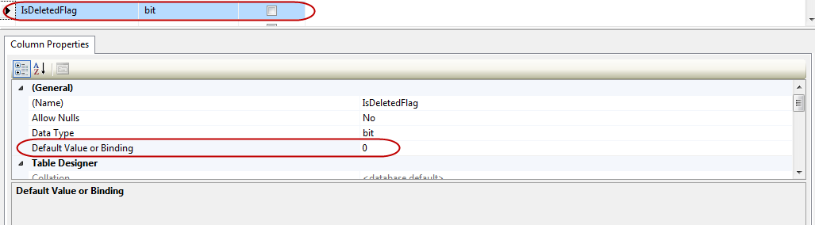

* Create **Foreign Key** constraint

We will a foreign key on ManagerID

- Right click on ManagerID and choose **Relationships...**

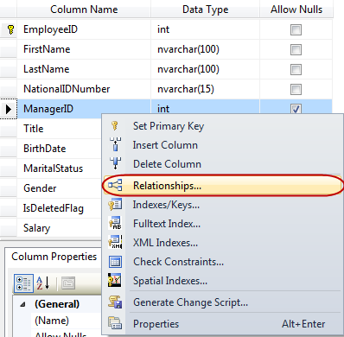

- Click **Add** and rename to FK_Employee_ManagerID, choose **Foreign Key Base Table** as Employee, **Foreign Key Columns** is EmployeeID click **Save**

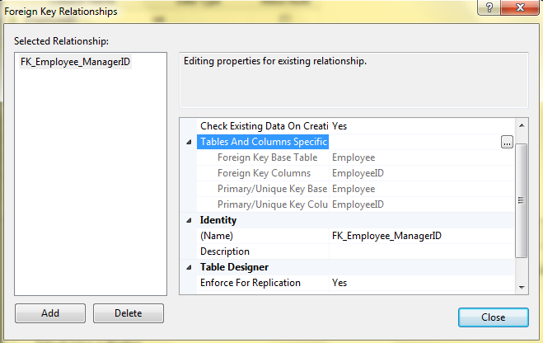

### Using statement

We can create the Employee and its constraints... by using below statement.

USE [CMC_Training]

GO

CREATE TABLE [dbo].[Employee](

[EmployeeID] [int] IDENTITY(1,1) NOT NULL,

[FirstName] [nvarchar](100) NOT NULL,

[LastName] [nvarchar](100) NOT NULL,

[NationalIDNumber] [nvarchar](15) NOT NULL,

[ManagerID] [int] NULL,

[Title] [nvarchar](50) NULL,

[BirthDate] [datetime] NOT NULL,

[MaritalStatus] [nchar](1) NOT NULL,

[Gender] [nchar](1) NOT NULL,

[IsDeletedFlag] [bit] NOT NULL,

[Salary] [decimal](19, 4) NULL,

CONSTRAINT [PK_Employee] PRIMARY KEY CLUSTERED

(

[EmployeeID] ASC

)WITH (PAD_INDEX = OFF, STATISTICS_NORECOMPUTE = OFF, IGNORE_DUP_KEY = OFF, ALLOW_ROW_LOCKS = ON, ALLOW_PAGE_LOCKS = ON) ON [PRIMARY],

CONSTRAINT [IX_Employee_NationalIDNumber] UNIQUE NONCLUSTERED

(

[EmployeeID] ASC

)WITH (PAD_INDEX = OFF, STATISTICS_NORECOMPUTE = OFF, IGNORE_DUP_KEY = OFF, ALLOW_ROW_LOCKS = ON, ALLOW_PAGE_LOCKS = ON) ON [PRIMARY]

) ON [PRIMARY]

GO

ALTER TABLE [dbo].[Employee] ADD CONSTRAINT [DF_Employee_IsDeletedFlag] DEFAULT ((0)) FOR [IsDeletedFlag]

GO

ALTER TABLE [dbo].[Employee] WITH CHECK ADD CONSTRAINT [FK_Employee_ManagerID] FOREIGN KEY([EmployeeID])

REFERENCES [dbo].[Employee] ([EmployeeID])

GO

ALTER TABLE [dbo].[Employee] CHECK CONSTRAINT [FK_Employee_ManagerID]

GO

ALTER TABLE [dbo].[Employee] WITH CHECK ADD CONSTRAINT [CK_MartialStatus] CHECK (([MaritalStatus]='M' OR [MaritalStatus]='S'))

GO

ALTER TABLE [dbo].[Employee] CHECK CONSTRAINT [CK_MartialStatus]

GO

## Column Level

Suppose, we only have Employee table from **Create basic table** demo (its means the table without constraints...)

* Create **NOT NULL** constraint

ALTER TABLE [dbo].[Employee]

ALTER COLUMN BirthDate DATETIME NOT NULL

GO

* Create **CHECK** constraint

ALTER TABLE [dbo].[Employee]

ADD CONSTRAINT [CK_MartialStatus] CHECK (([MaritalStatus]='M' OR [MaritalStatus]='S'))

GO

* Create **Default Value** constraints

ALTER TABLE [dbo].[Employee]

ADD CONSTRAINT [DF_Employee_IsDeletedFlag] DEFAULT ((0)) FOR [IsDeletedFlag]

GO

* Create **Foreign Key** constraint

ALTER TABLE [dbo].[Employee] WITH CHECK ADD CONSTRAINT [FK_Employee_ManagerID] FOREIGN KEY([EmployeeID])

REFERENCES [dbo].[Employee] ([EmployeeID])

GO

# Table Indexes

We are going to create index for ManagerID column.

- Right click on ManagerID and choose **Indexes / Keys...**

- In the **Indexes / Keys** dialog choose **Columns** as ManagerID, **Type** as Index and **Save**

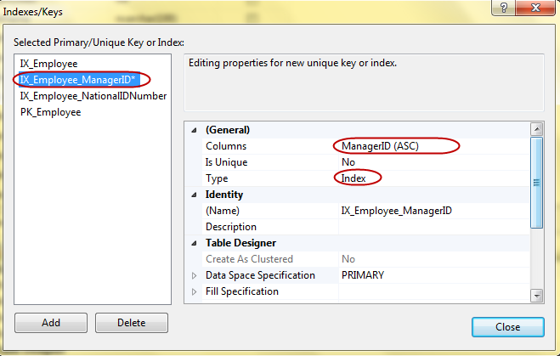

# Identity demo

In this demo, we will create identity for EmployeeID column.

## Using Graphic tool

- Click on EmployeeID and in **Column Properties** choose Yes for Identity Specification. You also can choose **Identity Increment** and **Identity Seed.** Click **Save** button

## 

## Using statement

ALTER TABLE dbo.Employee

ADD EmployeeID INT IDENTITY(1,1)

## Code Sample

Suppose, we insert 2 records into Employee table without specific EmployeeID as below

USE CMC_Training

GO

INSERT dbo.Employee (FirstName, LastName, NationalIDNumber, ManagerID, Title, BirthDate, MaritalStatus, Gender)

VALUES ('Bill', 'Gates', '123456', NULL, 'CEO', '1959-01-01', 'M' , 'M')

INSERT dbo.Employee (FirstName, LastName, NationalIDNumber, ManagerID, Title, BirthDate, MaritalStatus, Gender)

VALUES ('Steve', 'Jobs', '123456', NULL, 'CEO', '1963-01-01', 'M' , 'M')

You can see EmployeeID is automatically increase.

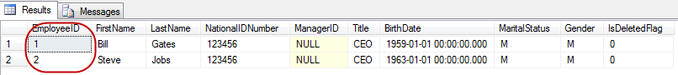

# Truncate Demo

- Copy and paste following statement and Executes

TRUNCATE TABLE [dbo].[Employee]

- Then, re-insert a record into Employee table

INSERT dbo.Employee (FirstName, LastName, NationalIDNumber, ManagerID, Title, BirthDate, MaritalStatus, Gender)

VALUES ('Bill', 'Gates', '123456', NULL, 'CEO', '1959-01-01', 'M' , 'M')

- You can see EmployeeID is reseted now



- Press Alt + F1 on the table, all table structures are still remain.

