**PWM**

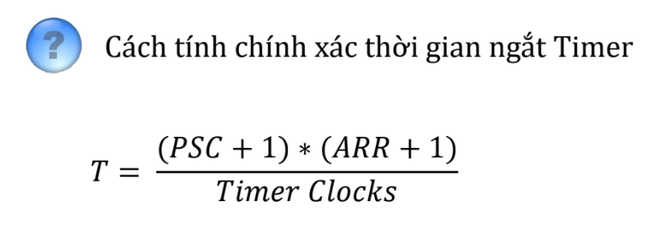

Chọn PSC = 79, ARR=1999, f_clock = 8MHz🡺tần số PWM = 8000000/(80*2000)=50Hz

ARR(**AutoReload Register**) = 1999 🡺 htimX.Instance->CCR1 = 1990*duty (duty: 0->1)

PWM1: timer3, PWM2: timer4

**Timer ngắt chu kì lấy mẫu**

Chọn chu kì lấy mẫu là 10ms=0,01s🡺chọn PSC = 799, ARR=99, F_clock = 8Mhz

Timer1

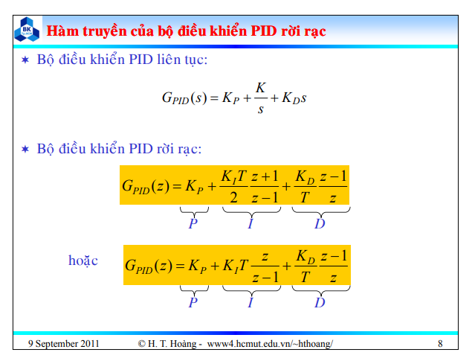

https://www.forum.payitforward.edu.vn/threads/1551/

Code:

P_part = Kp*(Error - pre_Error);

I_part = 0.5*Ki*T*(Error + pre_Error);

D_part = Kd/T*( Error - 2*pre_Error+ pre_pre_Error);

Out = pre_out + P_part + I_part + D_part ;

pre_pre_Error = pre_Error

pre_Error = Error

pre_Out = Out