Implement functions described in homework I and II in the library header file named GenSLL.h. Then desmonstrate them through the home work III (which include “GenSLL.h”)

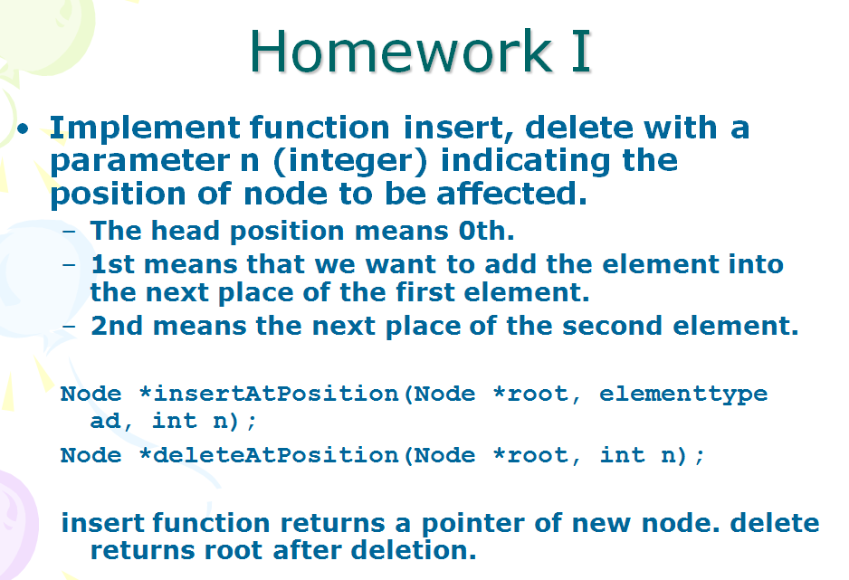

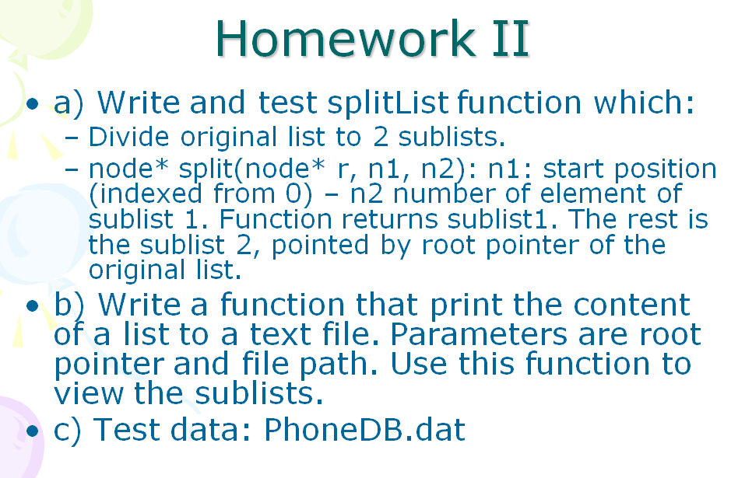

**HOMEWORK III (Just use the Singly Linked List)**

