Overview

Overview
Artificial intelligence is proliferating new business grounds with impressive success. One of the key factors contributing to AI’s effective implementation is the availability of agile and dynamic libraries like TensorFlow.
Posenet is one of TensorFlow applications. It is a vision model that can be used to estimate the pose of a person in an image or video by estimating where key body joints are.
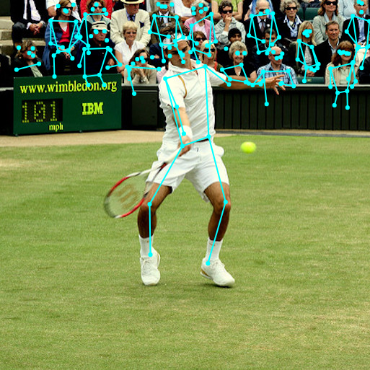

Pose estimation has many uses, from interactive installations that react to the body to augmented reality, animation, fitness uses, and more.

Summary
This document give the detail report about:
- Prepare environment to build Posenet app on RZ/G2E board
- Implement Posenet on RZ/G2E board
- Output result
- Issue and restriction
- Future features

Terminology
The following table shows the terminology related to this module.
Table 2.1 Terminology
Terms | Explanation
BSP | Board support package
tf | Tensorflow
tflite | Tensorflow lite
tfjs | Tensorflow json
SDK | Software Development Kit

Operating environment

Background
This section lists all required hardware, software to build and run Posenet app.

Hardware Environment
The following table lists the hardware needed to use posenet app.
Table 3.1 Hardware Environment
Name | information
RZ/G2E EK874 board | Revision 3
RZ/G2E CPU | Arm Cortex A53 Dual MPCore 1.2 GHz
Camera output | Resolution: 640x480
Linux PC | Core i5, RAM 8GB

Software Environment
The following table lists software needed to use posenet app.

Table 3.2 Software Environment
Name | Version
onnx | 1.7
onnxruntime | 1.0.0 or 1.4.0
tflite2onnx | 0.2.0
opencv | 4.1.1
BSP for RZ/G2E board | 1.0.4

Attached items
This document will attach below items:
Table 3.3 Attached Items
Name | summary
model_conversion.zip | model conversion tool
opencv_4.1.1.bb | Recipe file for opencv
0001-Update-maximum-number-of-supported-camera-from-8-to-.patch | Patch file for opencv
posenet_camera.zip | Source code of Posenet camera app
environment_conversion.txt | List of software and version
cam_output_129x129.avi | Result with input size 129x129
cam_output_257x257.avi | Result with input size 257x257
cam_output_513x513.avi | Result with input size 513x513

Model conversion

Background
PoseNet is application of TensorFlow. Currently, ONNX has no official model converted from TensorFlow, so need to use model conversion tool to convert tf model to onnx model.

Required software for model conversion tool
For running conversion tool, need to install required software on Linux PC.
Copy environment_conversion.txt file in attachment folder and run below command to install required software:
# pip install -r environment_conversion.txt

Working flow of model conversion tool:
- Download tfjs models (.json file)
- Convert tfjs models to tf models (.pb file)
- Convert tf models to tflite models (.tflite file)
- Convert tflite models to onnx models (.onnx file)

Usage of model conversion tool

Get instruction by running following command:
Command to get instruction as below:
# python3 convert.py --hint True

Currently, convert tool support below:

- model: mobilenet
- stride: 8 or 16
- Image size width = image size height, (width - 1) should be divisible by stride
  - Example: when we select stride = 16, width and height should be selected as below: width = height = X and (X - 1) % 16 should be 0, so we can choose X = 257 or 129 or 513.

Command for model conversion:
Command to convert model as below:
# python3 convert.py --model mobilenet --stride <stride> --tensor_size <1 x 3 x width x height>

Example command with stride = 16, width = height = 129
# python3 convert.py --model mobilenet --stride 16 --tensor_size 49923

Example command with stride = 16, width = height = 257
# python3 convert.py --model mobilenet --stride 16 --tensor_size 198147

Example command with stride = 16, width = height = 513
# python3 convert.py --model mobilenet --stride 16 --tensor_size 789507

Output of model conversion tool:
After run conversion command, the output of this tool is onnx model
Example output with stride = 16, width = height = 129
- mobilenet_stride16_imagesize129.onnx
Example output with stride = 16, width = height = 257
- mobilenet_stride16_imagesize257.onnx
Example output with stride = 16, width = height = 513
- mobilenet_stride16_imagesize513.onnx
Note: For more information about model architecture converted. Please check below link
https://storage.googleapis.com/tfjs-models/savedmodel/posenet/mobilenet/float/100/model-stride8.json
https://storage.googleapis.com/tfjs-models/savedmodel/posenet/mobilenet/float/100/model-stride16.json

Yocto build environment for PoseNet App

Background
This section gives instruction to prepare environment to build and run Posenet app.
Building Yocto environment to run RZ/G2E board
Building SDK environment to build Posenet app

Package for Yocto environment
Prepare following directories with commit in Yocto directory
Table 6.1 Package for Yocto build
Package | commit
meta-gplv2 | f875c60ecd6f30793b80a431a2423c4b98e51548
meta-linaro | 75dfb67bbb14a70cd47afda9726e2e1c76731885
meta-openembedded | 352531015014d1957d6444d114f4451e241c4d23
meta-qt5 | c1b0c9f546289b1592d7a895640de103723a0305
poky | 7e7ee662f5dea4d090293045f7498093322802cc
meta-rzg2 | 254953bd4f3f263f826d2208c82e7ad895bbaaa7
meta-renesas-ai | 09461265862253e24215473cb8c66ea49c8ee09d

Patch file for opencv
When running RZ/G2E board with camera, the device name of camera is /dev/video8 (It is 9th video). Maximum number of supported camera on opencv version 4.1.1 is 8. So it get error while opencv cannot get the output of camera. Patch file is used to extend video device number.
Replace current opencv_4.1.1.bb in meta-renesas-ai/meta-rzg-ai/recipes-support/opencv by our opencv_4.1.1.bb include patch file for extending camera device number.
Note: opencv_4.1.1.bb and 0001-Update-maximum-number-of-supported-camera-from-8-to-.patch in the attached folder.

Build Yocto procedure
Run below commands to prepare environment for building Yocto and SDK:
# source poky/oe-init-build-env
# cp ../meta-renesas-ai/meta-onnxruntime/templates/ek874/* conf/
# ln -sf /data2/downloads

Update below variables in conf/local.conf
- BB_NO_NETWORK = "1“
- IMAGE_INSTALL_append = "onnxruntime-staticdev onnxruntime-dev onnxruntime-examples opencv opencv-samples libopencv-core libopencv-imgproc libopencv-photo libopencv-imgcodecs libopencv-videoio libopencv-highgui“

Run below commands to build Yocto and SDK:
# bitbake core-image-weston
# bitbake core-image-weston-sdk -c populate_sdk

Output environment

Image
Environment for G2E board in below directory:
- build/tmp/deploy/images/

SDK
SDK toolchain in below directory:
- build/tmp/deploy/sdk/poky-glibc-x86_64-core-image-weston-sdk-aarch64-toolchain-2.4.3.sh
Run the SDK toolchain and enter target directory for SDK environment
# ./ build/tmp/deploy/sdk/poky-glibc-x86_64-core-image-weston-sdk-aarch64-toolchain-2.4.3.sh

Example for entering target directory: /data2/hoaphan/onnxruntime2/sdk

Build PoseNet app

Background
This section gives guideline to build Posenet app

Steps to build Posenet app
Extract the posenet_camera.zip to Linux PC
Source SDK environment before building posenet app
Example command to source SDK environment:
# source /data2/hoaphan/onnxruntime2/sdk/environment-setup-aarch64-poky-linux

Run below command to build posenet app:
#make

After building Posenet app, there is Posenet app as below:
- /poseNet_camera

Usage of PoseNet app

Background
This section gives guideline to use Posenet app

Required environment

Hardware environment:
RZ/G2E board (run with image and rootfs from 5.1.1)
Camera: All kind of camera that RZ/G2E can support. For detail information, refer 3.2

Software environment:
Copy Posenet app from step 6.2 to folder in RZ/G2E board
Example location: /posenet_camera/poseNet_camera
Copy onnx model from converting model step to folder in RZ/G2E board as below structure:
posenet_camera
|--------models/<onnx model>
|--------poseNet_camera
Example:
posenet_camera_cpp
|--------models/mobilenet_stride16_imagesize257.onnx
|--------poseNet_camera

Option run of PoseNet app

List all supported model of Posenet
To list all supported model of posenet, run below command:
# ./poseNet_camera –a

Instruction of posenet app
To get the instruction of posenet app, run below command:
# ./poseNet_camera –h

Select model architecture
-model <model architecture>
There are 2 model architecture:
- Mobilenet
- Resnet50 (not support)
Currently, Posenet app support mobilenet architecture only

Select model index
-model_index <model index>
Posenet app support 3 model as below:
Model 1:
Stride: 16
Input image size: 129x129
Input tensor size: 49923
Model 2:
Stride: 16
Input image size: 257x257
Input tensor size: 198147
Model 3:
Stride: 16
Input image size: 513x513
Input tensor size: 789507

Select camera index
-cam_index <camera index>
Check the device name of camera on board to update cam_index variable
Example: /dev/video<camera index>

Enable/disable measure time and print poses score
Base on demand, user can enable or disable measure time and print poses score as below variable:
-measure_time <option>
-print_poses_score <option>
<option> = 1 to enable
<option> = 0 to disable

Example command:
# ./poseNet_camera -model mobilenet -model_index 2 -cam_index 8 -measure_time 0 -print_poses_score 0

Output result

Background
This section gives output of running Posenet app and the performance judgement.

Output

Output result of model 1 (MobileNet, stride: 16, image size: 129x129)
Video file: cam_output_129x129.avi
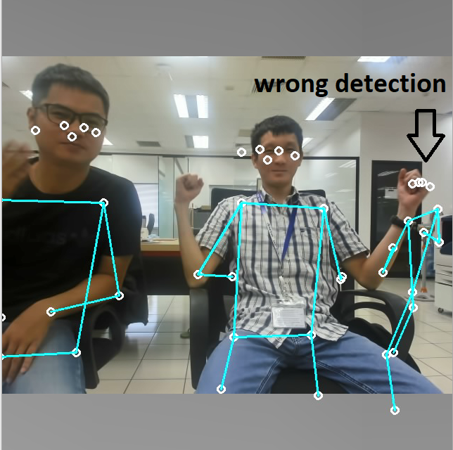
Image capture:

Output result of model 2 (MobileNet, stride: 16, image size: 257x257)
Video file: cam_output_257x257.avi
Image capture:
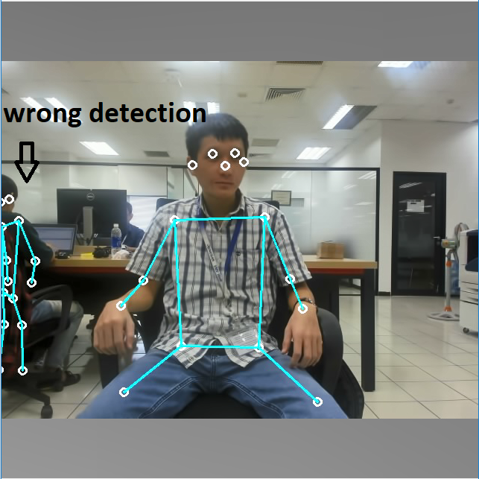

Output result of model 3 (MobileNet, stride: 16, image size: 513x513)
Video file: cam_output_513x513.avi
Image capture:
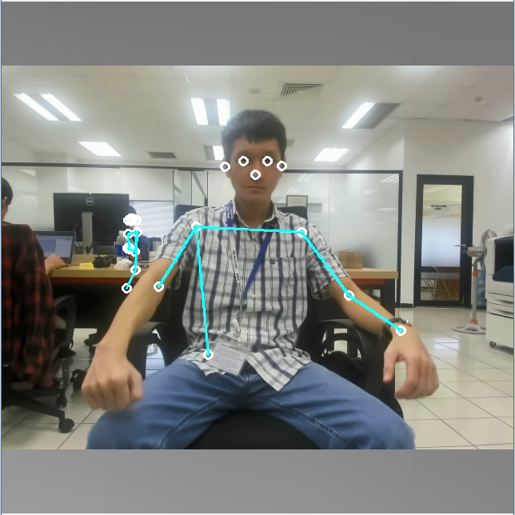

Performance measurement
Below table show performance report for posenet app with difference model
Table 9.1 performance
model | MobileNet (129 x 129) | MobileNet (257 x 257) | MobileNet (513 x 513)
Preprocessing (ms) | 61.255 | 55.617 | 93.41
Run model (ms) | 239.39 | 793.026 | 2784.874
Postprocessing (ms) | 29.616 | 23.624 | 30.34
Total (ms) | 330.261 | 872.267 | 2908.624
Frame per second (FPS) | 3.02790823 | 1.14643796 | 0.343805181
Speed | high | mid | low
Correctness | low | mid | high

Issues and solutions

Background
This section lists all issues in the development process of Posenet app.

Can not convert TensorFlow models with dynamic shape
Description: Can’t convert Tensor Flow model with dynamic shape to ONNX model. In this case, converted models architecture are MobileNet and ResNet.
Working flow of model conversion:
- Get tfjs model from TF hub (file .json)
- Convert tfjs to saved model format (file .pb)
- Use tfonnx tool to convert saved model to onnx format (https://github.com/onnx/tensorflow-onnx)
- Use ONNX Runtime to load and run converted model.
Issue: Get error in class ONNX Runtime::ComputePadAndOutputShape

Root cause: there are some limitations in conversion between Tensorflow and ONNX, especially for dynamic shape
Solution: Set input shape of model to fixed value. Dynamic input shape model is changed to static input shape model.
Example:
Table 10.1 input shape
 | Model with dynamic shape | Model with static shape | Note
Input shape | [1, -1, -1, 3] | [1, 513, 513, 3] | The value -1 will be replace with dynamic value when running model
Input shape | [1, -1, -1, 3] | [1, 257, 257, 3]
Input shape | [1, -1, -1, 3] | [1, 129, 129, 3]

Working flow of model conversion with Solution:
- Get tfjs model from TF hub (file .json)
- Convert tfjs to saved model format (file .pb)
- Convert saved model format to TFLite with input shape specified [1, 513, 513, 3] or [1, 257, 257, 3] or [1, 219, 219, 3]
- Use tflite2onnx Python library (https://pypi.org/project/tflite2onnx) to convert TFLite to ONNX format
- Use ONNX Runtime to load and run converted model.
Note:
- We can’t use tf2onnx due to it requires saved model format (.pb) as input. But saved model format can’t set input shape with specified.
- The counter measure just apply for MobileNet. About ResNet we have another issue described in next page (10.2).

Can not convert ResNet model with static shape
Description: Can’t convert ResNet model with static shape
Working flow of model conversion with counter measure:
- Get tfjs model from TF hub (file .json)
- Convert tfjs to saved model format (file .pb)
- Convert saved model format to TFLite with input shape specified [1, 513, 513, 3] or [1, 257, 257, 3] or [1, 219, 219, 3]
- Use tflite2onnx Python library (https://pypi.org/project/tflite2onnx) to convert TFLite to ONNX format
- Use ONNX Runtime to load and run converted model.
Issue: Get error when convert TFLite to ONNX use tflite2onnx.

Root cause: The model conversion tool does not support TFLite operations
Solution: Currently, we have not converted ResNet to ONNX yet. We also skip it due to low priority. In the future, if we need to convert ResNet to ONNX. There are 2 potential solutions:
- Waiting the new version of convert tool tflite2onnx
- Try use other format such as Keras (.hdf5) , graph model instead of TFLite.

Restrictions

Background
This section lists all restrictions of Posenet app.

Model architecture
Description: PoseNet app doesn’t support ResNet architecture:
Root cause: ResNet can't be run by ONNX runtime after converting TF to ONNX. Because ONNX Runtime has not supported some operations as TF yet.

Input image shape
Description: Posenet app doesn’t support dynamic image shape
Image shape: (n image, Channel , Height, Weight)
Root cause: Currently, we can convert TF model to onnx model with dynamic shape but getting errors when running by ONNX Runtime. So we work around by changing dynamic image shape model to static image shape model: (1, 3, 513, 513), (1, 3, 257, 257) and (1, 3, 129, 129).

Input stride
Description: Mobilenet architecture supports 3 stride: 8, 16, 32. But model conversion tool supports 2 stride: 8 and 16, not support stride 32
Root cause: there are no tfjs model with stride 32.

Future features

Background
Currently, Posenet app have some issues and restrictions. So these issues and restrictions will be handle in the future.

Future features
In the future, the Posenet app will be update below features:
- Support dynamic image shape
- Support Resnet architecture
- Support all stride 8, 16, 32

Reference
Posenet app use below references:
- https://www.tensorflow.org/lite/models/pose_estimation/overview
- https://github.com/tensorflow/tfjs-models/tree/master/posenet
- https://github.com/atomicbits/posenet-python

