物件導向程式設計實習第一次作業
班級:五專資工二甲
姓名:薛羽涵
學號:5b3g0001
指導老師:吳建中

- 題目

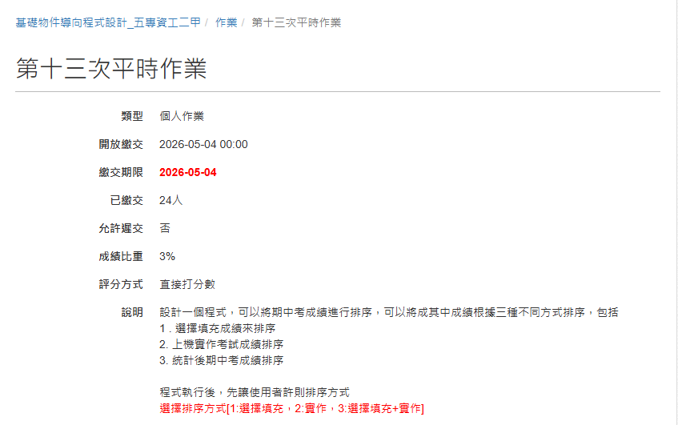
- 程式

#include <iostream>
#include <fstream>
#include <string>
#include <sstream>
#define N 47

using namespace std;

int main()
{
cout << "選擇排序方式[1:選擇填充、2:實作、3:選擇填充+實作] ";
int a;
cin >> a;

string id[N],name[N],score1[N],score2[N],score3[N],data;
int i;

ifstream file("data.csv");

if (file.is_open()){
i=0;
while (getline(file,data))
{
stringstream token(data);
getline(token,id[i],',');
getline(token,name[i],',');
getline(token,score1[i],',');
getline(token,score2[i],',');
getline(token,score3[i]);
i++;
}
// 排序
for (int k = 0; k < i - 1; k++){
for (int j = 0; j < i - k -1 ; j++){
if (a == 1){
if (stof(score1[j]) < stof(score1[j + 1])){
string tmp;
tmp = id[j]; id[j] = id[j + 1]; id[j + 1] = tmp;
tmp = name[j]; name[j] = name[j + 1]; name[j + 1] = tmp;
tmp = score1[j]; score1[j] = score1[j + 1]; score1[j + 1] = tmp;
tmp = score2[j]; score2[j] = score2[j + 1]; score2[j + 1] = tmp;
tmp = score3[j]; score3[j] = score3[j + 1]; score3[j + 1] = tmp;
}
}
else if (a == 2)
{
if (stof(score2[j]) < stof(score2[j + 1]))
{
string tmp;
tmp = id[j]; id[j] = id[j + 1]; id[j + 1] = tmp;
tmp = name[j]; name[j] = name[j + 1]; name[j + 1] = tmp;
tmp = score1[j]; score1[j] = score1[j + 1]; score1[j + 1] = tmp;
tmp = score2[j]; score2[j] = score2[j + 1]; score2[j + 1] = tmp;
tmp = score3[j]; score3[j] = score3[j + 1]; score3[j + 1] = tmp;
}
}
else
{
if (stof(score3[j]) < stof(score3[j + 1]))
{
string tmp;
tmp = id[j]; id[j] = id[j + 1]; id[j + 1] = tmp;
tmp = name[j]; name[j] = name[j + 1]; name[j + 1] = tmp;
tmp = score1[j]; score1[j] = score1[j + 1]; score1[j + 1] = tmp;
tmp = score2[j]; score2[j] = score2[j + 1]; score2[j + 1] = tmp;
tmp = score3[j]; score3[j] = score3[j + 1]; score3[j + 1] = tmp;
}
}
}
}

system("pause");
for (int j=0;j<i;j++)
if (a==3)
cout << j+1 << " " << name[j] << " " << id[j] << " " << score3[j] << endl;
else if (a==2)
cout << j+1 << " " << name[j] << " " << id[j] << " " << score2[j] << endl;
else if (a==1)
cout << j+1 << " " << name[j] << " " << id[j] << " " << score1[j] << endl;

file.close();
}
else
cout << "找不到檔案!" << endl;

return 0;
}

- 程式說明

利用ifstream讀取檔案，再利用氣泡排序法按照成績高低排序，最後印出結果

- 執行結果
