物件導向程式設計實習第十九次作業
班級:五專資工二甲
姓名:薛羽涵
學號:5B3G0001
指導老師:吳建中

- 題目

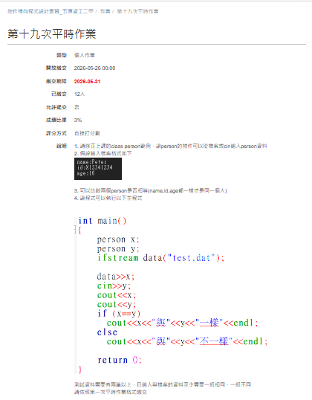

- 程式

#include <iostream>
#include <fstream>

using namespace std;

class person{
friend ostream & operator << (ostream &out,const person a);
friend ofstream & operator << (ofstream &out,const person a);
friend istream & operator >> (istream &in,person &a);
friend ifstream & operator >> (ifstream &in,person &a);
string name;
int age;
string id;
public:
person(string n="none", string i="none", int a=0){
name=n;
id=i;
age=a;
}
bool operator ==(person x){
return (name==x.name && id==x.id && age==x.age);
}
};

ostream & operator << (ostream &out, const person a){
out << "name=" << a.name << endl;
out << "id=" << a.id << endl;
out << "age=" << a.age << endl;

return out;
}
istream & operator >> (istream &in, person &a){
cout << "name:";
in >> a.name;

cout << "id:";
in >> a.id;

cout << "age:";
in >> a.age;

return in;
}
ifstream & operator >> (ifstream &in,person &a){
string temp;
getline(in,temp,':');
in >> a.name;
getline(in,temp,':');
in >> a.id;
getline(in,temp,':');
in >> a.age;

return in;
}
ofstream & operator << (ofstream &out, const person a){
out << a.name << endl;
out << a.id << endl;
out << a.age << endl;

return out;
}

int main()
{
person x;
person y;
ifstream file("test.dat");

file >> x;
cin >> y;
cout << "----------------------" << endl;
cout << "檔案資料:" << endl;
cout << x;
cout << "輸入資料:" << endl;
cout << y;
cout << "----------------------" << endl;
if (x==y)
cout << x << "與" << endl << y << "一樣" << endl;
else
cout << x << "與" << endl << y << "不一樣" << endl;

return 0;
}

- 程式說明

本程式利用 C++ 類別與運算子重載來管理人物資料。首先建立 person 類別，包含姓名（name）、身分證字號（id）及年齡（age）三個資料成員，並重載輸入、輸出及比較運算子。程式會先從 test.dat 檔案讀取一筆人物資料存入物件 x，再由使用者輸入另一筆資料存入物件 y。接著將兩筆資料顯示在畫面上，並利用 == 運算子比較姓名、身分證字號及年齡是否完全相同，最後輸出兩筆資料是否一致的比較結果。

- 執行結果
