1. It should be possible to add the same product to the cart twice.

I don’t get this comment, as the user can add as many items as he wants of the same products

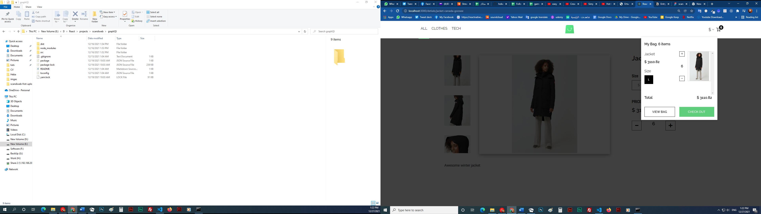

1. Please fetch the currency list from the API.

I do, the code for fetching them is in Header.js

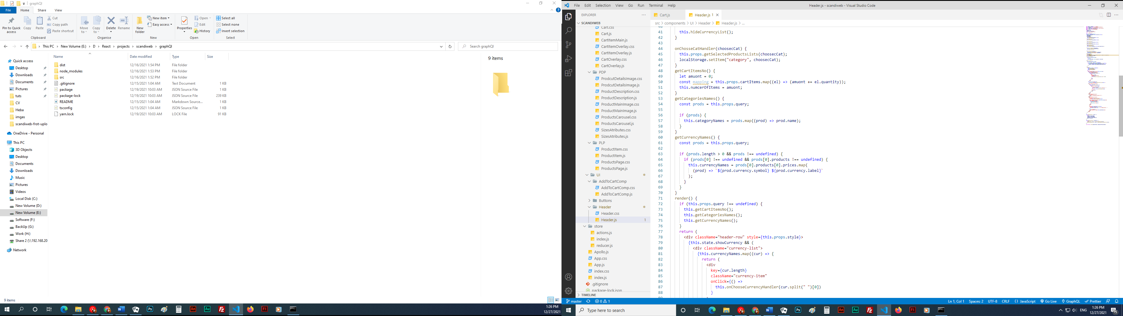

1. PLP looks awful and should be redone completely. Please look at the design.

Would you plz tell me what is the main differnece between my implentation and the desing that I should fix ?

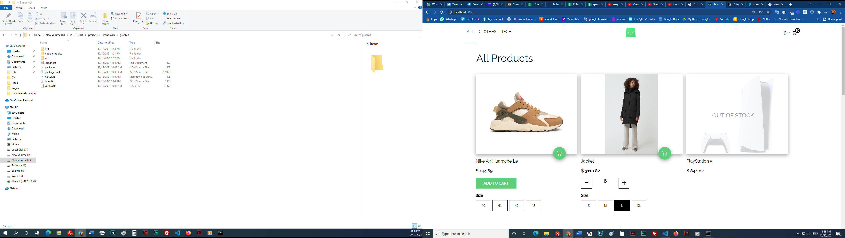

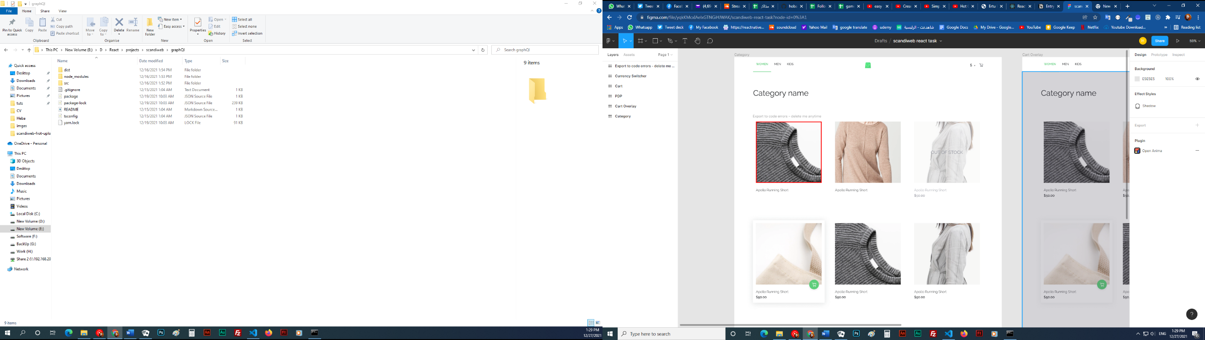

1. Only some image thumbnails are visible.

There are scroll arrows

