Parametric representation of lines in 3D space

A line is a geometric object, defined by two points A and B. It is infinite in length, passing through the points and extending forever in both directions. A line segment (or just segment) is also defined by two points, its endpoints, but extends only from one endpoint to the other. Although these objects, lines and segments, are very familiar, it is important to describe their parametric representation, as it was one of the solutions, which helped us to implement the linear blend skinning technique.
In order for the linear blend skinning to work, the algorithm, implementing it, has to know exact coordinates of each vertex, which is going to be affected during the animation of the character. The parametric representation of a line/segment enabled us to find the required vertices, as well as their positions in 3D space.
The parametric representation of a line L can be written as:

L(t) = A + b * t

where b is a vector: b = B – A, A is a starting point of a segment and B is an ending point of a segment.
This construction gives us a way to name and compute any point along the line L. This is done using a parameter t, that distinguishes one point on the line from another. As t varies, so does the position of L(t) along the line.
If t = 0, L(0) evaluates to A, so at t = 0 we are at point A. At t = 1 then L(1) = A + (B – A) = B. As t varies, we add a longer or shorter version of b to the point A, resulting in a new point along the line. If t is larger than 1, this point lies somewhere on the opposite side of B from A, and when t is less than 0, it lies on the opposite side of A from B. Below is a picture illustrating these facts in a graphical 2D view, although 3D version uses the same ideas.

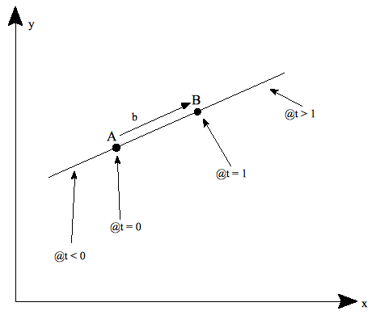
A very useful fact is that L(t) lies a fraction t of the way between A and B when t lies between 0 and 1. For instance, when t = 0.5 the point L(0.5) is the midpoint between A and B and when t = 0.3, the point L(0.3) is 30% of the way from A to B. This is clear from equation L(t) = A + b * t since | L(t) – A | = | b | * | t | and | B – A | = | b |, so the value of | t | is the ratio of the distances | L(t) – A | to | B – A |.

