Animating human body

The base of any character animation is it's skeleton. A skeleton is a hierarchical structure that let you pose and animate your model. Skeletons are composed of series of joints and bones that form joint hierarchies. Each joint has a number of children joints and one parent. Only the root joint does not have a parent and end-joints don't have children. From a programmers point of view joint hierarchy can be treated as a tree data structure, having a root, nodes and leaves.

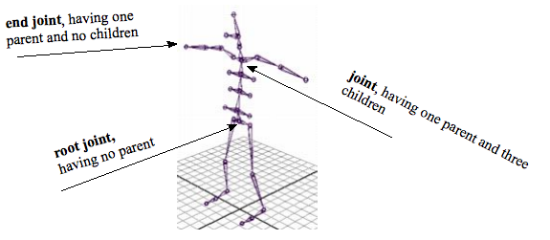
To animate a character, first of all, the animation data has to be applied to characters skeleton (every joint, that the skeleton consists of). Generally, the motion of an individual joint consists of translation, rotation and scale components (scaling is usually applied to character's bone). All these components can be merged together to give an overall transform using homogenous coordinates. If the translation, rotation and scaling is being applied, the overall transformation can be defined as multiplication of corresponding matrices:

M = T * R * S

where M is an overall transformation matrix, T is translation matrix, R is rotation matrix and S is scale matrix.
In our case, only the root joint had translational data, applied to it, whereas all other joints were being applied with rotational data. No scaling data was introduced in our motion capturing data.
For the animation to look correctly, a forward kinematics technique has to be applied. With forward kinematics, you rotate or move individual joints to pose and animate your joint chains. Moving a joint affect’s that joint and any joints below it in the hierarchy. For example, if you want a joint chain to reach for a particular location in space, you have to rotate each joint individually so that the joint chain can reach the location. To do this, you rotate and translate the joint chain’s parent joint, then the next joint, and so on down the joint chain.
From a more detailed point of view, each joint has a local transformation, that describes its orientation within its local coordinate system, which in turn is a subject to its parent's local orientations. To obtain a global matrix transform for a given joint, the local transform needs to be pre-multiplied by it's parents global transform, which itself is derived by multiplying its local transform with its parent's global transform and so on, until you reach the root joint. For the root joint, the local and the global transforms are the same. The equation below outlines this combination sequence, where n is the current joint, whose parent joint is n – 1, n = 0 is the root joint and M is the joint's transformation matrix.

M^{n}_{global} = ∏^{n}_{i = 0} M^{i}_{local}

So, for example to get the global transformation of the left ankle joint, the overall transformation sequence might look like this:

M _{global left ankle} = M _{local root} * M _{local left hip} * M _{local left knee} * M _{local left ankle}

