Preparing the character for animation

Our model consists of 18 joints, defined in the BVH data file: Hips (root joint), LeftHip, LeftKnee, LeftAnkle, RightHip, RightKnee, RightAnkle, Chest, Chest2, LeftCollar, LeftShoulder, LeftElbow, LeftWrist, RightCollar, RightShoulder, RightElbow, RightWrist and Neck. All of these joints should be positioned in such a way, that the skeleton is drawn in a T-pose. Below is a picture of our skeleton.

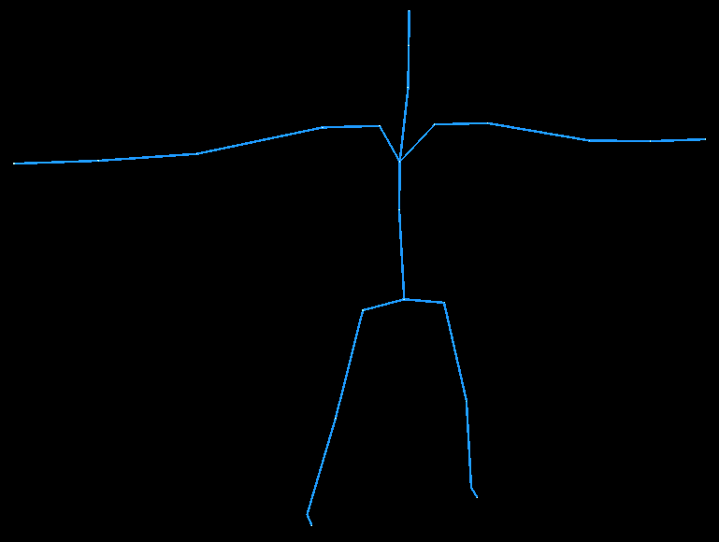

The joints, mentioned above, allow our model to be correctly animated in 3D scene, although much detail is not achieved as the movement of fingers and toes is not animated. Each joint has a mesh applied to it, which is not affected by the animation data, except being rotated or translated in the scene. The connection between the meshes is being done automatically during the construction of the character. The algorithm for doing that is:

    - find two vertices, belonging to the mesh and its parent mesh, which have the shortest distance of all the vertices.
    - Determine some threshold value, which can be just user defined (for example 5%). The threshold value determines the longest distance between vertices, belonging to the mesh and its parent.
    - Find all other vertices, which are necessary to connect, by calculating the distance between each of them. If the distance is between the shortest distance and the distance, calculated from the threshold value, then those two vertices have to be connected.

Each connection between the mesh and its parent has subvertices. This is necessary for every joint rotation to look smooth. The more subvertices we have, the smoother the rotation looks. To find positions of subvertices on the connecting line, we apply the parametric representation of a line. To give a better view, of how subvertices are introduced in our model, the image of model's right knee is provided. In the image you can see two meshes being connected by two connecting lines, each of which has four subvertices. Of course, this picture is provided just for explanatory purposes, the full connection between the meshes should have much more connecting lines.

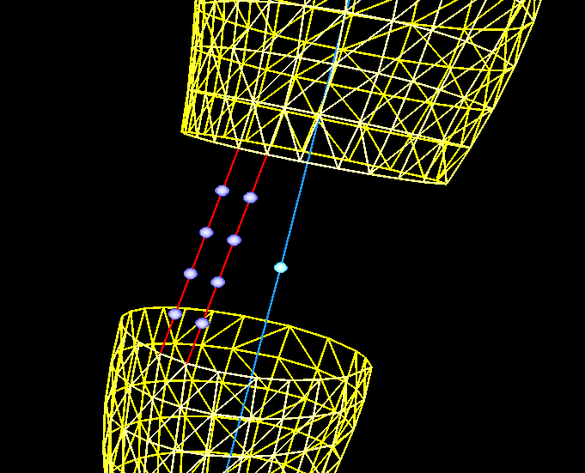
Any line function can be written as: L(t) = A + b*t, where A is the starting point of a line, b is a vector, determining the direction of a line and t is a paramter value. A more detailed explanation of the parametric representation of the line can be found in documents section 4.
Since the above mentioned algorithm finds the positions of the first vertex, necessary to connect, (which is letter A in the parametric representation of the line) and the second one (let's mark it's position as letter B), we can find the direction vector b = B - A. Now taking t from 0 to 1 we get the position of the subvertex, which is between A and B. In fact if we took t = 0, from the parametric representation of the line we get the position of vertex A, and if we took t =1 , we get the position of vertex B. So to determine the position of the first subvertex on the line, we need to set t = 1/N, where N is the total number of subvertices. To determine the position of the second subvertex on the line, set t = 2 * 1/N. In general, to find the n'th subvertex position on the line, we can set

t = n * 1/N

Now to calculate the position of subvertices after rotation, we apply the linear blend skinning technique, which means that each subvertex has some weight (let's mark it as w), which influences the angle it has to be rotated. Of course, each subvertex weight could be determined manually (for example, user defined), but we found that it is pretty easy to determine it automatically to get the satisfying overall result.
Let's consider that we have N vertices on the connecting line. The joint is being rotated by angle A. Each vertex weight w is being determined by it's position on the connecting line:

w = P * 1/N

where P is the position on the connecting line.
So the first vertex on the line has the weight w = 1 * 1/N, while the last vertex on the line has the weight w = N * 1/N = 1.
Now, considering the angle each vertex has to be rotated, the first one is rotated by A * 1 * 1/N degrees, while the last one is being rotated by A * N * 1/N = A degrees. After rotating all the subvertices, they are being connected to polygons.

