Analysis of effects of adopting reward / penalty system on maintaining low BR for children

**Treatment conditions:**

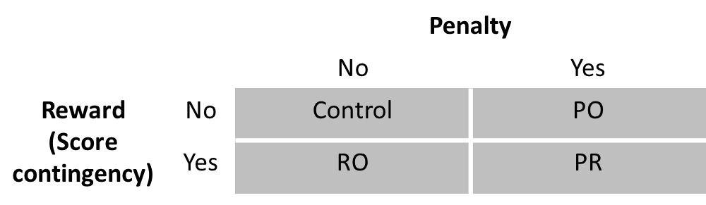

Control: No penalty on high BR and no reward on maintaining low BR.

PO (Penalty Only): Barrier moves up on high BR (with height indicating BR)

RO (Reward Only): Reward on maintaining low BR

PR (Penalty & Reward): Reward on maintaining low BR. Barrier moves up on high BR (with height indicating BR)

Note: The reward could be bonus score / more stars / elements of surprise

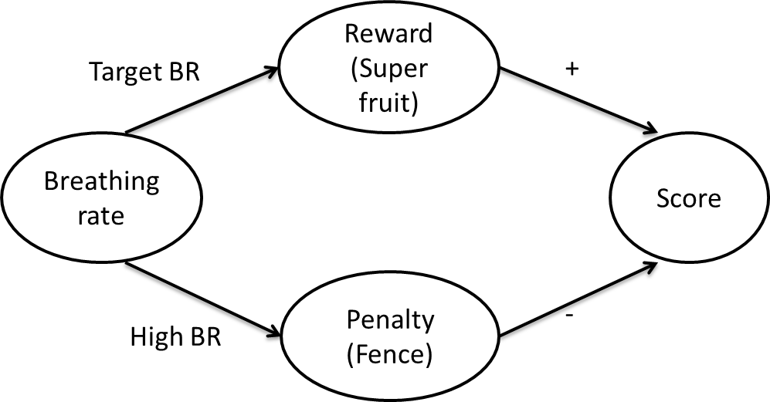

**Protocol:**

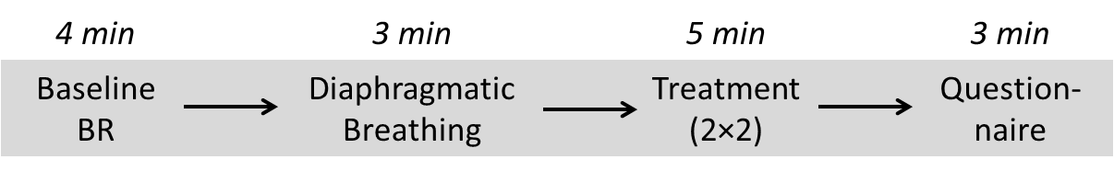

Within-subjects?

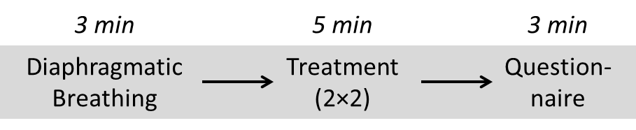

**Done**

* Cosmetics:
  + Glowing sun as pacing guidance
* BF
  + Super fruit reward on maintaining low BR
  + Visually connect fence with super fruit.
  + Fence height change smooth filter

**To do**

* BF
  + Guidance on when BR too high
  + Four games for four conditions
* Trivial
  + Change time to progress bar
  + Add animations and sounds for super fruits events