SCOREBORED

Preview: add text to indicate that it’s interactive:
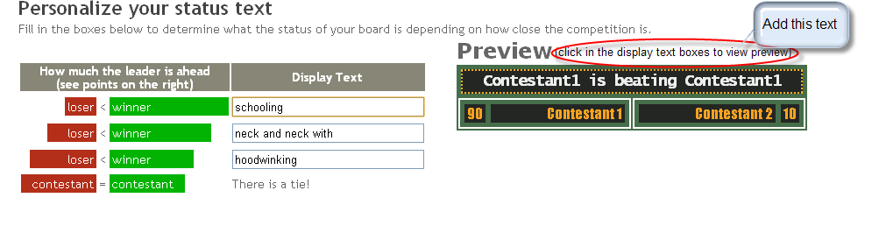

Boards

Editing:
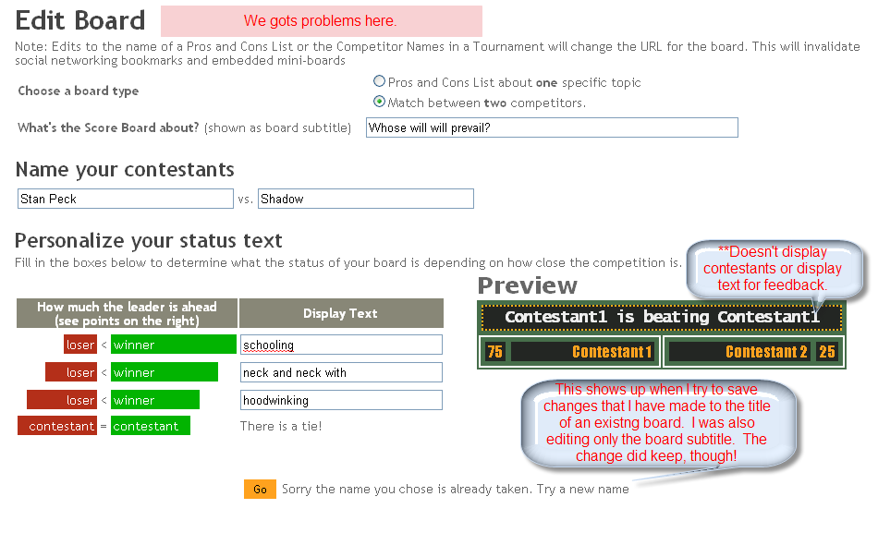
http://www.scorebored.net/users/make_scoreboard.aspx?edit=Stan_Peck_vs_Shadow

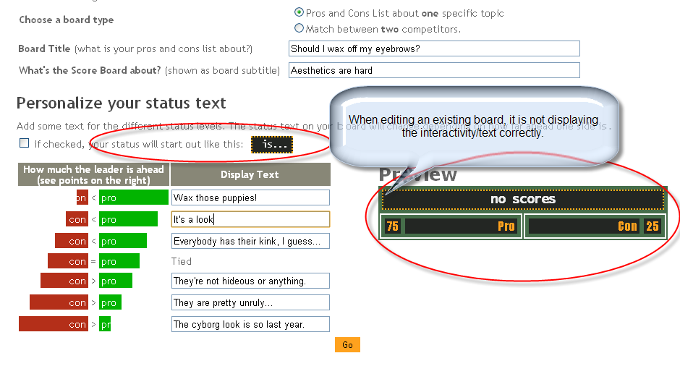

**Jenny vs. Jesus:

My Match board

The edit button 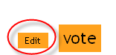should look a bit different from the vote button (different color?), and maybe be a bit bigger (though I definitely don’t think it should be as large as the Vote button.

General Commentary

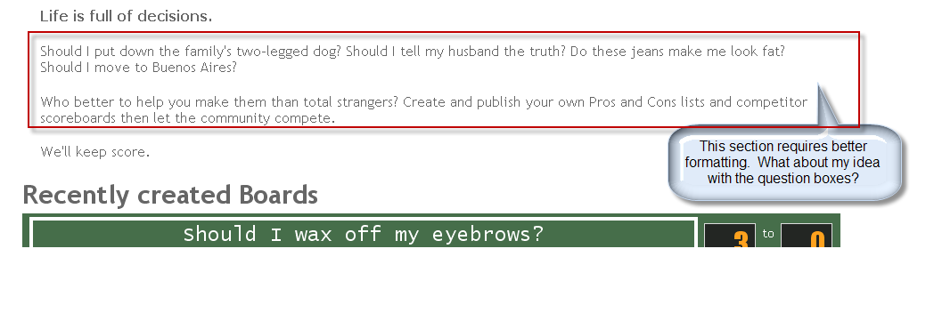

Scoring

