SCOREBORED

Boards
**“Is this the face of a computer programmer” link is broken. Error received: Server error in ‘/’Application. Object reference not set to an instance of an object.
This is the link: http://www.scorebored.net/bored/Is_this_the_face_of_a_computer_programmer%23
Tried it again and it is working now, but the comments and voting up/down aren’t working.

**Jenny vs. Jesus:
Problem with the scoring. I “agreed” with one of the comments on the side, and it took away a point. Shouldn’t it add?
Ty: Need better steps to reproduce this
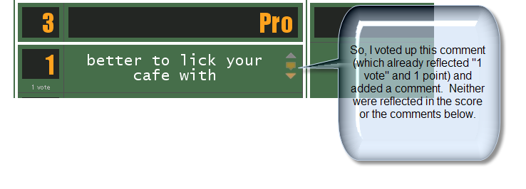
the original error was produced when I clicked the “up” or “agree” arrow, and it detracted a point from the total score. I can no longer seem to reproduce this error, but the aforementioned error (voting not affecting the score or registering the comments) seems to be consistent.

**WORKING CORRECTLY: Monkey/Robot; Death Match;

I still think that a person should be allowed to comment without voting.
The mechanism of the site is unclear.
Ty: They can. The middle box on the score line. Create some explanation/screen caps with pointers to buttons to explain this.
Ok, cool. However, when going to “reply” to one of the comments at the bottom, it takes it as a vote. It needs to be a simple comment:
Ty: was just a formatting thing in the box. Fixed now.
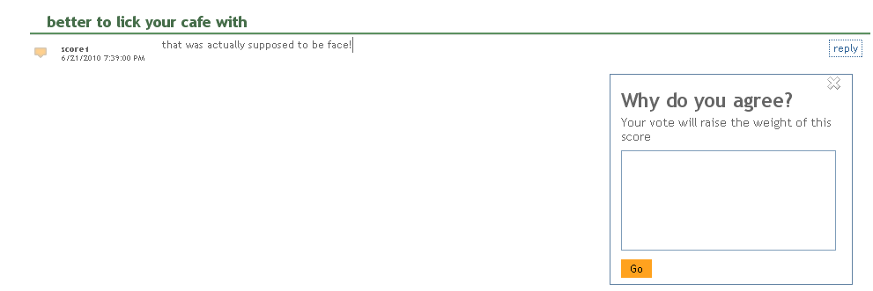

Search
Broken.
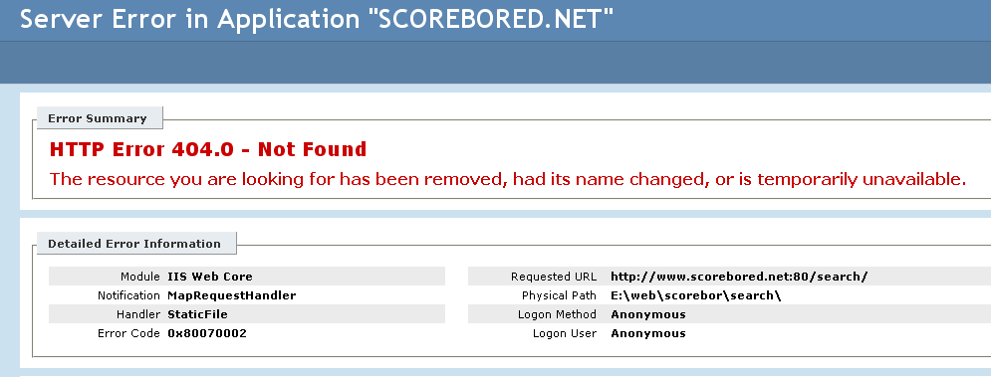

Registration
*I was able to successful register
*the user “homepage” should initially show the how to info if no boards have yet been created

When a person registers with the website the box that pops up saying “Continue” but when the button is clicked it does nothing. The box should indicate that the user should complete their registration via the email that was sent. Also, I think the onscreen content should be different than the screen prior to sign-up. If they have already signed up then we know that they aren’t an eeevil spammer.
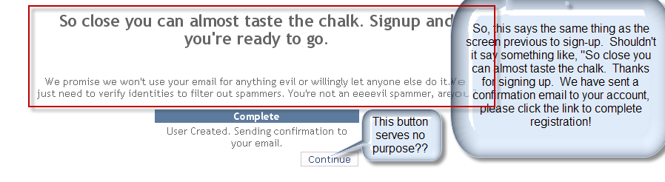

How Does it Work?
- Each of these sentences needs punctuation.
- We need to emphasize the list types. Perhaps a different color font, italics, or quotations? Ex: Choose to create either a Pros and Cons list or set up a Match between two competitors. Italics (bold)
  - Is it possible to hyperlink (as it is with “sign up”) the list types to “create a board” blank slates?
- TYPO+edits:
  - Scores are created by other users who will be instructed to include a reason for the score and then weight the value from 1-5.
  - Other users can vote those scores up (agree) or down (disagree), which will affect the overall impact of the line item on the total score.
  - Add additional comments to justify your rationale.
At the end have a link to “create a new board.”

Put numbers at the edges of the status boxes
Ty: Too much of a pain. Screws up the formatting. Gave up after 25 mins
Jp: ok.

Pro/Con

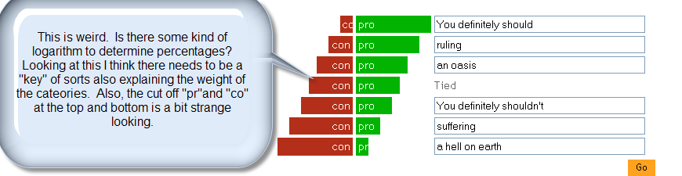
The preview is also strange. It would be much better to show a “sample” board such as the “Should I move to BA”board and then add comments to explain the different sections. The “You definitely should” et al without additional context doesn’t make any sense, and in fact confuses the matter. At the very least we need some kind of context cue to understand the meaning of the different “ratings”, otherwise it just loses all sense.
Better now with preview?
Jp: Nope, it failed.

Server Error in '/' Application.

The resource cannot be found.
Description: HTTP 404. The resource you are looking for (or one of its dependencies) could have been removed, had its name changed, or is temporarily unavailable. Please review the following URL and make sure that it is spelled correctly.
Requested URL: /make_scoreboard.aspx

Version Information: Microsoft .NET Framework Version:2.0.50727.4200; ASP.NET Version:2.0.50727.4016

Match
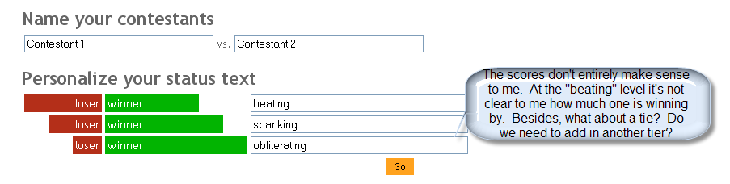

- NOTE about the preview section! It took me a moment to really understand how it was working. I like what you have done with it, but it is not at all clear until the user starts to create a board and can see the “preview” change! It looked like something static. I think that we should have a pop-up of an “example” board, and then add instructions at that top that indicate when the user starts to create their board they can “preview” what it will look like with the content that they enter below.
  - This is my comment prior to understanding that the preview section changes as content is added: The “preview” section is also odd. We should use a “real” example so that it makes sense. Jesus vs. Jenny, etc. It took me awhile to even register that the scores are showing and determining who is beating who, so maybe there is a way to call attention to the differentiation of the scores? Also, is this really a “preview”? Does the user ever really see a screen that looks like this? Remember we’re trying to show someone what to expect and how to use something, so we really need to be clear.

My Match board
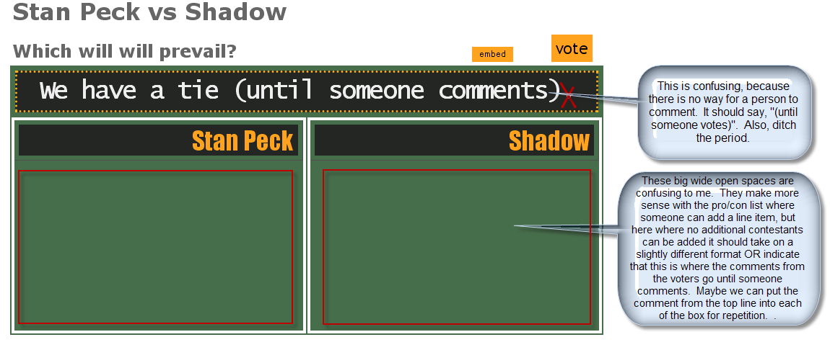
- I also think that the embed button should go at the bottom. I don’t really get it here, especially coming before vote. There is also no additional explanation, so I think something should be added. Added social networking links at bottom. Will fix formatting later.
- I saw this. Nice. But still no link to facebook, just the “like”?
- When adding line items the form doesn’t automatically clear. It should. fixed
- The scoring doesn’t necessarily auto-adjust correctly. This is another reason why I think that there should be another tier for “tie” since the score is uneven but I thought it was the tie line. It should only be a tie when the scores are exactly tied. Due to a misunderstanding about board setup. improved
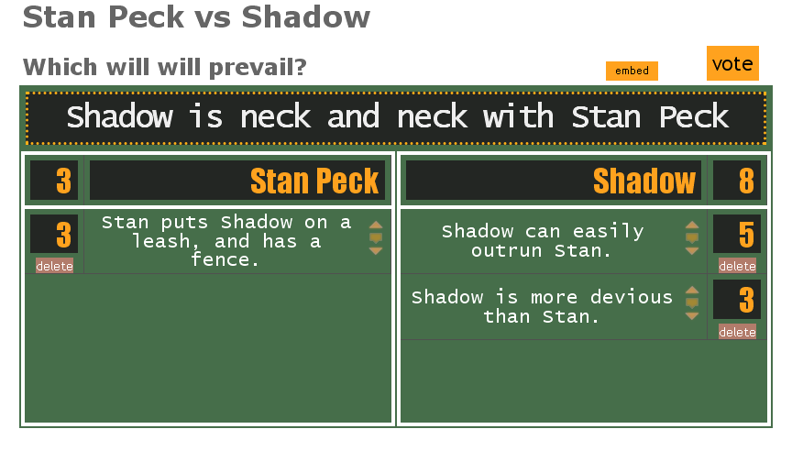

EDIT Capability!!! Done (should now be edit button on your boards next to vote)

Great! However, when I went to edit and submit the edit, I see this screen:

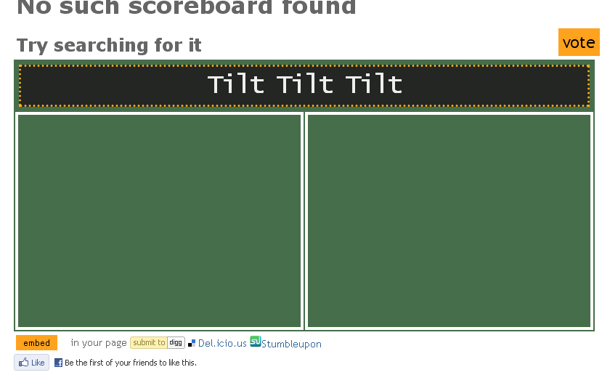
The good news is that the edits apparently do capture, which I saw when I went back to my boards. One thing! The edit button should look a bit different from the vote button (different color?), and maybe be a bit bigger?

General Commentary

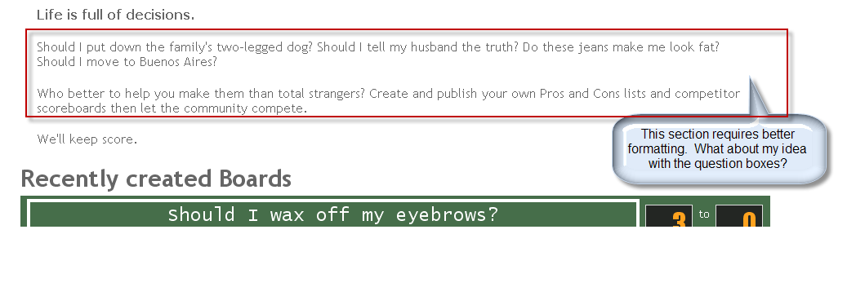
- I think that we need to arrive at a standard of saying “sign up”. It’s not one word, so we should do a find and replace and always use sign-up or “sign up”, but not “signup”. Changed to “join”
- We also need to have a standard in punctuation. Sometimes I’m not seeing punctuation where we need to see it, and other times I see it where we don’t need it. I tried to note all instances that I saw.
  - Comments should be editable by the author. Currently there is only the option to delete (which is better than nothing, but people like to correct their own typos, etc.). I also think that other users should be able to comment on other comments! Make it like dig with hierearchal comments.
If you hit “reply on another user’s comment it puts an “@username” in from of the comment like in YouTube. Otherwise it gets really complicated.
  - Active USER (comment creator, etc.) view: will just have delete for now
  - 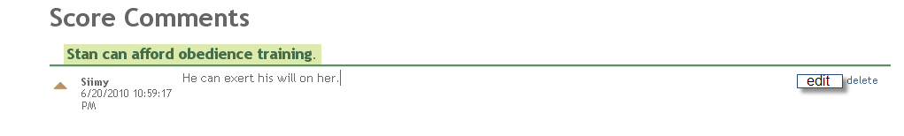
  - Participating USER view (someone who is looking at the board, not the creator)
  - (something to the effect of):
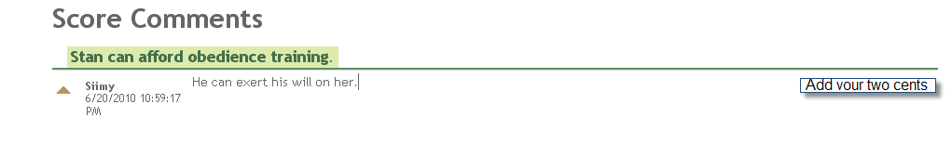
Whoops! I just saw that you have a “reply” in the existing boards. That’s fine by me, but I think it should maybe say something snappier.

  - People should be able to cancel or otherwise back out of making comments. Currently the only way is to click out of the space, and that is OK, but it’s not really clear. She wants a close button. done

