Summary Description: Arduino Weather Station, with Anemometer, Built for an Engineering Course

Tags: electronics; software; nature projects; Arduino; DHT22; Anemometer; Rotary Encoder; 3D modeling; 3D printing; product reporting

Why I did this: It was the project of one of my engineering courses where the focus was to learn some Arduino electronics building and to learn how to brainstorm and report projects (for imaginary customers). We were tasked with building a wind speed sensor (turbine) using a rotary encoder and Arduino, plus 2 additional sensors of our choice. I was able to build on my Fusion 360 3D modeling and printing skills by printing some wind blades and housings. Finally, we had to summarize our project into a report PDF.

(summary pic of system)

Design Walkthrough:

I won’t go into too much textual detail here because I made a link to 3-minute video showcasing the project, and I have linked the project pdf report.

3-minute showcase video:

<https://drive.google.com/file/d/1wErHDm5pf5-6gQ0QlYfw-1ThCe2kLK8U/view?usp=sharing>

Project summary report (includes 3D models and Arduino code):

<https://drive.google.com/file/d/1RKcPiP9LFywomvhY5QyFRuR3Nwy8ELt4/view?usp=sharing>

Given that this was done during the 2020 pandemic (so everyone’s isolated with virtual group meetings), and I was the self-appointed leader of the project (with the most experience with 3D modeling, Arduino electronics, and reports), I would confidently say I did more than 90% of the project myself.

(pics of system)?

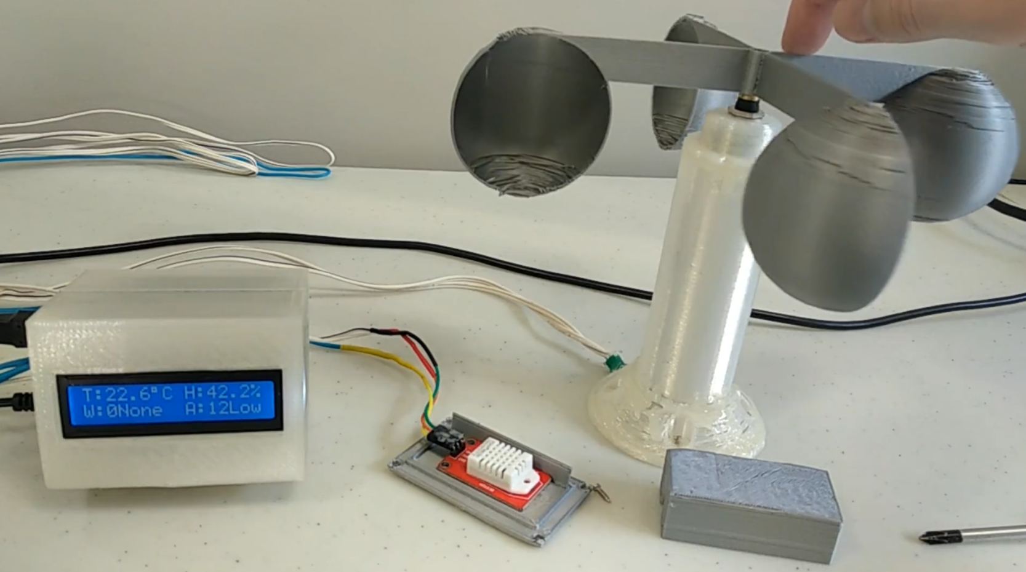

Lessons Learned and Future Changes:

Reports are a nice tool. I did the project a few years ago, so I forgot the material since then, but the report I made certainly jogs my memory as to what work I had to do to build this system.

References:

N/A (There are ones seen within the report.)