
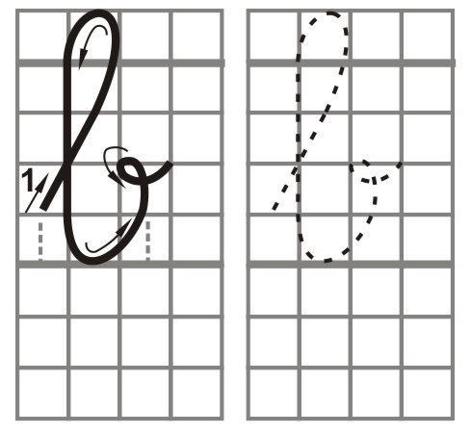
Bài tập viết 2
ngày
tên:
Khoảng trống để kẹp vào bìa ----- http://sites.google.com/site/unitapviet/ ----- dzunglee.saigon@gmail.com
bbbbbbbb

bbbbbbbb
bbbbbbbb
bbbbbbbb
bbbbbbbb
bbbbbbbb
bbbbbbbb
bbbbbbbb
bbbbbbbb
bbbbbbbb
bbbbbbbb
bbbbbbbb
bbbbbbbb
bbbbbbbb
bbbbbbbb
bbbbbbbb
bbbbbbbb
bbbbbbbb
bbbbbbbb

