IBM Composer Files Link:

[quantum-computing.ibm.com/composer/files/new?initial=N4IgdghgtgpiBcICcA2AjEgLADgPoEEBnQgSwHMxYwAXAWgCZcBFNAYxABoQATGQ1gE4kADtRIB7MAhCcQARwiEo0gPIAFAKIA5JvgDKAWQAE9AHQAGANwAdMCTCsANgFdeR6-JiOSAIzSn7Vg8bMFs5ARgyIzkAbXoAXRDBSKNWOMTbWwEATwAKNAAqYRIASmiY8wywAQ](quantum-computing.ibm.com/composer/files/new?initial=N4IgdghgtgpiBcICcA2AjEgLADgPoEEBnQgSwHMxYwAXAWgCZcBFNAYxABoQATGQ1gE4kADtRIB7MAhCcQARwiEo0gPIAFAKIA5JvgDKAWQAE9AHQAGANwAdMCTCsANgFdeR6-JiOSAIzSn7Vg8bMFs5ARgyIzkAbXoAXRDBSKNWOMTbWwEATwAKNAAqYRIASmiY8wywAQAPXPNTQuKy2LQq1hryto5YypCACy72ztb4noqqgQAvetNMItLyvqy6hvoFlpi2pJGtsd6qwgB3CGEl-b2QnNmAVg3zq7raBpR70Z2h8eWwQffbDs%2BByuMwa82aDxWs3W4L%2BDl23SBtlgimcEXORloAD5UhMQsjCKiYEMMdi0tsQABfIA)

**QUESTION 1**

1. <https://qui.science.unimelb.edu.au/circuits/60b462067b095e0049101fcc>

Heavy states are and

1. State probabilities

Qiskit Code : Q1c.py

Device : ibmq_manila

Circuit Image :

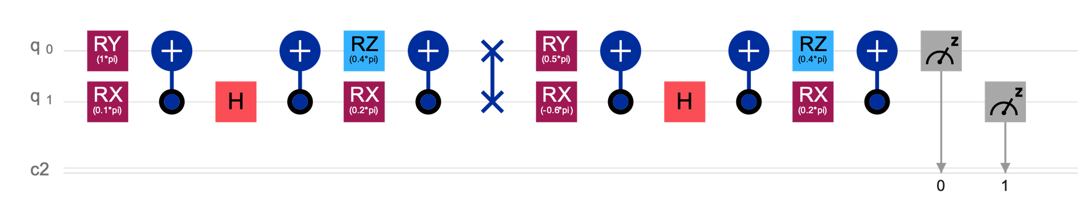

Transpiled Circuit Image:

Results :

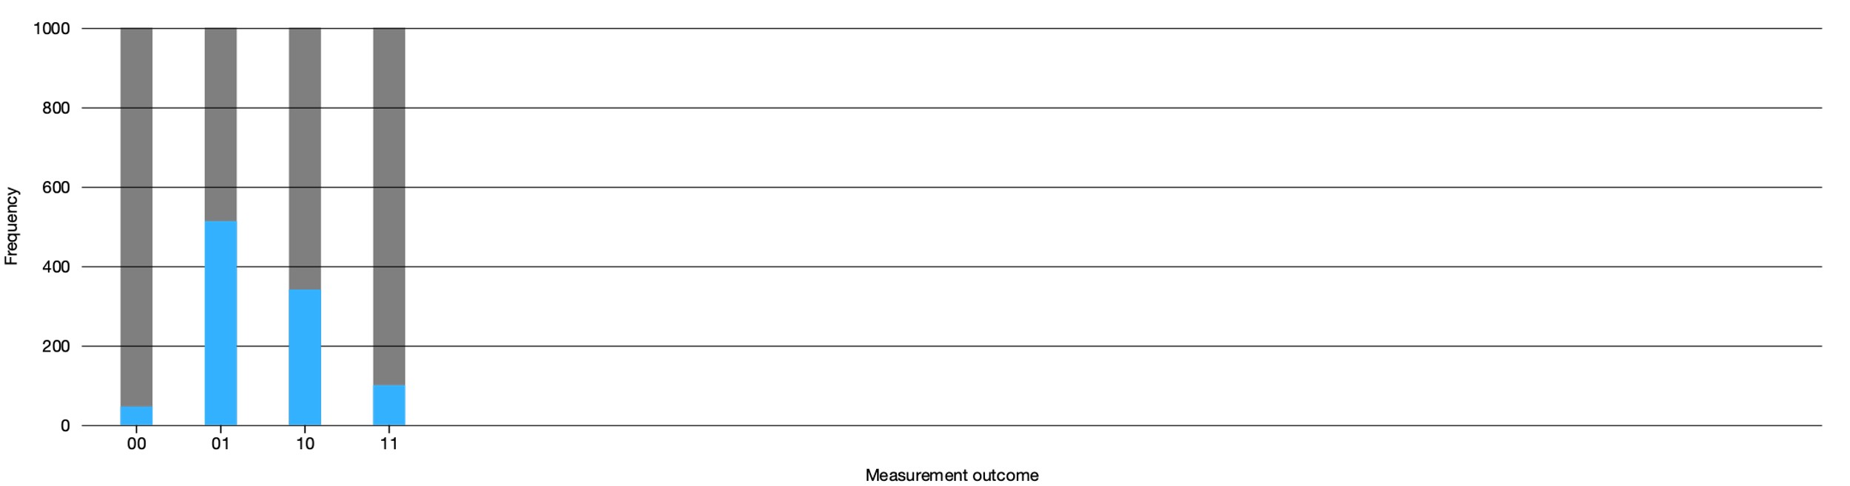

**QUESTION 2**

1. Qiskit Code : Q2a.py

Device : ibmq_manila

Circuit Image :

Transpiled Circuit Image:

Results :

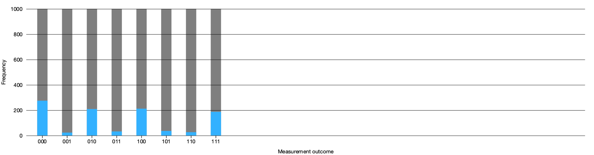

1. <https://qui.science.unimelb.edu.au/circuits/60b4621d088e4a008b256bde>

1. Yes, the code successfully amplified the state, as shown in the results below. Having run 1000 shots, we can safely assume that this amplification of the state is not due errors.

The way the circuit works is that it starts of with a Hadamard gate on all the three qubits, and then runs the oracle (before the first barrier) to flip the phase of the state. In this case, the oracle is made up of a Toffoli gate controlling on the first two qubits and then two more Hadamard gates surrounding the target qubit. Combined, this flips the phase of only the state. This Toffoli and Hadamard phase-flip combination can also be used during the mean-reversion stage (middle of the second and third barriers) since IBM does not allow for multi-control qubits. We can also optimise away the two adjacent Hadamard gates at the very start of the circuit.

Qiskit Code : Q2c.py

Device : ibmq_manila

Circuit Image :

Transpiled Circuit Image:

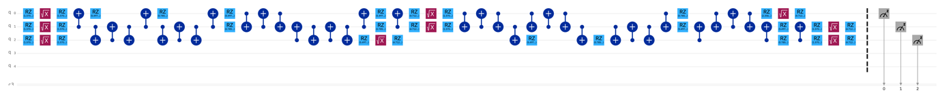

Results :

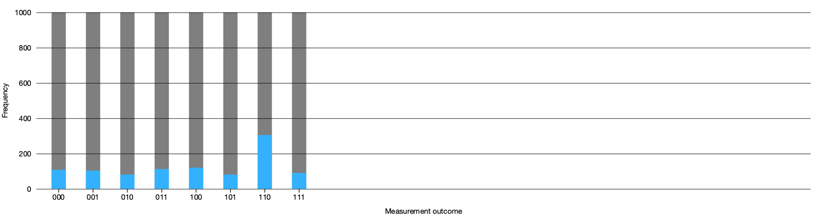

**QUESTION 3**

1. <https://qui.science.unimelb.edu.au/circuits/60b3d0ca2a724f006a69d178>

Using concepts that I used in the first assignment, my first goal was to create the W-3 state, which was the state and then modifying the magnitudes and phases. The creation of the W-3 state made up the first five qubits of the circuit.

Upon calculating the probability from the magnitudes in the given K-state, we can see that the state has a 0.5 probability while the and states make up and of the remaining 0.5. Hence, the first qubit was to create the two 0.5 probability distributions and the following R gate was used to split one of the 0.5 probabilities into and of itself. Ignoring the phases that was applied, the other CNOT and X gates were to flip the bits around till we get the final three and states that we want. The last step is to flip the phases according to the rotations specified in the K-state, which is the role of the final Z gate controlled on the other two gates (since we only need to alter the phase of the state).

1. Following the code above, I replicated the same gates apart from the introduction of a U-gate and some changes to the final RZ angle rotation. Due to IBM not allowing a rotation gate with a custom axis, I used the U-gate that most closely replicated the custom axis.

Qiskit code : Q3.py

Device : ibmq_manila

Circuit Image :

Transpiled Circuit Image:

1. Results :

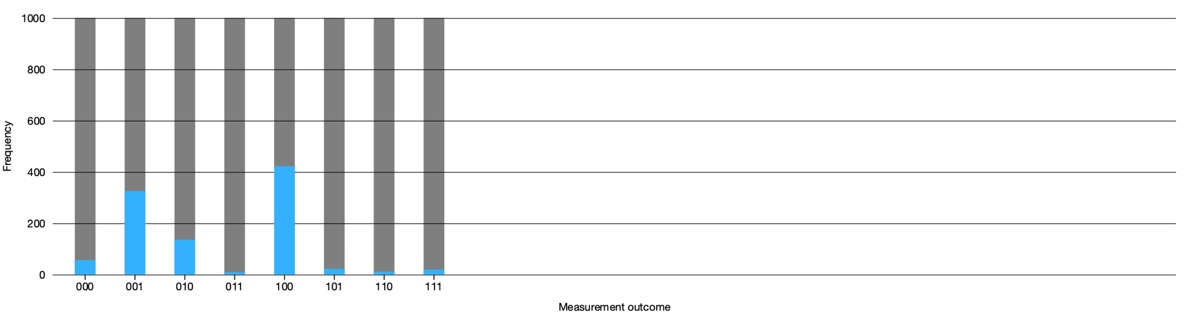

As shown above, upon running 1000 shots, our circuit successfully returned a frequency that approximately replicated the error-free probabilities we got from QUI. That said, there were some minor errors that resulted in our circuit reading the other states. One error that stands out is the state. This could come in the form of an X- or Y rotation-error in one of the qubits.

1. Results:

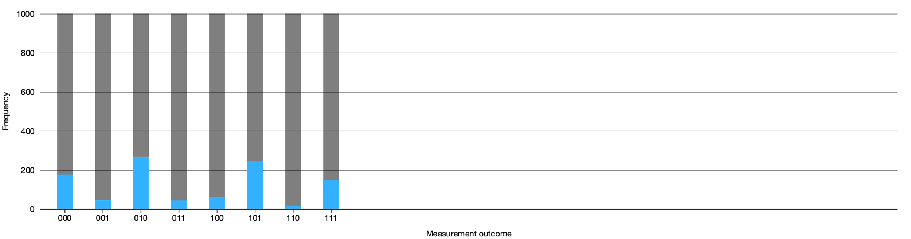

Resulting probability of measuring

Ideally, it should be 0.134

Adding the terms, we get a magnitude of and thus

**QUESTION 4**

1. <https://qui.science.unimelb.edu.au/circuits/60b43ebcf25ca0003e5fe604>
2. With the single terms, all we need to do is apply a measure gate as it defaults to measuring in the Z basis.

With the terms, what we need to do is change the basis. Since the gate is essentially a gate, this means all we need to do is apply the Hadamard gate before measuring, then measure it in the -basis with the measurement gate, and after measuring, we can change it back to the original version by applying a second Hadamard gate.

Similarly, with the terms, since the gate is essentially a gate, this means all we need to do is apply the gate before measuring, then measure it in the -basis with the measurement gate, and after measuring, we can change it back to the original version by applying a gate.

With the double measurement terms, we can just measure them separately using the appropriate methods as defined above and multiply them both.

1. Minimum