# Gaining Geometric Intuition of SVD

Cherie Ho

One of the key ideas that we covered in class is, when possible, to transform the problem into a system of linear equations. Once it is a linear system, we can easily solve it with Singular Value Decomposition (SVD). SVD is a widely-used technique that provides a least-squares solution to a linear system. It has heavily applied in many areas, such as, data analysis, machine learning, computer vision, mechanics; however, it is difficult to grasp an intuition of the decomposition. With solvers, you only get the decomposed matrices, but that does not provide a geometric understanding of the individual components. For example, covered in class, a key component of “least squares approximation of rigid body transformation” is the composition of U and V obtained from SVD. However, it is difficult to understand why the combination works.

To better understand how each decomposed component contribute to the final transformation, I propose to build a tool that can visualize the individual transformations due to U,S and V, similar to Figure 1. Users can enter any 2x2 matrix into the tool and the corresponding decomposition will be visualized. To demonstrate the use of the tool, several motivating use case will be tested: Identity, Rotation, Reflection, Shear, Positive Definite Matrix. The goal of this tool is to help users or students gain a better understanding of SVD. With a better geometric intuition, it potentially opens us up to more applications of the decomposition.

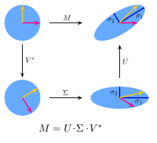

Figure 1: Visualized SVD Decomposition of matrix M