
CAN THO UNIVERSITY
COLLEGE OF INFORMATION AND COMMUNICATION TECHNOLOGY
THESIS IN
INFORMATION TECHNOLOGY
(HIGH-QUALITY PROGRAM)
Topic
THE DWARF’S ADVENTURE: SAVING SNOW WHITE WITH SCRATCH
Advisor: Dr. Do Thanh Nghi Student: Tran Duy Bao Anh
ID: B2105662
Course: K47
Can Tho, 02/2024
ACKNOWLEDMENTS
First and foremost, I would like to extend my sincere gratitude to Dr. Do Thanh Nghi’s assistant for their valuable support throughout every phase of this thesis. Their guidance has been supportive in my introduction to game programming using Scratch.
I am deeply thankful to my family for supporting me financially and mentally, this allows me to complete this thesis in a timely manner.
Lastly, I would like to express my appreciation to my friends for their encouragement and insightful feedback. Their positive comments have been a source of motivation and inspiration throughout this journey.

TABLE OF CONTENT
ACKNOWLEDMENTS 2
TABLE OF CONTENT 3
CHAPTER 1: INTRODUCTION 5
1. Meaning of topic: 5
2. Objective: 5
a. Objective of myself: 5
b. Objective of this game: 5
3. Summary of achieved results: 5
CHAPTER 2: IMPLEMENTATION CONTENT 6
1. Activities diagram: 6
2. Setting: 8
a. Cover page: 8
i. Code of play button: 8
ii. Code of help button: 9
iii. Code of Drawf_start: 9
b. Introduction 1: 9
Code of next button: 9
c. Introduction 2: 10
Code of finish button: 10
d. Level 1: 10
i. Code of map lv 1.1: 11
ii. Code of map lv 1.2: 11
iii. Code of apple 1: 12
iv. Code of snake: 13
v. Code snake 2: 14
e. Level 2: 14
i. Code of map lv 2.1: 15
ii. Code of map lv 2.2: 15
iii. Code of apple 2: 16
iv. Code of apple 3: 17
v. Code of lion: 18
vi. Code of fake Snow White: 19
f. Level 3: 20
i. Code of map 3.1: 21
ii. Code of map 3.2: 21
iii. Code of bear: 21
iv. Code of Witch: 22
g. Lose backdrop: 22
i. Code of Dwaf_end: 23
ii. Code of retry button: 23
h. Win backdrop: 24
i. When Drawf touch obstacles: 24
j. Rules of adding heart: 25
k. Code of number of lives, heart, level, score: 26
i. Code of number of apple: 26
ii. Code of number of lives: 27
iii. Code of level: 28
l. Code of sound: 28
m. Code of score table: 29
n. Code of Drawf: 30
i. Code of “Drawf appear” block: 31
ii. Code of “Drawf move left” and “Drawf move right”block: 31
iii. Code of “Drawf Jump” and “Drawf Fall” block: 32
iv. Code of “Turn to next level” block: 33
v. Code of “Lose if there is no heart” block: 34
vi. Code of “Win if meet real Snow White” block: 34
3. Result: 35
CHAPTER 3: CONCLUSION 36
1. Recap of tasks performed and achievements: 36
2. Development direction: 36
REFERENCES 37

CHAPTER 1: INTRODUCTION
- Meaning of topic:
Studying and learning about this topic holds profound importance to me. Firstly, it offers me the opportunity to familiarize myself with the visual programming environment Scratch - a programming environment that is totally new to me. Secondly, it allows me to engage in creative game development and enrich dynamic aspects of game design. Thirdly, it aids in cultivation of my programming mindset and problem-solving skills such as debugging code. Lastly, it enables me to blend elements of entertainment and education, alleviate the stress associated with programming. Therefore, I can accumulate valuable experiences in solving errors encountered in game programming, paving the way for more complex game creations in the future.
This game serves a meaningful purpose by providing players with insights into potential obstacles they might face. Consequently, they can devise gameplay strategies to overcome these challenges, supportively fostering critical thinking and problem-solving abilities.
- Objective:
- Objective of myself:
I set a goal to build a meaningful game. It's a simple game but it enhances memory, sharpens problem-solving skills, and fosters creative strategies. Additionally, I know how to use Scratch code blocks to control characters, create animations, and handle collisions. Moreover, I can design a player-friendly interface. Finally, I can apply this knowledge to real-world programming in the future.
- Objective of this game:
The game of rescuing Snow White also has the goal of rescuing the princess, who has been kidnapped by the Evil Queen (Witch). The Dwarf must overcome obstacles and collect apples to eat during the search for Snow White. Players will win the game by successfully bringing Dwarf to Snow White’s place while preserving at least one life. In contrast, if Drawf hits obstacles and loses all his lives, players are defeated.
- Summary of achieved results:
Through learning game programming with the Scratch application, I have successfully absorbed knowledge and mastered common commands of the Scratch programming language to create games. This game is completed with essential features such as: the Dwarf character can move, jump, interact with objects, and earn bonuses. Additionally, the game offers a user-friendly interface, displaying points, the number of apples collected, and the Dwarf character's lives.

CHAPTER 2: IMPLEMENTATION CONTENT
- Activities diagram:
When click green flag, cover_page will appear where Drawf appear and tell player to help him to find Snow White. Players can select one of the two butons: play button and help button.
Upon pressing the help button, the screen will present a brief introduction to the game scenario to players, along with a next button. When players press the next button, the screen will display instructions on how to play the game, accompanied by a finish button. Finally, when players click the finish_button, the screen will return to cover page. On the other hand, when clicking the play button, the game will start from level 1.
Players will have a maximum of 5 lives and will start playing from level 1. At the beginning of the game, players are provided with 3 hearts. When they touch obstacles or lava, they lose 1 heart. If they reach 0 hearts, they lose and the game ends. When they reach the end of the map and still have lives left, they proceed to the next level until they encounter Snow White, then they win and the game ends.
While playing this game, players must use left or right key to move horizontally, use up key to jump vertically to overcome obstacles.
At level 1, players familiarize themselves with movement controls, overcome simple obstacles, and collect 1 apple.
At level 2, players encounter more difficult obstacles (including lions, fake Snow White), but they can collect 2 apples to gain an extra life. However, if they mistakenly rescue the fake Snow White, they lose and the game ends.
At level 3, players encounter a bear, the wicked witch along with the real Snow White. In this stage, players cannot collect apples anymore, so they must carefully pass Witch to rescue Snow White. When they encounter the real Snow White, they win and the game ends.
At the end, there will be a notification of win/lose and the player's score. If they lose, the default score is 0, otherwise, if they win, the score equals the remaining lives plus the number of apples collected.
Activities diagram
Click green flag
Cover page will appear and display a Dwarf who tell player to help him find Snow White
Click ‘PLAY’
Click ‘HELP’, introduction 1 appear
Show level 1
Show level 2
Show level 3
If there is no heart or touch fake Snow White
If there are over 0 heart
Turn to lose backdrop
Turn to win backdrop
Click ‘RETRY’
Click ‘NEXT’, introduction 2 appear

Click ‘FINISH’
Touch obstacle
Complete lv1
If there are over 0 heart
Touch obstacle
Complete lv2

Check
Check
Check
If there are over 0 heart
Touch obstacle
Complete lv3

Check
Check
Check
- Setting:
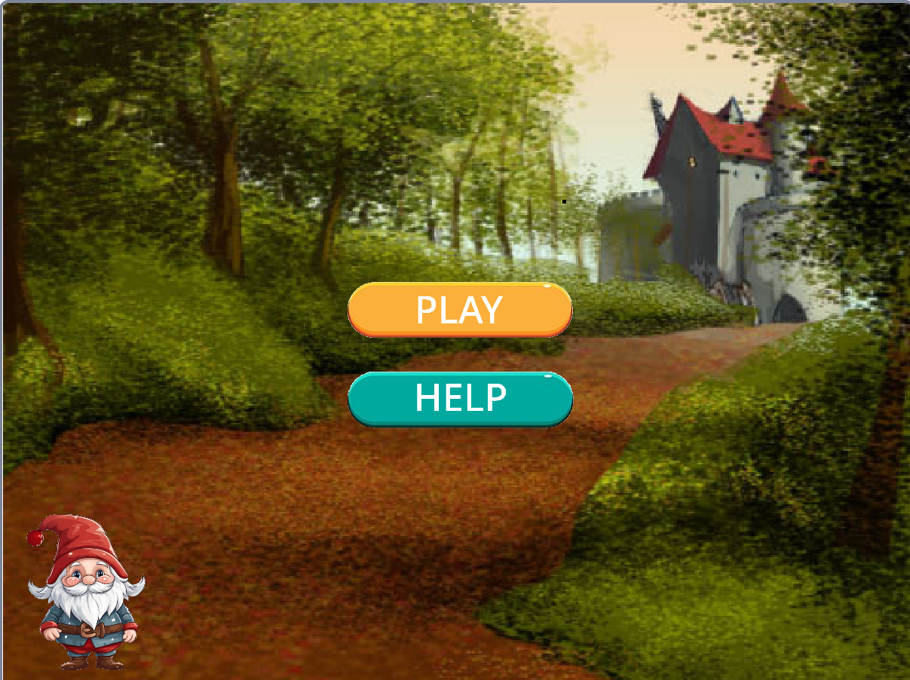
- Cover page:
Upon clicking the green flag, the screen will display a cover page with a play button, a help button, and an illustration of the Dwarf.
The Dwarf will request players to help him save Snow White.
Upon clicking the play button, the screen will turn to level 1. Alternatively, if players click the help button, introduction 1 will be displayed, providing an overview of the game and instructions on gameplay.

- Code of play button:

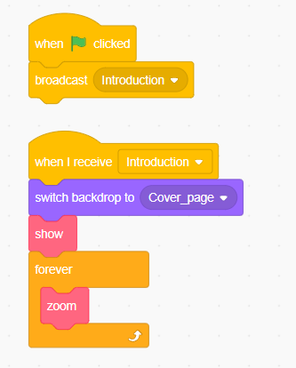

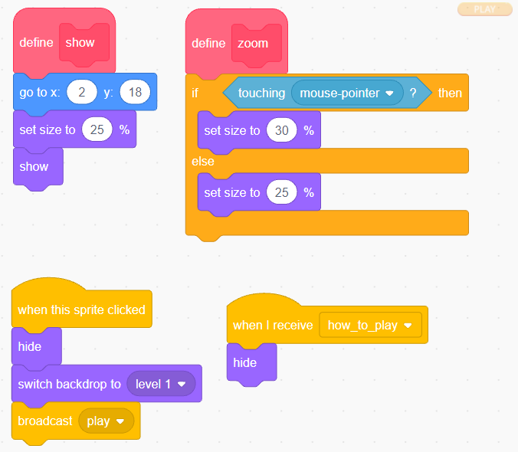

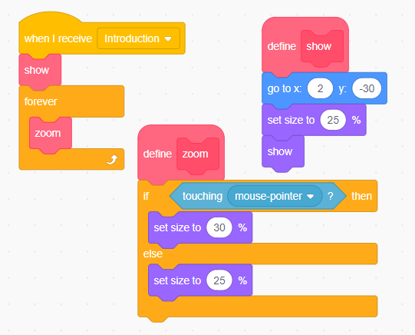
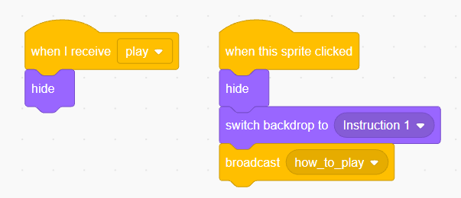
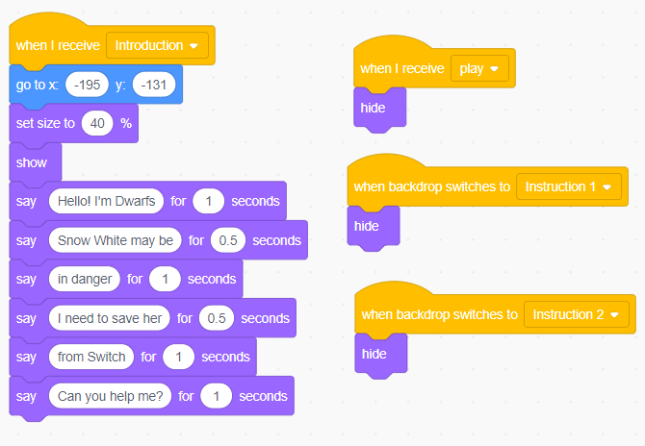
- Code of help button:
- Code of Drawf_start:

- Introduction 1:

When players click on next button, “Introduction 2” will appear on the screen.
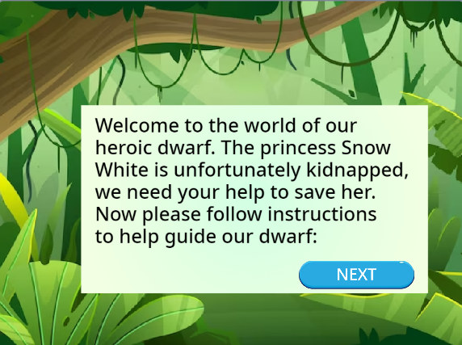
Code of next button:
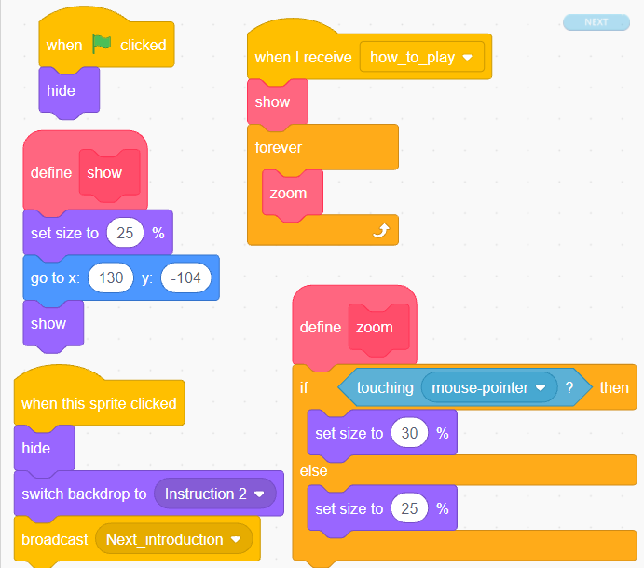

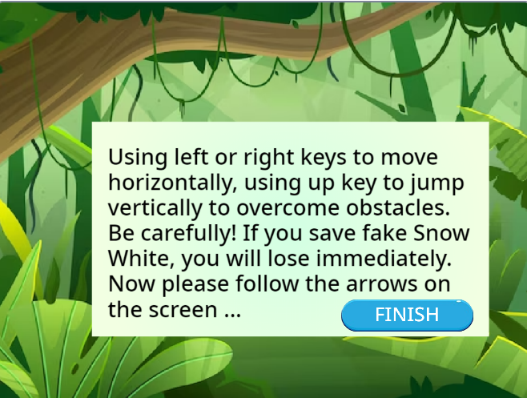
- Introduction 2:
When clicking on the finish button, the screen will return to the cover page.
Code of finish button:

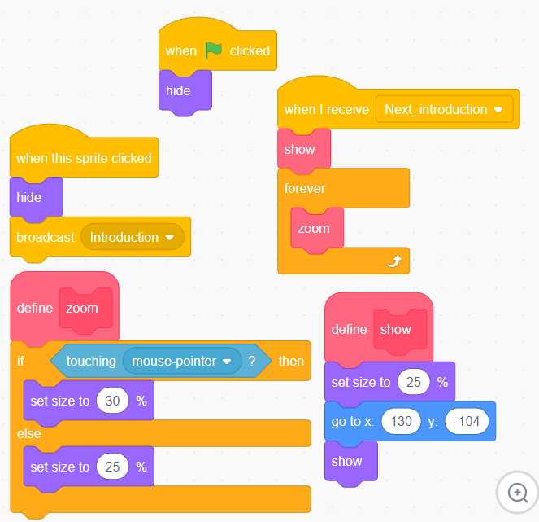
- Level 1:
When clicking ‘Play’, the screen will promptly display the interface of level 1 with many obstacles such as snakes, water, lava, spikes. Whenever the Dwarf encounters these obstacles, 1 heart will be subtracted from his total lives bar. Additionally, there will be an apple positioned within this level, which can add one heart when the Dwarf touches it. Lives in this game are counted according to the following rule: when the Drawf has 3 lives left, touching the apple will augment the count to 4 lives. At that point, a golden heart will appear, representing the fourth life.
The five pictures below which are the interface of level 1 contains starting, progressing and ending.
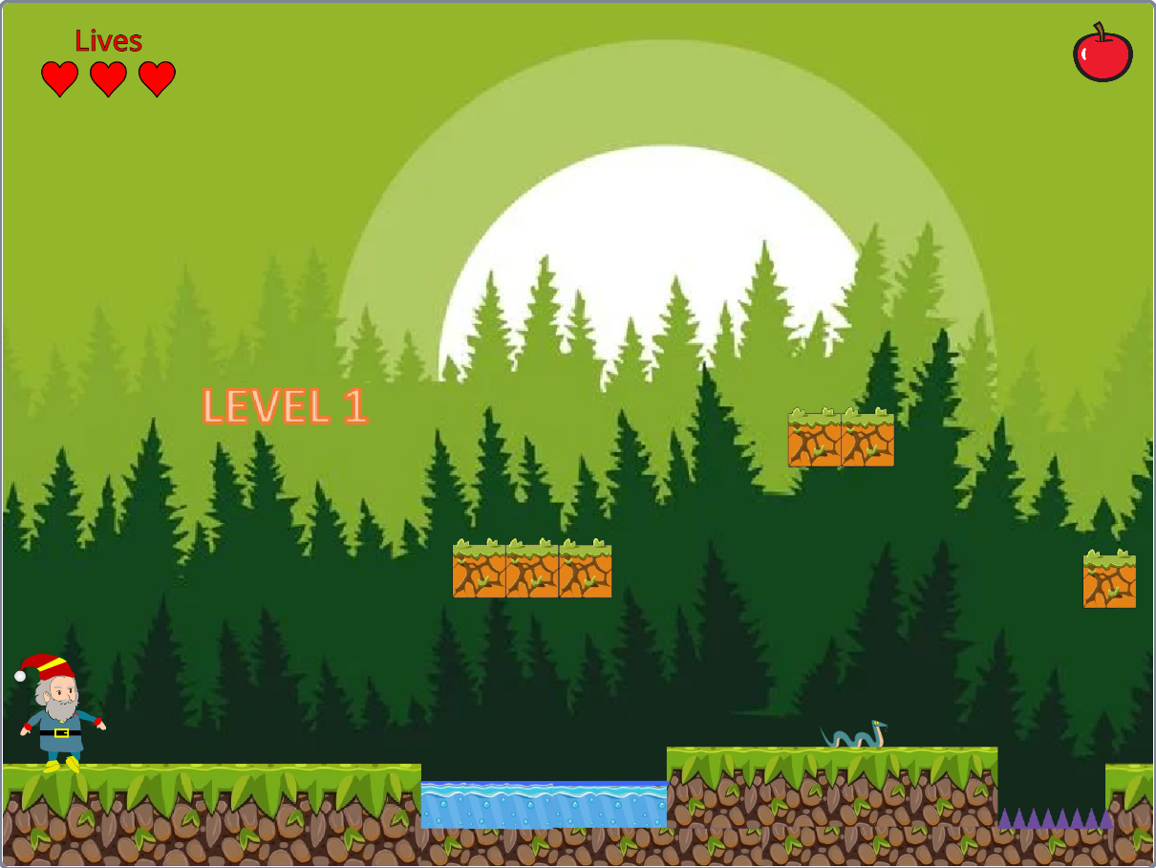
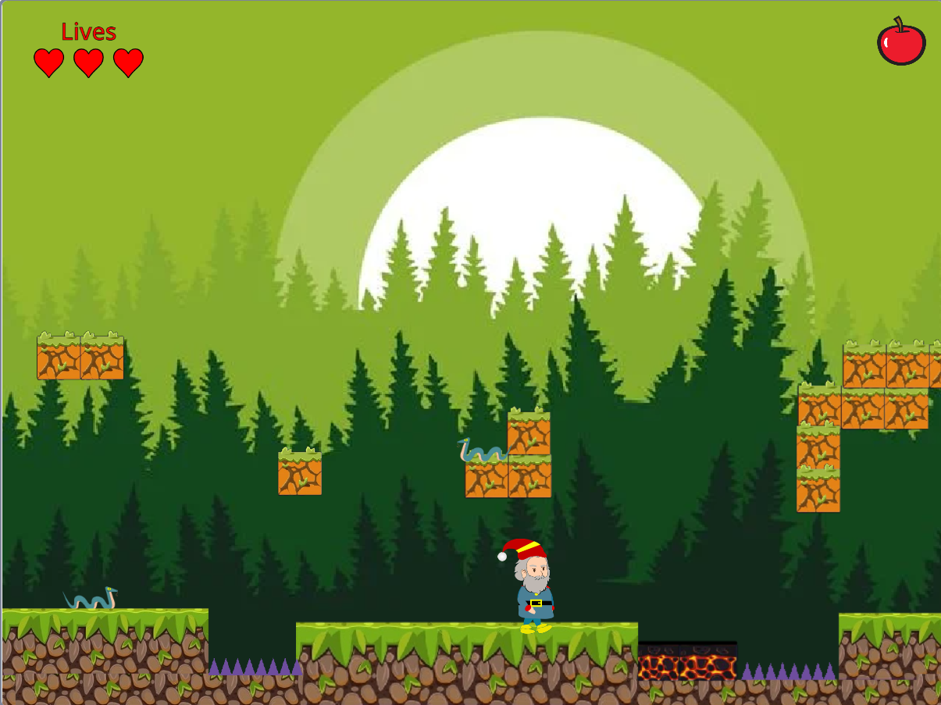
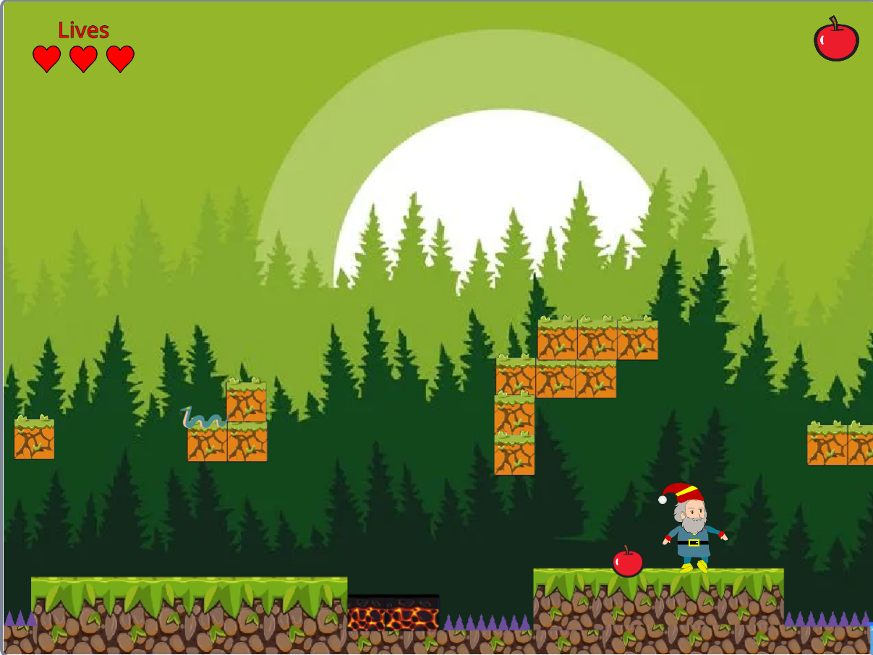
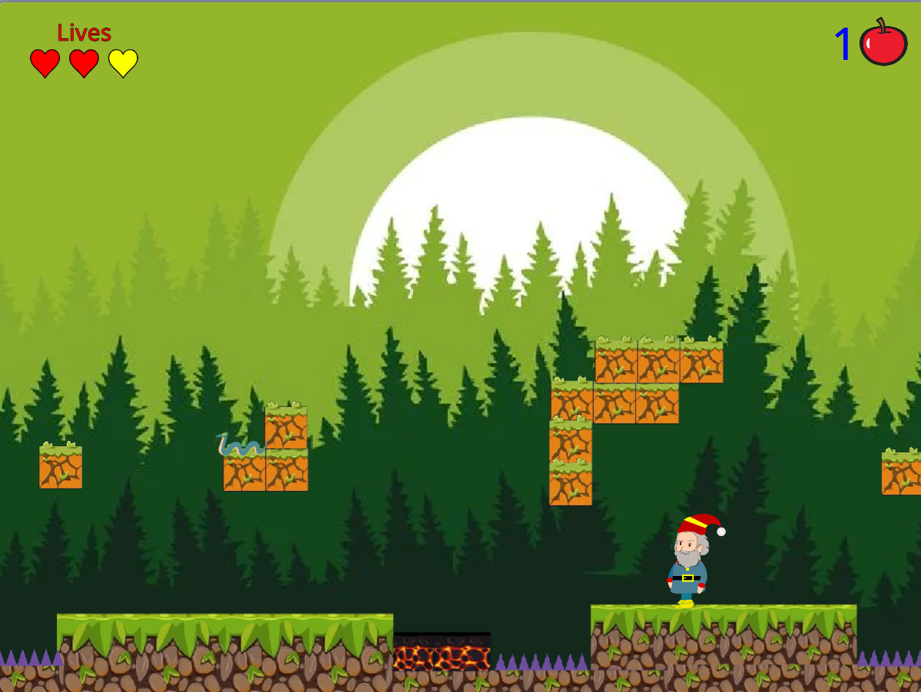

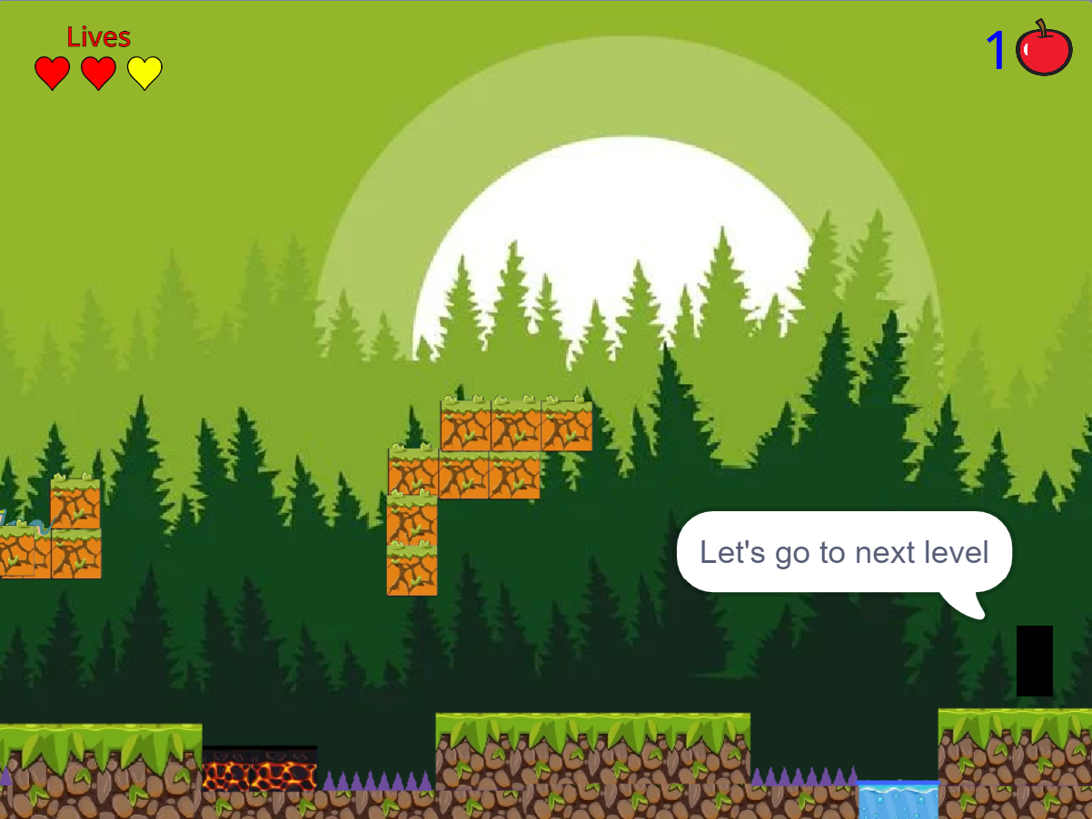

This level contains 2 little maps, including map lv1.1 and map lv1.2:

- Code of map lv 1.1:
When level 1 starts,
the Drawf_move will reset to 0.
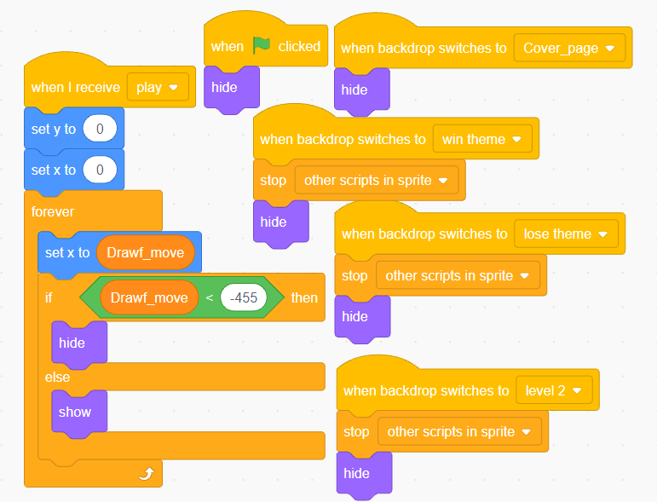
- Code of map lv 1.2:
After map level 1.1 end, map lv 1.2 appear.
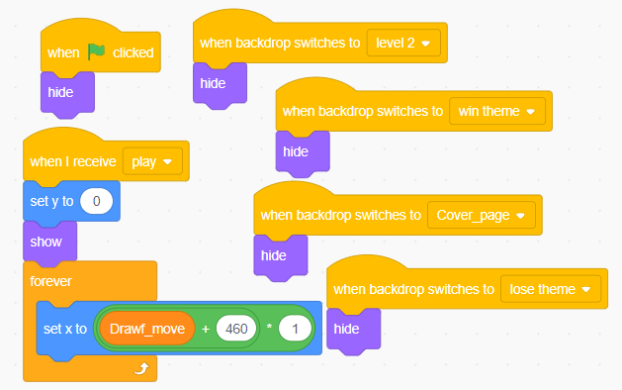
- Code of apple 1:
If the Dwarf touches apple 1, it will start sound, hide and stop its script. When Drawf touch apple 1, he will receive 1 heart to his lives. In case, his lives is equal to 5, his lives will not increase.
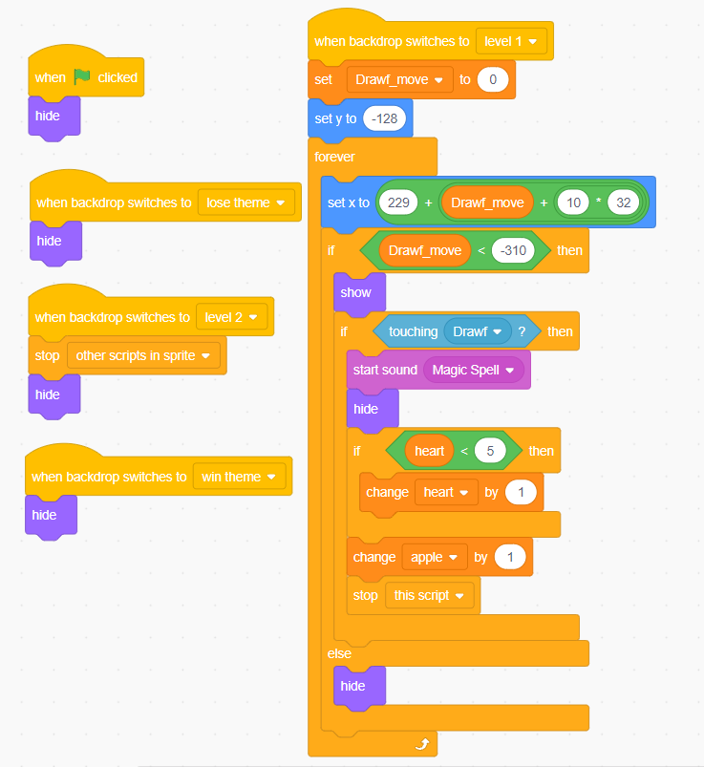

- Code of snake:
If the Dwarf touches snake, it will hide. Until screen turn to other backdrop, its script will stop.
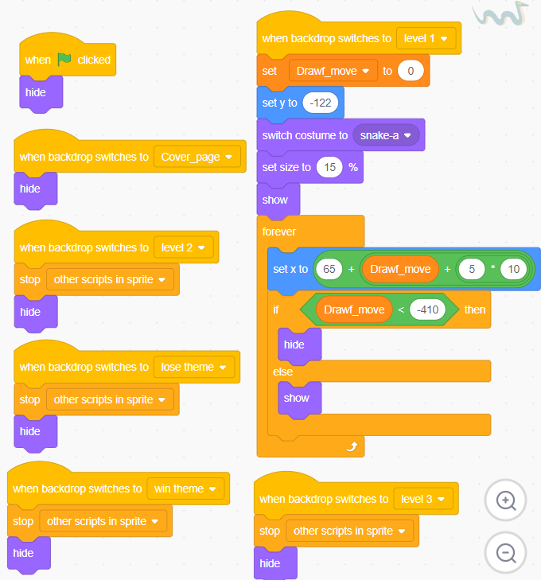

- Code snake 2:
If the Dwarf touches snake 2, it will hide. Until screen turn to other backdrop, its script will stop.
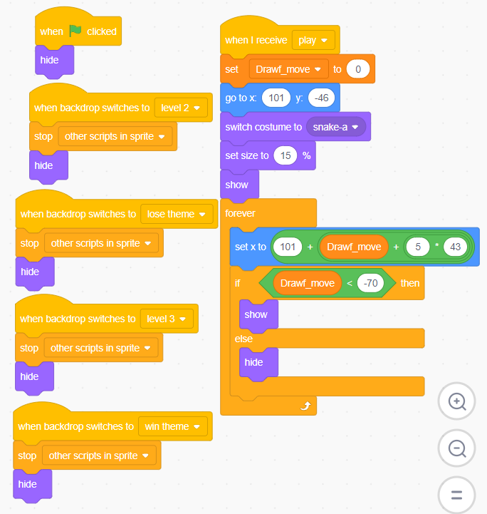
- Level 2:
When position of x exceeds 214, the screen will promptly transfer to the interface of level 2. In this level, obstacles include lion, water, lava, spikes, and fake Snow White. The rule of adding and subtracting lives is similar to level 1. However, if the Dwarf touches fake Snow White, players will lose the game immediately.
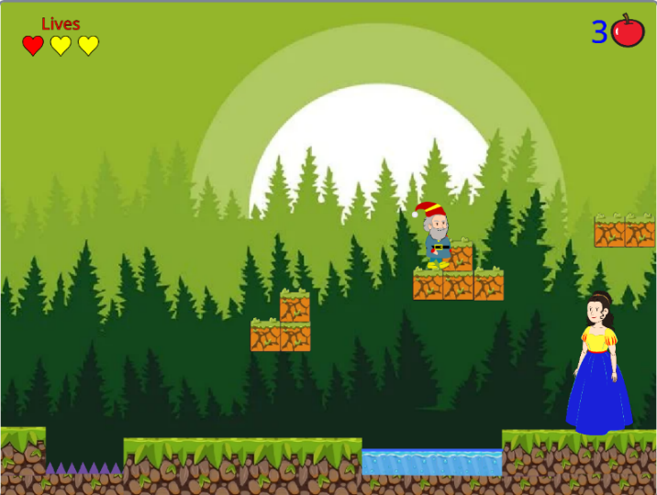
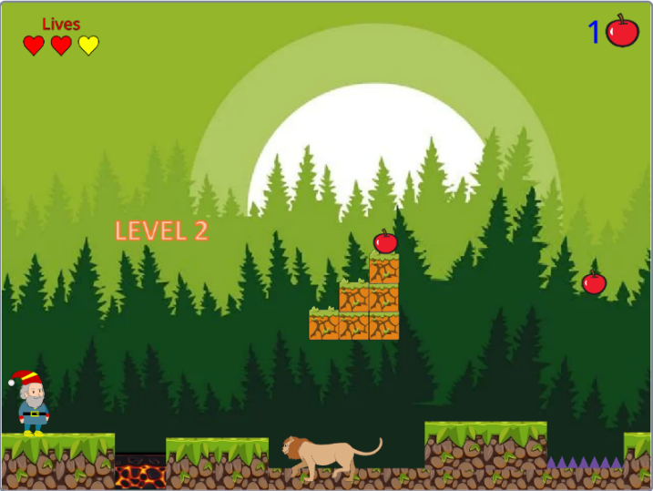
The fourth images below which are the interface of level 2 contains starting, progressing and ending.
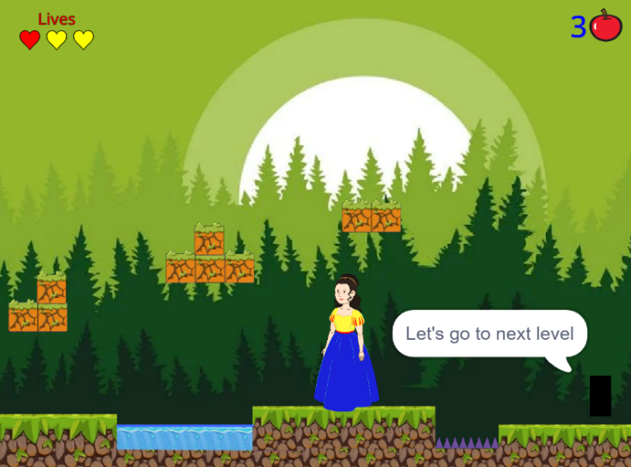
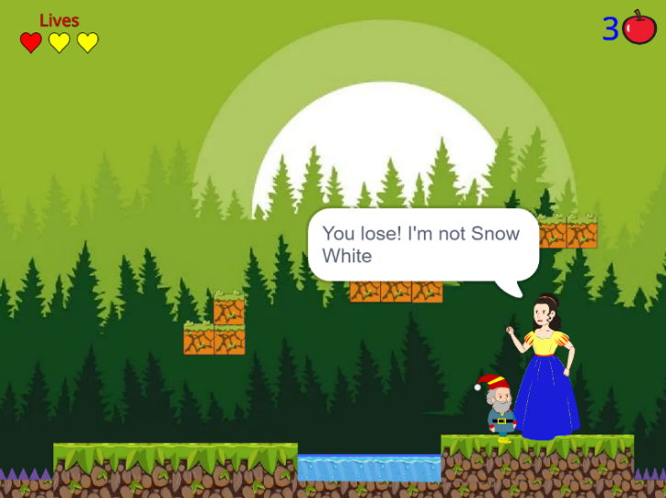

This level contains 2 little maps, including map lv2.1 and map lv2.2:

- Code of map lv 2.1:
When level 2 starts,
the Drawf_move will reset to 0.
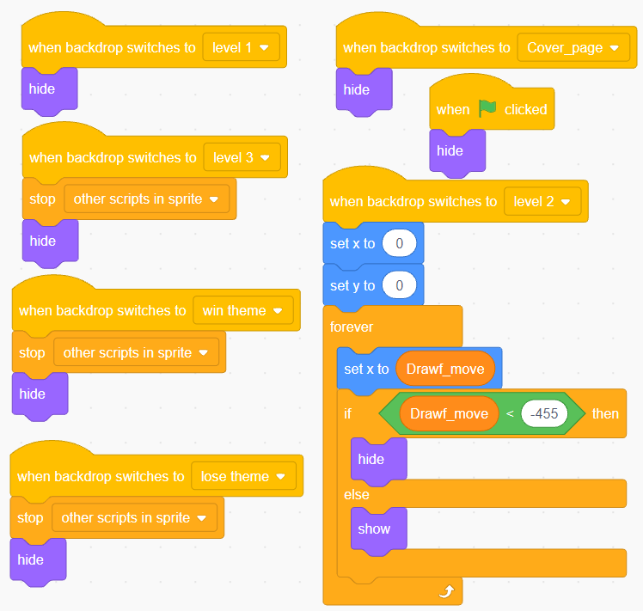
- Code of map lv 2.2:
After map level 2.1 end, map lv 2.2 appear.
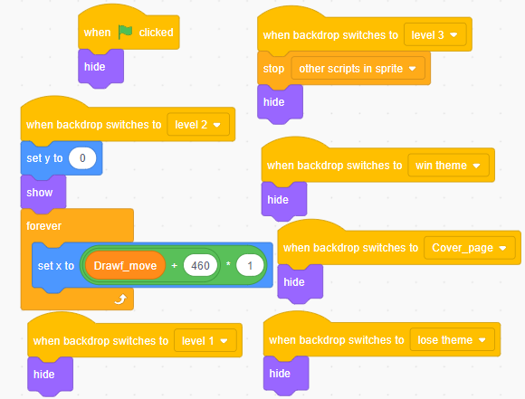
- Code of apple 2:
If the Dwarf touches apple 2, it will start sound, hide and stop its script. When Drawf touch apple 2, he will receive 1 heart to his lives. In case, his lives is equal to 5, his lives will not increase.
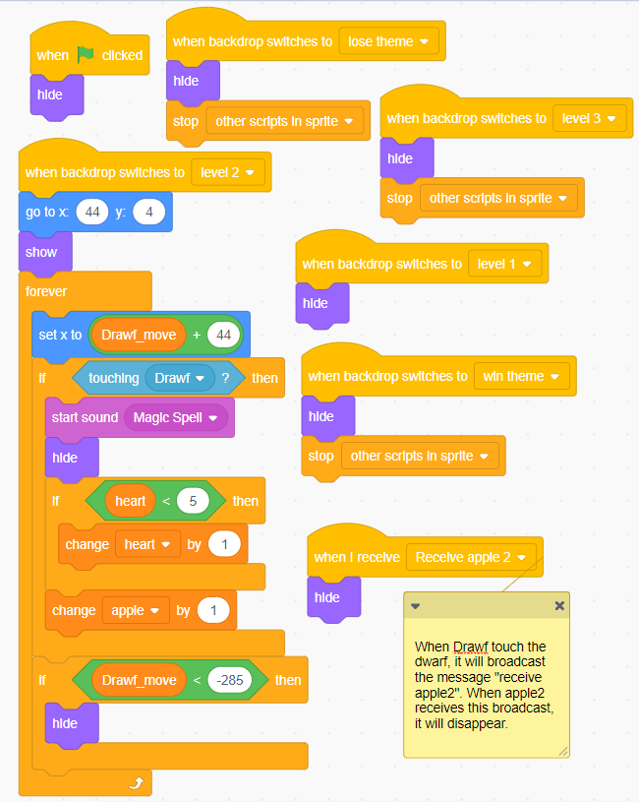

- Code of apple 3:
If the Dwarf touches apple 3, it will start sound, hide, and stop its script. When Drawf touch apple 3, he will receive 1 heart to his lives. In case, his lives is equal to 5, his lives will not increase.

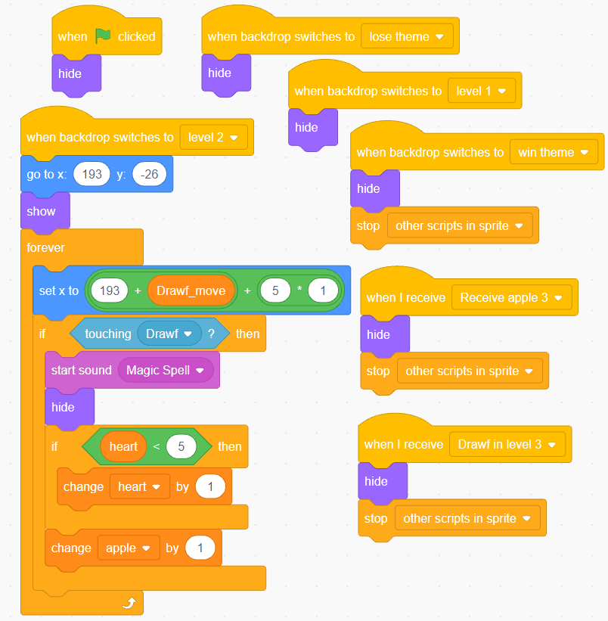

- Code of lion:
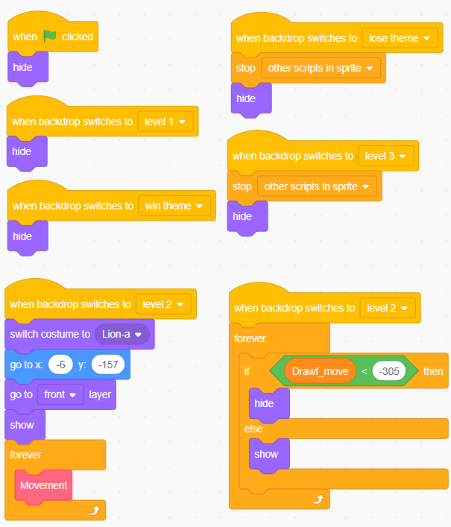

The lion moves back and forth, changes x-coordinates accordingly to the Drawf_move. When Drawf touches it, he will be subtracted 1 heart from lives (this thing will be shown in code if Drawf).
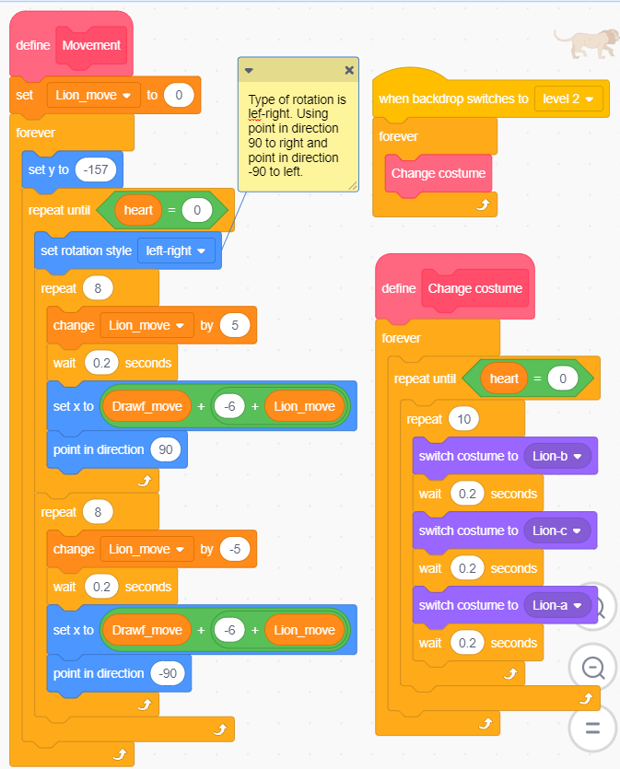

- Code of fake Snow White:
When Drawf_move < -305, the fake Snow White will appear. During this time, if the dwarf touches her, the player will immediately lose because he has mistakenly rescued the fake snow white.
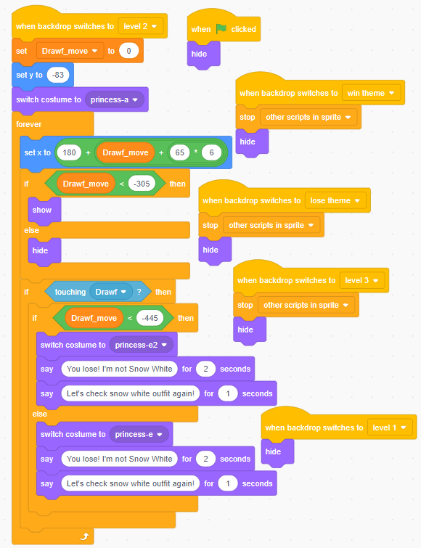

- Level 3:
When the position of x exceeds 214, the screen will immediately show the interface of level 3. In this level, obstacles include a brown bear, a flying witch, water, lava, spikes, and fake Snow White. The rule of adding and subtracting lives is similar to level 1. Additionally, if the Dwarf touch fake Snow White, players will lose the game immediately.
The three images below which are the interface of level 3 contains starting, progressing and ending.
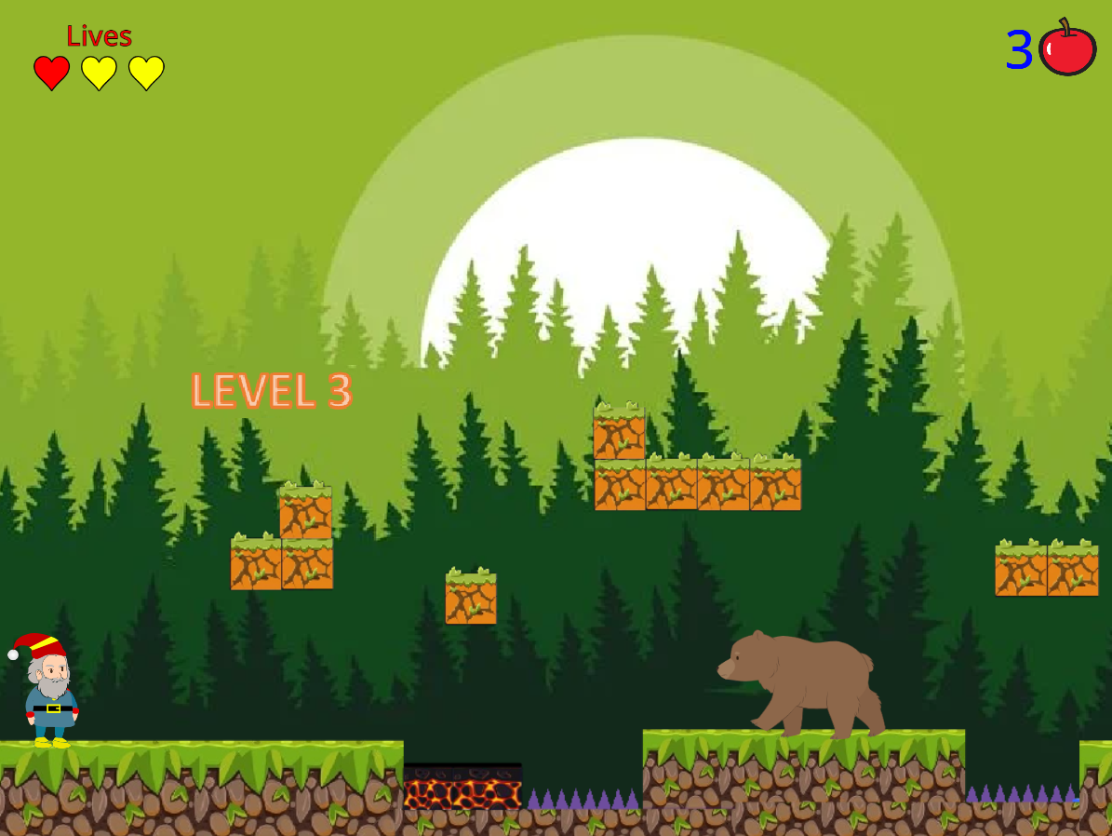
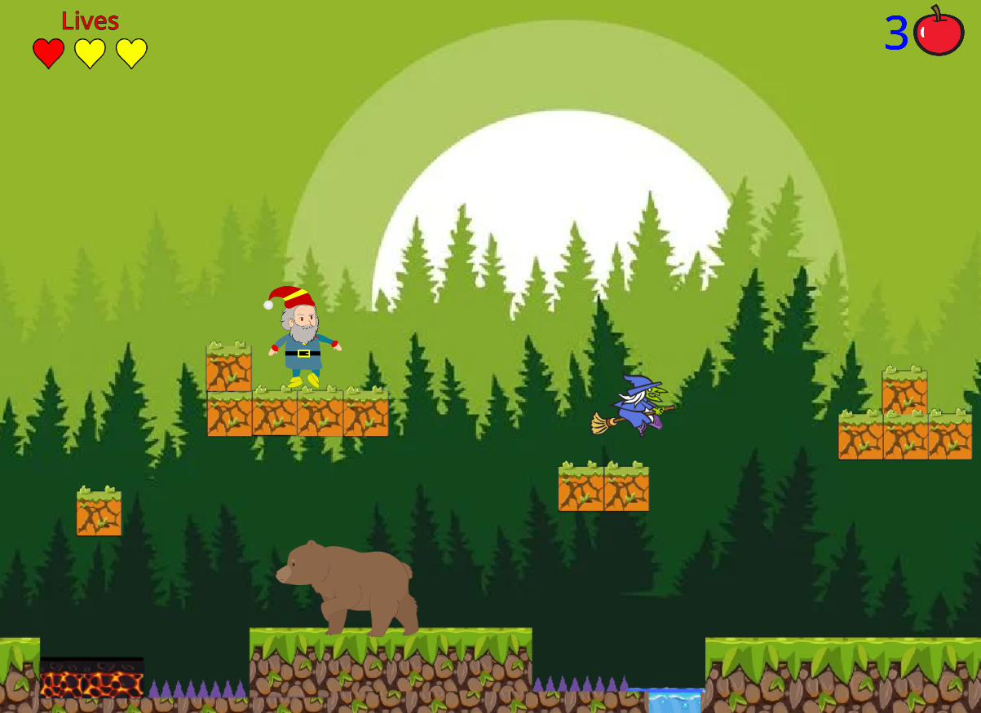

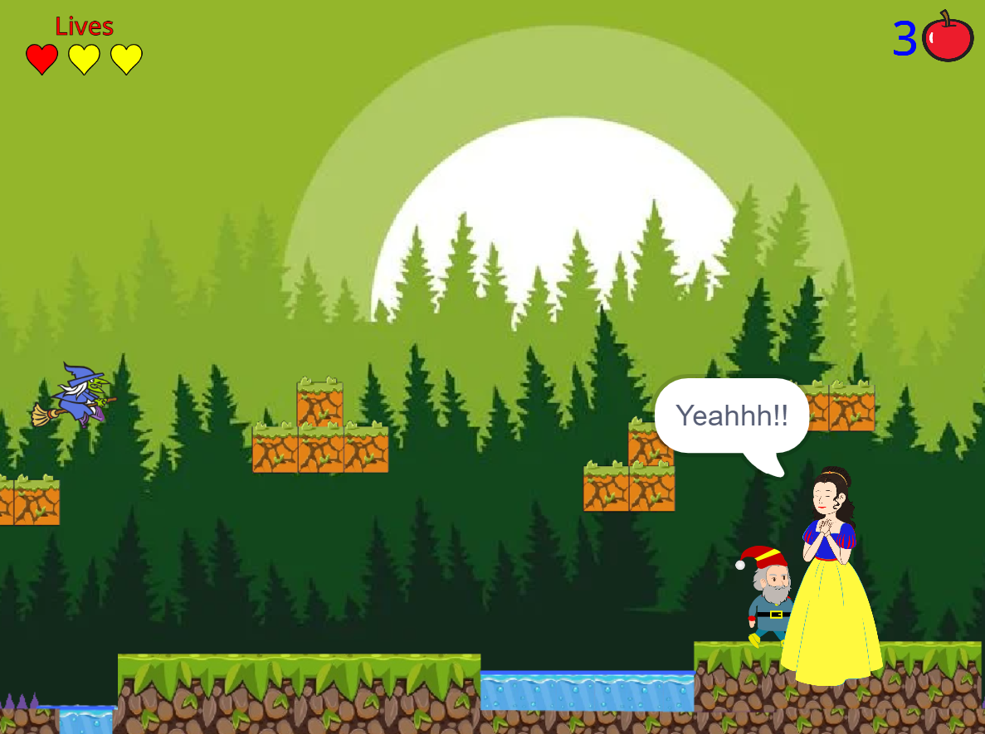

This level contains 2 little maps, including map lv3.1 and map lv3:
- Code of map 3.1:
When level 3 starts,
the Drawf_move will reset to 0.
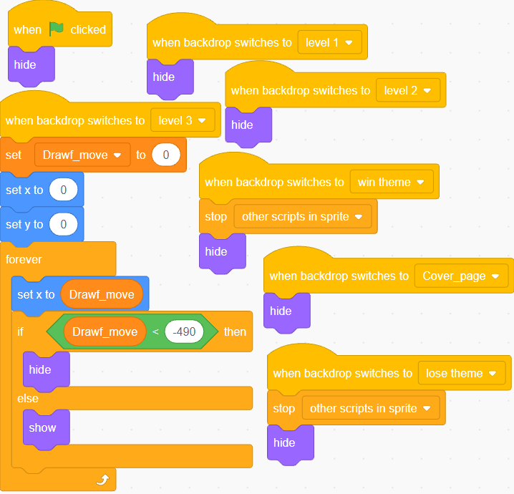
- Code of map 3.2:
After map level 3.1 end, map lv 3.2 appear
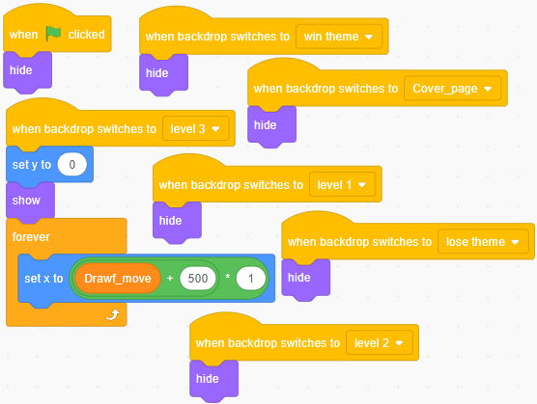

- Code of bear:

The operating principle of the bear is similar to that of the lion in level 2.
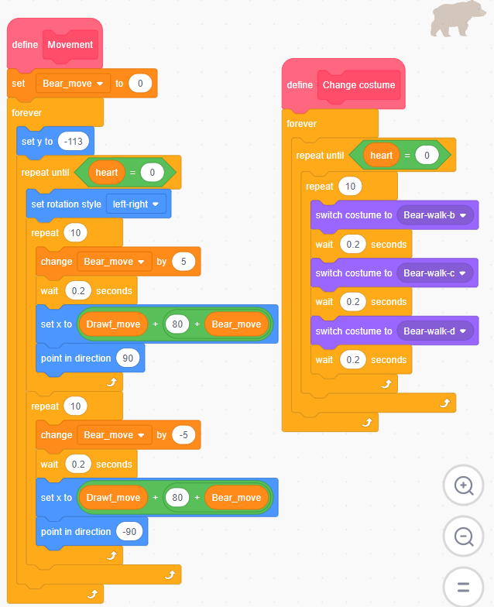

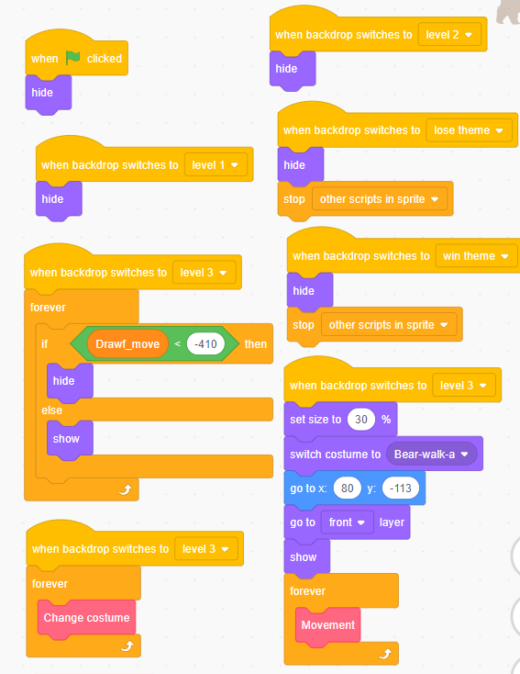
- Code of Witch:
The witch will glide along the triangle shape. When the Dwarf touches it, 1 heart will be deducted (this thing will be shown in code of Drawf) the player will replay that level from the beginning.
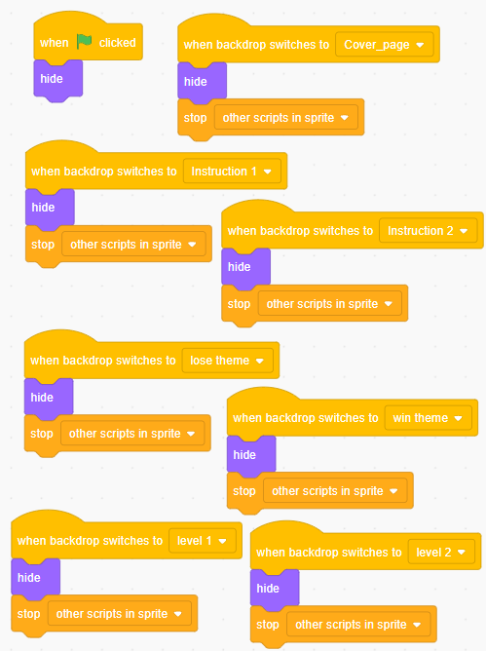
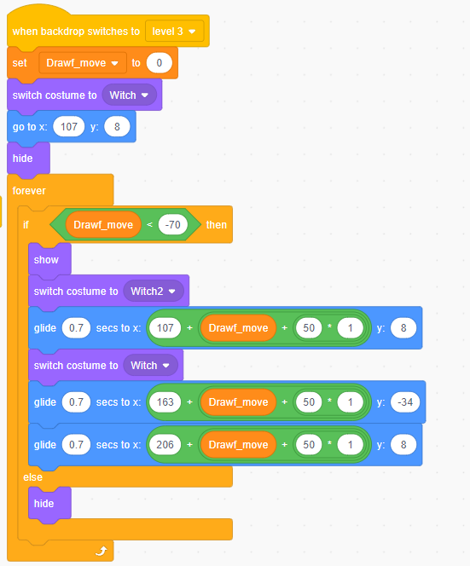

- Lose backdrop:
If losing, the score table will default to 0.
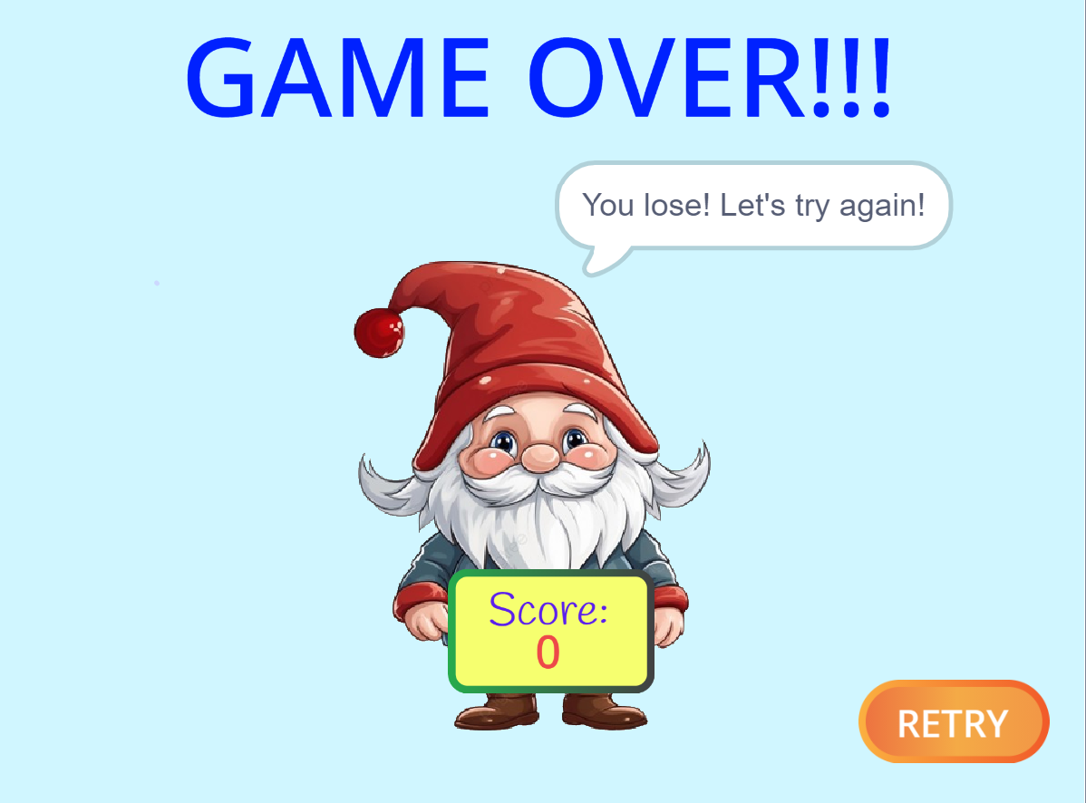
Score table
- Code of Dwaf_end:
This sprite is used for lose backdrop and win backdrop.
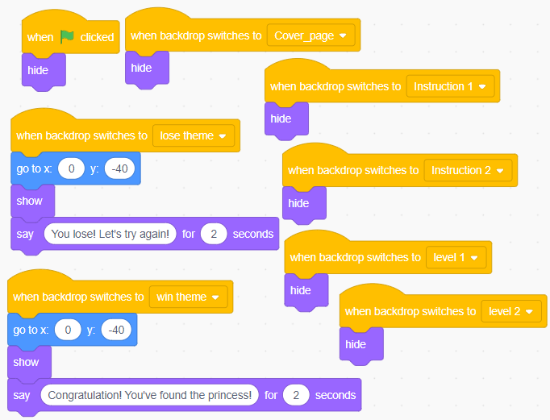
- Code of retry button:
This sprite is used for lose backdrop and win backdrop
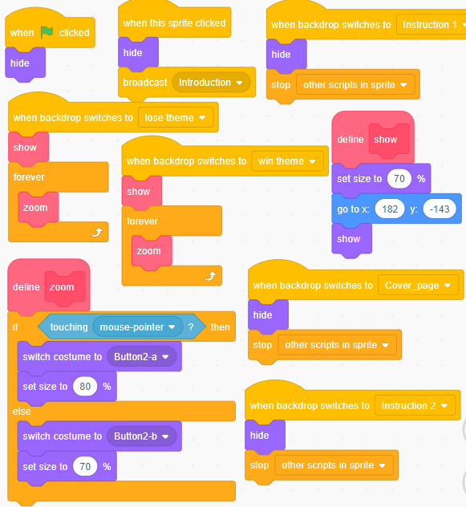
- Win backdrop:
Code of score table is showed at section k.
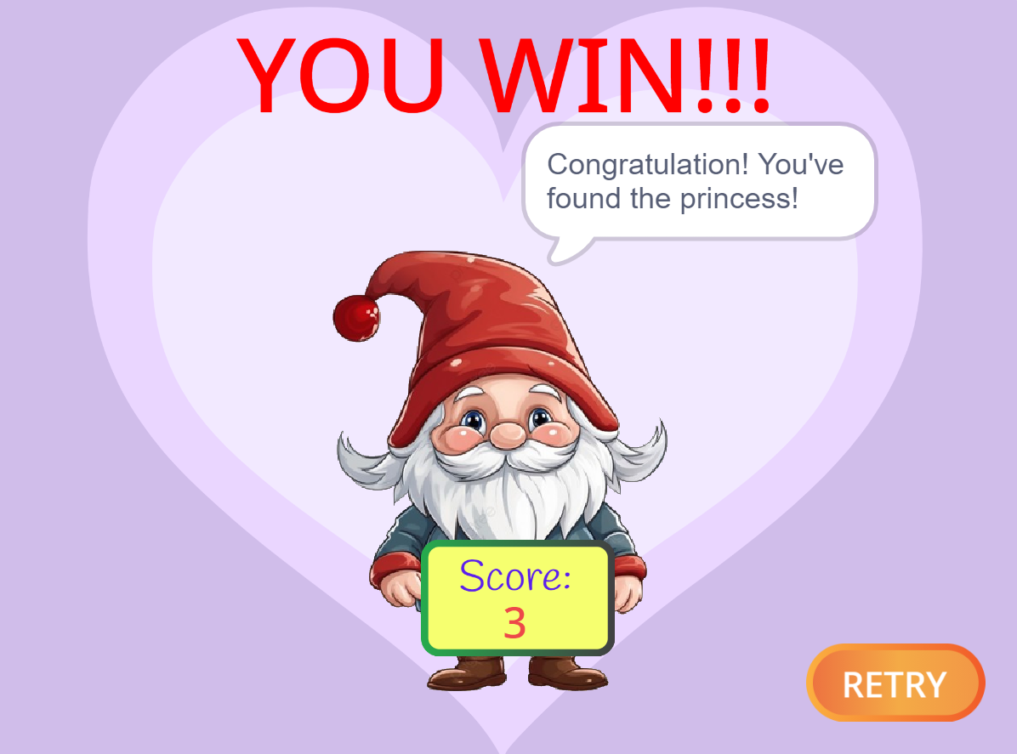
Score table
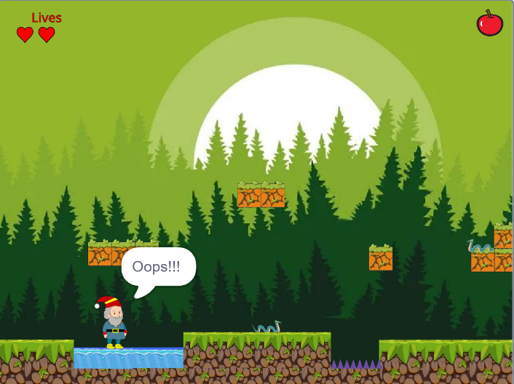
- When Drawf touch obstacles:
He will say “Oops!!!”. In that case, the player must replay that level from the beginning, unless they touch the fake Snow White, am immediately loss will be applied.

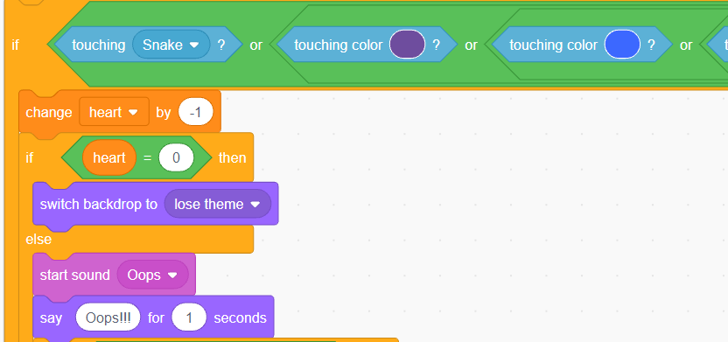
Here are some of obstacles that Drawf may touch
- Rules of adding heart:
Each time Dwarf consumes an apple, he will gain one additional life, up to a maximal limit of 5 lives.
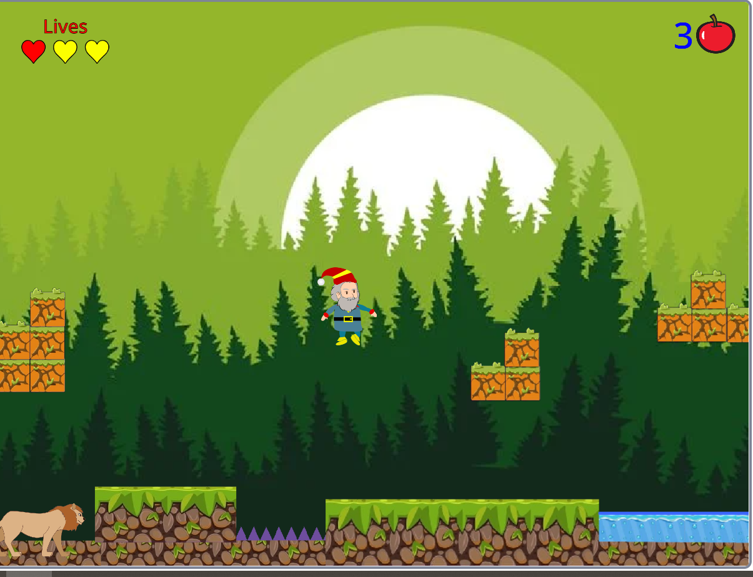
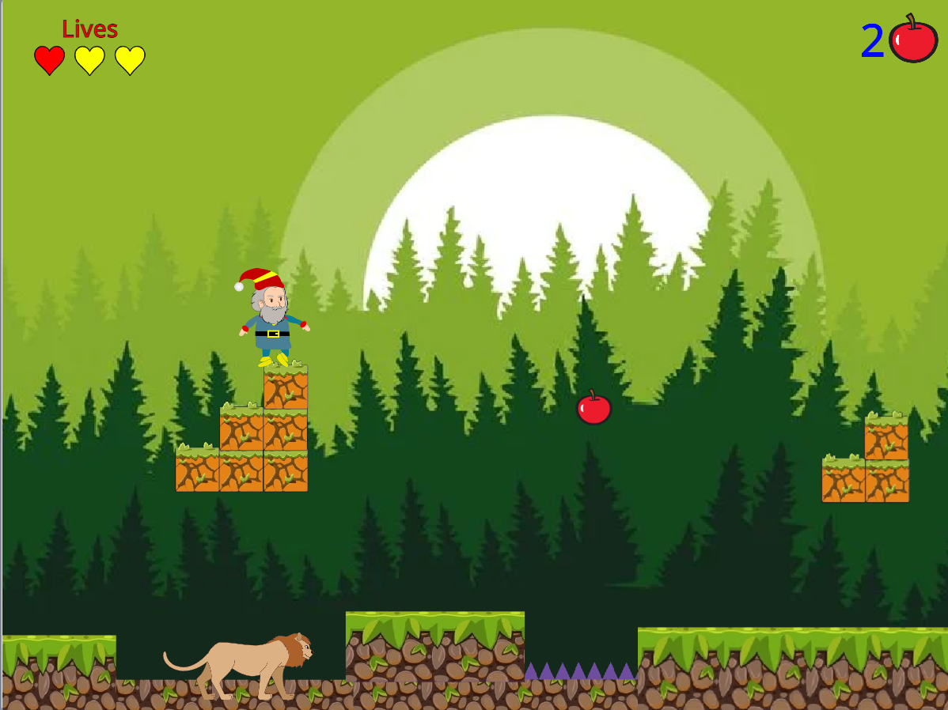

- Code of number of lives, heart, level, score:
- Code of number of apple:
The costume of the apple will change based on the value of the variable "apple".
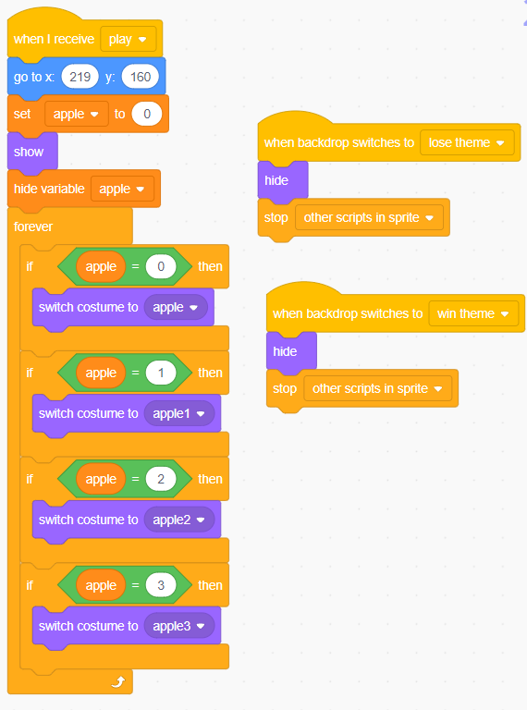

- Code of number of lives:
The costume of the lives will change based on the value of the variable "lives".
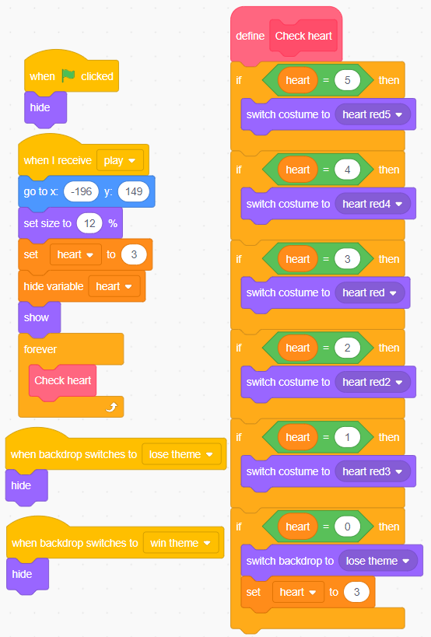

- Code of level:
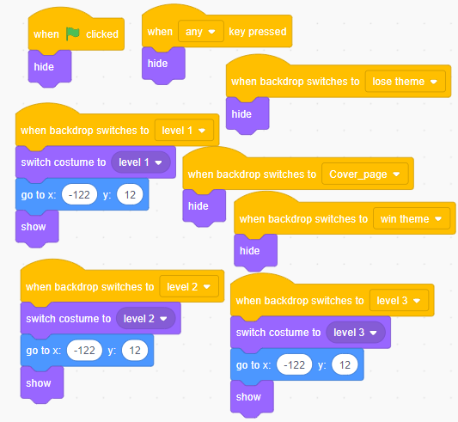
- Code of sound:
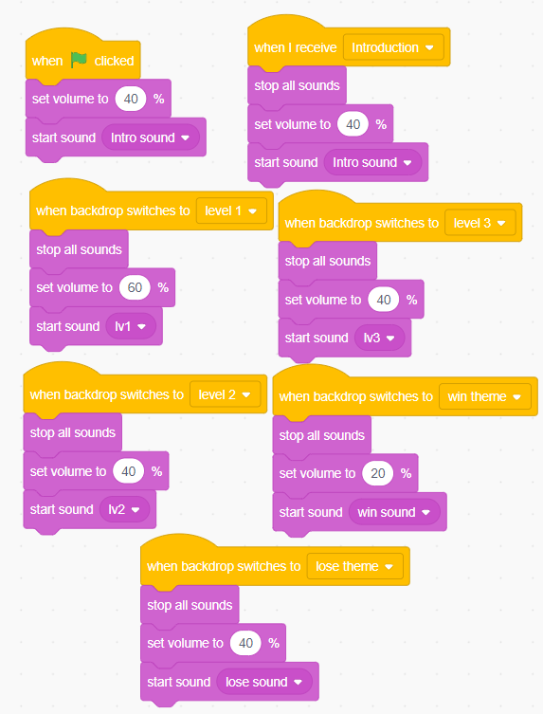
- Code of score table:
Player’s scores are calculated by combining the points from hearts and apples. In the event of loss, the score resets to zero.
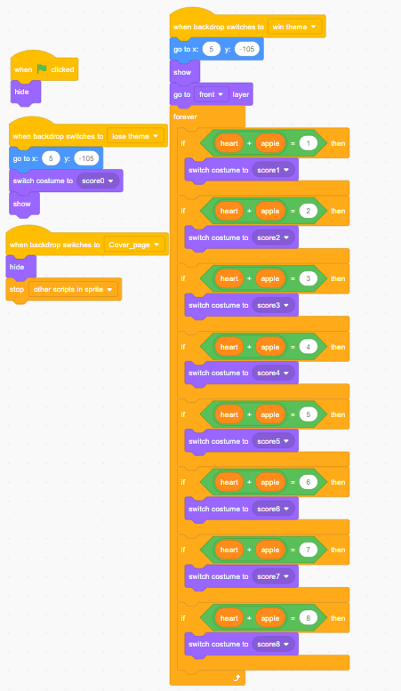
- Code of Drawf:
He will hide until receiving broadcast “PLAY”. When screen turn to win backdrop or lose backdrop, he hides
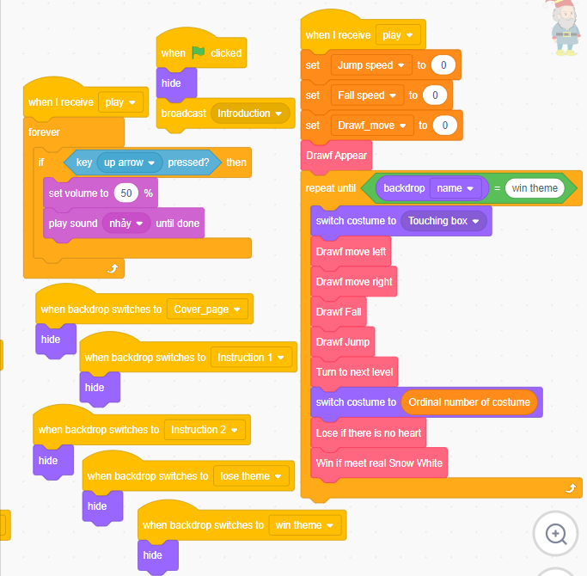

- Code of “Drawf appear” block:
Drawf will appear with costume number 1 and x = -221, y = -117. Initially, the parameters related to the Dwarf are set to 0.
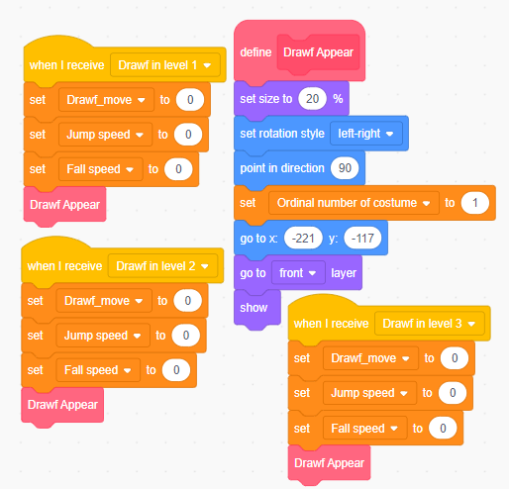
- Code of “Drawf move left” and “Drawf move right”block:
If position x of Drawf is over -221, he cannot move left. If position x of Drawf is over 215, he cannot move right.
When Drawf is moving, using Drawf_move to count steps in order to synchronize the movement of the map of each level.
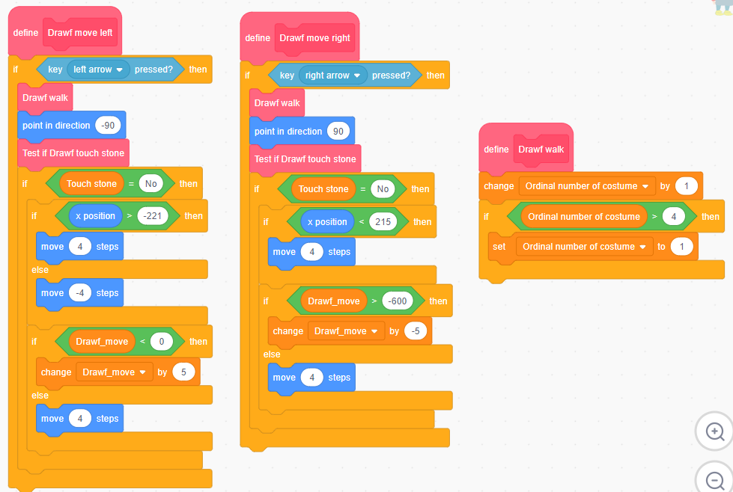
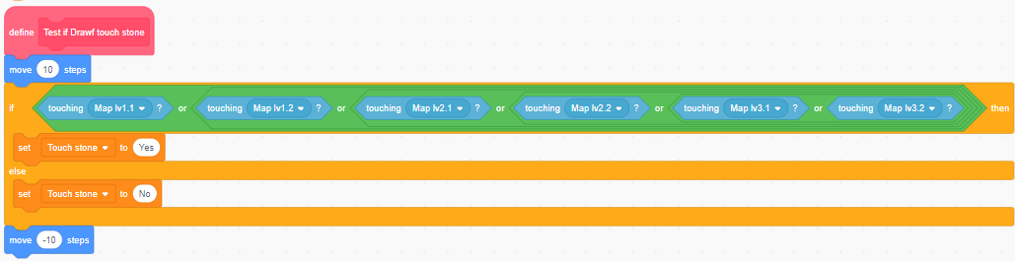
During moving left/right, system always check whether Drawf touches sprites named map lv1.1, map lv1.2, map lv2.1, map lv2.2, map lv3.1, map lv 3.2
- Code of “Drawf Jump” and “Drawf Fall” block:
When Drawf is on land, he can jump with jump speed is 14. If the jump speed is greater than 0, change position y according to the formula: y = y + 14 + 13 + 12 +… + 1 until the jump speed equals 0 then stop. At that point, the y-coordinate gradually decreases according to the
formula: y = y – fall speed (fall speed is increasing by 1.75 each time until fall speed equals 7, then stop).
IF Drawf’s head touches land, then gradually fall according to the formula: y = y – fall speed (fall speed is increasing by 1.75 each time until fall speed equals 7, then stop).
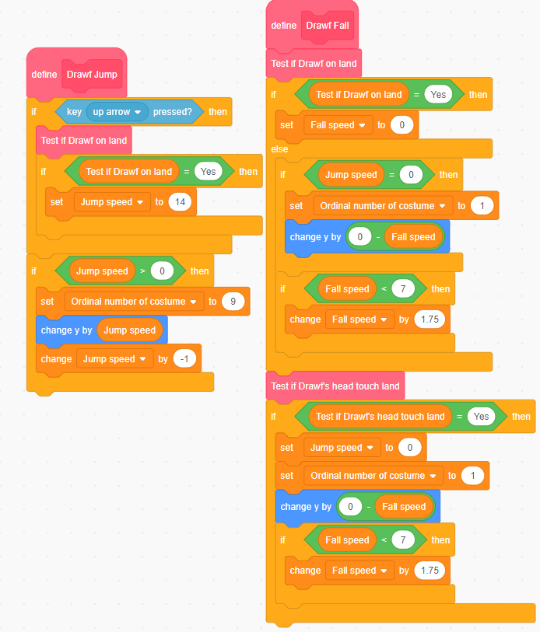
  - Code of “Test if Dwarf on land” and “Test if Drawf’s head touch land” block:
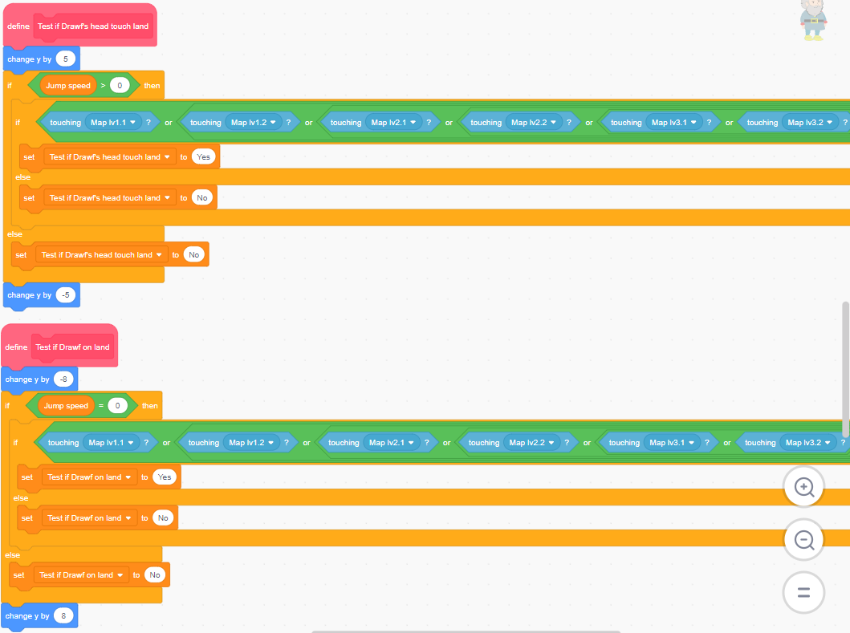
During jumping and falling, system always check whether Drawf touches sprites named map lv1.1, map lv1.2, map lv2.1, map lv2.2, map lv3.1, map lv 3.2
- Code of “Turn to next level” block:
This block is used to switch to the next level if the x-coordinate of the dwarf is greater than 214.
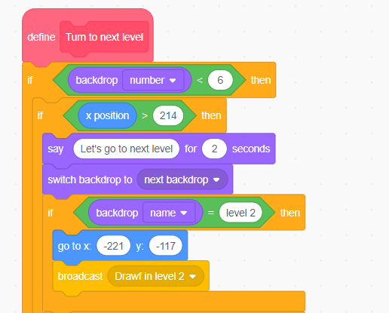
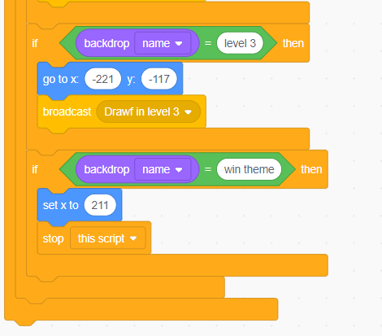

- Code of “Lose if there is no heart” block:
This block is used to check whether the Dwarf still has a heart. If lives of him is over than 1, the game continues; otherwise, it switches to the losing screen and the game stops altogether.
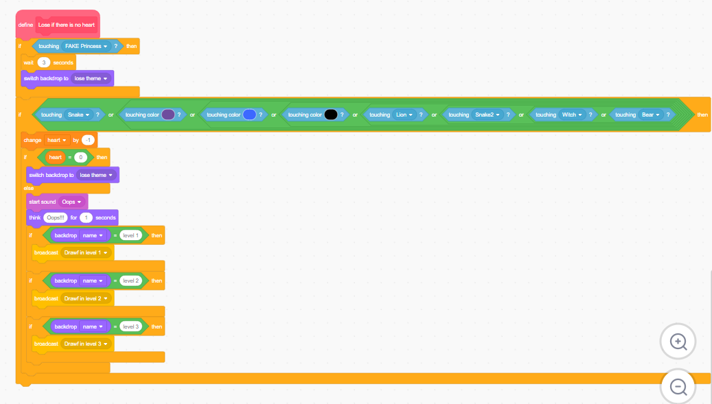
- Code of “Win if meet real Snow White” block:
When the dwarf has found Snow White, the screen switches to the win backdrop. 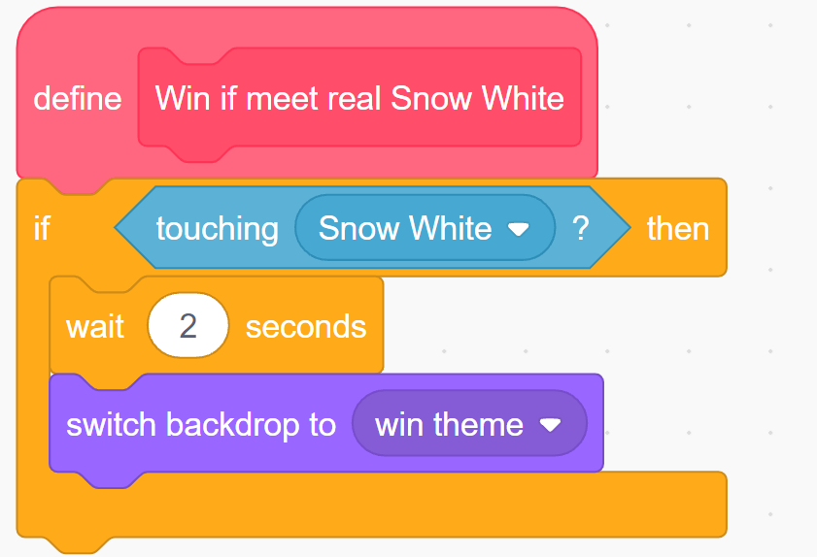
- Result:
After exploring programming with Scratch extensively, I have learned how to use and connect commands, as well as the operating principles of some common commands of new language programming Scratch. Additionally, I have enhanced my programming skills and devised common calculations for game development. After trying this game programming, I have gained valuable experience from programming on Scratch, resulting in:
- The game runs smoothly without errors.
- Accurate operating of basic functions.
- User-friendly interface with suitable sounds.

CHAPTER 3: CONCLUSION
- Recap of tasks performed and achievements:
- Completed building the "Dwarf Rescue Snow White Princess" game using Scratch
- The game features character movement, scoring, managing lives
- Attractive interface, user-friendly
- Successfully combined entertainment and programming learning elements
- Development direction:
In the upcoming versions, I intend to add swimming and wild animals combat as self-defense abilities for the Dwarf. Furthermore, by adding a two-player mode, improved graphics, multiple levels, and different seasonal backgrounds will significantly enhance the game’s appeal to players. Additionally, time limits can increase intensity and challenges of the game positively.

REFERENCES
Image:
- Block of map (from Pinterest):
https://www.pinterest.com/pin/126241595799348126/feedback/?invite_code=d9fa9b69f9b54b9a9127ddf9d75879c8&sender_id=720857621514544702
https://www.pinterest.com/pin/539587599116894263/feedback/?invite_code=b900800904fe48d2845eafff1f0daae6&sender_id=720857621514544702
https://www.pinterest.com/pin/944489353079926035/feedback/?invite_code=3ff73d0efb9d4a97b840d4f84419c887&sender_id=720857621514544702
- Theme (from Template.net):
https://www.template.net/editable/102379/green-forest-background
Sound:
- Sounds of introduction, lose backdrop, win backdrop and each level (from Pixabay.com):
https://pixabay.com/vi/music/synthwave-neon-gaming-128925/
https://pixabay.com/vi/music/tro-choi-video-8-bit-background-music-for-arcade-game-come-on-mario-164702/
https://pixabay.com/vi/music/synthwave-on-the-road-to-the-eighties-loop1-177567/
https://pixabay.com/vi/music/giai-ieu-tre-em-ang-so-creepy-devil-dance-166764/
https://pixabay.com/vi/music/tro-choi-video-8-bit-halloween-story-166454/
- Sound of the Dwarf when jumping and the Dwarf's outfit (from Scratch.mit.edu):
https://scratch.mit.edu/projects/760264984/
Video (from Youtube):
https://www.youtube.com/watch?v=QuZA24FEiIs
Internet documentary:
Nga Hoàng – Giải thích các câu lệnh của Scratch – T4/2020 https://laptrinhscratch.com/giai-thich-tat-ca-cac-cau-lenh-cua-scratch/
Tài liệu Scratch 3-Tổ bộ môn trường Tiểu học Lý Tự Trọng Q.12 - 31/10/2020 https://thlytutrong.hcm.edu.vn/to-bo-mon/tai-lieu-scratch 30/ctmb/85397/592233

