

THESIS IN
INFORMATION TECHNOLOGY
(HIGH-QUALITY PROGRAM)

Topic
STUDENT MANAGEMENT SYTEM WITH PYTHON AND MYSQL
Advisor: Dr. Do Thanh Nghi | Student: Hoang Tien Dat  ID: B2111976  Course: K47

Can Tho, 02/2023

Contents
ACKNOWLEDGEMENTS 3
Chapter 1: INTRODUCTION 4
Topic: 4
Objective: 4
Brief summary of the outcome: 4
Chapter 2: IMPLEMENTATION OF THE STUDENT MANAGEMENT SYSTEM 4
System proposal: 4
Database: 5
1. monhoc (Subject) 5
2. giaovien (Teacher) 5
3. lop (Class) 5
4. Giangday (Teaches) 5
5. diem (Grades) 5
Create table and insert code of this database: 6
Create procedure and function code of this database: 10
Programming language: 14
Library: 14
Result achieved: 14
1. Show student. 15
2. Add student 17
3. Change student personal information 18
4. Remove student 21
5. Show all the student in CLASS 22
6. Display student’s academic transcript 22
7. Add a grade column for student 24
8. Modify student grade 30
9. Delete student’s grade column 31
CHAPTER 3: CONCLUSION AND FUTURE DEVELOPMENT 32
CONCLUSION: 32
FUTURE DEVELOPMENT: 32
REFERENCES 33

ACKNOWLEDGEMENTS
First and foremost I am very happy for the assistant of Dr. Do Thanh Nghi each phase of this thesis. I gained many experience when the first time, I have come into contact with game programming in Python and Mysql.
Secondly, I am grateful about the support from the rest of my family. Because of the financial assistance and permission, I can finish the thesis in the earliest time.
Lastly, I want to thank my friends. They gave me good comments.

Chapter 1: INTRODUCTION

Topic:
- Building a simple student management system with Python-MySQL.

Objective:
- The objective of this system are to create an simple student management system with Python-MySQL, this system will handle some of the function including adding, modifying, deleting, and review the student information, with the utilize of Mysql database to perform manipulation with data. And Python to extract data from the database then format them.

Brief summary of the outcome:
- The student management system will perform correctly all of it function. Main feature include adding, modifying, and removing student records, as well as generating academic transcripts. Additionally, the system allows for viewing student information, listing students by class, and managing assessment grades.

Chapter 2: IMPLEMENTATION OF THE STUDENT MANAGEMENT SYSTEM

System proposal:
- In my project this system will provide an platform for understanding how the student management system manage data.

Database:
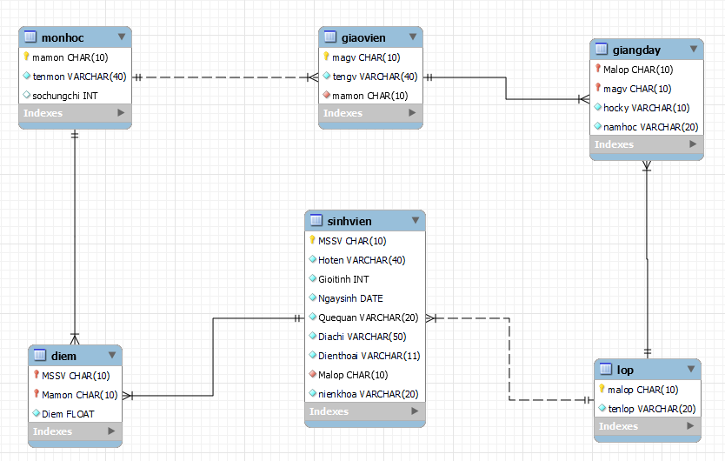

monhoc (Subject)
- The 'monhoc' table used to store the subject of all student can register.
- Each class primary key ('mamon'), a name ('tenmon'), and tells you how many credits student took ('sochungchi').

giaovien (Teacher)
- The 'giaovien' table stores information about the teachers.
- Each teacher has a primary key ('magv'), and also store their name ('tengv'). It also tells us which subject they teach ('mamon').

lop (Class)
- The 'lop' table is to separate all of student into class.
- Each class has a primary key ('malop') and a name ('tenlop').

Giangday (Teaches)
- The 'Giangday' show us which teacher with primary key ('magv') is teaching which class ('malop').
- It also includes the time they teach it, like the semester ('hocky') and school year ('namhoc').

diem (Grades)
- The 'diem' table is like a report card.
- It connects a student primary key ('MSSV') with a subject primary key ('mamon') and stores their grade ('Diem').

Create table and insert code of this database:
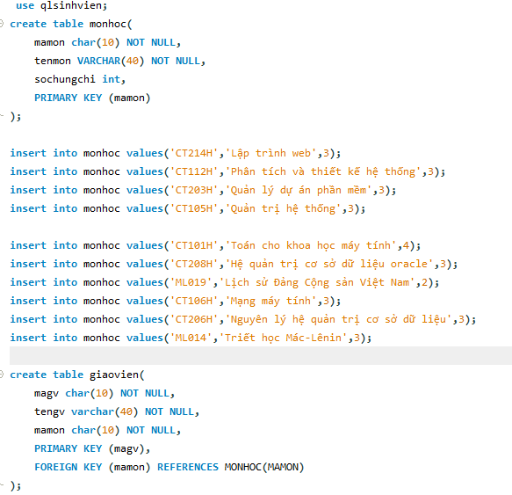
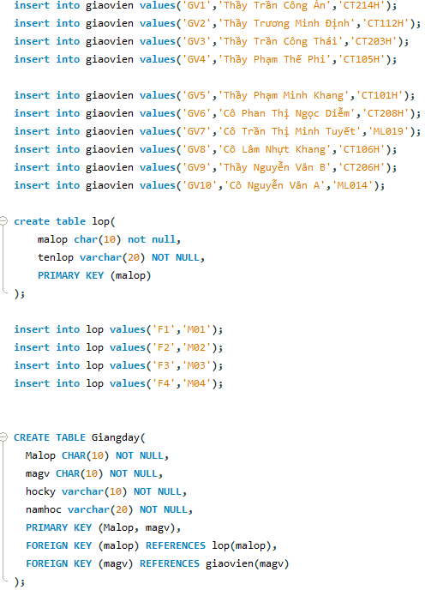
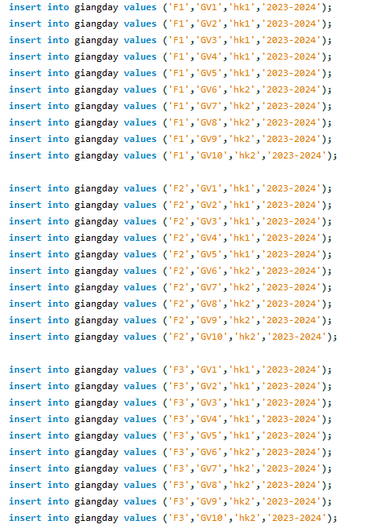
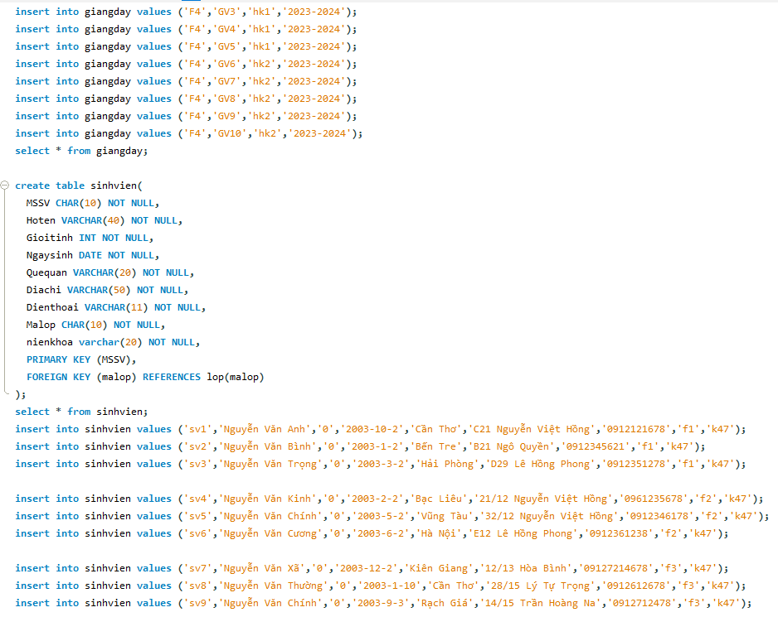
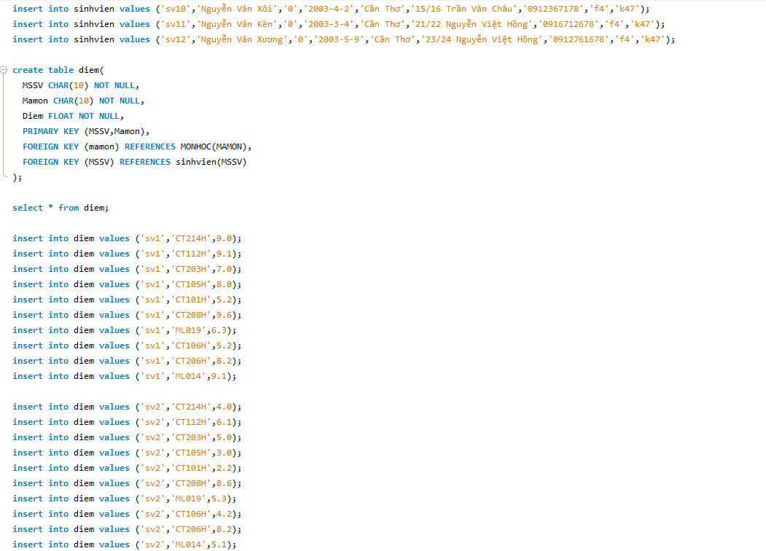
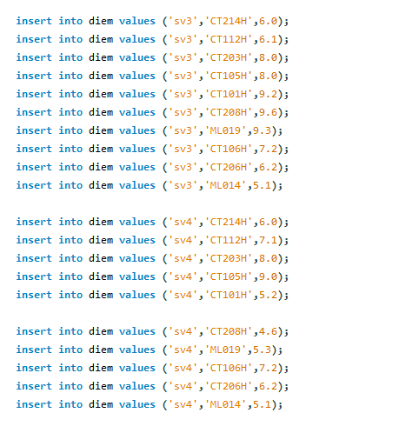

Create procedure and function code of this database:
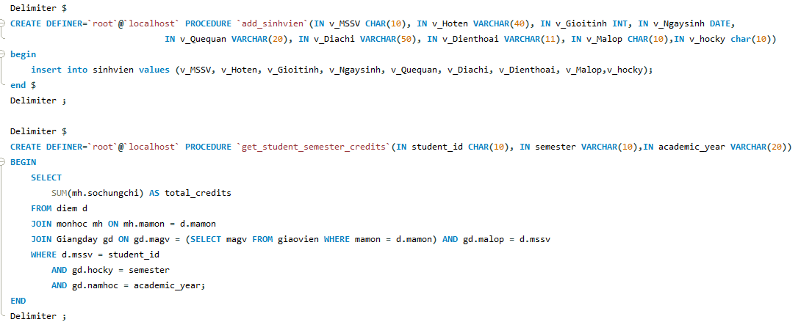
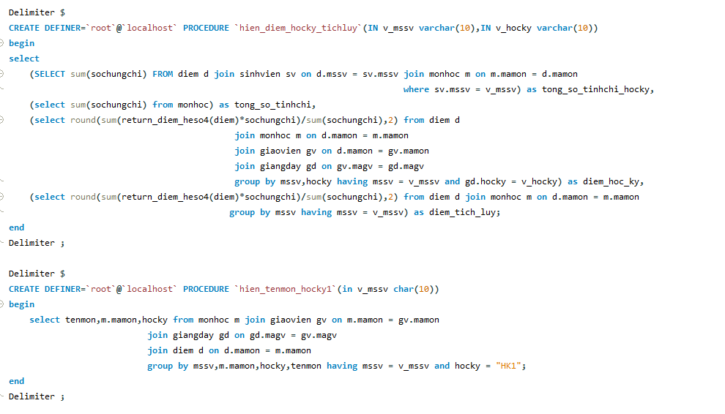
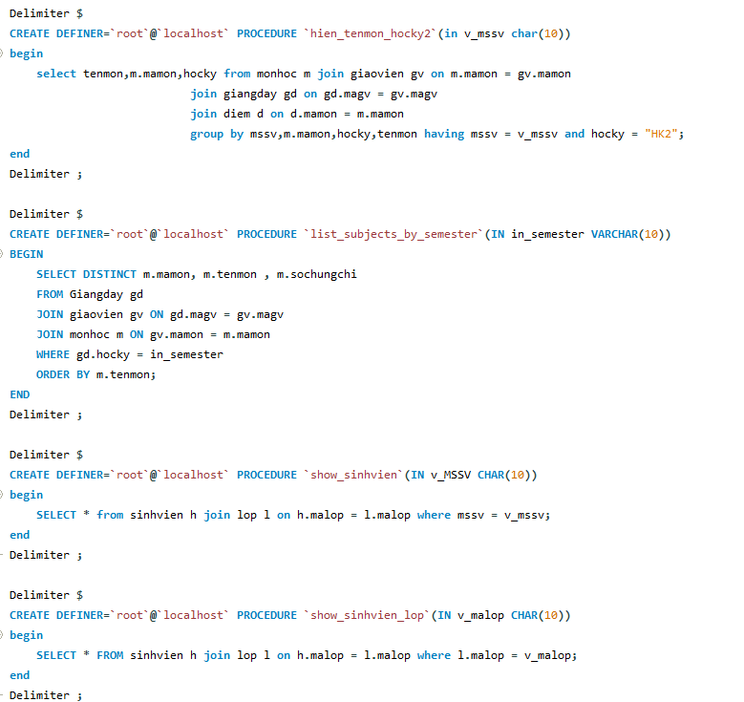
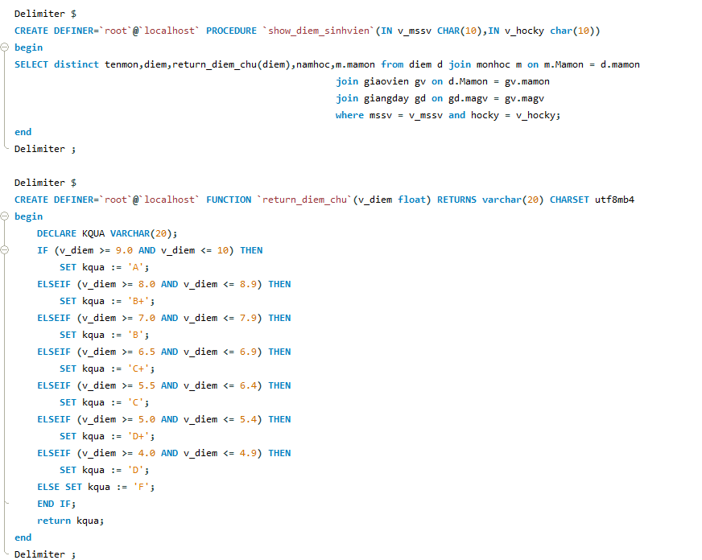
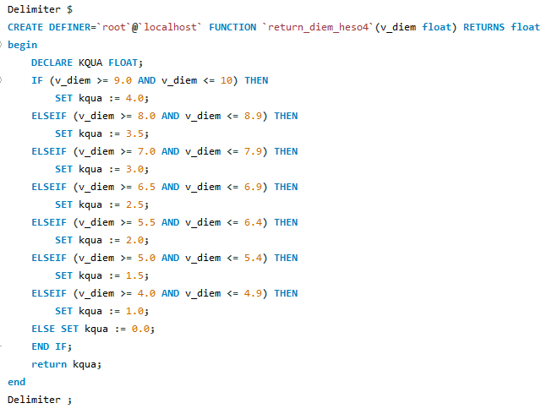
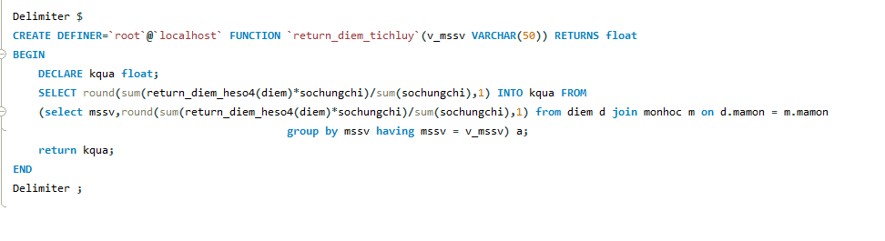
All procedure used in database:
- show_sinhvien(v_mssv): show student information
- show_sinhvien_lop(v_malop): show all student in one class
- show_diem_sinhvien( v_mssv, v_hocky): show score of student in specific semester
- hien_diem_hocky_tichluy(v_mssv,v_hocky): show the GPA in semester and overall GPA of student
- hien_tenmon_hocky1(v_mssv): show all subject of student that already have score in the second semester
- hien_tenmon_hocky2(v_mssv): show all subject of student that already have score in the second semester
- list_subjects_by_semester(v_hocky): show all subject in specific semester
All function used in database:
- return_diem_chu(v_diem): return the score by alphabet from input v_diem.
- return_diem_heso4(v_diem): return diem in the scale of 4 from input v_diem.
- return_diem_tichluy(v_mssv): return the overall GPA

Programming language:
- This system management student is coded in Python. For a student with an experience in many language like me, the python code is very approachable, it have it own declare syntax, and many library to support the coding process. And it also enable access to mysql database using mysql.connector library.

Library:
- This project uses Python libraries to make development easier and handle many different tasks. The 'mysql.connector' library lets the code connect to the MySQL database where all the student information is stored. I use the 'datetime' library to work with dates, especially for storing student birthdays.

Result achieved:
- With the support of Python functions, this project has many well ability like add, retrieve, modify, updating, and delete student with the help of code in mysql database. Also this system features a code based interface that enables user to interact with it (The user may have some experience in coding field to interact with this project more comprehensively).
- 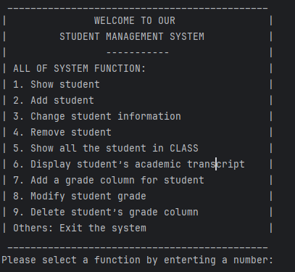
Output of all of my function:

1. Show student.
Code of this function:
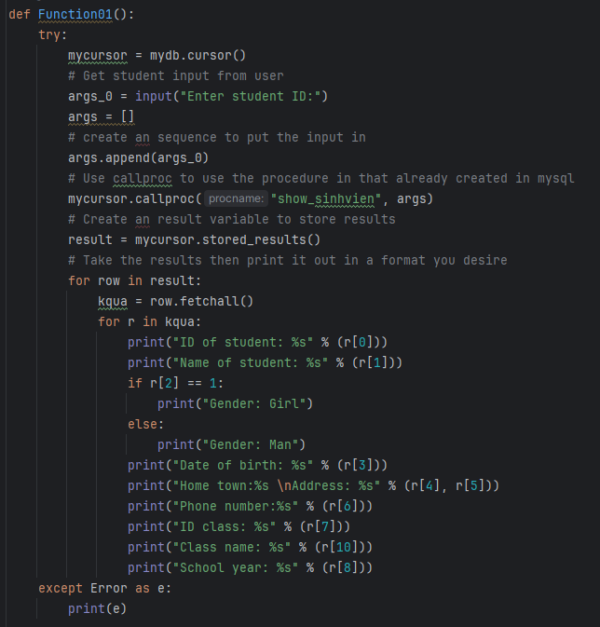
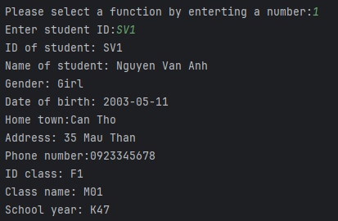
- The first function of this student management system is Show student, this function allow user to show the student information, by selecting the number 1 in the code, it will show all of the student information such as student ID, the name, gender, dob,…

2. Add student
Code of this function:
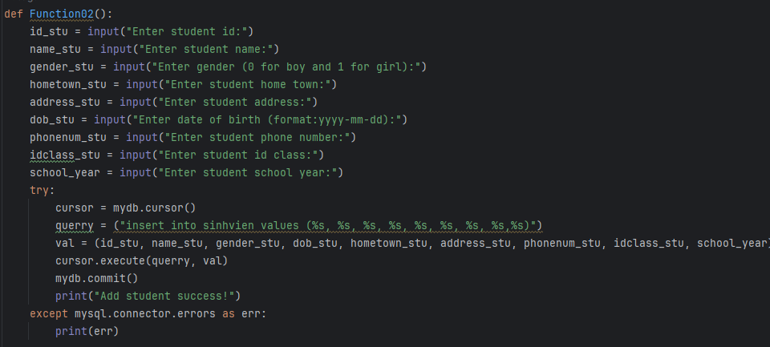
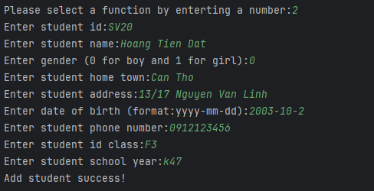
Re-check by using function 1:
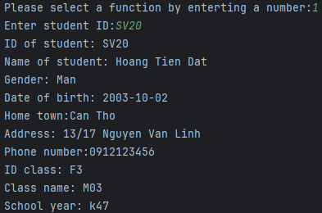
- The second function shows the process of adding a new student information to the system. By selecting number 2, user can add information of a new student in to the database(Please note in the dob they must type in the exact format of the date in order for it to work). If the function run correctly then it will display the info of the new student by using function 1.

3. Change student personal information
Code of this function:
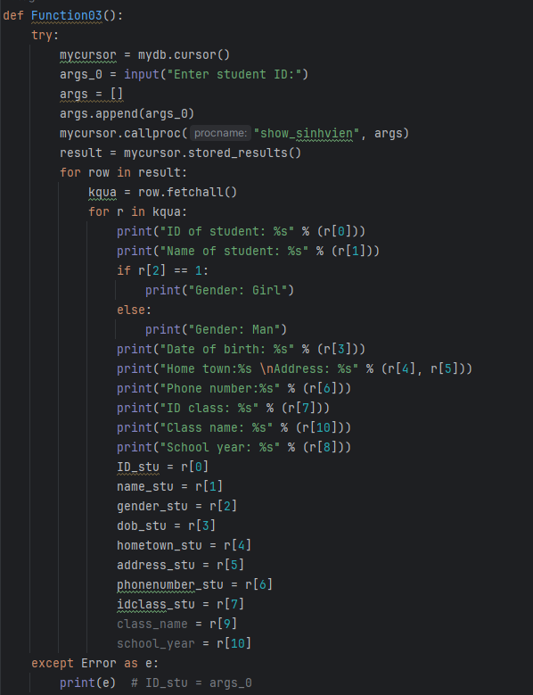
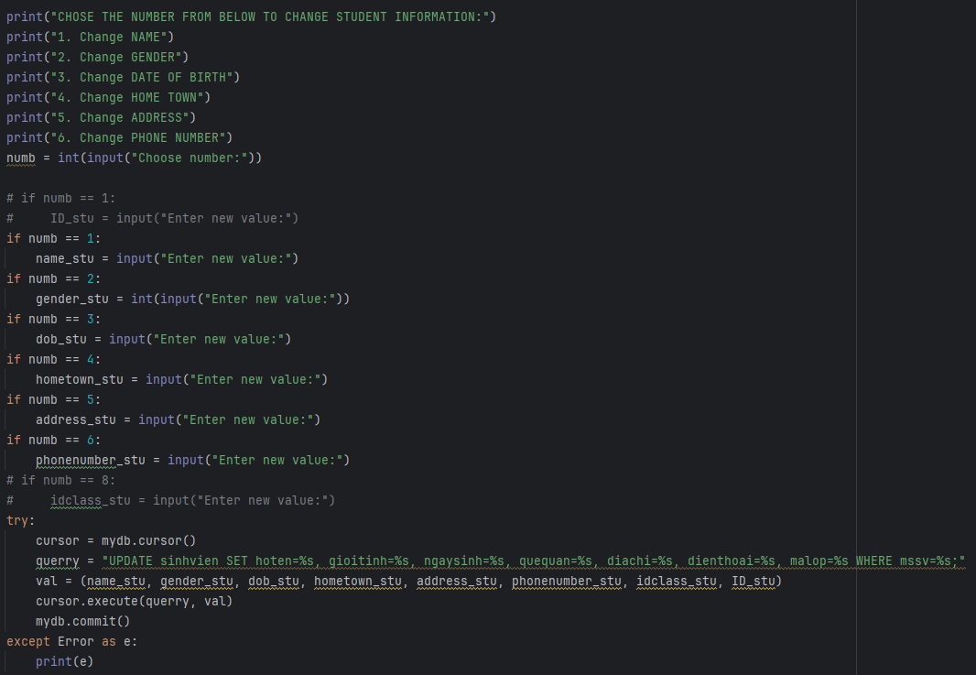
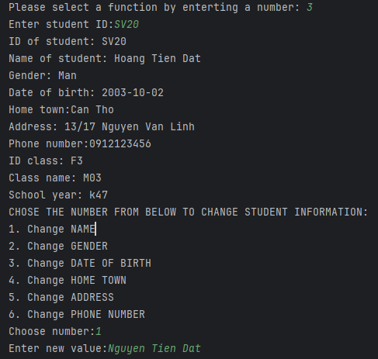
Re-check by using function 1:
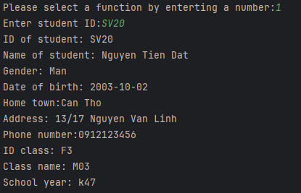
- The third function show how you can change information about a student that's already saved in the system. The function is accessed by selecting the number 3. First the program need an ID of a student you want to change information. Once you do that, it shows all of the information for that student. Then it will show all of the option of student information that can be changed. After you choose what to change, you type in the new info, and it updates the record for you.

4. Remove student
Code of this function:
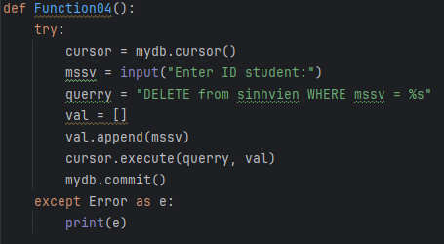
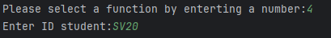
Re-check by using function 1:
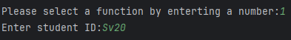
- This image shows how to remove a student's personal information from the system. You would access this function by selecting the number 4 from the main menu. The system asks you to type in the ID of the student you want to delete. Once you enter the system will process to delete permanently the information of that student in the system. You can check by using function 1, if it does not exist then the information will not be showed.

5. Show all the student in CLASS
Code of this function:
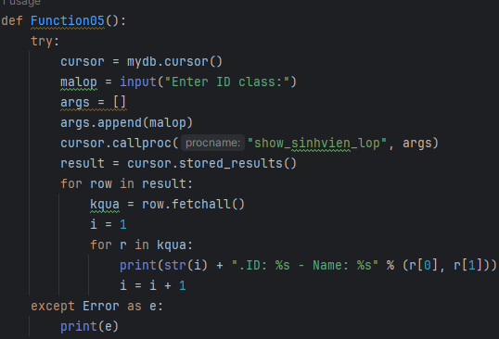
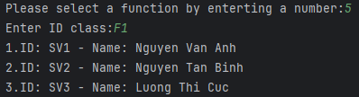
- This image displays the 'Show All Students in 'Class' function. This feature is accessed by selecting an option 5 from the main menu. Once selected, the system retrieves and displays a list of all the students currently enrolled in the class. The information typically shown for each student includes their student ID and name.

6. Display student’s academic transcript
Code of this function:
This function purpose is to display the GPA and OVERALL GPA of student:
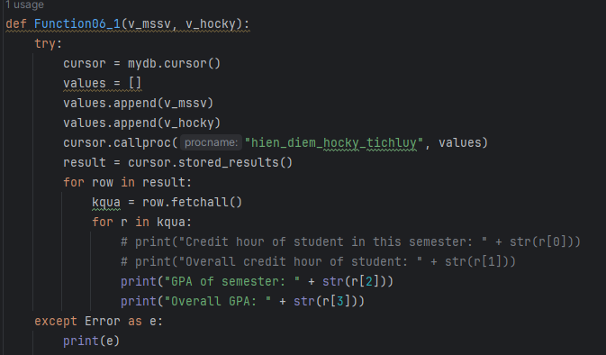
This function purpose is to display the score of student and their GPA and OVERALL GPA by using function 6_1
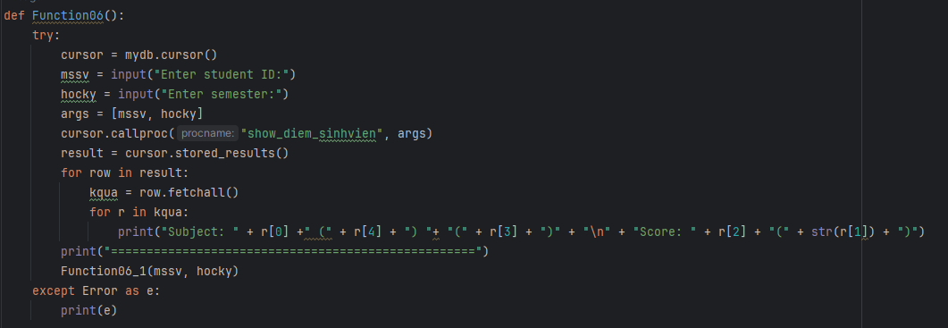
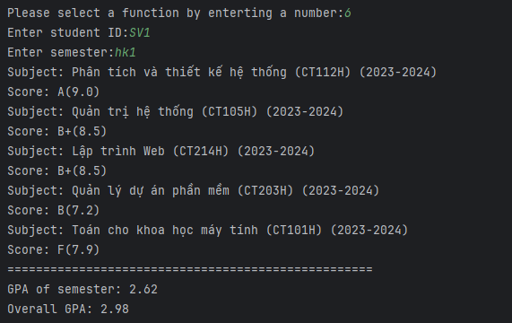
- This function 6 shows what a student's academic transcript looks like in the system. You'd get to this function by picking option 6 from the main menu. It has you type in the ID number of the student, and then it looks up their transcript. Transcripts show things like the student's name, all the courses they've taken, their grades, and probably how many credits of each course. The transcript also includes student overall GPA, and your GPA for a specific semester.

7. Add a grade column for student
Code of this function:

This function used to show all subject of student, that they already have score.
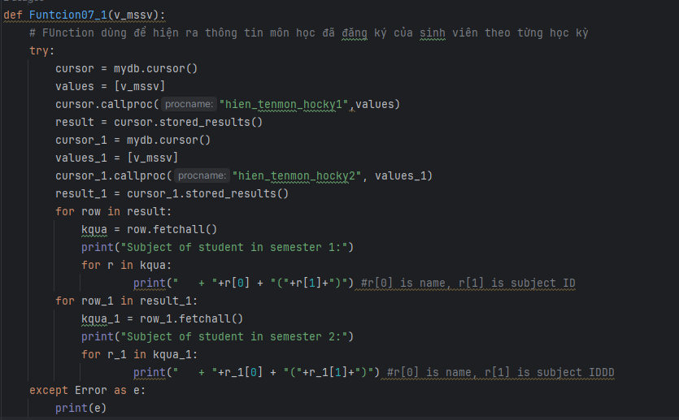
This function purpose is to display all of subject from each semester.
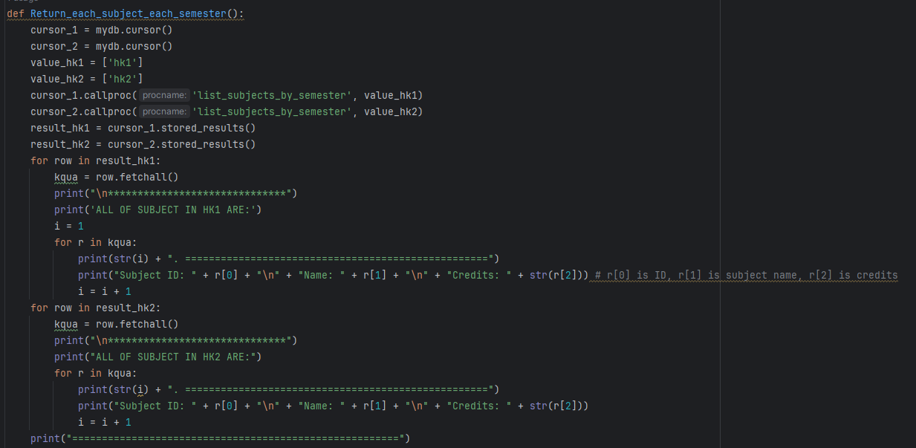
And by combining two of the above function, we have function 7:
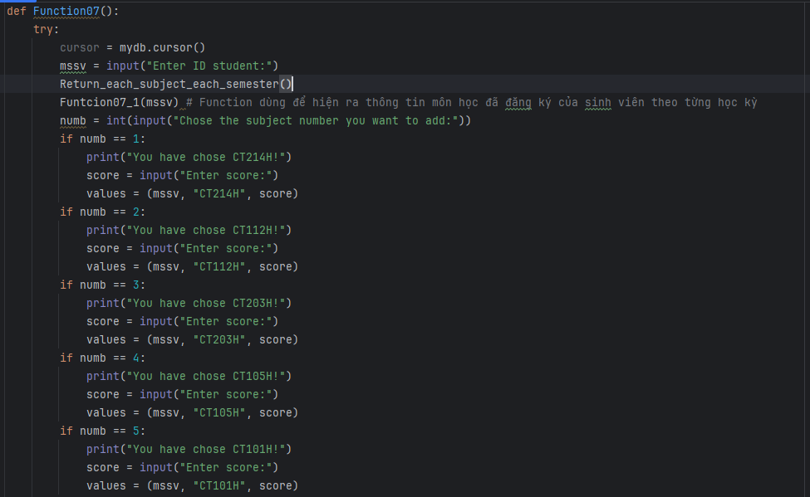
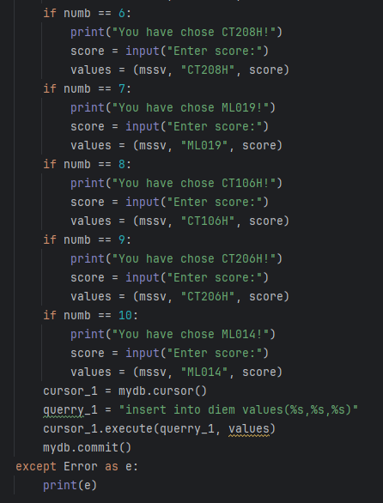
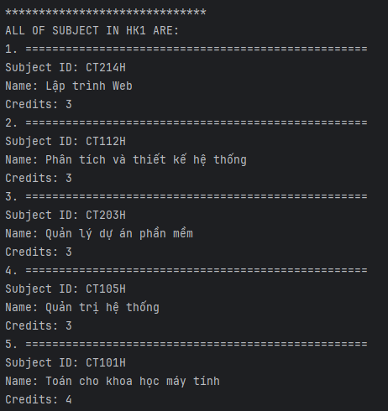
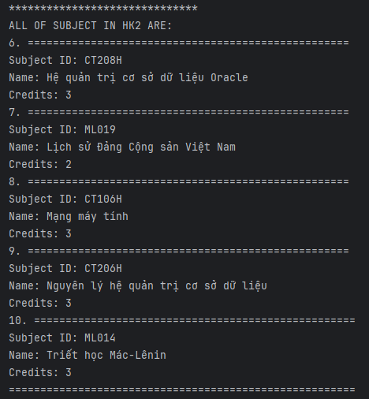
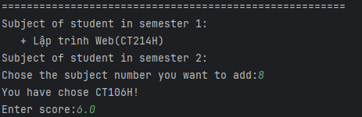
Recheck by using function 6:

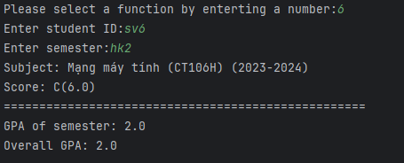
- This function 7 shows that how to add a column grade for a student work in this system. First it will show you the number of subject that are available included their name, subject ID and credits. Then next it will show the subject of student that already have score in each semester, you can easily detect the subject in the menu (All of subject of student from hk1 will be in the range of 1=>5, and the subject of hk2 are from 6=>10). And final you need to chose the subject number to add and enter the score.

8. Modify student grade
Code of this function:
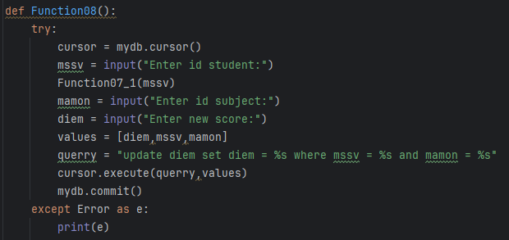
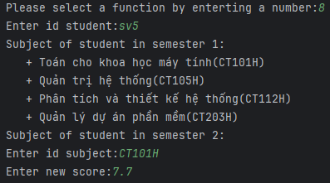
Recheck by using function 6:
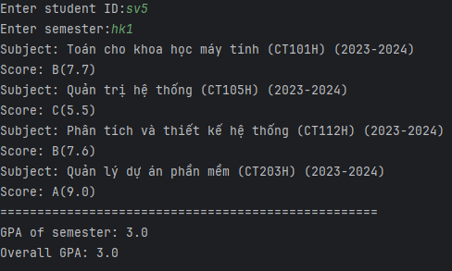
- This function 8 shows how to go in and change a student's grades. You'd get here by choosing option 8 from the main menu. First, it'll ask for the student's ID. Once you type that in, it show their record and shows you all their current grades. You can pick the specific class where you want to change the grade, then type in the new grade, and it updates the system.

9. Delete student’s grade column
Code of this function:
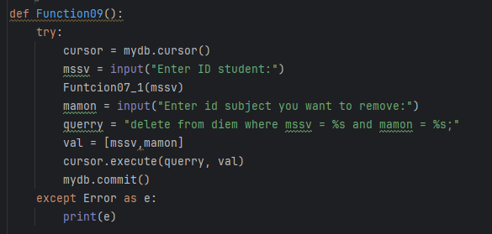
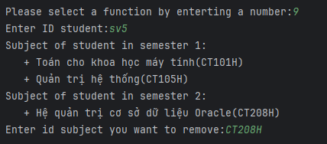
Recheck by using function 6:

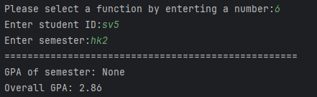
- This function 9 shows the function for deleting a specific grade from a student's academic transcript. The user can selecting the option 9 from the menu. The system then prompts the user to enter the ID of the student whose grade needs to be deleted. Once the ID is type in, the system displays a list of that student's courses and grades. The user can then select the specific course and grade to permanently remove from the record.

CHAPTER 3: CONCLUSION AND FUTURE DEVELOPMENT

CONCLUSION:
- This project was about building a system to keep track of student information. It help the user to add students, look up student records, make changes, and even delete them if needed. The whole system uses a database to keep everything organized.

FUTURE DEVELOPMENT:
- This project still have many thing to improve, like by adding the libraries like NumPhy to enabled more advance feature like grade calculations and statiscal analysis of student data. And more importantly, it need an user interface (GUI) for the user to interact with the system more easily.

REFERENCES
MySQL. (2023). 5.1 Connecting to MySQL Using Connector/Python. MySQL Connector/Python Developer Guide. MySQL :: MySQL Connector/Python Developer Guide :: 5.1 Connecting to MySQL Using Connector/Python

MySQL. (2023). 10.5.5 MySQLCursor.callproc() Method. MySQL Connector/Python Developer Guide. MySQL :: MySQL Connector/Python Developer Guide :: 10.5.5 MySQLCursor.callproc() Method

Viettuts. "Lệnh SELECT MySQL trong Python - Học lập trình Python." Viettuts, 2023, https://viettuts.vn/bai-tap-python#goto-h2-3.

