CDMA algorithm

CDMA is a friendly user interface used to show how the CDMA is carried out at the sender and the receiver.

It starts with a window asks whether you are the sender or the receiver.

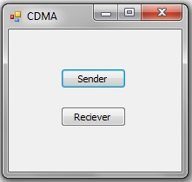

If you press sender, this window will appear.

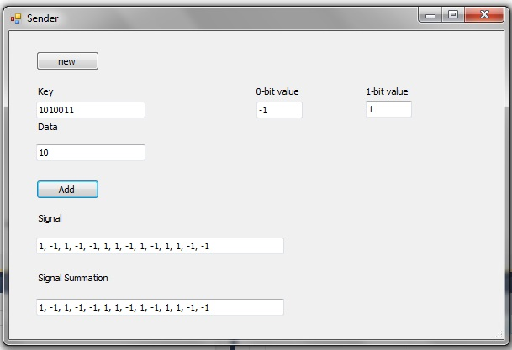

**New Button**: if pressed it will start a new session.  
**Add Button**: if pressed it first checks if the **key box**, the **data box**, the **1s box** or the **0s box** is empty. If so an error message appears else it processes this information forming the signal resulting from applying the CDMA in the **Signal box** and adds it to the rest of signals that has been entered so far in the Signal **Summation box**.

If you press receiver, this window will appear.

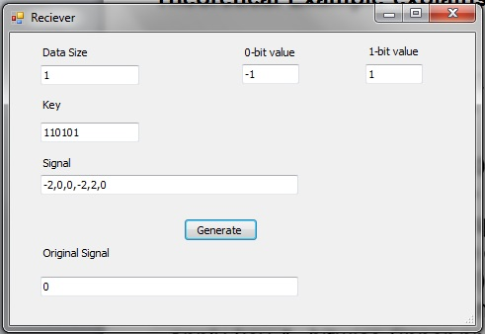

**Generate Button**: if you press this button, it first checks if any box is empty and if so, an error message appears. If not It calculates the original data of the receiver show it in **Original Signal Box**.

**Note**: The Signal entered in **Signal box** has to be separated by comma and comma only.