**CREATE DB MYSQL FOLLOW ENTITY API C# NET6**

**Package (all version is 6.0.0 for net 6):**

1. Entity framework core
2. Entity framework core.tool
3. Entity framework core.design
4. Pomelo.entity framework core.mysql

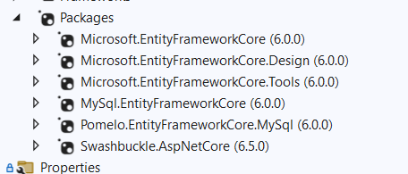

Link: <https://www.youtube.com/watch?v=SdtOGowW-Dk>

B1: create entity

B2: create AppDbContext

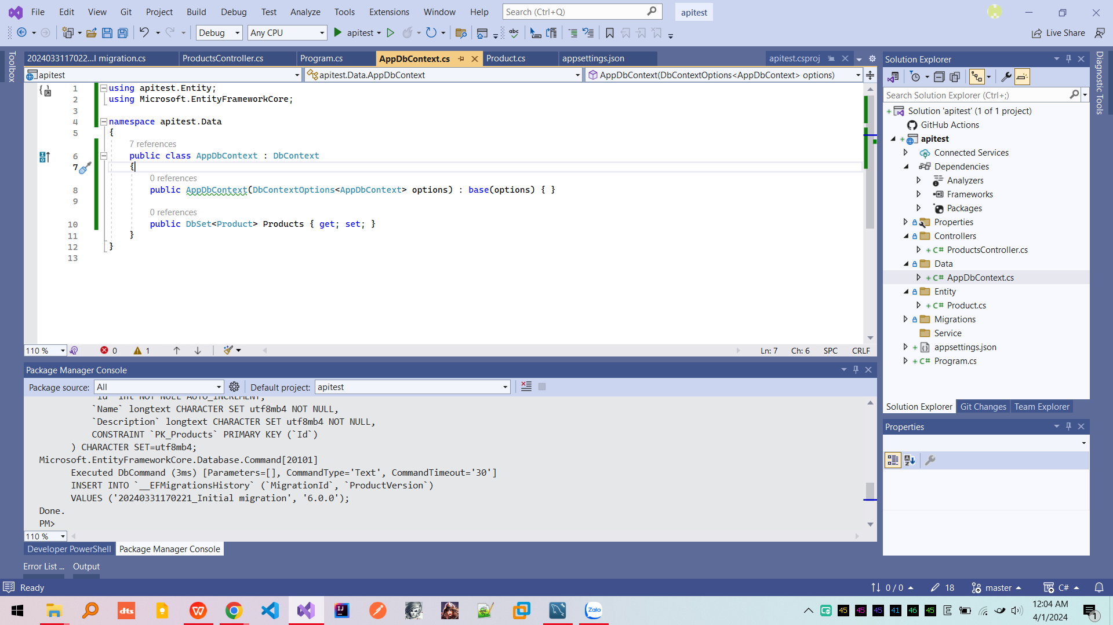

B3: add connection string

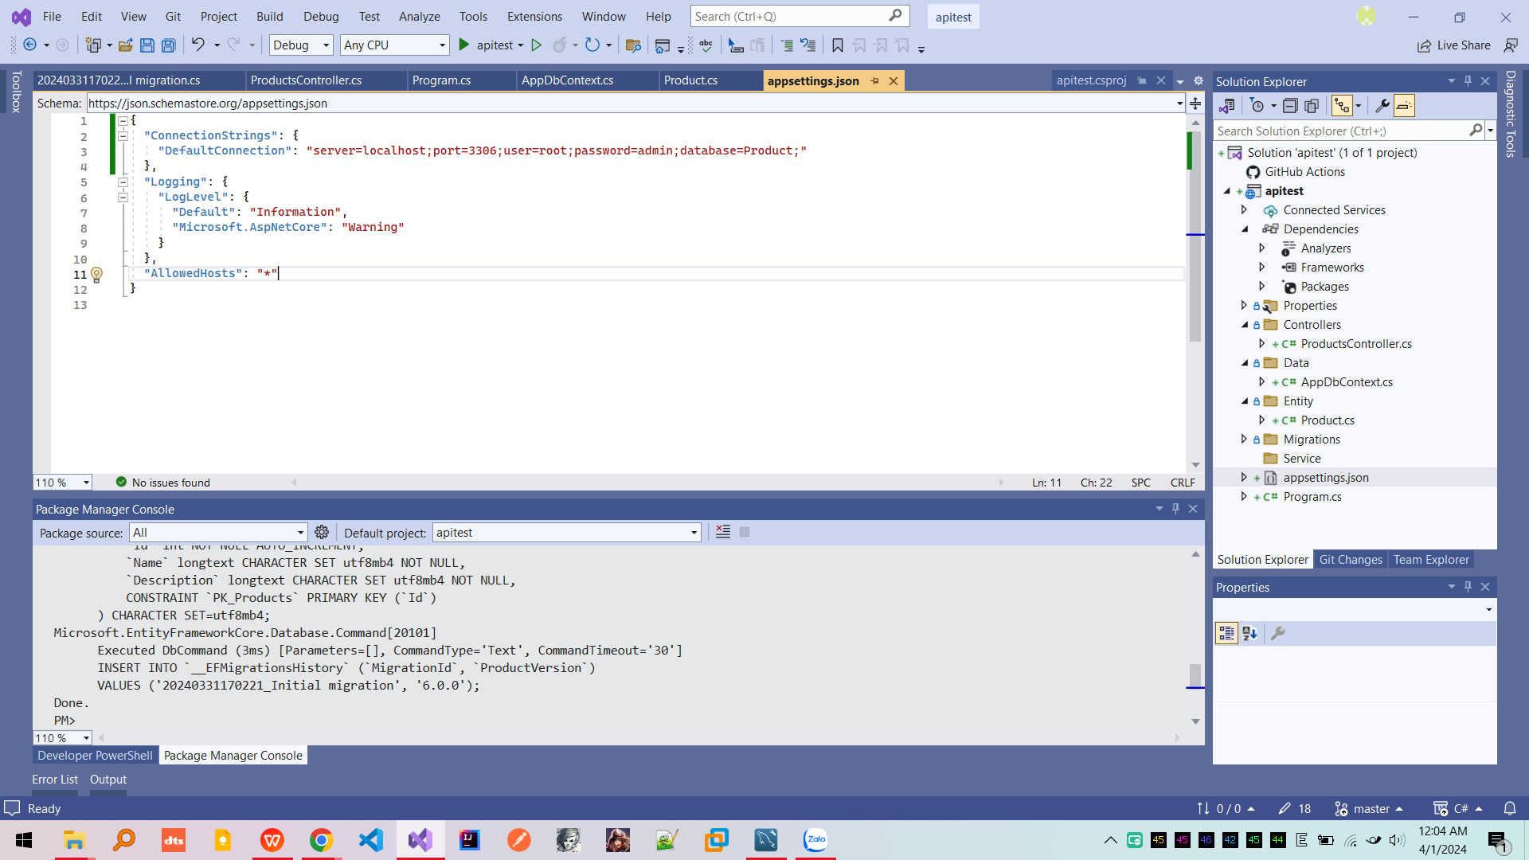

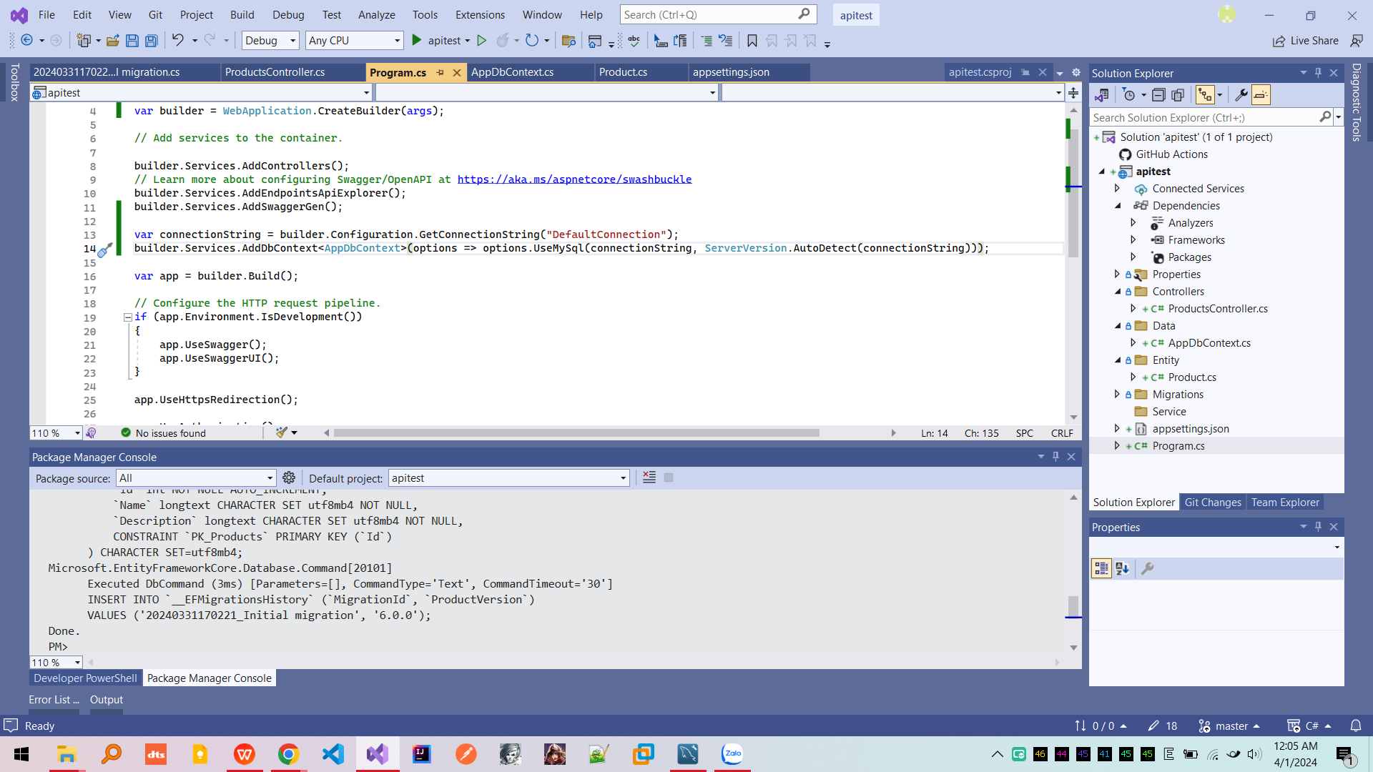

B4: Create controller

B5: 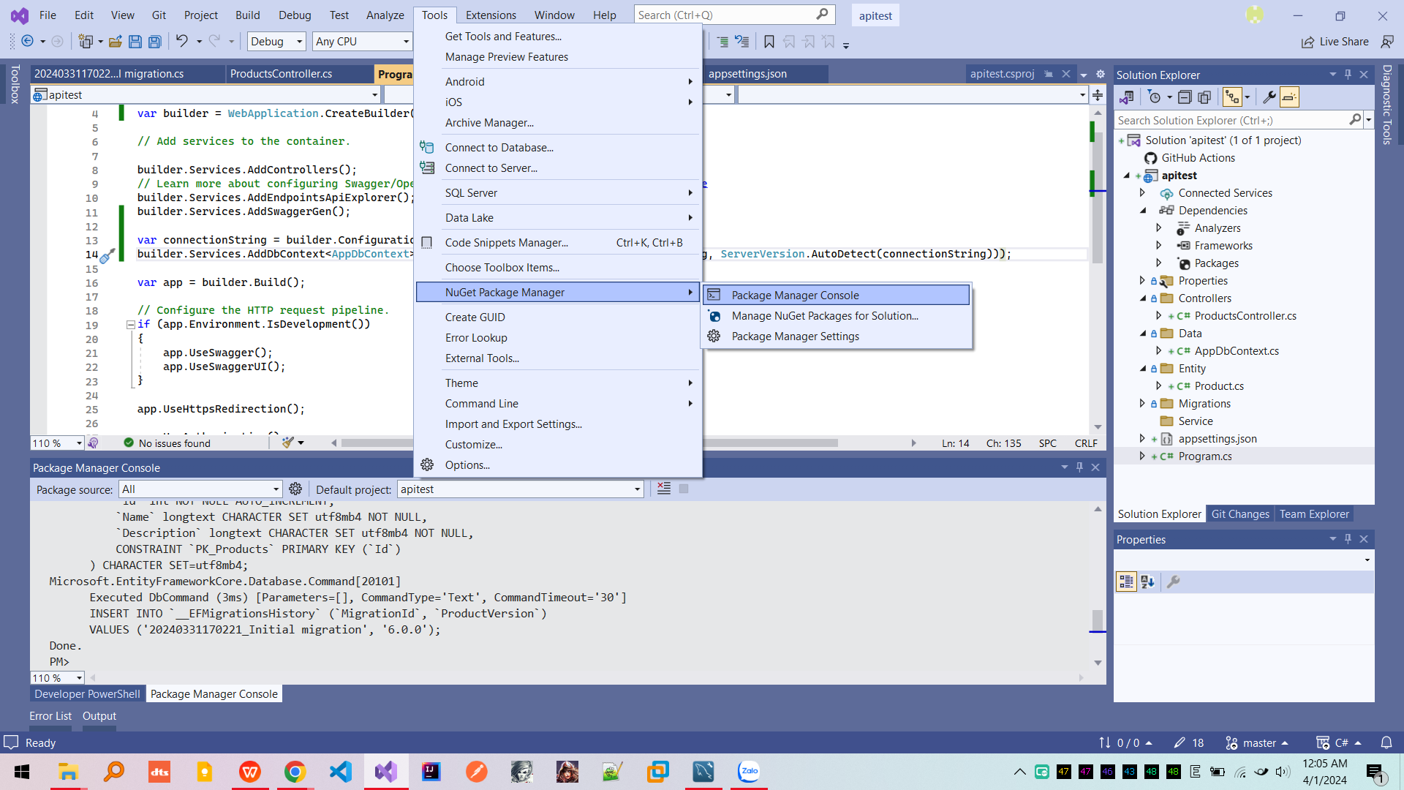

Run: “add-migration “name class” ” in nuget package console

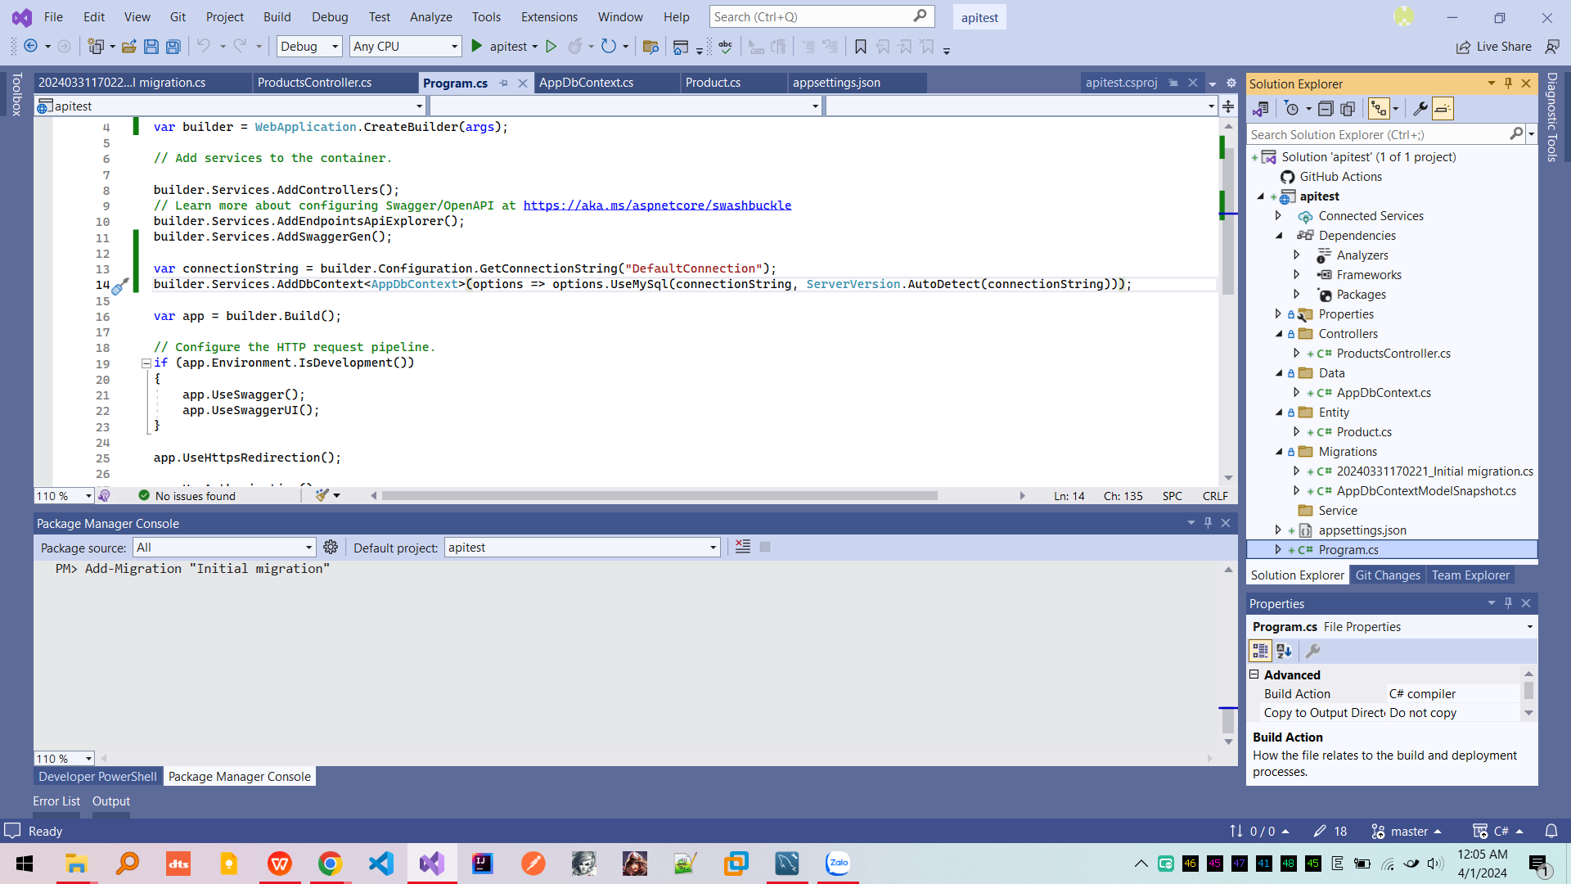

Then run “update-database”

