Lab 10
Highlighting
By Hoda Malak

Q1: Create a bmp image file from sheet1, containing a meaningful title and caption, and insert it into your document.
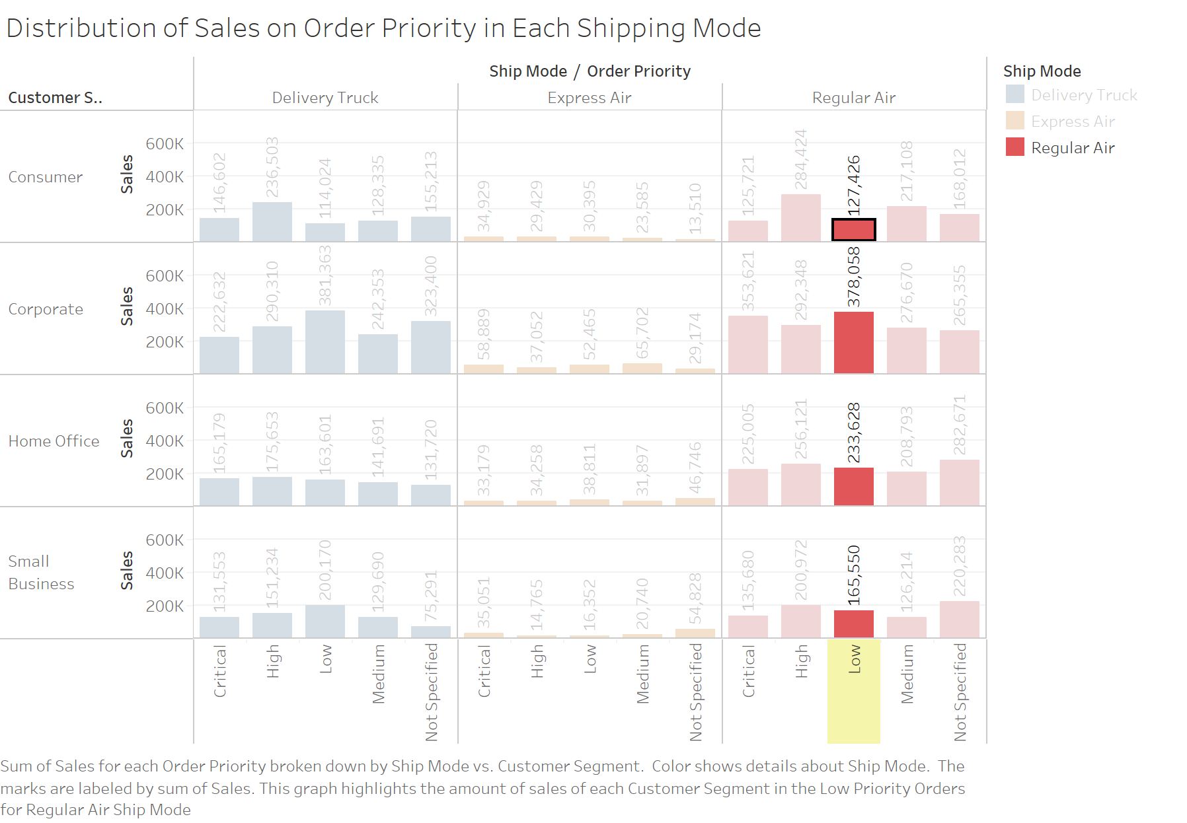
Q2: Create a bmp image file from sheet2, containing a meaningful title and caption, and insert it into your document.

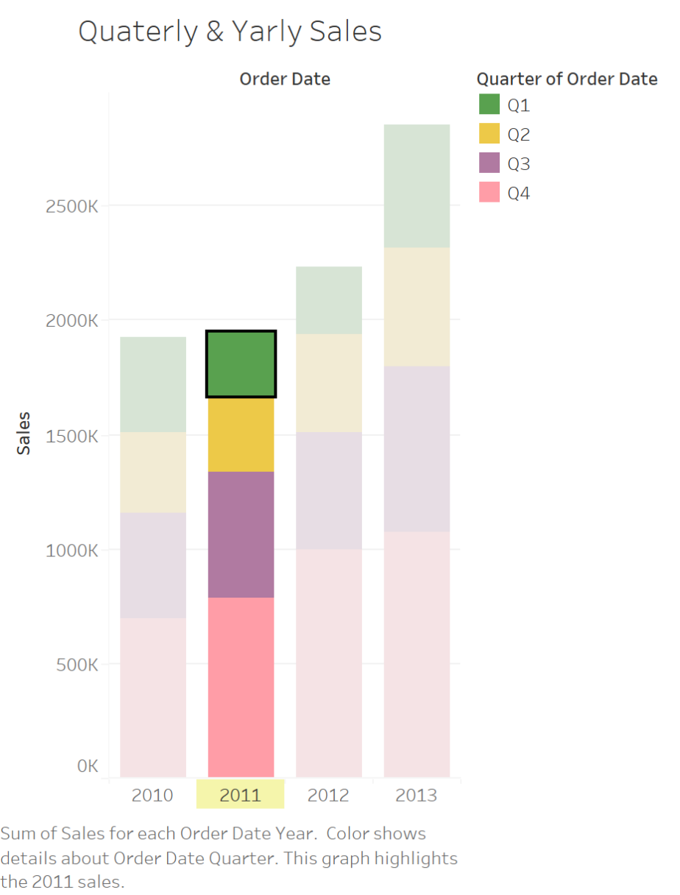
Q3: Select “South” region in “Technology” and figure out the highlighted divided bars in “Subcategory Sales”. Provide snap shots of results.
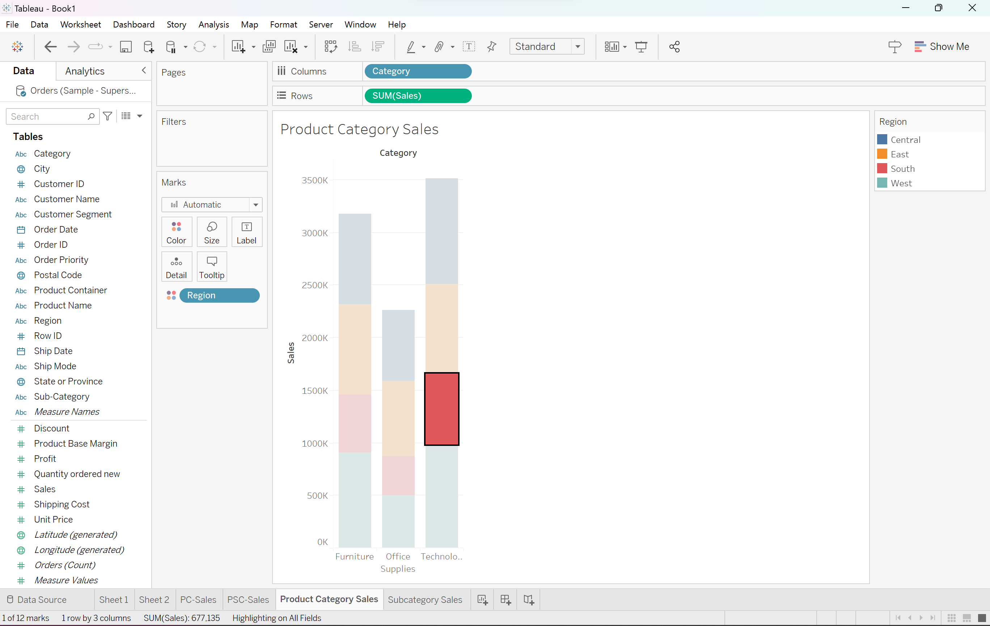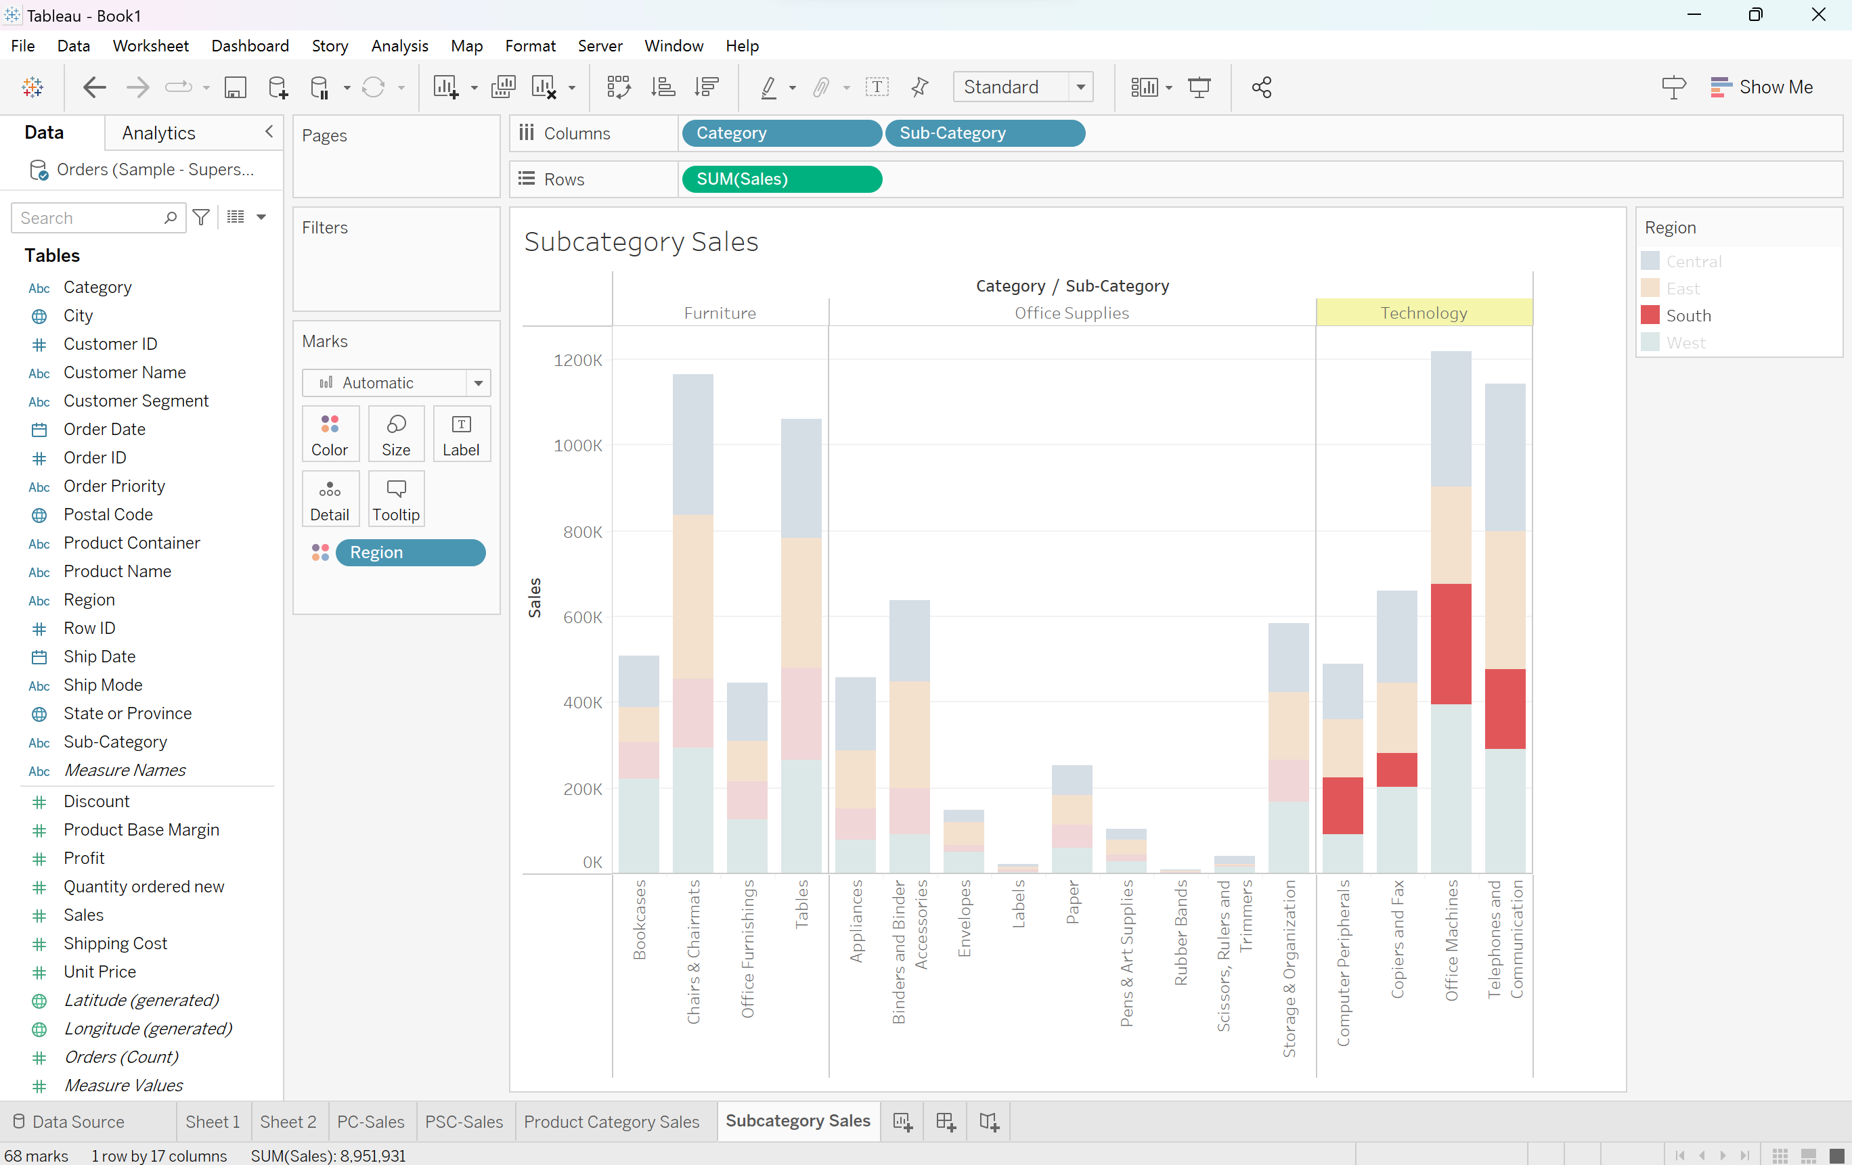

Q4: Select “West” region in “Office Supplies” and figure out the highlighted divided bars in “Subcategory Sales”. Provide snap shots of results.
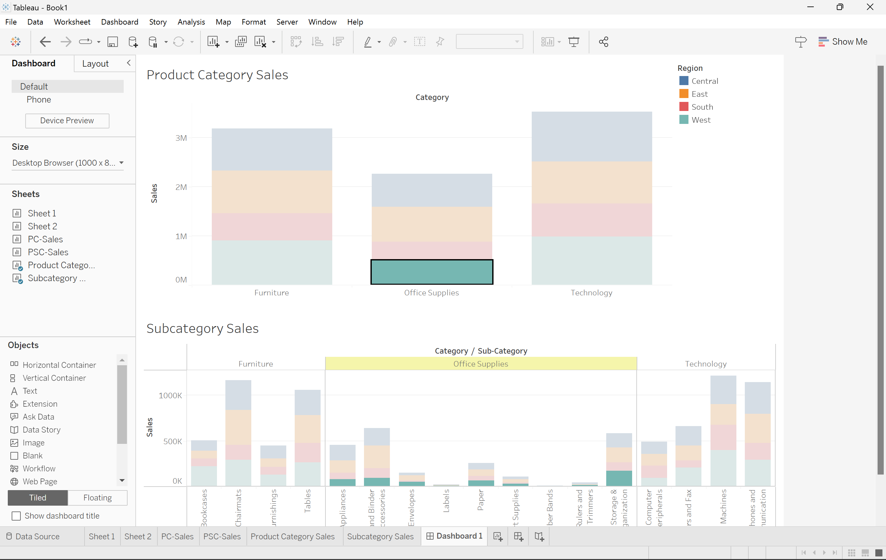
Q5: Click on “Idaho” and then “information” and see how it goes to the Idaho web page. Provide a print screen of the result.
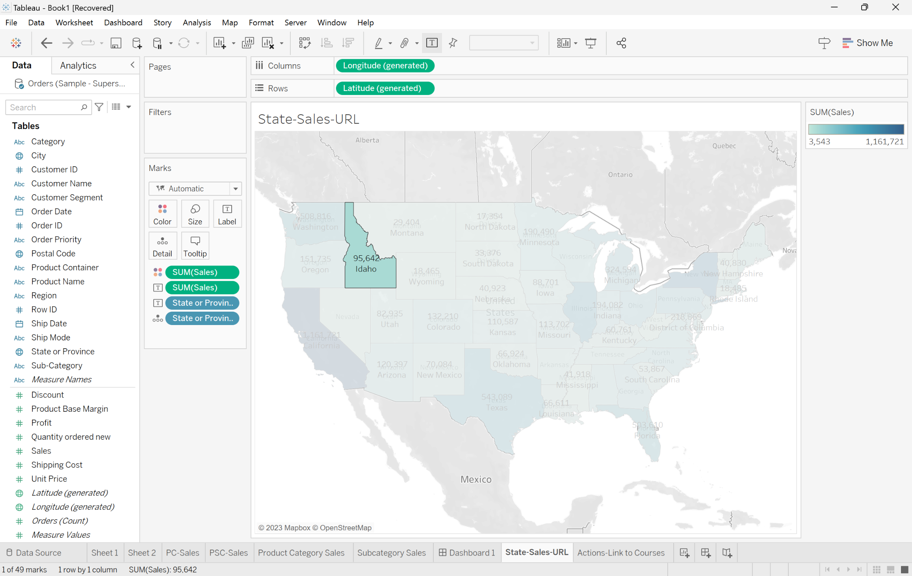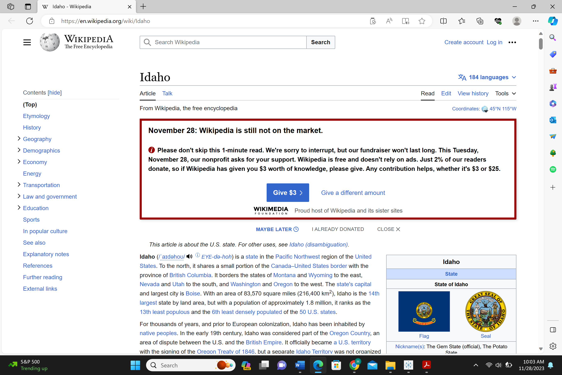
Q6: Click on “easymock” and see how it goes to its associated site. Provide a print screen of the result.
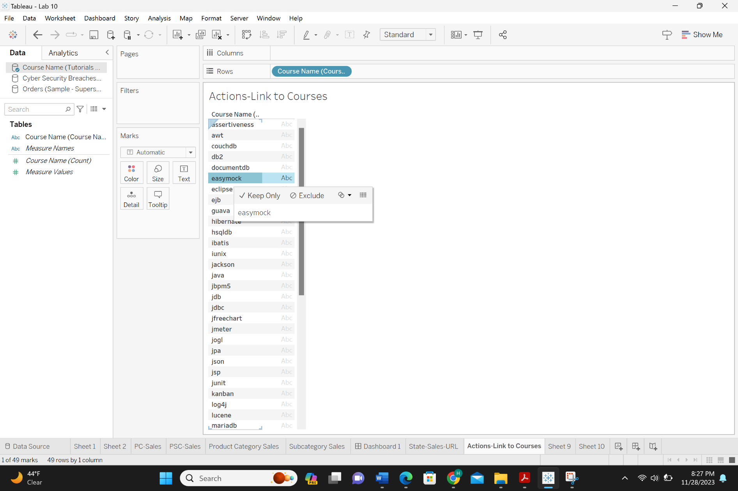

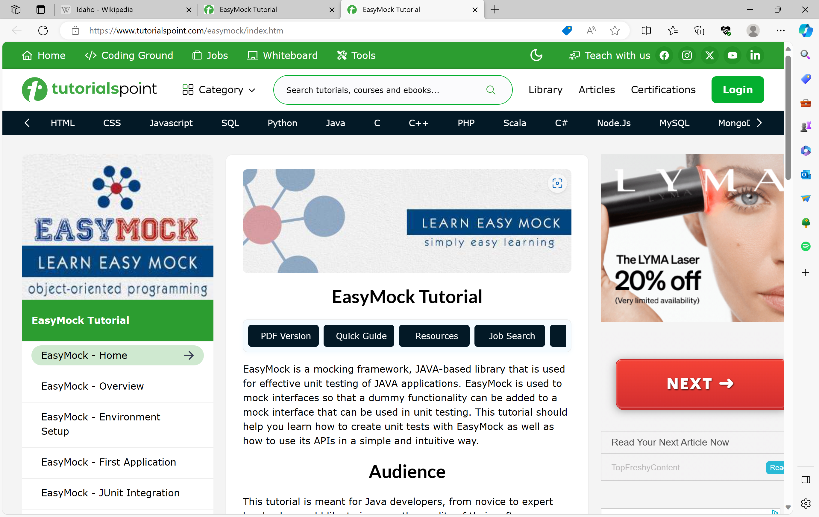

More Questions.
Q6: Create a tree map based on “ABC” dataset. Highlight any part that you feel interesting and matching any visual patterns. [Help: see from Lab 8]
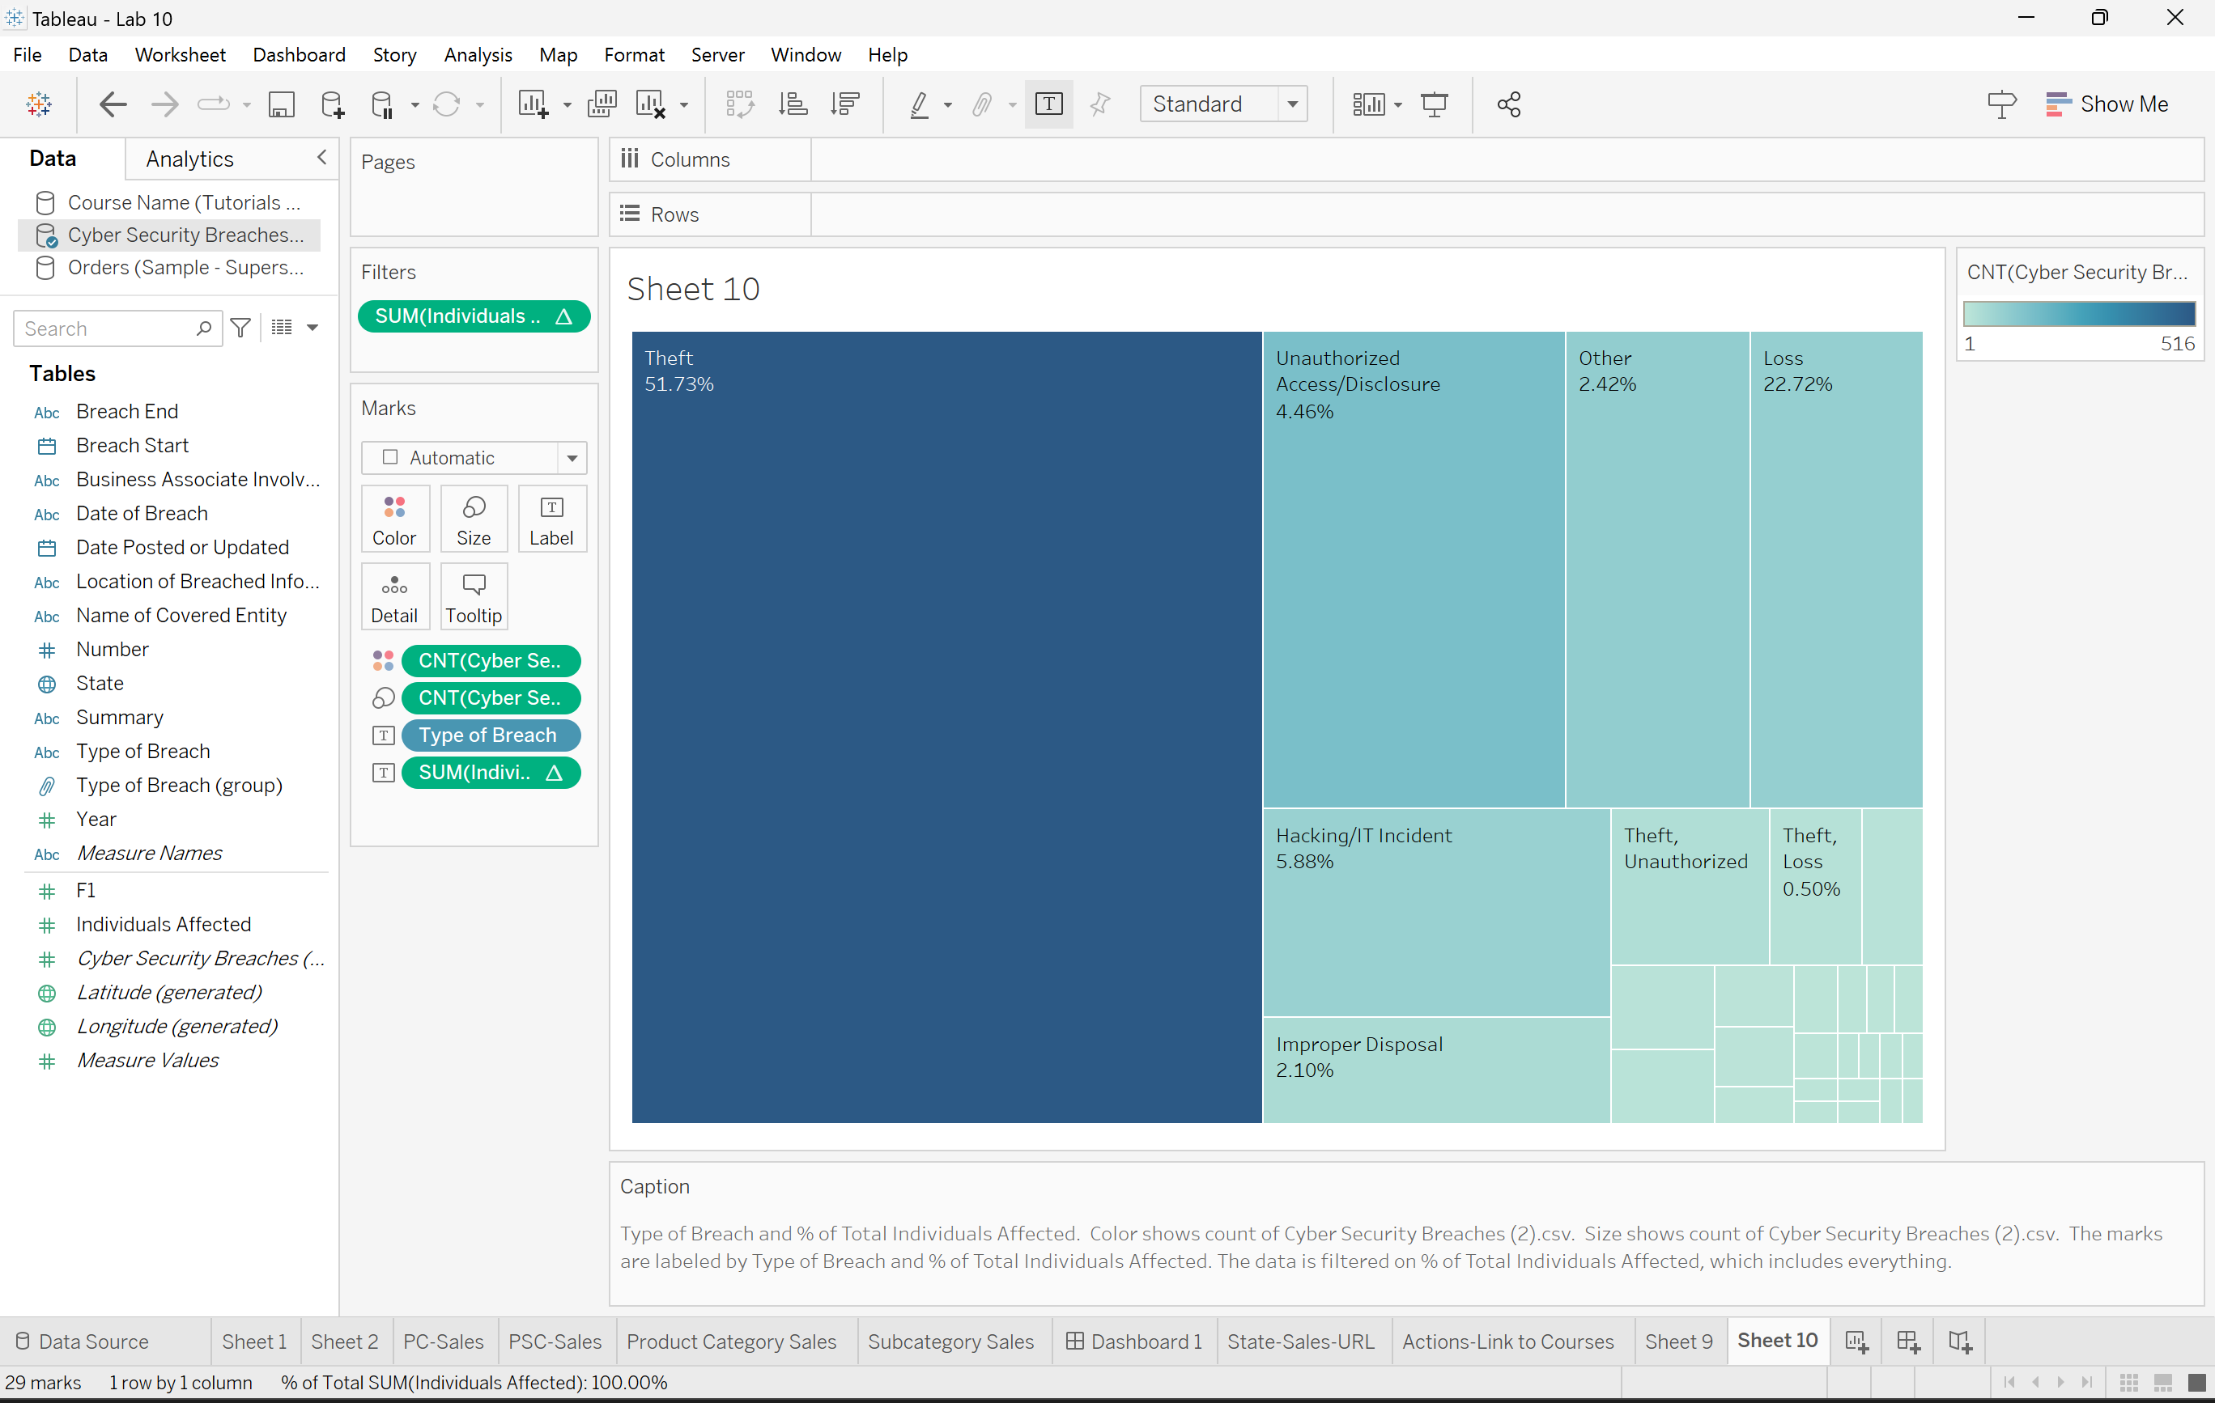
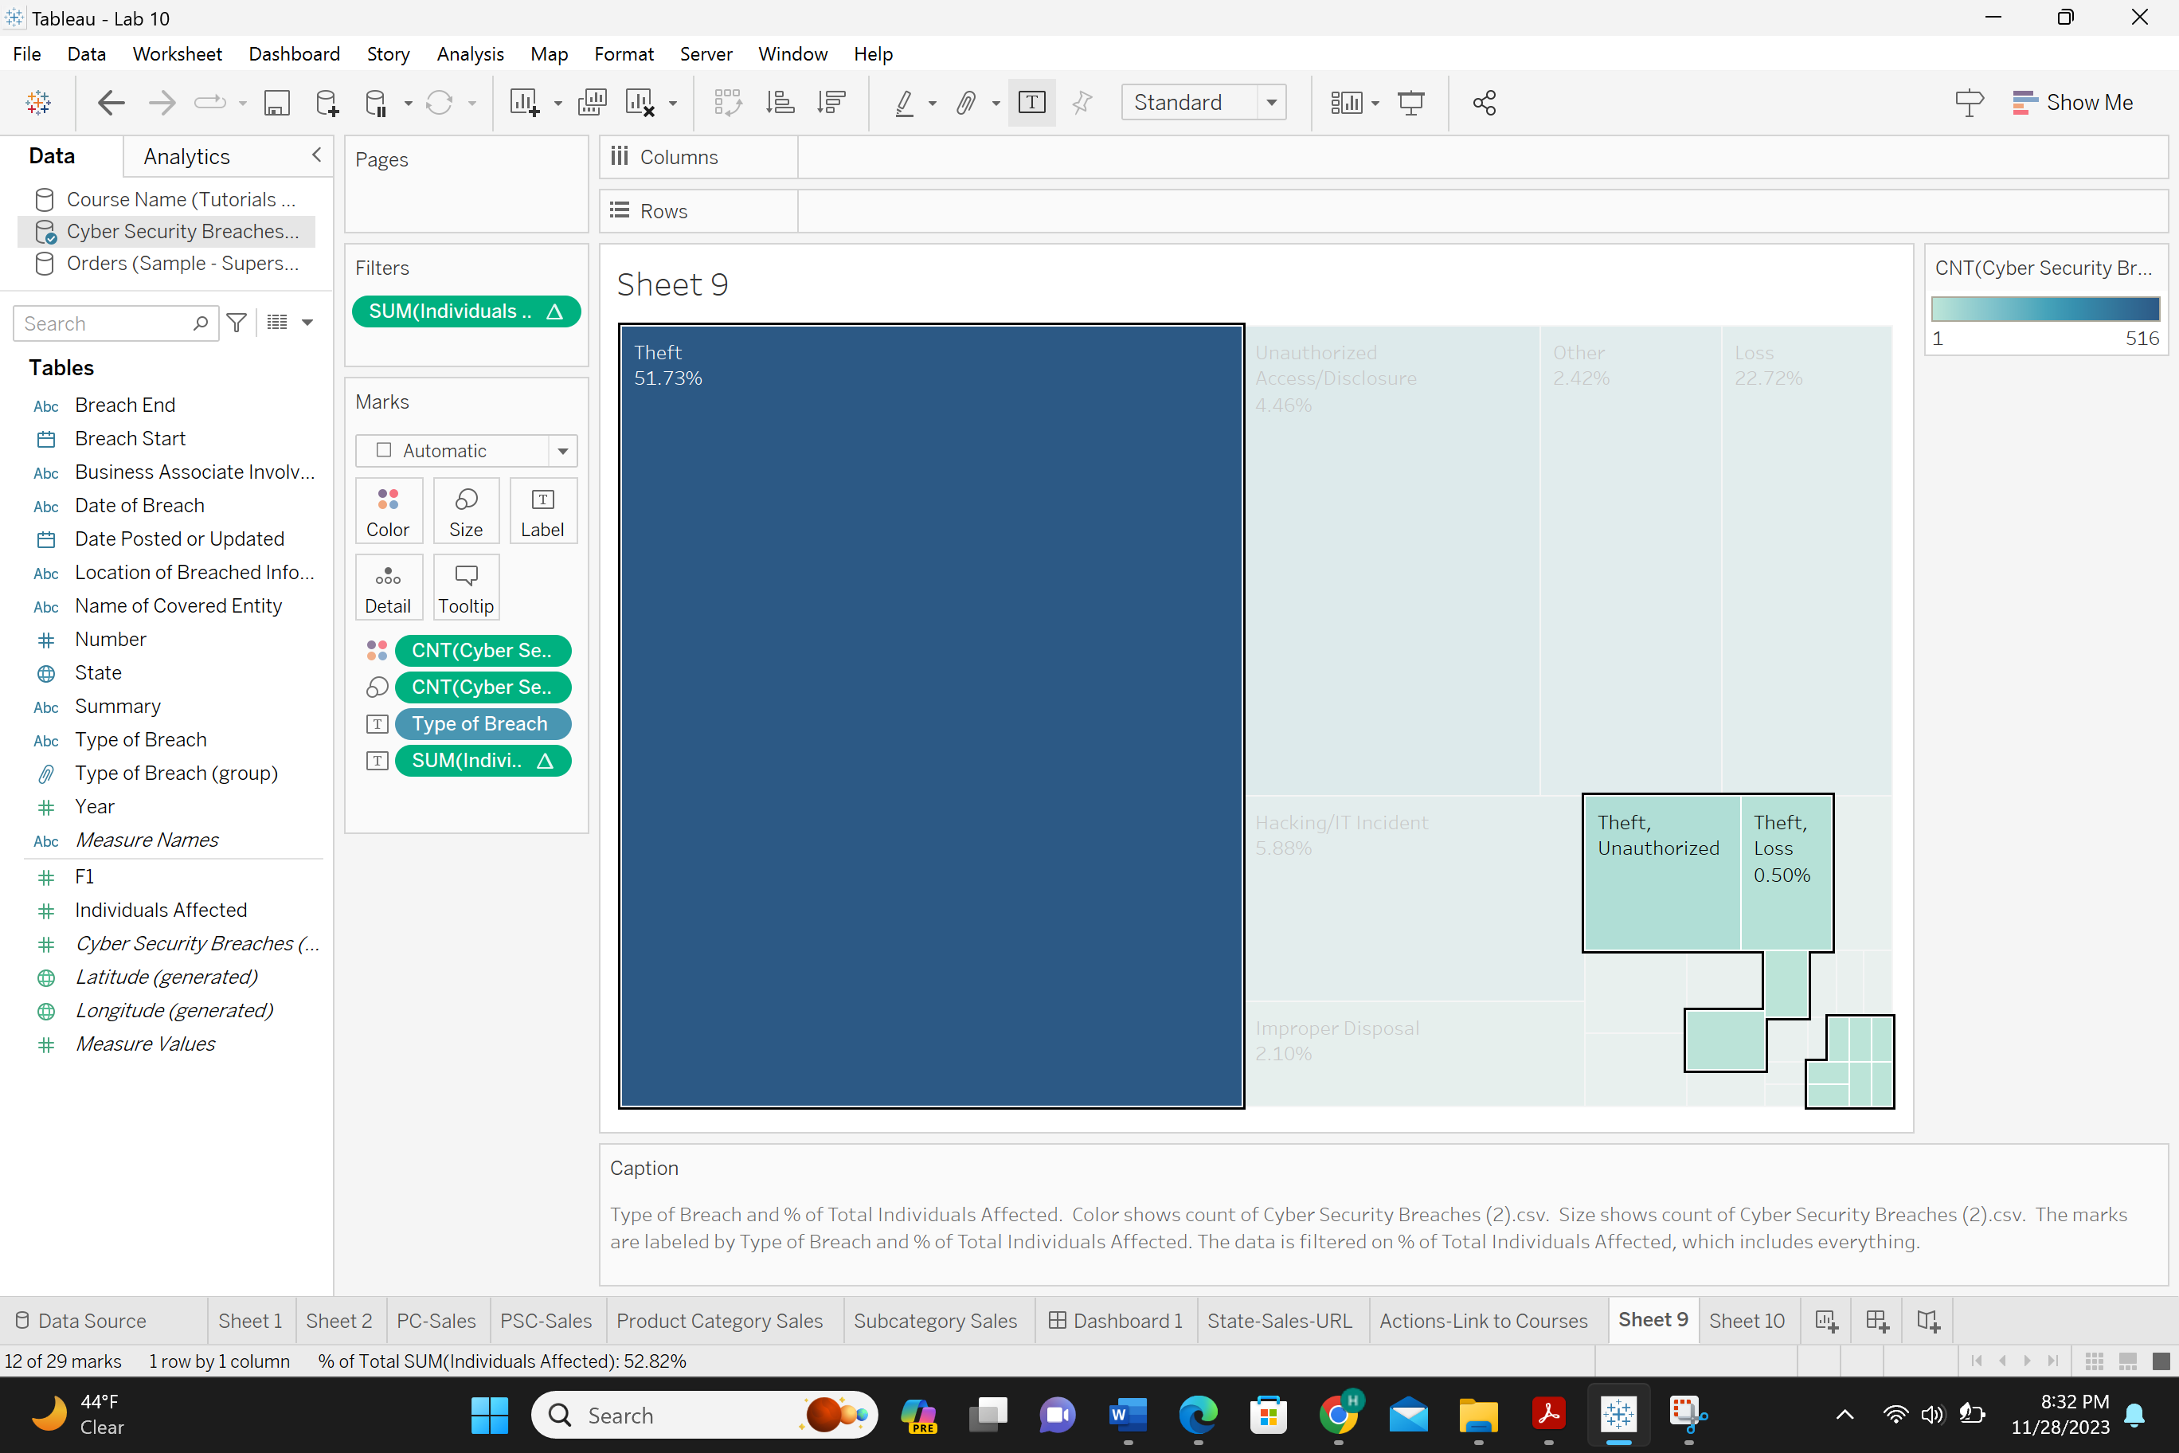
Highlighted above is all the Data Breaches that contain theft type breaches.

Q7: Create a map plot for different location related data from “ABC” dataset, show some patterns. [ Help : see from lab 9]
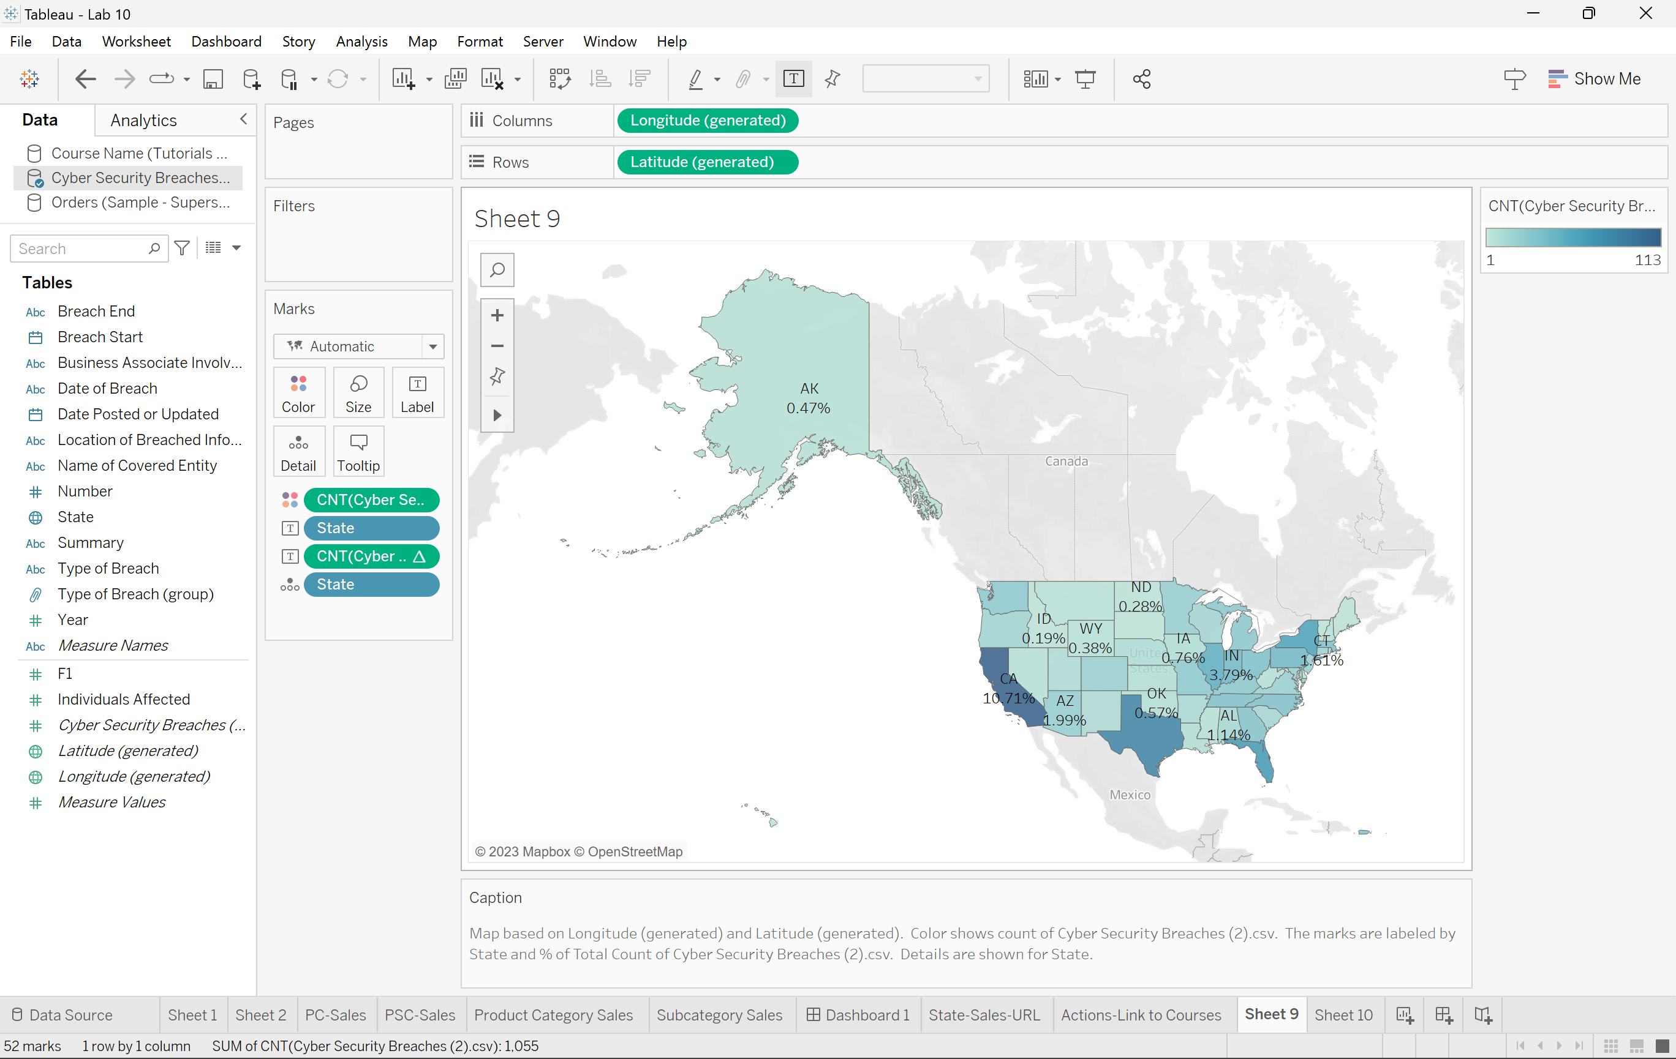
Q8: Give a snapshot of a multidimension plot that you have practiced/created through Tableau or any other software.
Note: You must submit a zip file with all Tableau source, and docs, pdf, files for this whole Lab 10.

