Measure names and measure values

Number of records
Sheet1:
- Drag the “number of records” and drop it in “Text” within Marks. It shows us the sum of number of records, which is “9426” here.
- You can verify it in Excel. Note that the first row is dedicated to the row headings. Drag “Region” and drop it in “Rows”.
- Then, you can see the distribution of records in each region.
- Combining all them together equals to the “9,426”.
- Go to the “Analysis” menu bar and select “Totals” and “Show Column Grand Totals”.
- Then its total equals to the total number of records.
- Remove “Region” from “Rows”.
- Drag and drop “Category” in “Rows”.
- Then, we can see the number of records is maximum for “office supplies”
- Clean the sheet.

Measure names
- Sheet2:
- Drop “Measure Names” in Rows.
- Drag “Measure Values” in “Text”.
- Then, all measure names are listed as same as names within “Measures” except “latitude”, “longitude” and “ measure values”
- The numbers in front of them are calculated based on statements written in “Measure Values”.
- example1: “Number of Records” is calculated by SUM(Number of Records).
- Example2: “Discount” is the SUM of the total of discount
- So, we can get summary from all the numbers at one location.
- Drag and drop “Measure Values” to “Columns” get the graphical method to show you everything at the same place.
- Then we can see the “Number of Records” is 9,426 an so on.
- Clear the sheet.
Q1: What is the total amount of Profit?
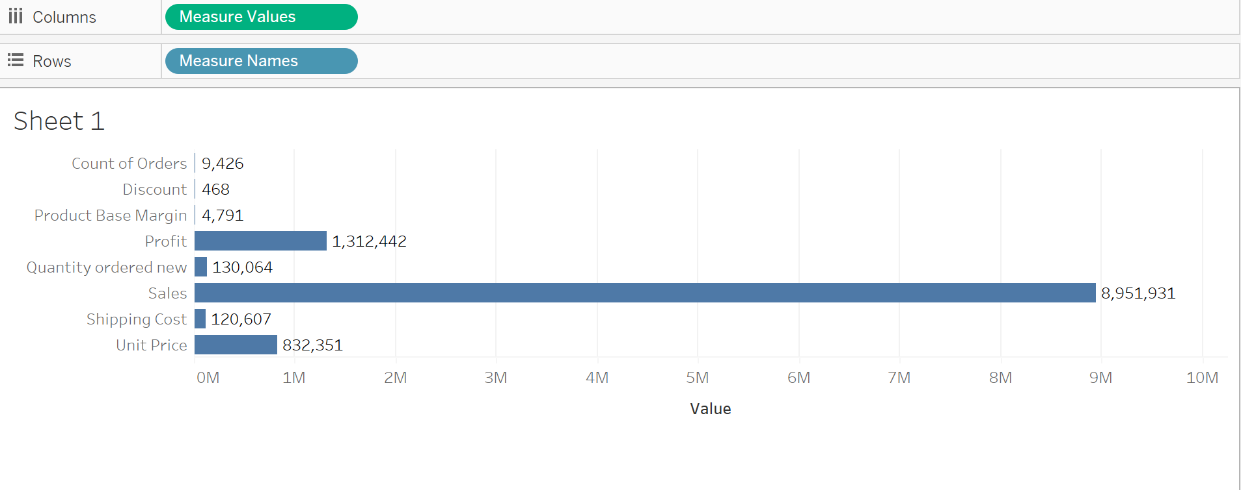
The total amount of profit is 1,312,442.

Measure names and measure values usage
- Sheet3:
- Where the charts are failed to combine that places you can use measure names
- Drop “Order Date” in columns and “Sales”, “Profit” and “Shipping Cost” in Rows. Make sure “Profit” is located in between.
- We want to see all these graphs at one place to compare and analyze. Therefore, click on the drop down of the “Profit” and select “Dual axis”
- Note that the first field as “Sales” does not have this option.
- So both axis have been combined into one and the colors can be recognized by the legend
- There is no “Dual axis” option for the third field (“Shipping Cost”) as well. Note that the first two fields are combined and shown with the same structure

How to combine different graphs into one sheet
- How can I create the three former line graphs in one place?
- First clear the sheet.
- Sheet4:
- Drag and drop “Order Date” into columns.
- Drag and drop “Measure Values” into filters, then it asks which field do you want?
- Select “Profit”, “Sales” and “Shipping Cost”, because they have same range of numbers. While “Discount” is in percentage and “Number of Records” is not in their range.
- Only values that are filtered based on the measure names will show up here.
- Then drag and drop “Measure Values” in Rows.
- In order to color all of them based on the measure names, drag “Measure Names” into color part and in order to attach labels, drop “Measure Names” into Label part as well.
•Sales is the highest among all of them and shipping cost is the lowest
Q2: Provide a snapshot of sheet4.
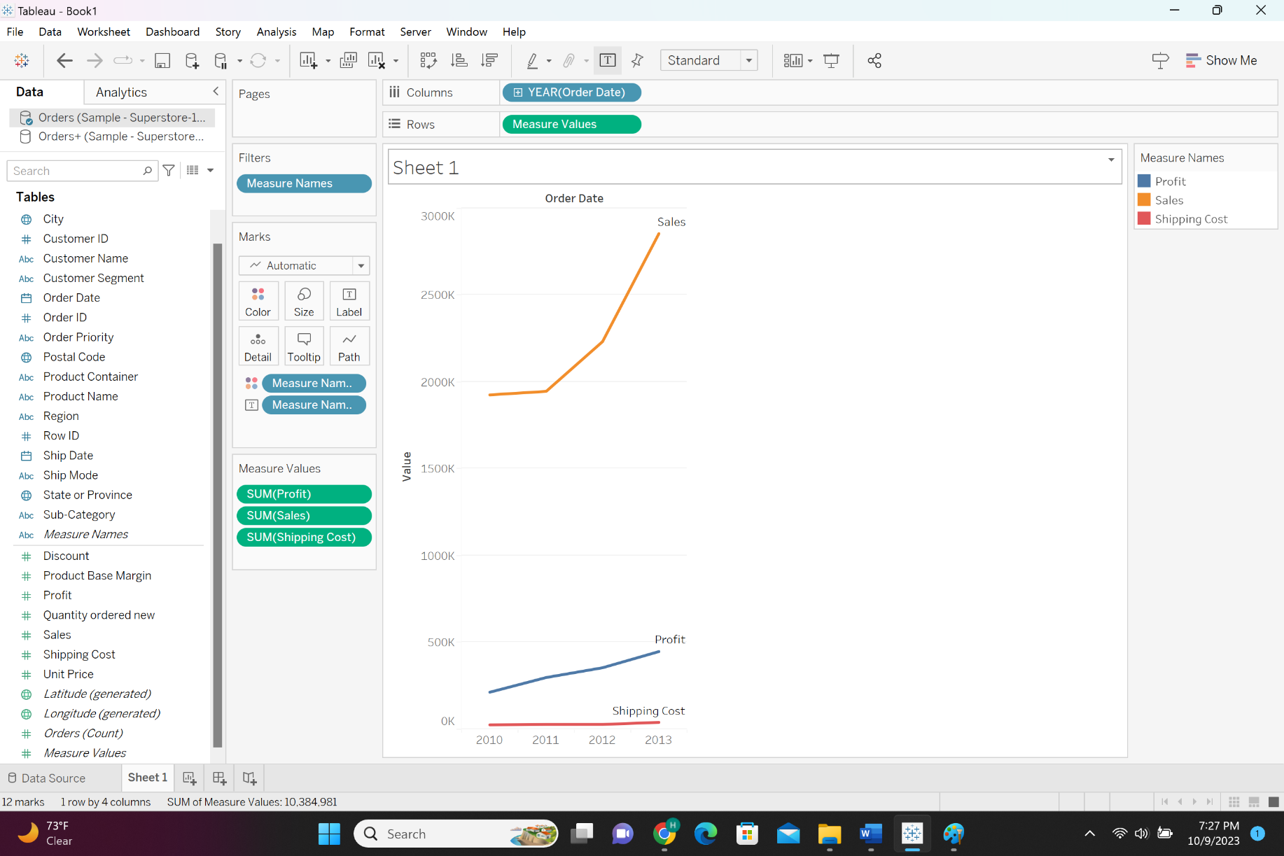
Q3: Which Measure Name has the highest Measure Value?
From the screenshot attached in Q2 one can see that sales is the measure name with the highest measure value because its curve is above all the other curves.

Difference between dimensions and measures Difference between discrete and continues
- If you pick up “Category” from discrete and drag it in Rows its name doesn’t change. It remains the same as it was (category), and different categories are shown. They can be distinguished.
- If you pick up the Sales (green color) which is a continues field and drag it in Rows, it can be aggregated, because SUM() appears before it. So, it can be aggregated into different functions such as Min, Max, Average.
- Now drag Category in Columns.
- Note to the different colors of discrete and continues fields. The fields in green color are continues and the fields in blue color are discrete.
- The discrete field has been distinguished in several parts and continues will be accompanied with aggregate functions.
- We will examine how we can distinguish discrete from continues in bar charts, map charts

The difference between discrete and continues
- Sheet1:
- Drag “Sub-Category” in Rows
- Drag “Sales” in columns and sort it in descending order
- What happens when you put a continues field or discrete field in Marks?
- Sheet1(Cntd):
- Pick up a discrete field from dimensions such as “Category” and drop it in Color part
- You can see separate colors are given to each category
The difference between discrete and continues
- Sheet1(Cntd):
- If you pick up a continues field such as “Sales” and drop it into color
- You will not get separate colors, you will get gradient colors instead from light to dark
- This is the difference between continues and discrete using color on the bar graphs
- So based on the colors, you can identify whether it’s a continues or discrete
- Sheet1(Cntd):
- Remove ‘Sales’ from Mark and drop ‘Regions’
- Q4: Provide a snapshot of sheet1. How do you interpret this bar graph?

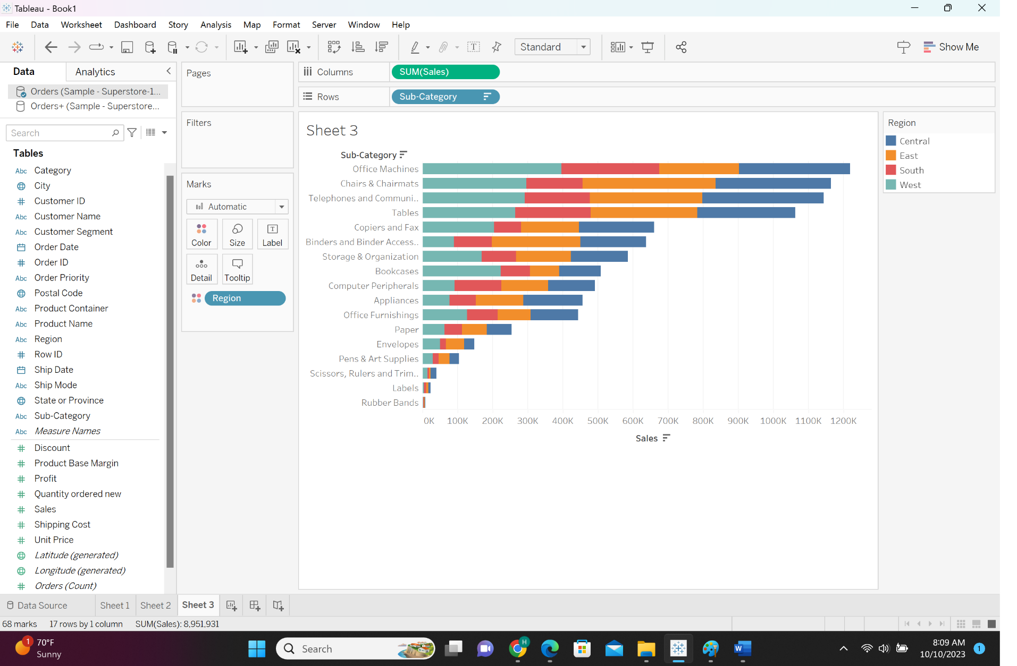
This bar graph shows the distribution of sales on the subcategories. Also within each subcategory it shows how the sales are distributed over the regions (central, east, south and west).

Color on the maps
- Sheet2:
- Double click “state or province”
- Go to maps, background maps and click offline
- We examine color on maps by measures
- Anything I pick up from measures part (Sales) and drop it to color spot, you will get a gradient color from dark to light
- Sheet2(Cntd):
- Drag “Sales” in “Color” spot
- Once you pickup anything from the dimensions as discrete field such as ‘Region’ and drop it in color spot, you will get the symbol graph
- Sheet2(Cntd):
- Drag “Region” in “Color” spot
- So when you assign colors on map by dimensions, you will get different symbols
- When you assign colors on map by measures you will get filled areas and you can recognize easily the highest and lowest values
Q5: Provide a snapshot of sheet2.

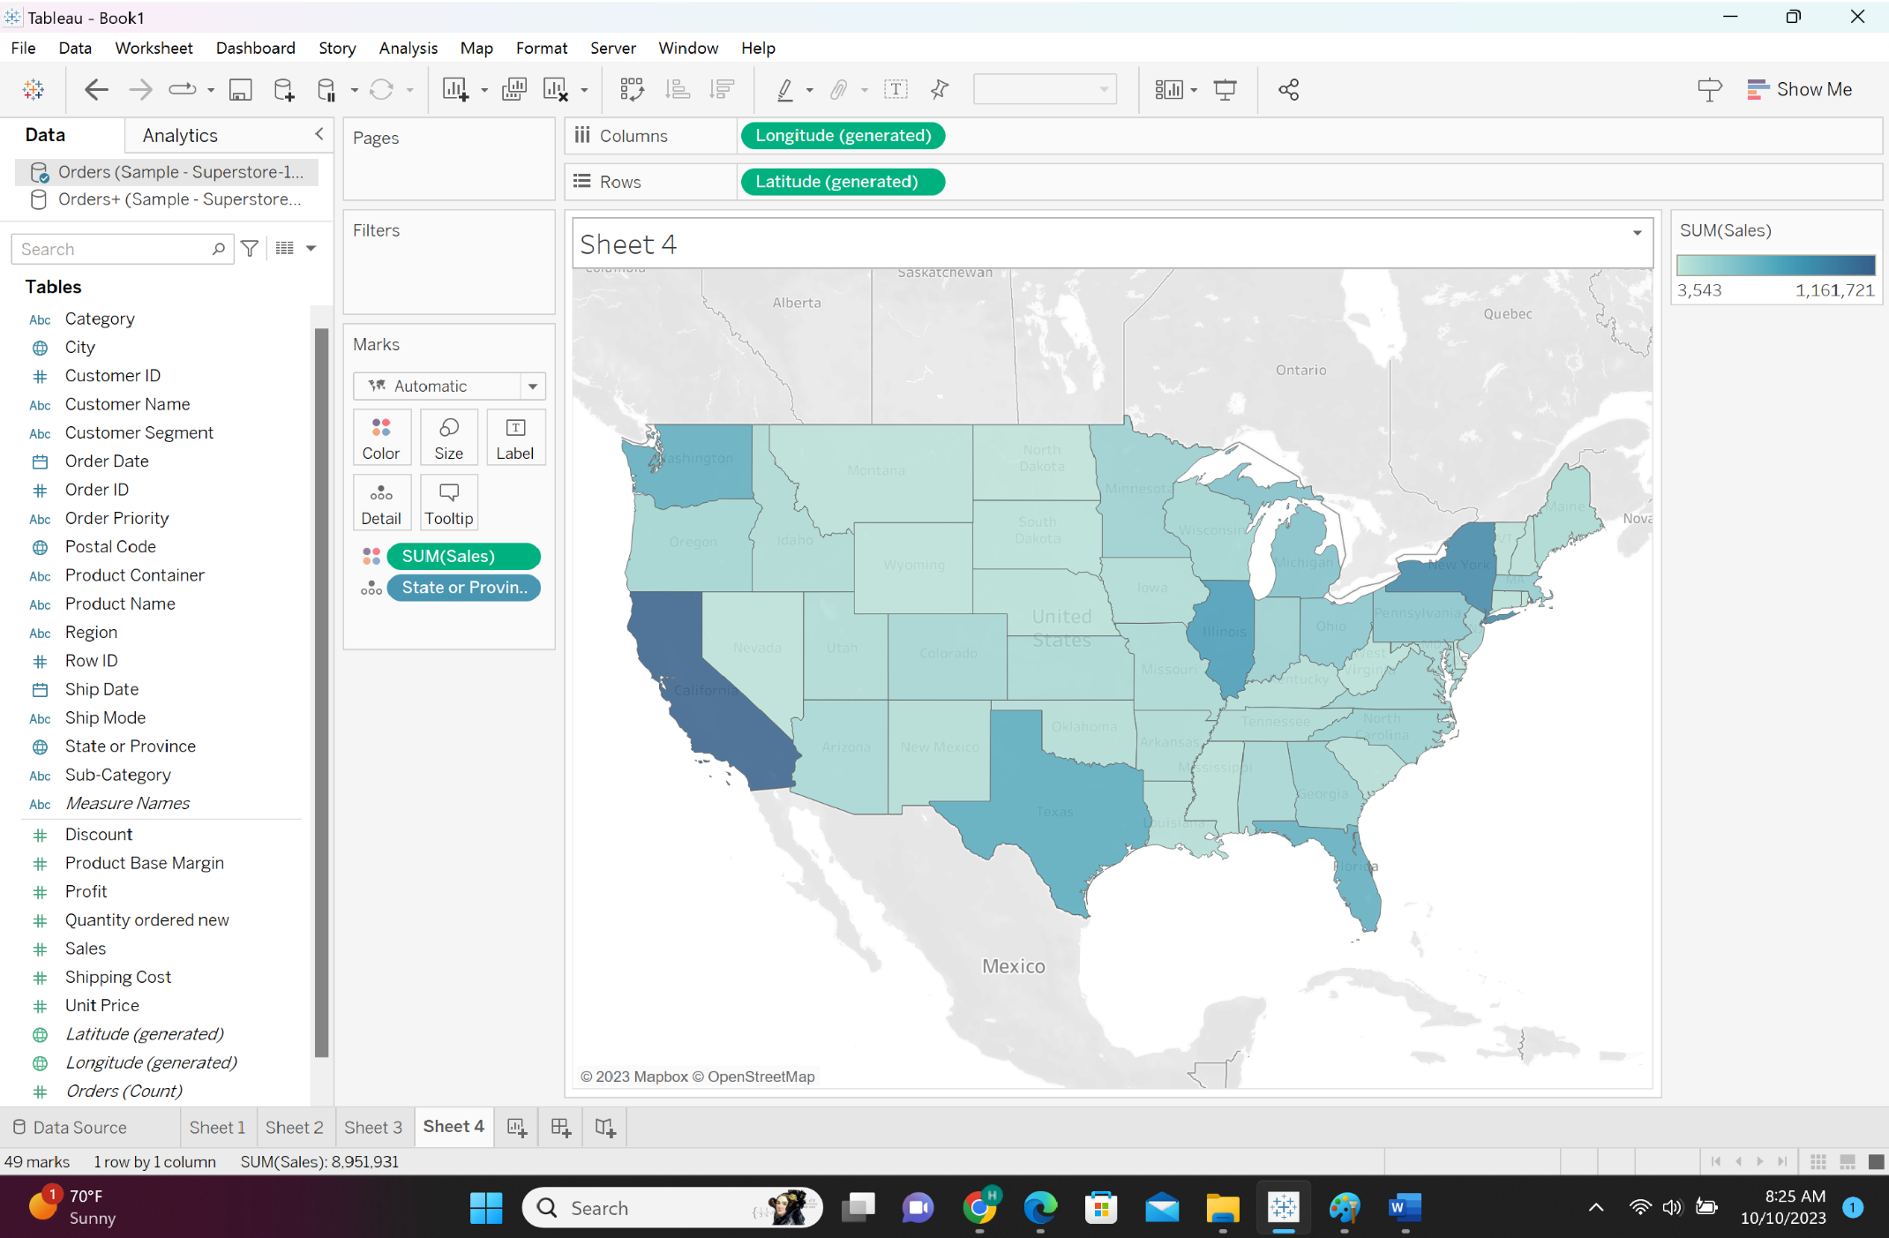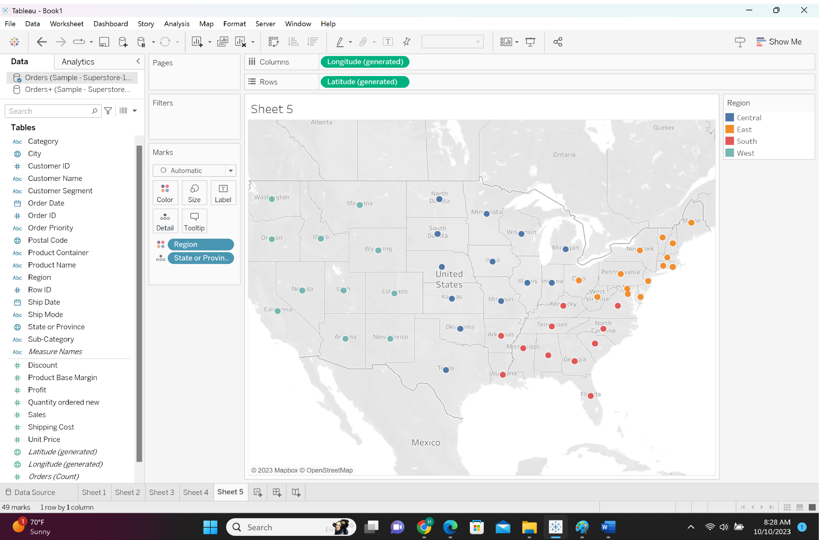

Filters with dimensions and measures
- When you want to create a graph you can use dimensions or measures. What is the difference?
- Sheet3:
- Drop “Sub-Category” into Rows
- Drop “Sales” into Columns and sort ‘Sales’ in descending order
- Now pick up “Category” that is discrete, and drop it into the filter spot. You will get a window which asks you which values you want?
- There are three options you can select, furniture, office supplies and technology.
Select “furniture” and click ok. Then only furniture is displayed.

How to work with parameters? Parameter by filters & parameters with sets

Parameters with filters
- Parameters are dynamic values, which you can change and you can interact.
- First, we make a bar chart and then we will show what parameters mean.
- Sheet4:
- Drop “Sub-Category” in Rows
- Drop “Sales” in Columns. Then, sales based on Sub-Category will be shown.
- Now we want to filter the Sub-Category based on the top 10 sales done.
- Sheet4(Cntd):
- First sort “Sales” in descending order.
- Pick up “Sub-Category” and drop it into Filters
- Select ‘Top’ and ‘by field’. Then select Top 10. Afterwards, it filters top 10s based on sum of sales. Click ok.
•Then only top 10 sales are displayed.
Q6: Provide a snapshot of sheet4.
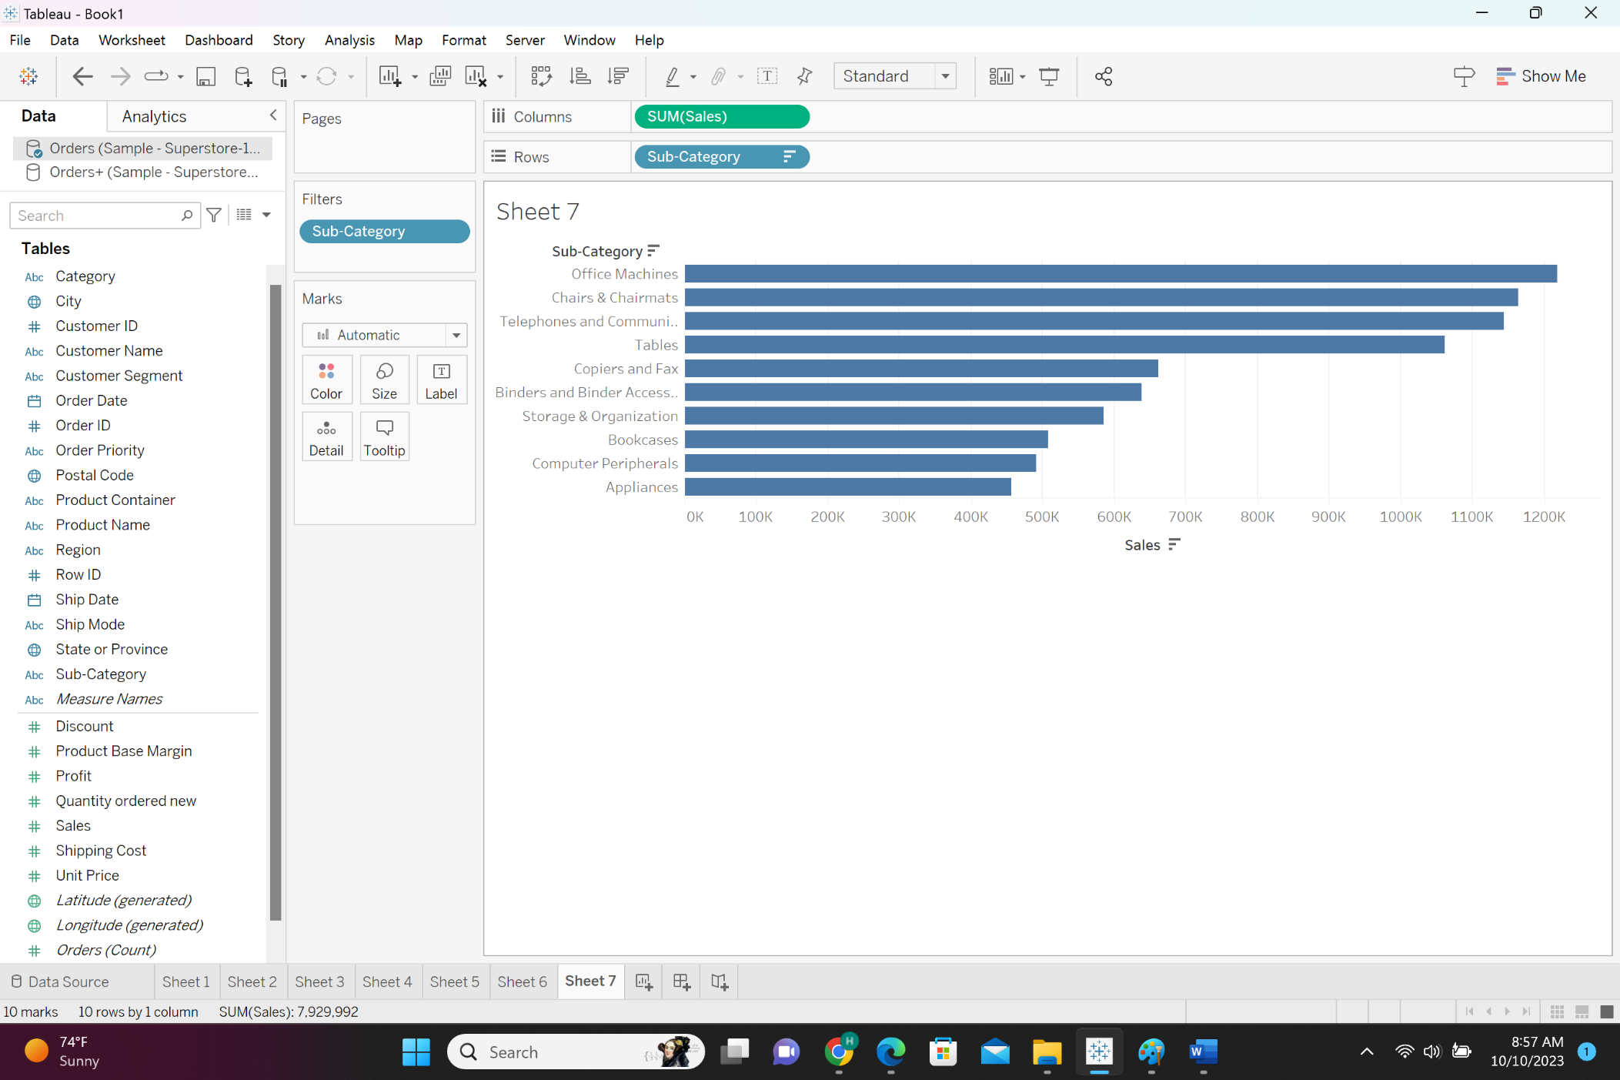
Q7: Which “Sub-Category” has the least sales done among the 10 top sales? How much sales done in that sub-category?

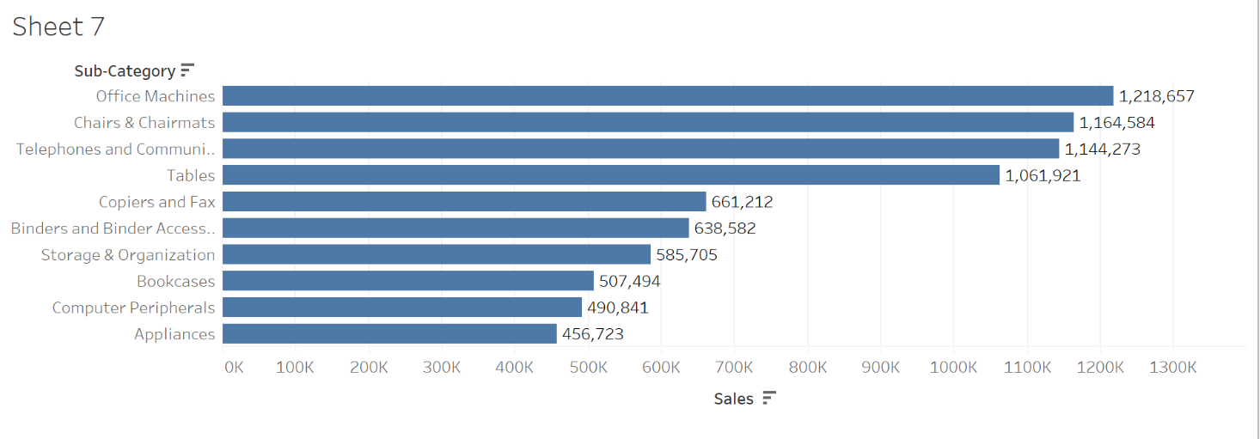
The subcategory with the least sales among the top 10 sales in appliances and the sum of sales in this sub-category is 456,723.
Q8: From the “ABC” dataset select top 10 data value from any of the columns and provide a snapshot.


