How to change title and caption?

Change title and caption
- We will learn how to insert and format title and caption.
- Sheet1:
- Drop “Category” and “Sales” in Columns and Rows, respectively.
- When a bar chart is created, it automatically gets a title name, which is by default the same as name of the sheet.
- Title is used to convey information about the chart, what exactly the chart is about.
- Sheet1(Cntd.):
- Double click on the Title of the chart to get the pop up window. Write “Category wise Sales” rather than <Sheet Name>. You can change format, color and other properties of the title, then click ok.
- If you want to insert some various other information, you can use “Insert”. Such as the sheet name, the file name, the count of sheets.
- Sheet1(Cntd.):
- Click on Insert and select “Data Source Name” and “Workbook Name”.
Q1: Provide a snapshot of sheet1.
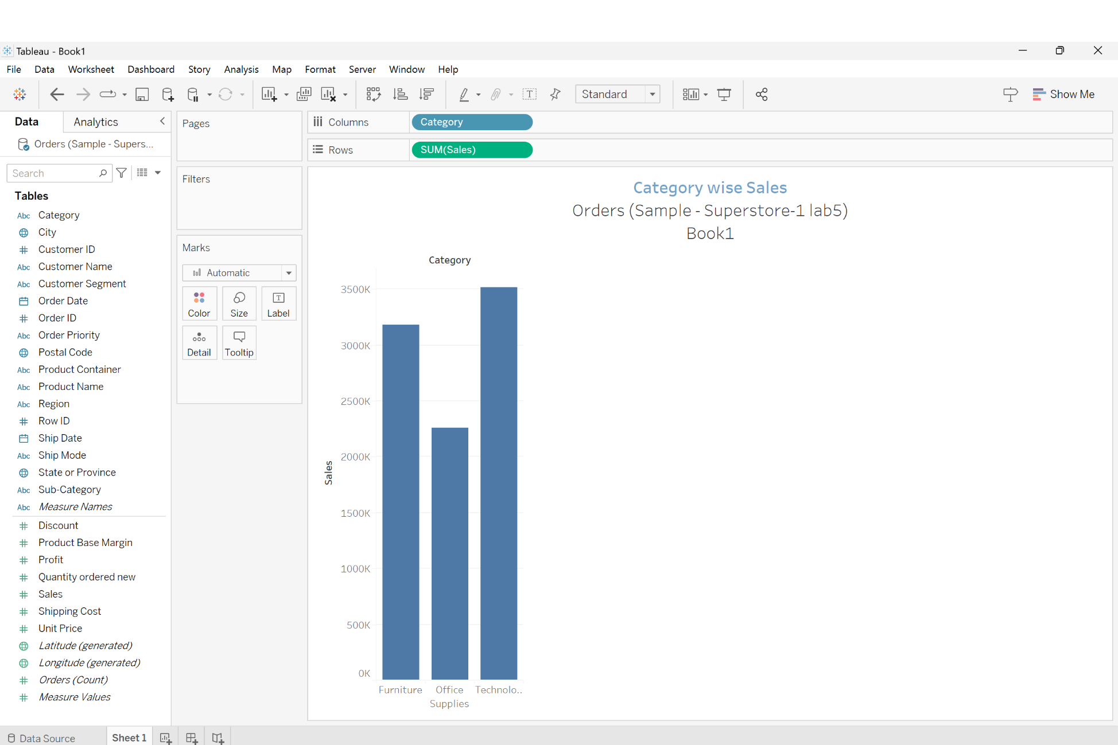

Change title and caption
- Caption also provides detail information about the chart to the user.
- Caption by default is positioned at the bottom, if it is not visible go the “Worksheet “ on menu bar and select “Show caption”. Then caption shows “Sum of Sales for each Category”, due to the assigned fields to Columns and Rows.
- To edit the caption, double click on its name and change the default name to “Sales based on category”. The other information can be added using the “Insert”.
- To change the format of title, click on the title name and then click on drop down menu, then select format title to see the “Format Title and Caption” on the left-hand side.
- Using that window, we can change the Title’s and caption’s shading and border.
- Thus, it is very easy to understand what the chart is about and all the information related to the chart.
How to export Tableau data into different formats

You can export Tableau data into
- Excel
- Power point
- Pdf
- MS Access database
- TWBX (Tableau Packaged Workbook)

Export to Tableau workbook
- First, clear sheet 1 and then create several data in different sheets.
- Sheet1:
- Columns: Region
- Rows: Sales
- Label and Color: Category
- Label: Sales
- Click on New Sheet and create Sheet2
- Sheet2:
- Columns: Region
- Rows: Sales
- Title: Sum of Sales for each region • Click on New Sheet and create Sheet3
- Sheet3:
- Columns: Region
- Rows: Sales
- Label and Color: Category
- Label: Sales
- Filter: Region and select only South
- Title: Sum of Sales for South
- Go to Worksheet menu and select show caption, the added caption explains the visualization

Export to Tableau workbook
- File → save , save in the format the project.
- File → save as, give the options .twbx and .twb
- Click on .twb and then save
- File → print to PDF
- What do you want to print, entire workbook or only the active sheet. Portrait or landscape. Assign a name and directory.
Any active sheet will be converted to pdf file.
- Afterwards the pdf file will be opened.
- Worksheet → Export → Image
- You can select title, view, caption, or color legend and save it into .png

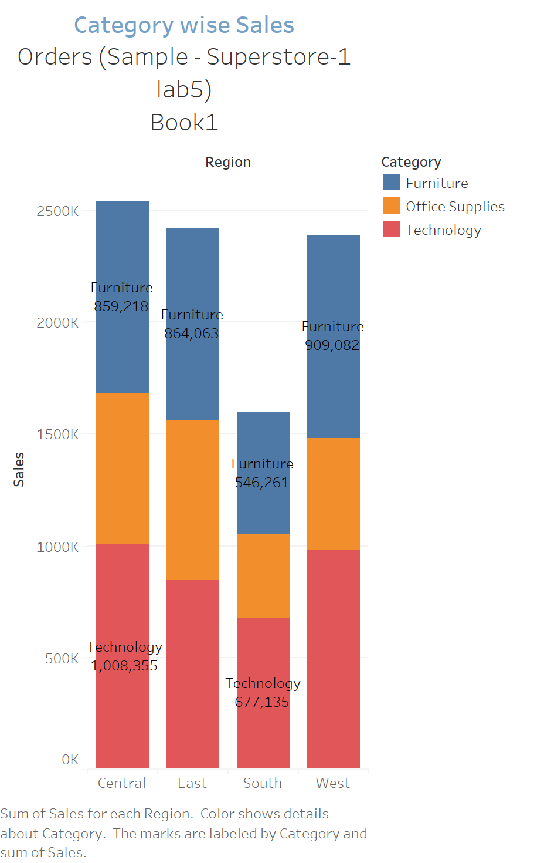
Q2: Create a png file from sheet1 and insert it into your document. Which category in West region witnessed the lowest sales?
The category which witnessed the lowest sales in the west region is the office supplies and this can be seen by comparing the size of the blocks in the bar. The office supplies block is significantly smaller than furniture and technology category blocks

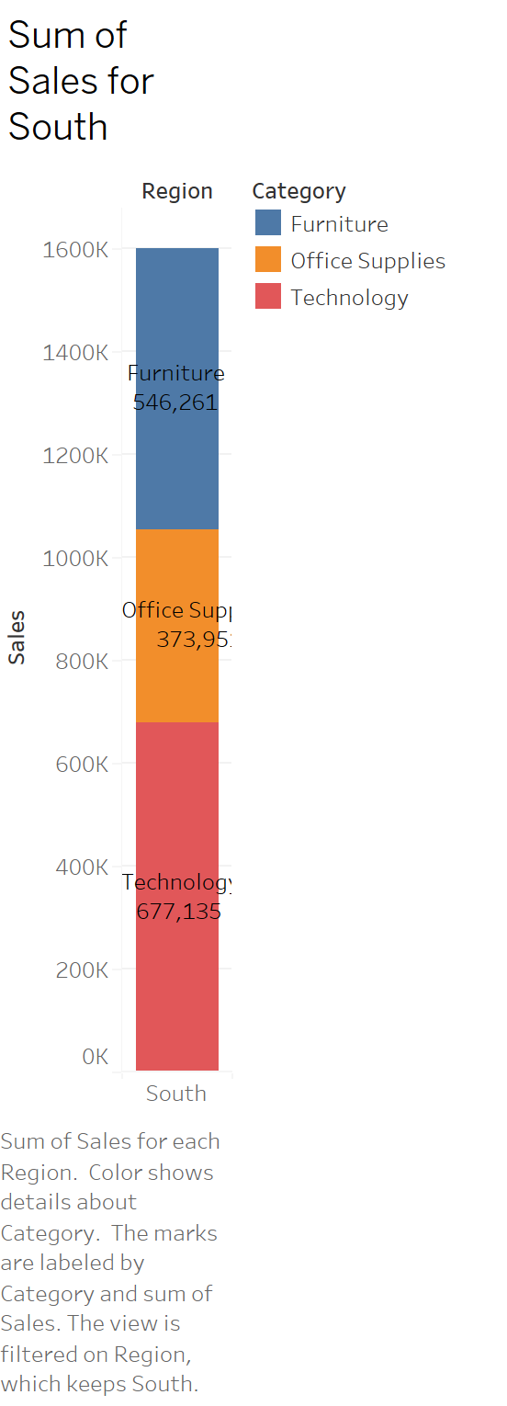
Q3: Create a png file from sheet3 and insert it into your document.
How much furniture is sold in South region?
The amount of furniture sold in South region is 546,261.

Granularity

Granularity
- Granularity means breaking down into small pieces.
- Sheet4:
- Columns: Profit
- Rows: Sales
- Then you get sum of profits and sum of sales in only one dot. So, one mark, and one row by one column traced on the sheet.
- If you want to break this one point into different pieces, you can use dimensions separately.
- Pick up “Ship Mode” and drop it in “Color” spot, then that single point is broken into three points. this is known as granularity.
- Sheet4(Cntd.):
- Now, pick up “Category” and drop it in “Shape”, then 9 marks will be generated.
- Then pick up “Customer Name” and drop it in “Color” part. There are so many customers in this database (4947 marks) and the resultant granularity becomes very high.
Q4: Take a screenshot of sheet4 and insert it into your document. Is this image informative in terms of customers names? Why is it not informative?
This image is not informative in terms of the customer names because we have 5181 customers having different names. Each name admits a different color in the legend. In other words, the way we are sorting the names is inefficient since every name is represented by a different color i.e., the colors have no significant meaning because of how much the graph is crowded with information.

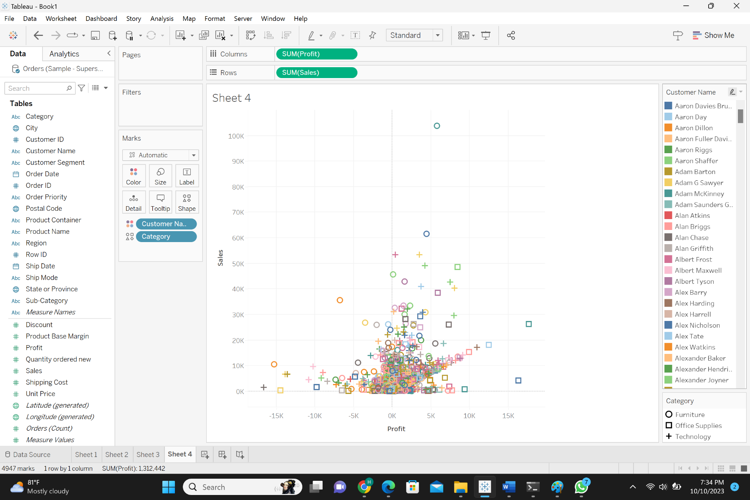

Granularity

- Sheet5:
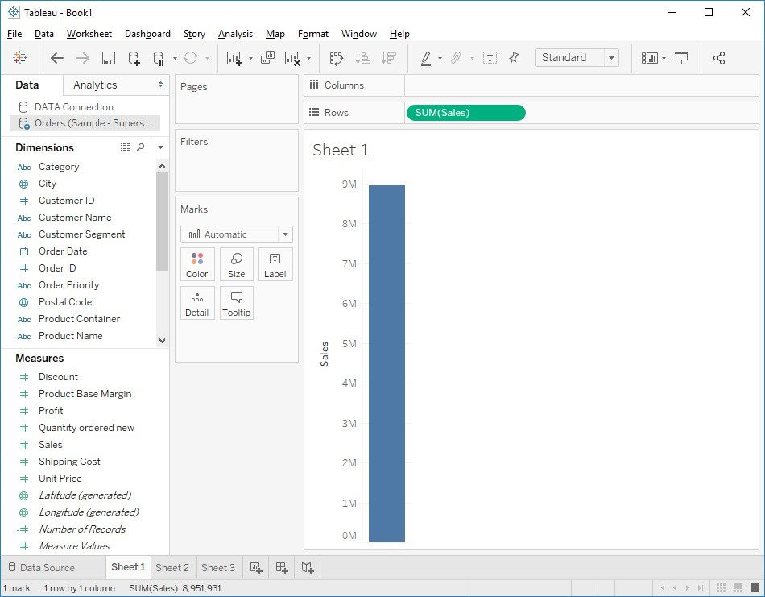
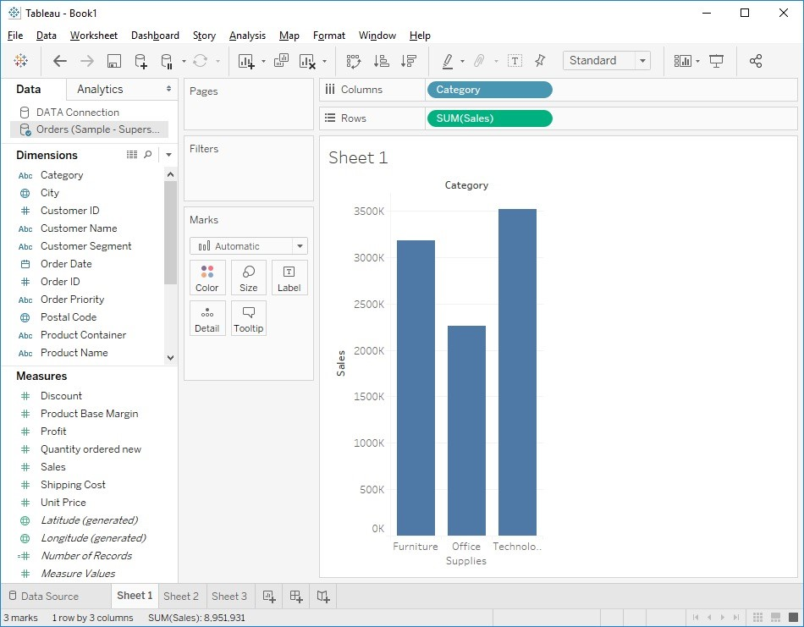
- Rows: Sales
- Then, we will get only one mark. If we want to divide it into details based on the “Category”, drop “Category” in Columns.
- Then it is broken into three different marks or is drilling down into details.
- So based on your dimensions and application, you can keep on crating granularity for map chart, bar chart, etc.
How to work with managing metadata
How to work with managing metadata
- How to hide/unhide fields
- How to rename fields
- How to create folders to put some fields inside

how to hide/unhide, rename fields
- Right click on the drop down of each field and select “Hide”. You may also choose “Hide All Unused Fields” to only keep the fields you used.
- If you want to see the hidden files, click on top drop down and choose “Show
Hidden Fields”.
- Right click on the drop down of each hidden fields and select “Unhide”
- Right click on the drop down of each fields and select “Rename”, or gently double click on fields and specify a different name to that field.

How to create folders
- If you have many fields, it is difficult to find related fields every time that you are interested in. In order to alleviate the problem, create a folder and put all related fields stored in that folder.
- click on top drop down and choose “Group by Folder”. Then it shows “Folders” in the top. Right click in the blank space below and choose “Create Folder”.
- Create a folder “Locations” and drag City, State, and Regions and drop it in “Locations”.
- You can do the same for the “Products”.
- As you see, the created folders differs from created hierarchies. Folders do not have drilling down properties and the order of fields within them does not imply anything.
Introduction to charts

Introduction to charts
- Tableau uses “Visualization Query Language” for creating different types of charts.
- Click on the “show me” button to see 24 different types of charts, which can be created in Tableau.
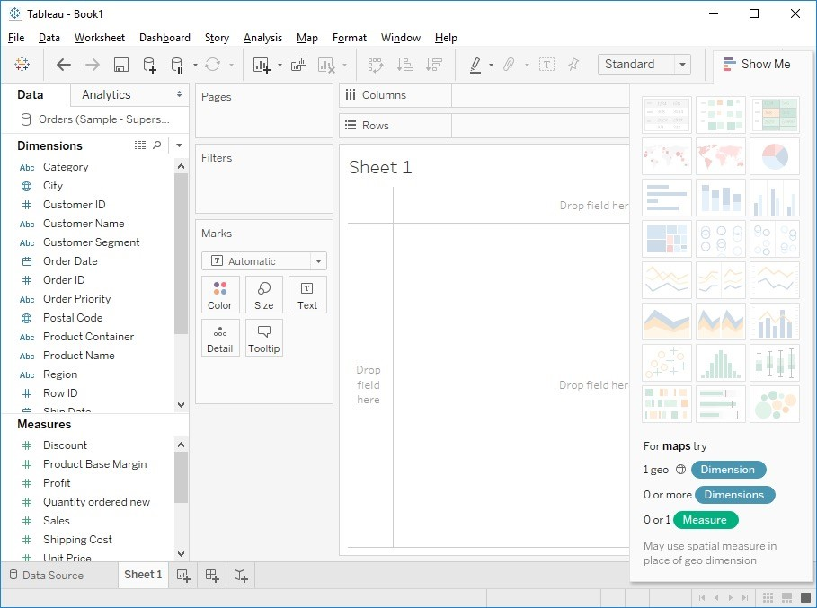
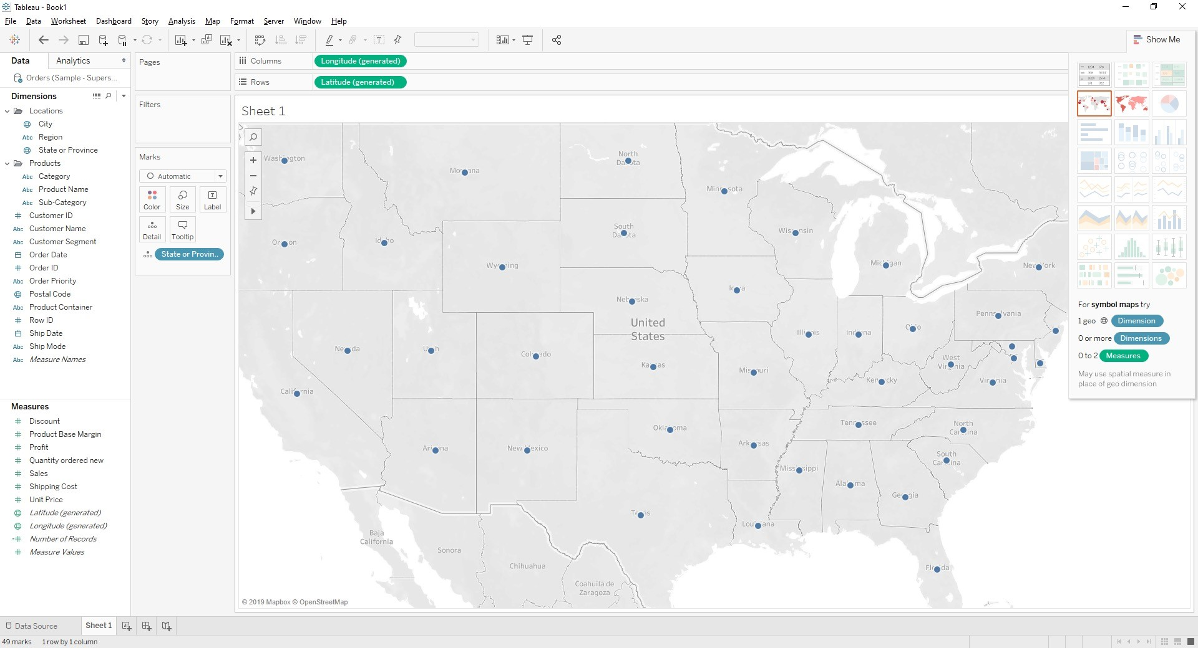
- Keep your cursor on each chart an see the name of the chart such as “text tables”, “heat maps”, “highlight tables” and so on.
- Each of them can be created based on fields in “Dimensions” and “Measures”.
- For example, if you want to create a map chart (such as symbol map), it needs “1 geographical dimension”, “0 or more dimension”, and “0 or 2 measures”.
- So, any field in “Dimensions”, with a geographical symbol is compulsory for creating a map chart, namely: “City” and “State or Province. If you have ” 0 Dimension” and “0 Measure”, still it works.
- Double click on “Sate and Province” and see how Tableau automatically creates “Symbol Maps”.

Introduction to charts
- For “Stack Bars”, we need “1 or more Dimensions” and “1 or more
Measures”.
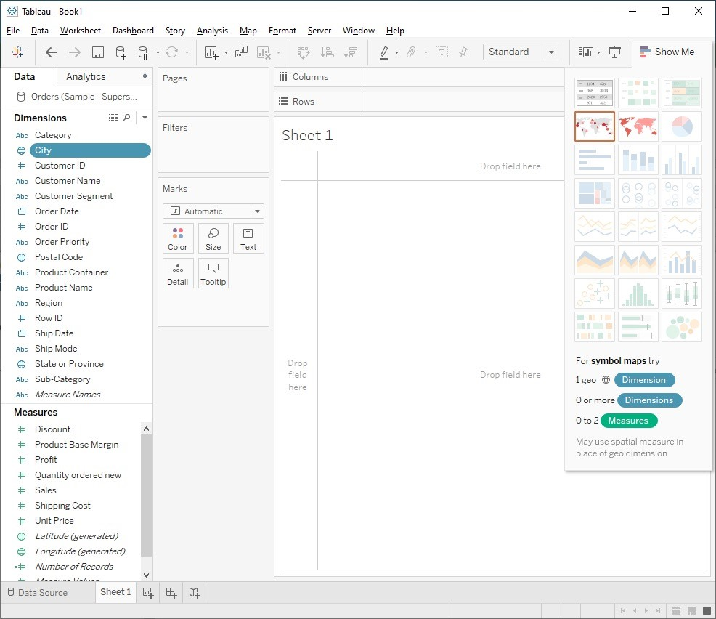
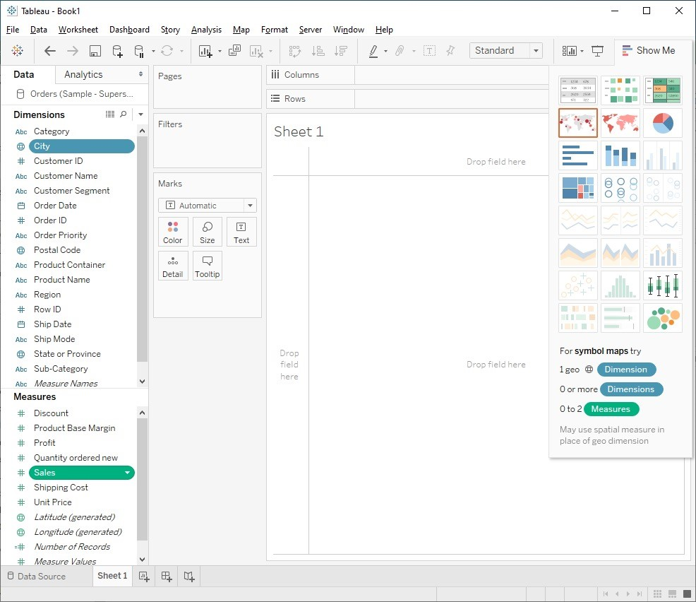
- Click on “City”, “Tableau Visualization Query” offers you the chars that can be created. The possible chars will be highlighted such as “symbol maps”, “maps”
- Click on “Category” that is only one dimension, nothing will be highlighted.
- Select “Category” and “Sales” by Ctrl key. Afterwards, some charts on the “Show Me” will be highlighted.
- This selection is carried out based on “Tableau Visualization Query” to select appropriate charts automatically.
- Select “Sales” then “Histogram” will be highlighted. It means that by using only one “Measure”, you can create a histogram

How to create a chart easily
- Select “Category” and “Sales” by Ctrl key, then select ”horizontal bars” from “Show Me”.
- Sheet6:
- Select “State or Province” and “Sales” by ctrl key, then select “maps” from all other charts that are being activated, then click on.
- Sheet7:
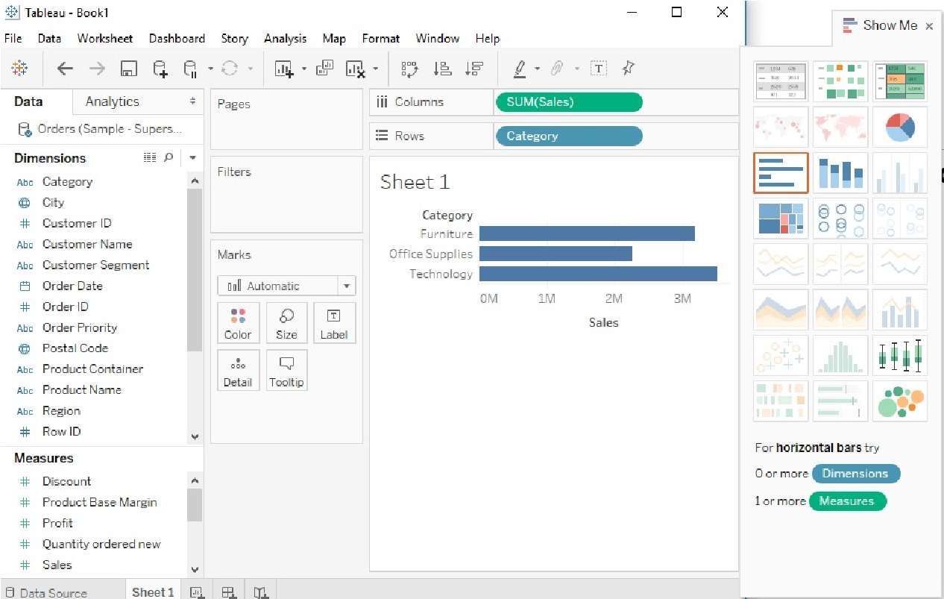
- Select “Order Date” and “Sales” by ctrl key, afterwards multiple chart such as line charts will be activated. Then click on “lines” chart to get the result.
Q5: Create a bmp file from sheet6 and insert it into your document.
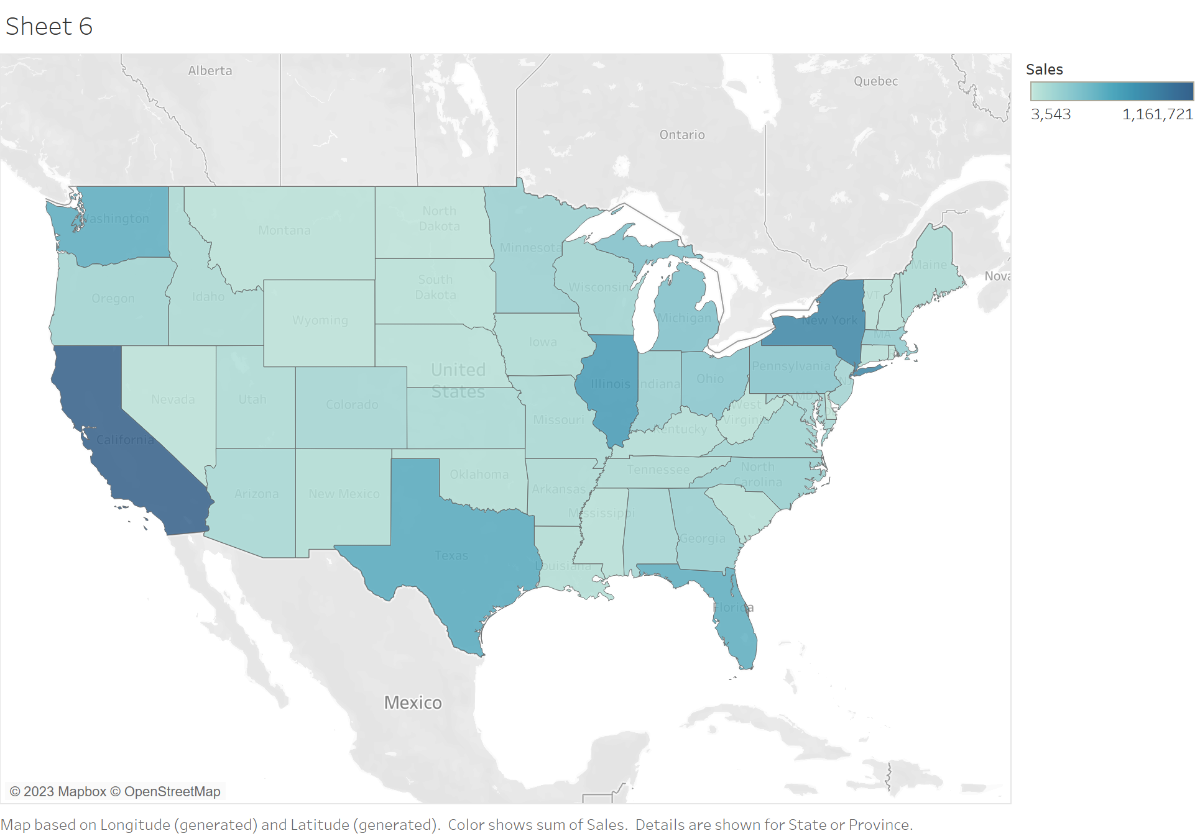
Q6: Create a bmp file from sheet7 and insert it into your document.
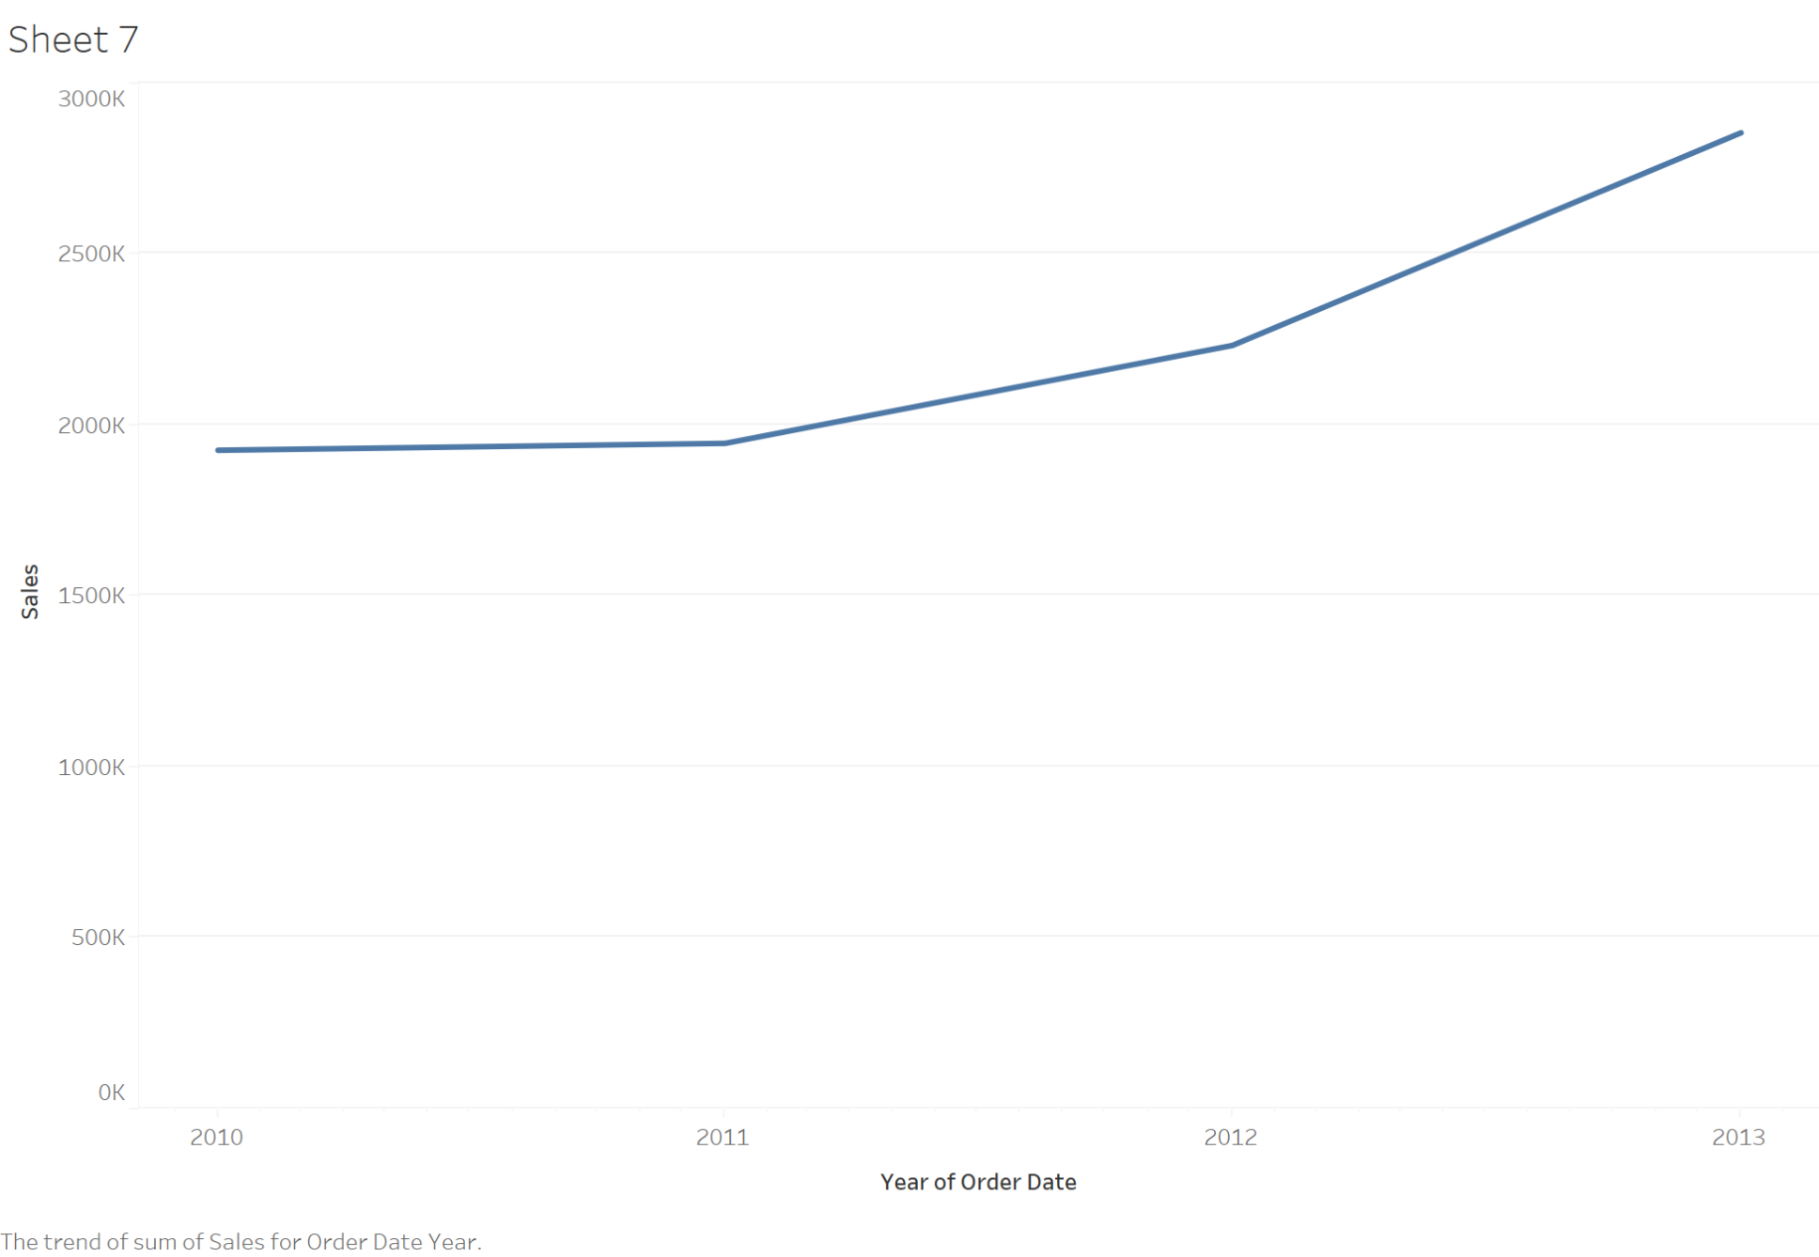
- If you select “States or Province” and “Sales” by ctrl key, no line chart will get activated, since it does not need geographical dimension.
- So based on the selected “Dimensions” and “Measures” the charts will be automatically selected and it shows the beauty of “Show Me” option, which helps you to find out which chart is appropriate for your purpose.
- Rather than traditional method for creating charts by picking up the fields and dropping them into cards, there are some shortcut techniques that you have to just double click on the fields, and you will be getting a chart immediately.
Shortcut techniques to create Charts
- Double click “Measures” first and “Dimensions” second, you will get a bar chart • Sheet8:
- Double click on “Sales” and then “Regions”, afterwards the bar chart is created
- Double click “Dimensions” first and “Measures’’ second, you will get a textual representation
- Sheet9:
- Double click on “Regions” and then “Sales”, afterwards the textual representation is created
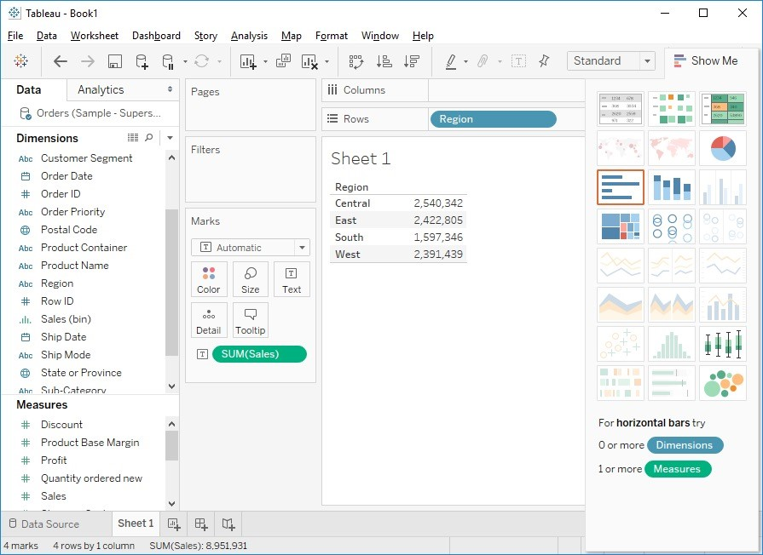
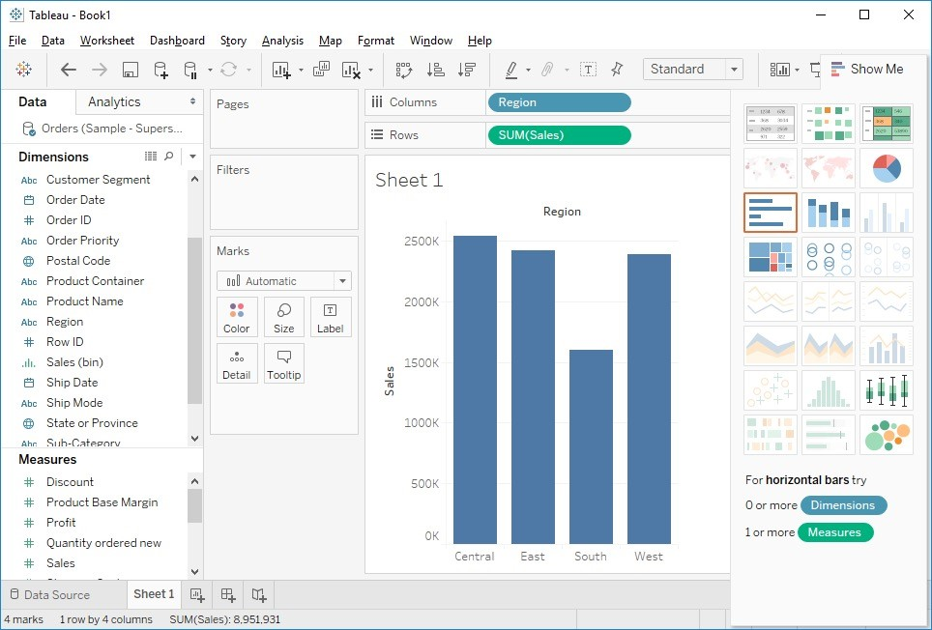
- Just we have to remember what should be selected first and what should be selected next, rather than drag and drop.
- Sheet10:
- Double click on “Order Date” and then “Sales”.
- Sheet11:
- Vice versa, Double click on “Sales” and then “Order Date”
- As you can see different types of representations used in sheet10 and sheet11, because “Tableau Visualization Query” language automatically select the best suited chart.
Q7: Create a bmp file from sheet10 and insert it into your document. Which type of representation is used?
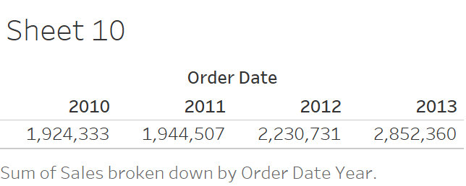

The type of this representation is a text table.

Q8: Create a bmp file from sheet11 and insert it into your document. Which type of representation is used?
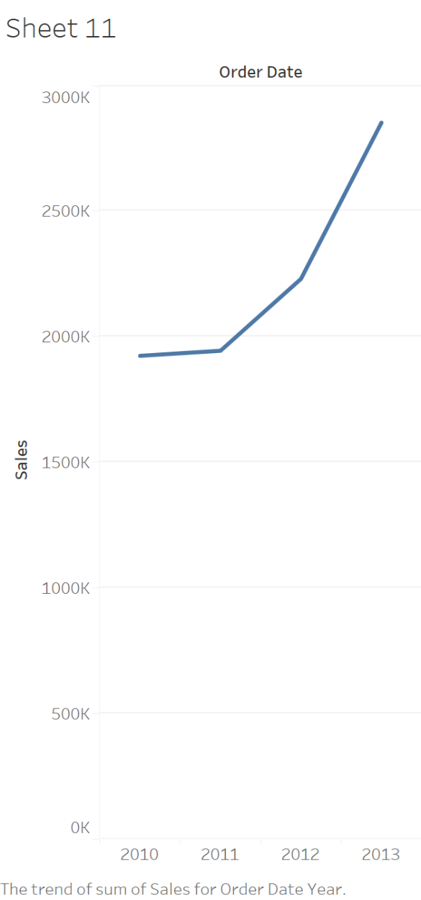
The type of this representation is a line graph.
Scatter charts Scatter charts
- Means that points will be scattered in the Cartesian plane.
- Sheet12:
- Double click on the “Sales” and “Profit” as two “Measures”, afterwards a point pops up on the Cartesian plane which shows total profit and total sales.
- If we want to find out how much “Sales” and “Profit” done category wise, drop “Category” on the cartesian plane. Then categories are shown by different symbols.
- Keep your cursor on each symbol and get information. Click on the “Size” in “Marks” and change their sizes.
- Drag “Category” to the label to assign “Label” to each symbols.
- Drag “Category” to the “Color” to assign color to each symbols.
Q9: Create a bmp file from sheet12 and insert it into your document.
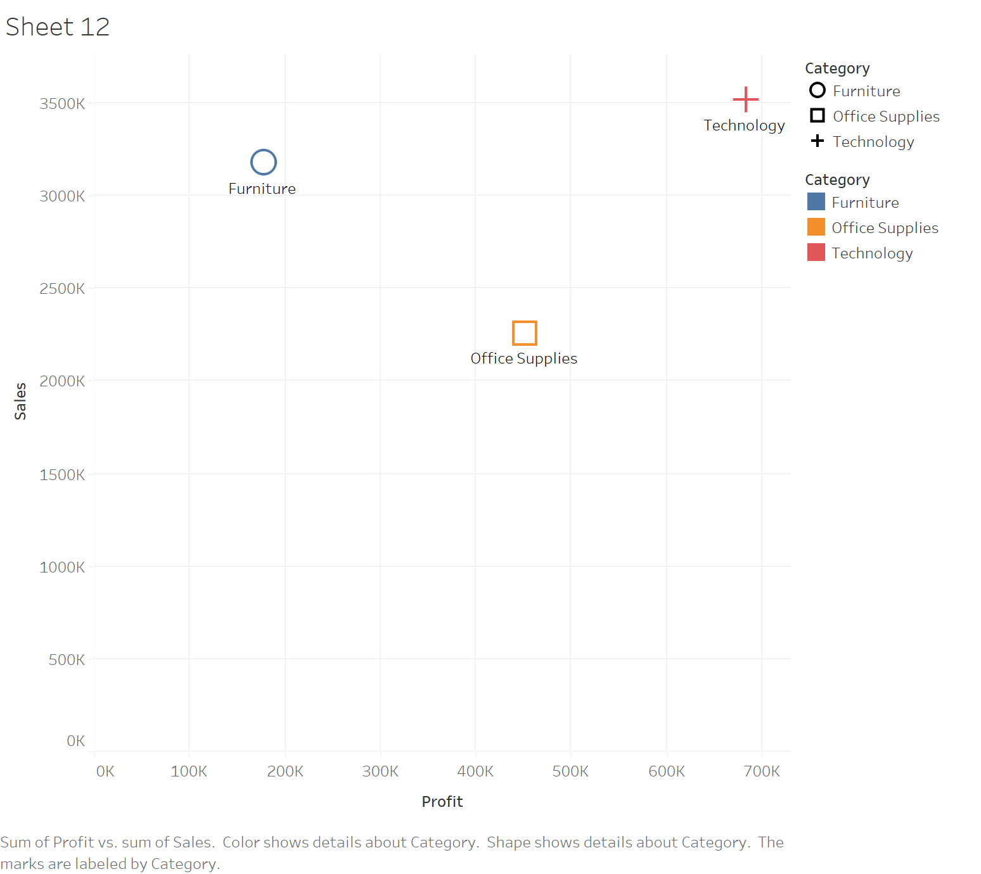

Scatter charts
- Now we want to create a scatter charts based on the customer, how much is the “Sales” and “Profits” done based on the customer.
- Sheet13:
- Select “Sales” and “Profits” by ctrl key, then click on “Show Me” button.
- There is “Scatter Plots” enabled, which says you need “2 to 4 Measures”, “0 or more Dimensions” to make it works.
- Click on “Scatter Plots” to get the result.
- Now we want to know which customer has done how much “Sales” and which customer has provided that much “Profit”.
- So drag “Customer Name” on the Cartesian plane.
- Hold the cursor on top of each circle then the detailed information pops up and you can see each customer’s name.
- Drag “Sales” to the label spot.
Q10: Create a bmp file from sheet13 and insert it into your document. What is the name of customer who made the most profit. How much in that profit.

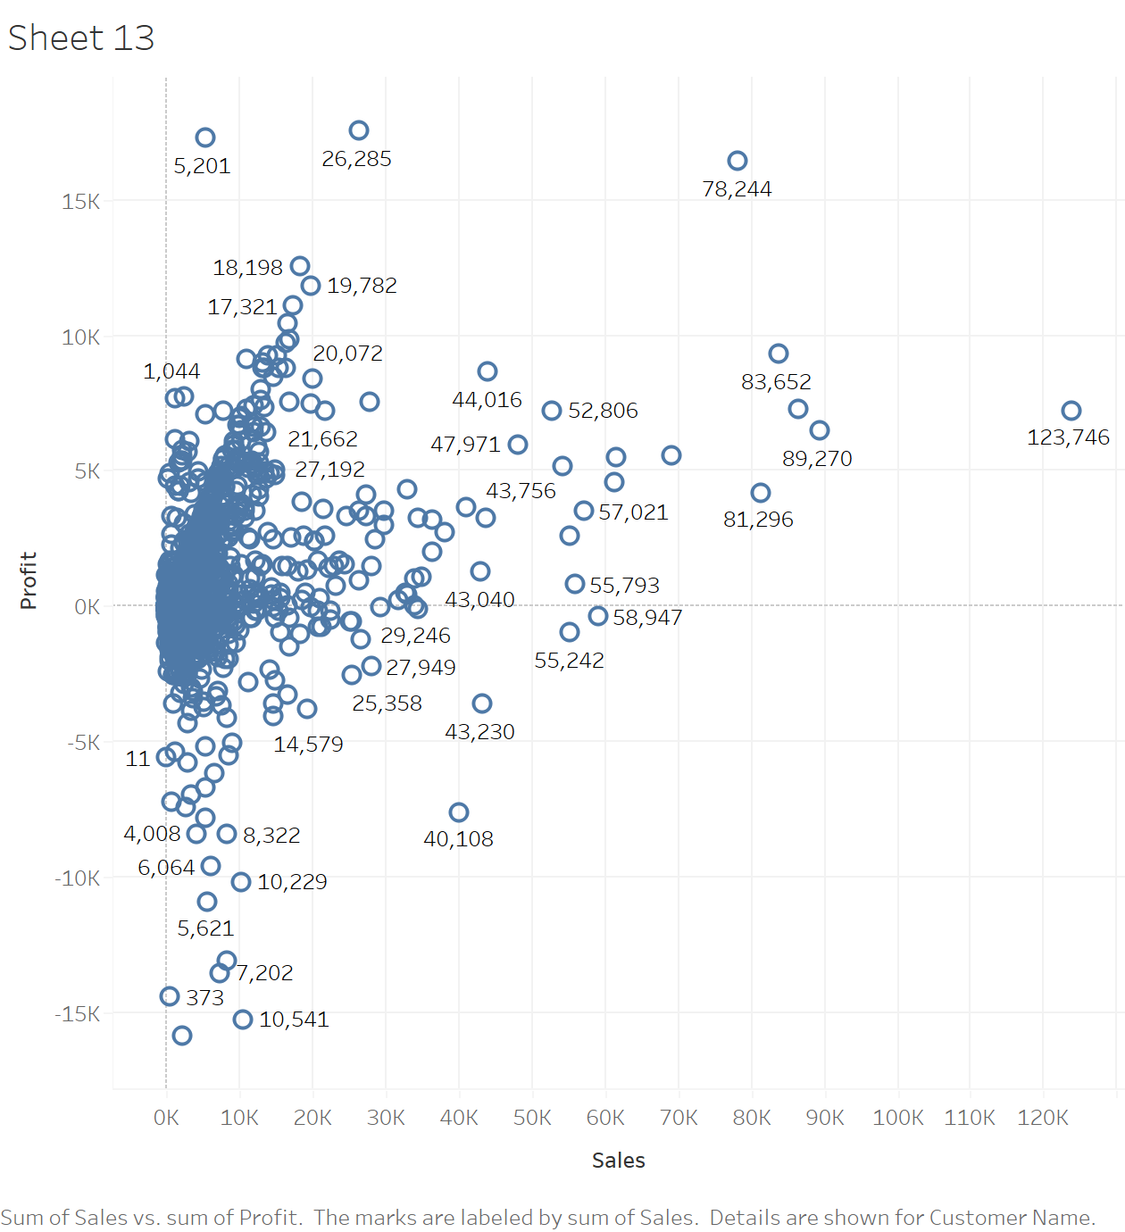
The name of the customer who made the most profit is Andrea Shaw. His profit was 17537.

Create an interactive scatter chart
- Interactive scatter charts can be created using filters.
- Sheet14:
- Double click on “Sales”, and “Profits”.
- Then double click on “Regions”.
- Then we see how much “Sales” and “Profit” done based on “Regions”.
- Click on the “Shape”, and then from its drop down select one of them and click on “Assign Palette” and ok. You can also increase their sizes by “Size”.
- Now, you can understand that “Sales” and “Profit” done by “Central” region was the highest.
- For creating an interactive charts, you have to use the filter.
- Click on “Category” and its drop down and select “Show Filter”, afterwards on the right hand side you will ger the filter and you can choose only “Furniture”, you get all only the options on the Cartesian plane associated with “Furniture”.
- You can infer that the “Profit” done by “West” for “Furniture” was the highest.
- For “Office Supplies” the “Sales” done by “East” was the highest.
- This quick analysis can be done by interactive scatter charts.
- Sometimes, it is difficult to understand how much the exact “Sales” done, or how much the exact “Profit” done, the scatter charts resolve the problem.

