Kibungo Local Market Hub

# PROJECT REPORT

Project Name: Kibungo Local Market Hub.

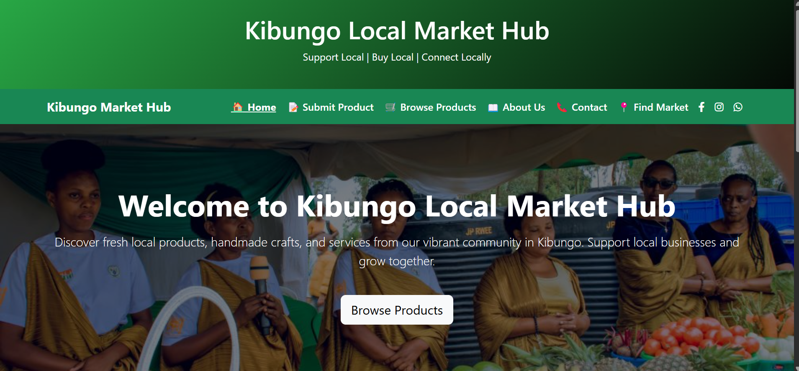

# 1. Introduction

The Kibungo Local Market Hub is a web-based application designed to address the challenges faced by local vendors and buyers in the Kibungo Sector.

# 2. Objectives

- Create an interface for local sellers to submit product listings.  
- Allow buyers to view and browse products.  
- Simulate social media integration.  
- Validate form inputs using JavaScript.  
- Use Bootstrap and CSS for a professional layout.

# 3. Tools & Technologies Used

- HTML, CSS (Bootstrap)  
- JavaScript  
- Font Awesome  
- Placeholder Images

- Adobe XD

# 4. System Overview

The application consists of structured sections for products, form submission, and social contact.

# 5. Key Features

- Product cards with images and info  
- Seller submission form with validation  
- Embedded Facebook feed and contact links to Instagram and WhatsApp

# 6. Limitations

- No backend or real-time updates  
- Placeholder images and simulated data only

# 7. Conclusion

This application shows how a front-end-only solution can serve local business needs effectively. With future expansion, it can integrate real-time features and databases.