PokemonApi

1-https://pokeapi.co/api/v2/ability/?limit=20

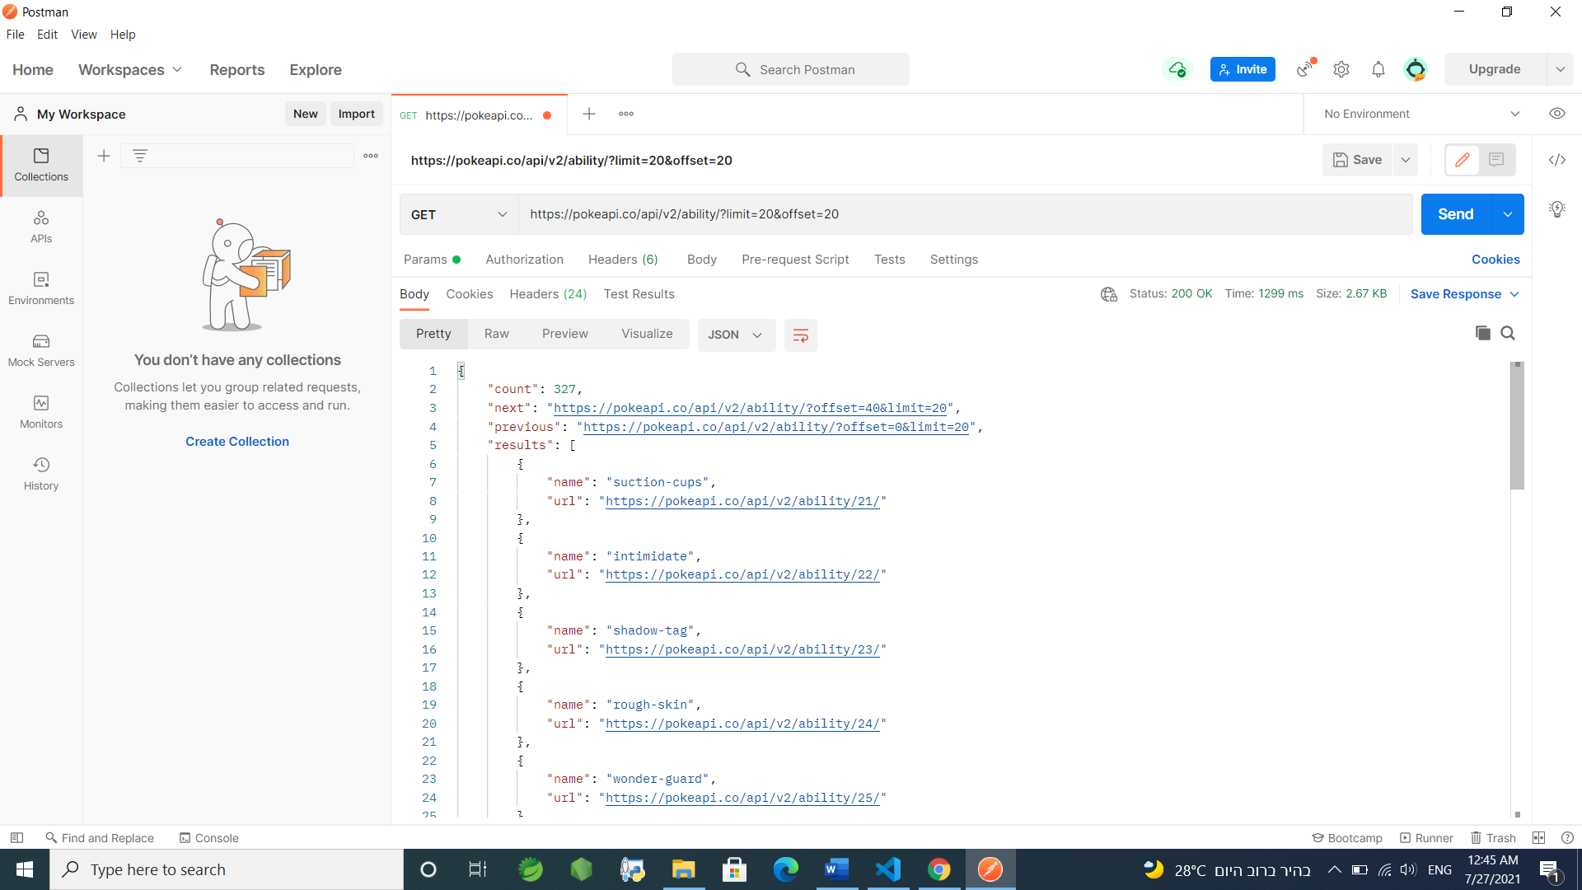

2-https://pokeapi.co/api/v2/berry-flavor/1

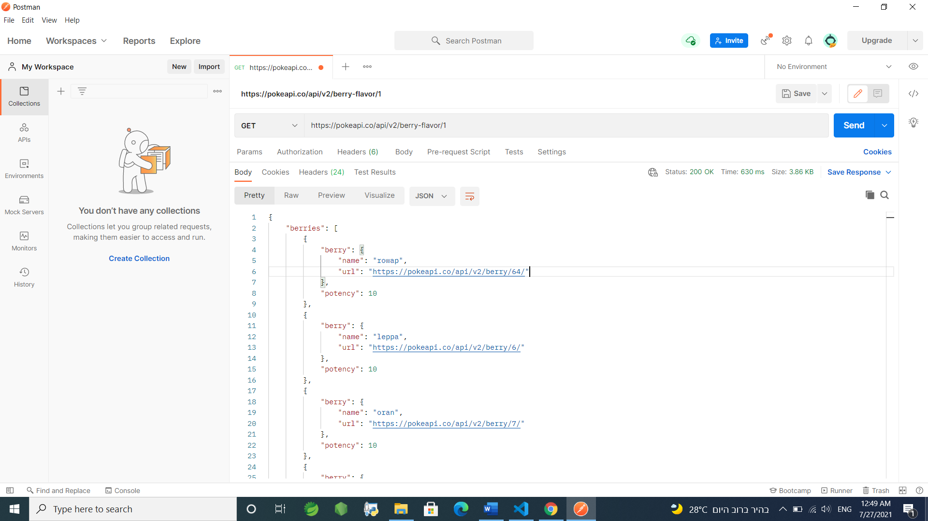

3-https://pokeapi.co/api/v2/contest-type/3

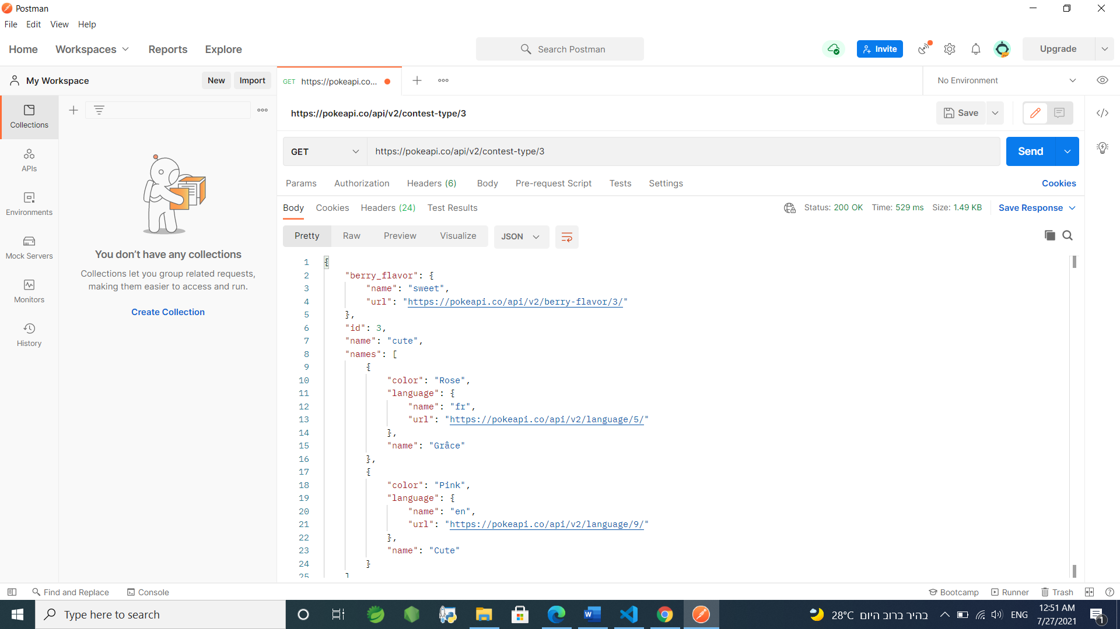4-https://pokeapi.co/api/v2/evolution-chain/7

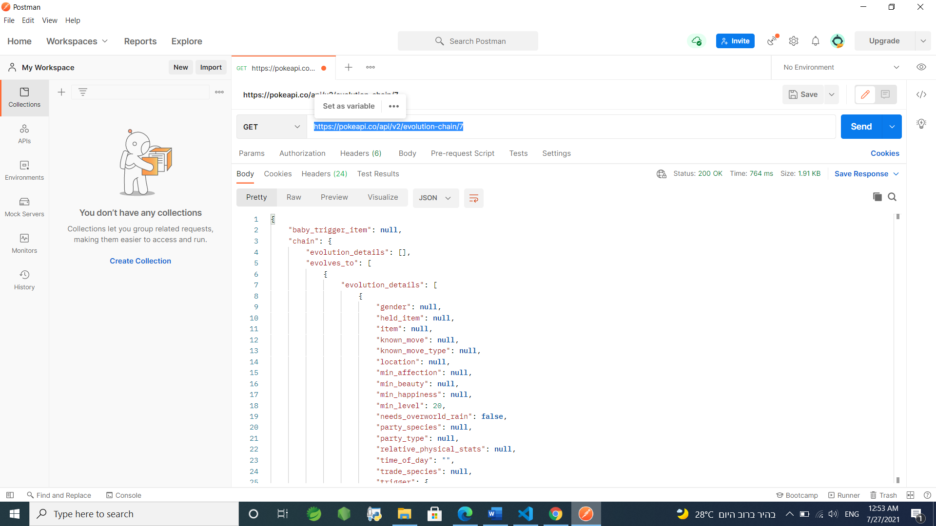

5-https://pokeapi.co/api/v2/generation/5

