Hodaya Sror & Suha Edris

ArielCast

Software Design Document

Names: Suha Edris & Hodaya Sror

Date: (06/06/2021)

**TABLE OF CONTENTS**

1. **INTRODUCTION 2**
   1. Purpose 2
   2. Scope 2
   3. Overview 2
   4. Reference Material 3
   5. Definitions and Acronyms 3
2. **SYSTEM OVERVIEW** **3**
3. **SYSTEM ARCHITECTURE** **3**
   1. Architectural Design 3-4
   2. Decomposition Description 4-5
   3. Design Rationale 5
4. **DATA DESIGN** **6**
   1. Data Objects 6-7
   2. Relationships and Complete Data Model7
5. **HUMAN INTERFACE DESIGN** **8**
   1. Overview of User Interface 8
   2. Screen Images 8-9
   3. Screen Objects and Actions 4
6. **REQUIREMENTS MATRIX** **9-10**

### INTRODUCTION

## Purpose

Optimize ‘learn from home’ experience for students. Ariel University is now using a system called “moodle” as the online system of teaching, where each course and lecturer has its own page.

ArielCast is built to create a platform that includes all the lecturers, courses information and lectures and recordings all in one place, accessible and available at all times, plus the option for both lecturers and students to communicate through emails and comments on the video/audio of the lectures.

## Scope

ArielCast is an android application, made for students and lecturers of the university.

The App helps students to do the following:

1. Watch lectures of their courses (in a player within the app).
2. Download audio/video of lectures from their app to their personal device.
3. Send messages to their lecturers available in the app.
4. Add comments on lectures video/audio.
5. Add certain lectures to the ‘watch later’ playlist.
6. Add courses to ‘My courses’ list (to follow the course and receive notifications when new lectures are added).
7. Get information on available courses, faculty and contact information.

The App helps lecturers to do the following :

1. Easy upload of video/audio of lectures recordings.
2. Quick responses to students' questions in lectures.
3. Send messages directly to all students following the course.
4. An orderly display of all the courses that the lecturer teaches.
5. Information about students who follow their courses (students names and emails).

## Overview

The purpose of this document is to help the reader visualize the solution to the project we are presenting. To verify how the design meets the requirements stipulated in the SRD document through design viewpoints. The design viewpoints will cover all design elements presented before.

## Reference Material

* Android studio documentation
* Firebase documentation
* Java documentation
* Youtube for different tutorials about android applications,firebase, design etc.
* Material of ‘software engineering’ course taken at the university last semester.

## Definitions and Acronyms

* Java - a programming language originally developed by James Gosling at Sun Microsystems. Java is a general-purpose, concurrent, class-based, object-oriented language that is specifically designed to have as few implementation dependencies as possible.
* Android - Developed by Google, a popular operating system for smartphones.
* Android Studio - is the official integrated development environment (IDE) for Google's Android operating system.
* Firebase - It is a database management system that provides a flexible and efficient database platform to maintain records of lecturer, student etc.

### SYSTEM OVERVIEW

The system that our university currently using both for students and lecturers is not very

accessible and not fully compatible for smartphones.

The system of arielCast application is compatible with android phones, more accessible in one place and will have the option of easily downloading course materials, communicating with the lecturer of the course and its students faster by having the options of adding comments,sending emails and using the courses forums. lecturers could upload their materials, see who follows them and communicate with the students.

### SYSTEM ARCHITECTURE

## Architectural Design

ArielCast app is an Android application developed with Java.

The app has backend data storage, real-time synchronization, and user-event logging using Firebase.

The app stores our data in the Firebase Realtime Database, which automatically synchronizes that data across devices.

Pictorial representation of android architecture with several main components and their sub components –

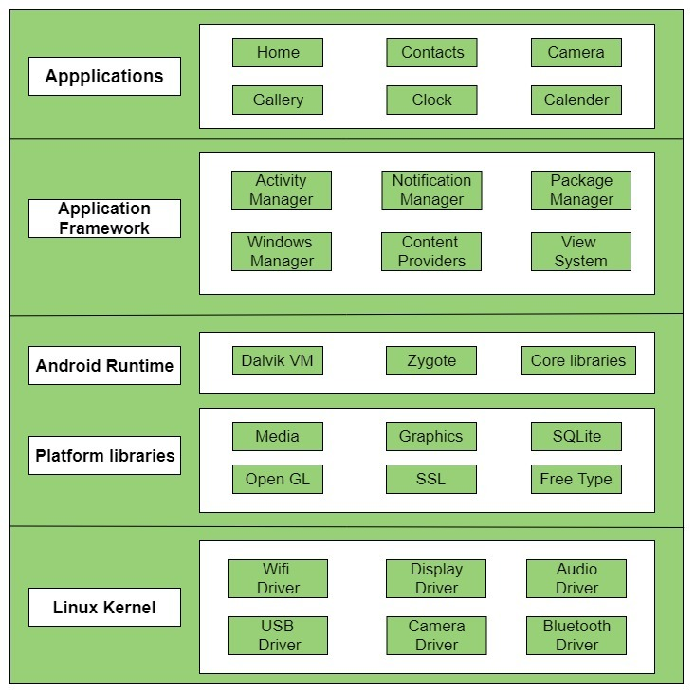

## Decomposition Description

The Android software stack generally consists of a Linux kernel and a collection of C/C++ libraries that is exposed through an application framework that provides services, and management of the applications and run time.

* **Linux Kernel**

The foundation of the Android platform is the Linux kernel. The layers above the Linux kernel rely on the Linux kernel for threading, low-level memory management, and other

underlying functionality. Using a Linux kernel enables Android to take advantage of Linux-based security features and allows device manufacturers to develop hardware drivers for a well-known kernel.

* **Libraries**

Running on the top of the kernel, the Android framework was developed with various features. It consists of various C/C++ core libraries with numerous open source tools.

* **Android Runtime**

It is the third section of the architecture. It provides one of the key components which is called Dalvik Virtual Machine. It acts like Java Virtual Machine which is designed specially for Android. Android uses it’s own custom VM designed to ensure that multiple instances run efficiently on a single device.

* **Application Framework**

The Android team has built on a known set of proven libraries, built in the background, and all of it is exposed through Android interfaces. These interfaces warp up all the various libraries and make them useful for the Developer. They don’t have to build any of the functionality provided by the android.

* **Applications**

Android applications can be found at the topmost layer. At the application layer we write our application to be installed on this layer only.

## Design Rationale

We used Firebase Platform to store our data because Firebase enables us to Build our application fast, without managing infrastructure.

FirebaseBacked by Google and also gives us functionality like analytics, databases, messaging and crash reporting so we can move quickly and focus on app users.

### DATA DESIGN

## **Data Objects**

All attribute types of the objects below are ‘String’.

* **Course**

**courseId -** Identity number given from the database for each course .

This attribute is unique for each course.

**courseName -** name of course .

**image -** image for the course .

**lecturerId -** Identity number of lecturer of the course .

**startDate -** start date of the course.

**endDate -** end date of the course.

* **Lecture**

**lectureId -** Identity number given from database for each lecture .

This attribute is unique for each lecture.

**lectureName -** lecture's name.

**courseId -** lecture’s courseId.

**date -** date of uploading the lecture.

**video_url -** url of lecture’s video - from firebase storage.

**search -** lecture’s name written lowercase.

* **Lecturer**

**lecturerId -** Identity number given from the database for each lecturer .

This attribute is unique for each lecturer.

**fullname -**  lecturer’s full name.

**email -** lecturer’s email address.

**phone -** lecturer’s phone number.

**password -** lecturer’s password for using ArielCast app .

* **Student**

**studentId -** Identity number given from database for each student .

This attribute is unique for each student.

**fullname -** student’s full name.

**email -** student’s email address.

**phone -** student’s phone number.

**password -** student’s password for using ArielCast app .

* **StudentCourses**

This object connects students with the course to allow them to follow it.

**studentId -** student’s Identity number.

**courseId -** Identity number of course.

**4.2 Relationships and Complete Data Model**

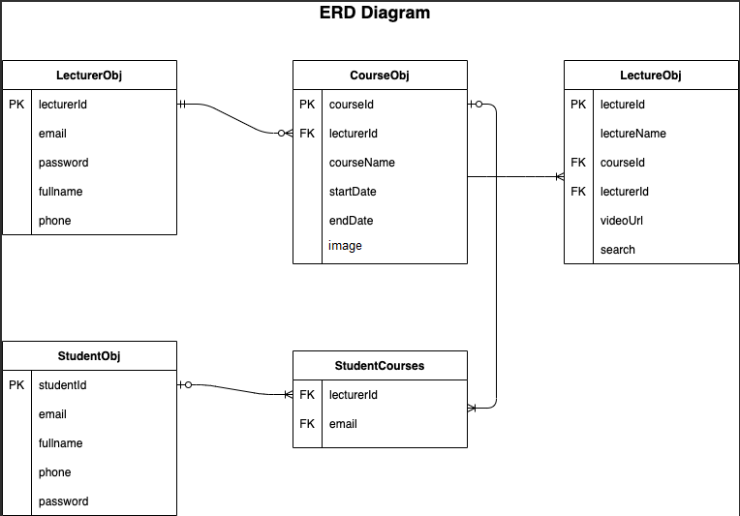

### HUMAN INTERFACE DESIGN

## Overview of User Interface

* Login page - Welcome page to login/register, with the options: forgot password, remember me.
* Register page - A form for registering new users.
* Main page - courses list (students get a list of the courses they follow and can search for more, lecturers get a list of their courses).
* Course page - A list of all lectures of the course.
* Lecture Screen - video/audio player of lectures’ recordings.

## Screen Images

|  |  |  |
| --- | --- | --- |
|  |  |  |
| Login Page | Register Page | Main Page (Student) |

|  |  |  |
| --- | --- | --- |
|  |  |  |
| Main Page (Lecturer) | Course Page | Lecture Screen |

### REQUIREMENTS MATRIX

|  |  |  |
| --- | --- | --- |
| **Requirements** | **Satisfied by**  **(Solution component)** | **Validate**  **(Test component)** |
| The app must allow users to log into their account using their email and password. | Login Page | test cases to test login functionality |
| The app must allow users to reset their password by clicking on "I forgot my password" and receiving a link to their verified email address. | Login Page | test cases to test TextView for email input . |
| The app storage includes information about app users . | Register Page | test cases to test register functionality. |
| The app must have enough storage capacity that it can store users ,courses and lectures’ information. | using FireBase. | Its Realtime Database can make 100 connections at once. It can store 1GB of data and 10GB of downloading capacity of 10GB per month.  **Storage-wise:** 5GB store and daily download capacity of 1GB. |
| The app allows uploading and downloading audio/video recordings of the lectures. | Add Lecture Page  (for upload)  Show Lecture Page  (for downloading) | test cases for test adding lecture details and lecture video file . |
| This app must allow sending messages and interaction between the lecturers and the students. | Sending a Email Page and Show lecture Page  (in comments View component ) | test cases for test message title , message body and email address. |
| The app allows users to search for courses and lectures in the app. | Student Main Page | test cases for test search functionality and filter of courses list. |

### 