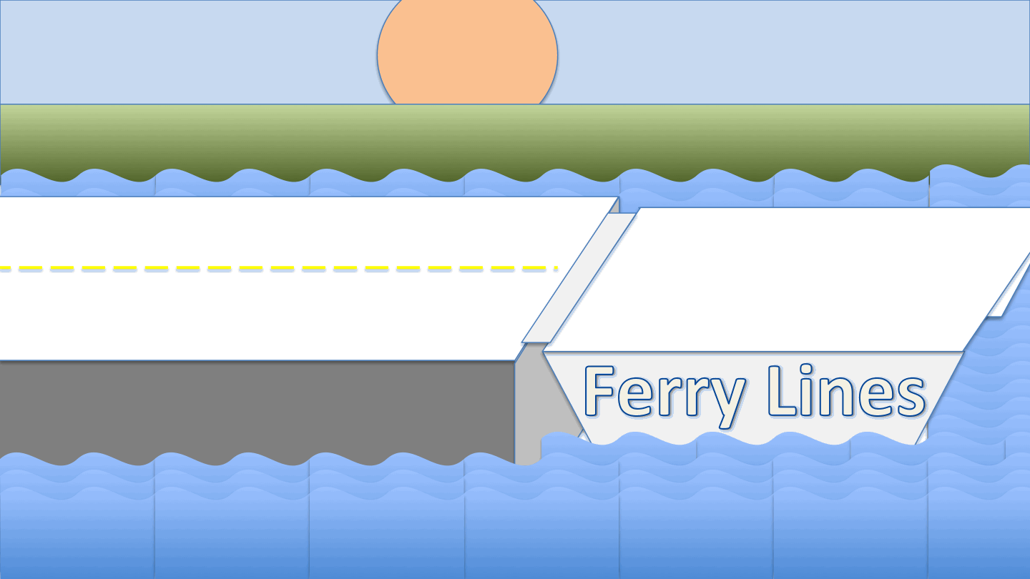

The Pelee Islander Ferry runs between Leamington and Pelee Island. The ferry is wide enough to support two lanes of vehicles throughout its length and is 24m long. The vehicles waiting to board the ferry form a single queue. The vehicles are either motorcycles, requiring 3m on the ferry, cars, requiring 5m on the ferry, or trucks, requiring 9m on the ferry. The operator can first determine the length of vehicles by inspecting the queue before boarding starts. The operator then directs each vehicle in turn to drive onto the port (left) or starboard (right) lane and directs the remaining vehicles to move up. The queue may be so long that not all vehicles will fit on the ferry. The goal is then to load as many vehicles as can possibly fit into on the ferry and to minimize the unused space on the ferry. The vehicles have to board the ferry in order of the queue, that is, vehicles cannot overtake vehicles in front of the queue.

Write a program to help the operator to maximize the load of the ferry. A sample solution that places vehicles randomly on the left or right lane is provided. Run random_queue() to see the sample solution in action. Your program is going to be tested with 5 different scenarios. You can run these scenarios by test1(), …, test5(). Your score is determined as follows for each of the 5 scenarios:

* If vehicles collide, you get a penalty of 10
* For each overfull lane, you get a penalty of 10,
* otherwise, the sum of the unused space is your score

The group with the lowest score wins.

*Restrictions*: You can only modify the function operator(); that function may access the global variable queue with the list of vehicles and call for each vehicle v

* v.length() for the length in m
* v.move_up(dx) to move a vehicle in the queue dx meters ahead, provided there is space in front of the vehicle (otherwise there is a collision)
* v.board_left() and v.board_right() to board the first vehicle in the queue if there is space on the lane (otherwise the lane will become overfull)

### Department of computing and software

Information Technology Building 202

## Qiang Xu

Load

the Ferry

M.Sc. Candidate

Associate Professor  
Outreach Coordinator

Ph.D. Candidate

## Natalie Perna

## Dr Emil Sekerinski

### E-Mail

macalat@mcmaster.ca

### Web

www.cas.mcmaster.ca

# McMaster University Engineering and Science Olympics 2015