Cody Hodges

DIG 3725-001

September 27, 2018

I added space shuttle pickups and obstacles to modify the 2D UFO tutorial.

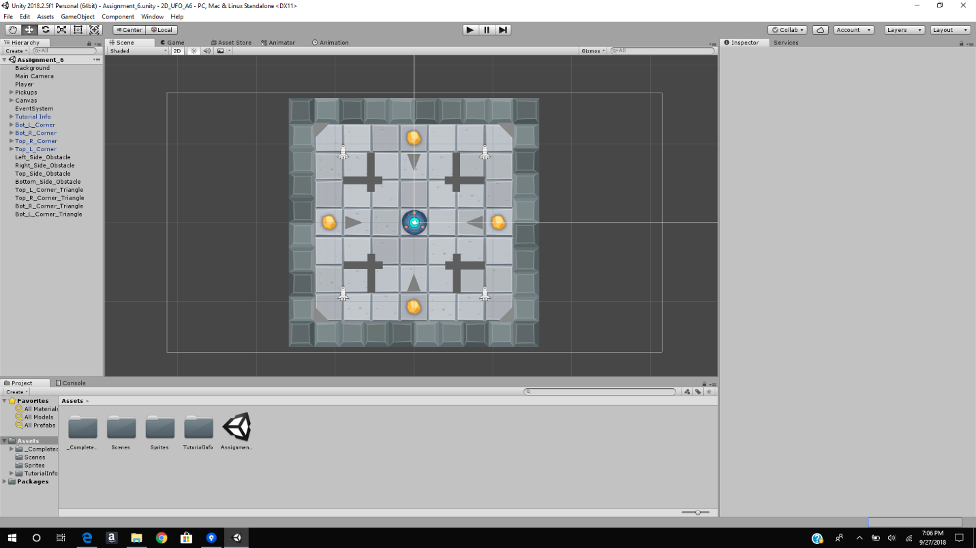

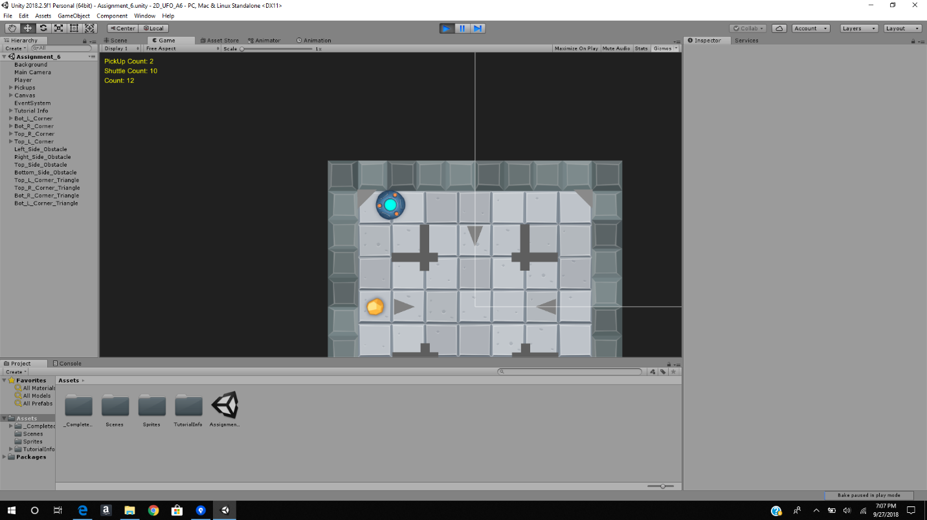

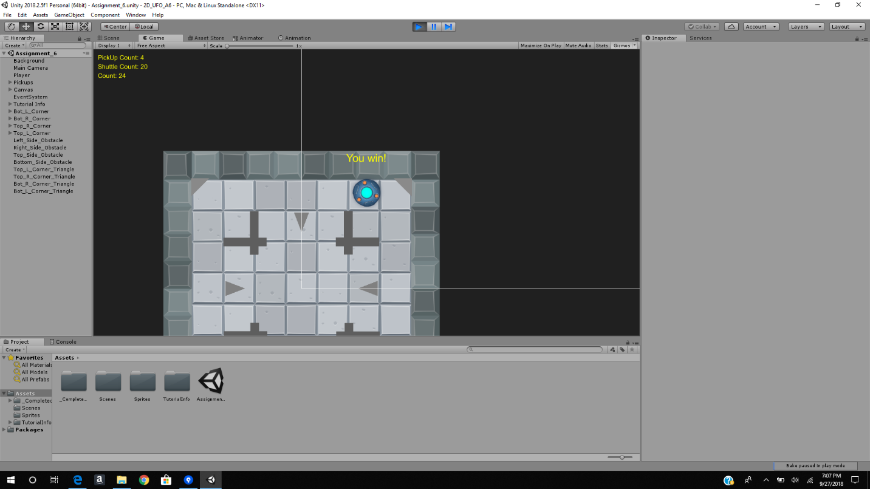

Github: <https://github.com/hodges522/cody_hodges_gdf2018_assignment6.git>