

**HÁLÓZATI OPERÁCIÓS RENDSZEREK ÉS IOT TECHNOLÓGIA**

**Ablak nyitvatartás monitorozása**

Hódi Szilárd

**Eszközök :**

arduino uno fejlesztőikártya  
 IR-08H infra távolságérzékelő  
 ESP-01S wifi sheild

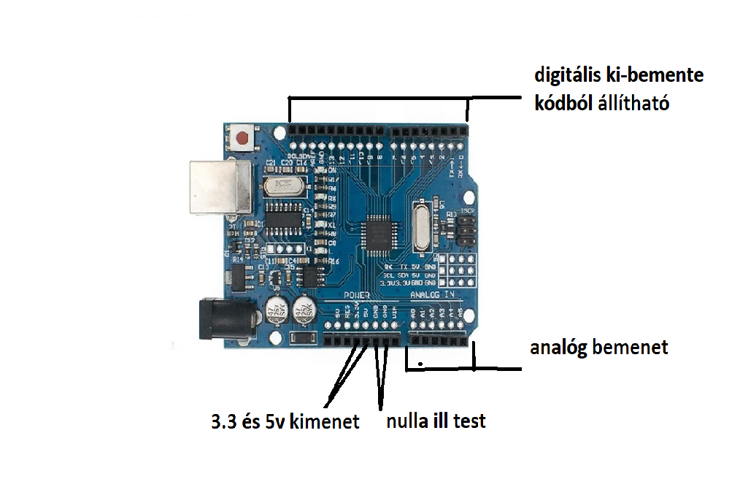**Arduino uno fejlesztőikártya:**

**IR-08H infra távolságérzékelő:**

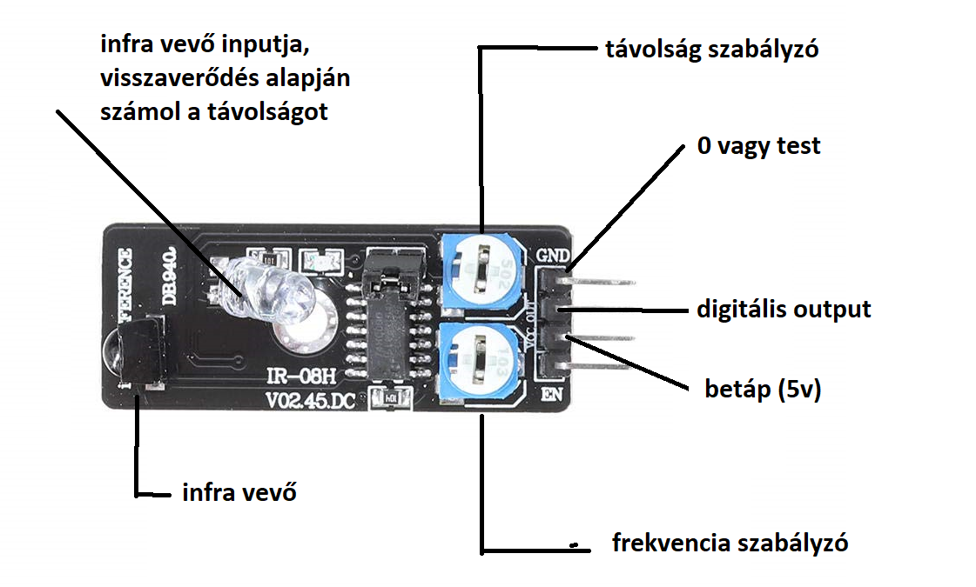

**ESP-01S wifi sheild:**

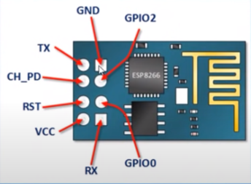

# TCP/IP AT Commands

A[T+CIPV6](https://docs.espressif.com/projects/esp-at/en/latest/esp32/AT_Command_Set/TCP-IP_AT_Commands.html" \l "cmd-ipv6): Enable/disable the network of Internet Protocol Version 6 (IPv6).

[AT+CIPSTATE](https://docs.espressif.com/projects/esp-at/en/latest/esp32/AT_Command_Set/TCP-IP_AT_Commands.html" \l "cmd-ipstate): Obtain the TCP/UDP/SSL connection information.

[AT+CIPSTATUS (deprecated)](https://docs.espressif.com/projects/esp-at/en/latest/esp32/AT_Command_Set/TCP-IP_AT_Commands.html" \l "cmd-status): Obtain the TCP/UDP/SSL connection status and information.

[AT+CIPDOMAIN](https://docs.espressif.com/projects/esp-at/en/latest/esp32/AT_Command_Set/TCP-IP_AT_Commands.html" \l "cmd-domain): Resolve a Domain Name.

[AT+CIPSTART](https://docs.espressif.com/projects/esp-at/en/latest/esp32/AT_Command_Set/TCP-IP_AT_Commands.html" \l "cmd-start): Establish TCP connection, UDP transmission, or SSL connection.

[[Data Mode Only] +++](https://docs.espressif.com/projects/esp-at/en/latest/esp32/AT_Command_Set/TCP-IP_AT_Commands.html" \l "cmd-plus): Exit from the [data mode](https://docs.espressif.com/projects/esp-at/en/latest/esp32/index_of_abbreviations.html" \l "term-Data-Mode).

[AT+CIPSEND](https://docs.espressif.com/projects/esp-at/en/latest/esp32/AT_Command_Set/TCP-IP_AT_Commands.html" \l "cmd-send): Send data in the [normal transmission mode](https://docs.espressif.com/projects/esp-at/en/latest/esp32/index_of_abbreviations.html" \l "term-Normal-Transmission-Mode) or Wi-Fi [normal transmission mode](https://docs.espressif.com/projects/esp-at/en/latest/esp32/index_of_abbreviations.html" \l "term-Normal-Transmission-Mode).

[AT+CIPSENDL](https://docs.espressif.com/projects/esp-at/en/latest/esp32/AT_Command_Set/TCP-IP_AT_Commands.html" \l "cmd-sendl): Send long data in paraller in the [normal transmission mode](https://docs.espressif.com/projects/esp-at/en/latest/esp32/index_of_abbreviations.html" \l "term-Normal-Transmission-Mode).

[AT+CIPSENDLCFG](https://docs.espressif.com/projects/esp-at/en/latest/esp32/AT_Command_Set/TCP-IP_AT_Commands.html" \l "cmd-sendlcfg): Set the configuration for the command [AT+CIPSENDL](https://docs.espressif.com/projects/esp-at/en/latest/esp32/AT_Command_Set/TCP-IP_AT_Commands.html" \l "cmd-sendl).

[AT+CIPSENDEX](https://docs.espressif.com/projects/esp-at/en/latest/esp32/AT_Command_Set/TCP-IP_AT_Commands.html" \l "cmd-sendex): Send data in the [normal transmission mode](https://docs.espressif.com/projects/esp-at/en/latest/esp32/index_of_abbreviations.html" \l "term-Normal-Transmission-Mode) in expanded ways.

[AT+CIPCLOSE](https://docs.espressif.com/projects/esp-at/en/latest/esp32/AT_Command_Set/TCP-IP_AT_Commands.html" \l "cmd-close): Close TCP/UDP/SSL connection.

[AT+CIFSR](https://docs.espressif.com/projects/esp-at/en/latest/esp32/AT_Command_Set/TCP-IP_AT_Commands.html" \l "cmd-ifsr): Obtain the local IP address and MAC address.

[AT+CIPMUX](https://docs.espressif.com/projects/esp-at/en/latest/esp32/AT_Command_Set/TCP-IP_AT_Commands.html" \l "cmd-mux): Enable/disable the multiple connections mode.

[AT+CIPSERVER](https://docs.espressif.com/projects/esp-at/en/latest/esp32/AT_Command_Set/TCP-IP_AT_Commands.html" \l "cmd-server): Delete/create a TCP/SSL server.

[AT+CIPSERVERMAXCONN](https://docs.espressif.com/projects/esp-at/en/latest/esp32/AT_Command_Set/TCP-IP_AT_Commands.html" \l "cmd-servermax): Query/Set the maximum connections allowed by a server.

[AT+CIPMODE](https://docs.espressif.com/projects/esp-at/en/latest/esp32/AT_Command_Set/TCP-IP_AT_Commands.html" \l "cmd-ipmode): Query/Set the transmission mode.

[AT+SAVETRANSLINK](https://docs.espressif.com/projects/esp-at/en/latest/esp32/AT_Command_Set/TCP-IP_AT_Commands.html" \l "cmd-savet): Set whether to enter Wi-Fi [normal transmission mode](https://docs.espressif.com/projects/esp-at/en/latest/esp32/index_of_abbreviations.html" \l "term-Normal-Transmission-Mode) on power-up.

[AT+CIPSTO](https://docs.espressif.com/projects/esp-at/en/latest/esp32/AT_Command_Set/TCP-IP_AT_Commands.html" \l "cmd-sto): Query/Set the local TCP Server Timeout.

[AT+CIPSNTPCFG](https://docs.espressif.com/projects/esp-at/en/latest/esp32/AT_Command_Set/TCP-IP_AT_Commands.html" \l "cmd-sntpcfg): Query/Set the time zone and SNTP server.

[AT+CIPSNTPTIME](https://docs.espressif.com/projects/esp-at/en/latest/esp32/AT_Command_Set/TCP-IP_AT_Commands.html" \l "cmd-sntpt): Query the SNTP time.

[AT+CIPSNTPINTV](https://docs.espressif.com/projects/esp-at/en/latest/esp32/AT_Command_Set/TCP-IP_AT_Commands.html" \l "cmd-sntpintv): Query/Set the SNTP time synchronization interval.

[AT+CIPFWVER](https://docs.espressif.com/projects/esp-at/en/latest/esp32/AT_Command_Set/TCP-IP_AT_Commands.html" \l "cmd-fwver): Query the existing AT firmware version on the server.

[AT+CIUPDATE](https://docs.espressif.com/projects/esp-at/en/latest/esp32/AT_Command_Set/TCP-IP_AT_Commands.html" \l "cmd-update): Upgrade the firmware through Wi-Fi.

forrás: <https://docs.espressif.com/projects/esp-at/en/latest/esp32/AT_Command_Set/TCP-IP_AT_Commands.html>

Ennek a sheild segítségével kapcsolódunk az internethez és küldjük a mért adatokat egy API kiszolgálónak.  
Kódból a megfelelő TCP/IP utasítások segítségével kommunikálunk a sheildel, illetve azon keresztül az API kiszolgálóval.