Blue Cow Customer Feedback Report
Sentiment, summarisation and customer-request analysis of generated feedback letters
1. Introduction
This report summarises the results of sentiment analysis, summarisation, and question answering applied to a set of customer feedback letters generated and analysed using Hugging Face models.
2. Summary of Findings
Number of letters analysed: 8
Negative: 4. Positive: 4. Neutral: 0.
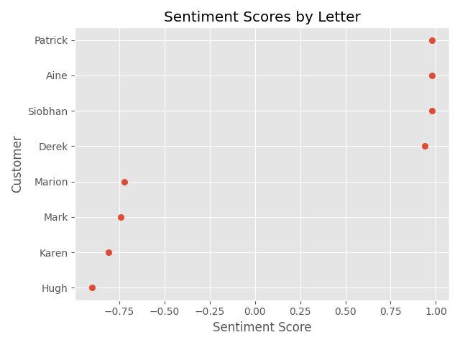
Figure 1. Signed sentiment scores across customer letters.
Summary of positive feedback
"I am pleased with the product and its performance" "The taste is delightful, and the energy boost it provides has significantly enhanced my daily routine"
Summary of negative feedback
The claim that this energy drink could potentially enable one to grow wings is not only misleading but also unrealistic . I am requesting a full refund or an exchange for a product that meets the standards of honesty and realism .
3. Negative Feedback
Letter analysis results
Name | Summary | Request
Mark | Blue Cow energy drink is not only misleading but also unrealistic . Mark writes to Blue Cow customer service asking for | a full refund
Marion | The product was marketed with the bold claim that it could provide extraordinary enhancements, specifically the ability | a full refund
Hugh | The experience has been nothing short of a scam, as the drink did not deliver on its outrageous claims . The deception | full refund of the purchase price
Karen | The promise of gaining superhuman abilities, such as growing wings, was the sole reason I invested in your product . Th | a miraculous solution that includes a set of wings and an op

3.1 Case Study: Most Extreme Negative Feedback
Customer letter
Dear Blue Cow Customer Service,
I am writing to express my extreme dissatisfaction and anger regarding the Blue Cow energy drink, which I purchased under the false promise of granting me the ability to grow wings. This product, advertised as a miracle elixir, has left me not only financially drained but also deeply deceived.
The experience has been nothing short of a scam, as the drink did not deliver on its outrageous claims. Not only did it fail to provide any supernatural benefits, but it also left me feeling foolish for believing in such nonsensical promises. The company's brazen false advertising has not only wasted my hard-earned money but has also caused significant distress and frustration.
I demand a full refund of the purchase price and additional compensation for the distress caused by this fraudulent product. I expect a prompt and satisfactory resolution to this issue, as I will not hesitate to take further legal action if my demands are not met. The deception perpetrated by Blue Cow has left me with a deep sense of betrayal, and it is only fair that I be compensated for the time and resources wasted.
Yours sincerely,
Hugh

Summary of complaint
The experience has been nothing short of a scam, as the drink did not deliver on its outrageous claims . The deception perpetrated by Blue Cow has left me with a deep sense of betrayal, and it is only fair that I be compensated for the time and resources wasted .
Customer request
full refund of the purchase price
Suggested response
Proposed company response
Dear Mr. Hugh,
Thank you for reaching out to us and expressing your concerns regarding the Blue Cow energy drink. We sincerely apologize for any disappointment or inconvenience our product may have caused you.
We understand how disheartening it can be when expectations are not met, and we regret that the advertising for our product did not live up to your hopes of achieving the impossible. We value our customers' trust, and we take your feedback seriously.
To address your concerns, we would like to offer you a full refund for your purchase. Additionally, we will investigate the matter further to ensure that our advertising is clear and accurate, preventing similar situations from occurring in the future.
We appreciate your patience and understanding as we work to resolve this issue. Our customer service team will contact you shortly to guide you through the refund process.
Once again, we apologize for any distress caused and thank you for bringing this matter to our attention. We hope to continue serving you in the future.
Sincerely,
Blue Cow Customer Service Team

4. Positive Feedback
Letter analysis results
Name | Summary | Request
Derek | The taste is refreshing, and I have noticed a significant energy boost after consuming it . I have not encountered any | not requesting any specific action
Aine | The taste is delightful, and the energy boost it provides has significantly enhanced my daily routine . I am confident | Aine
Patrick | The refreshing flavor and invigorating effects have made it an indispensable part of my daily routine . Patrick is reac | free samples
Siobhan | The invigorating taste and the remarkable energy boost it provides have significantly enhanced my daily routine . I am | free samples

4.1 Case Study: Most Extreme Positive Feedback
Customer letter
Dear Blue Cow Team,
I am writing to express my utmost satisfaction with your energy drink. The invigorating taste and the remarkable energy boost it provides have significantly enhanced my daily routine. Your commitment to quality and the delightful flavor profile have made it an indispensable part of my day.
I am thrilled with the product and would like to request a few free samples to share with friends who might also appreciate the benefits. Your brand's dedication to customer satisfaction is evident, and I believe this gesture would further solidify my loyalty.
Thank you for considering my request. I eagerly await your positive response and look forward to continuing my support for Blue Cow.
Yours sincerely,
Siobhan

Summary of praise
The invigorating taste and the remarkable energy boost it provides have significantly enhanced my daily routine . I am thrilled with the product and would like to request a few free samples to share with friends .
Customer request
free samples
Suggested response
Proposed company response
Dear Siobhan,
Thank you for your kind words and for choosing Blue Cow for your energy needs. We are delighted to hear that you've found our energy drink both invigorating and beneficial to your daily routine. Your feedback is greatly appreciated and helps us to continue improving our products.
We are pleased to offer you a few complimentary samples for you to share with friends. We trust that they will enjoy the taste and quality as much as you have. We value your loyalty and look forward to your continued support for Blue Cow.
Sincerely,
Blue Cow Customer Service Team

