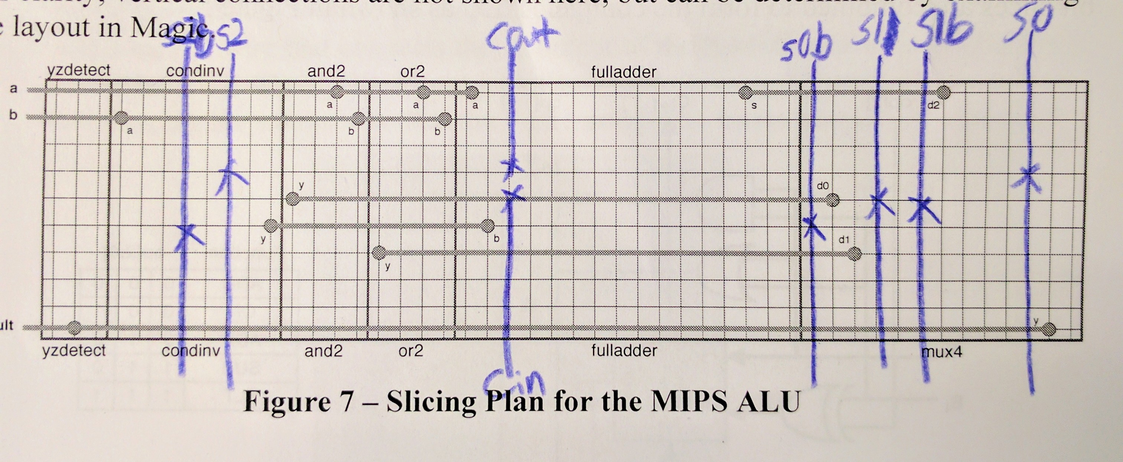
Christer Hoeflinger & Ian Miller

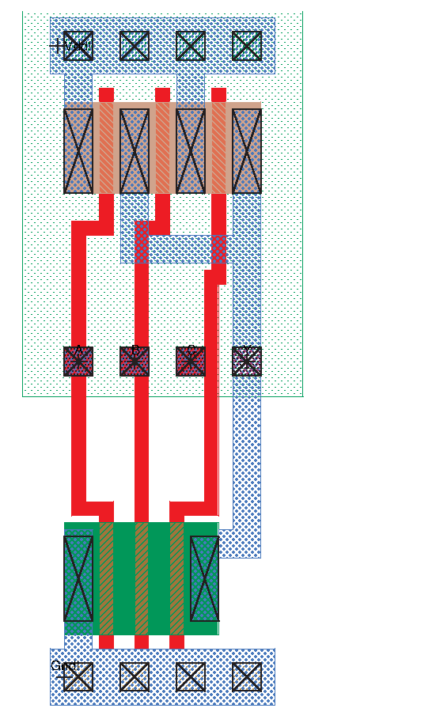

Lambda: 40x100
Lambda Squared: 4000

Microns: 12x30
Microns Squared: 360

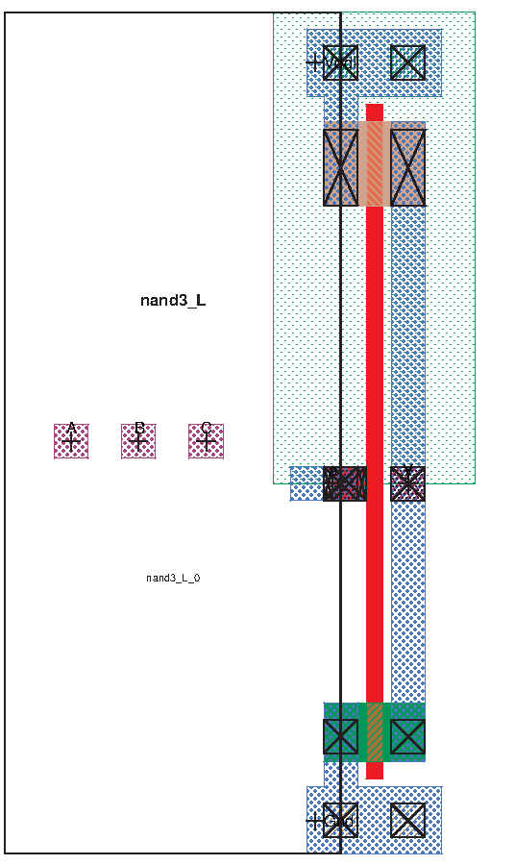

Lambda: 56x100
Lambda Squared: 5600

Microns: 16.80x30.00
Microns Squared: 504

Lambda: 32x868
Lambda Squared: 27776

Microns: 9.60x260.40
Microns Squared: 2499.84

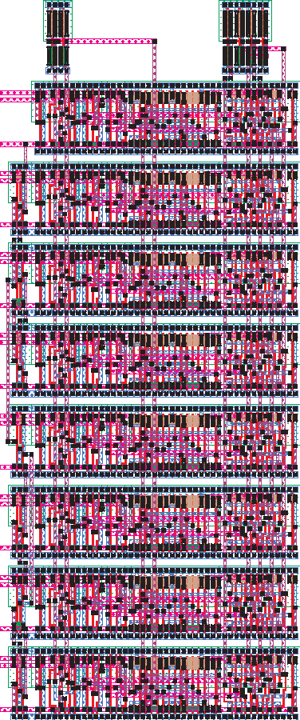
Lambda: 413x983
Lambda Squared: 405979

Microns: 123.90x294.90
Microns Squared: 36538.11

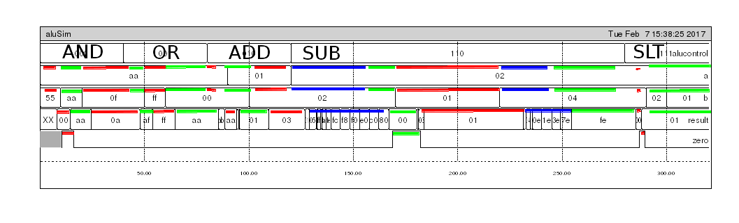

This lab took us 3.5 hours to complete.
Note: all sections of blue in the waveform show carry delay in the alu.

