Ian D. Miller, Christer Hoeflinger
ECE 425L
Deliverable 3 Report
April 25 2017

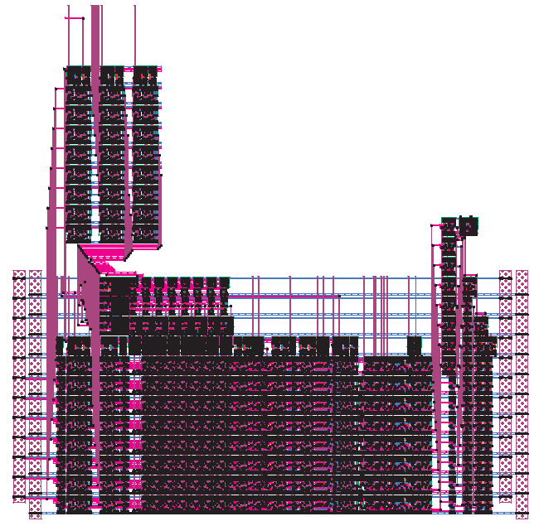Figure 1: Overall Datapath Layout
Here you can see the datapath with the shifter added. The first registers needed to be moved to ensure the datapath fit in the 3000x3000 form factor that we are using. This was then tested in IRSIM to prove that the shifter was functioning properly. The original test that was run non the datapath was modified to include the shift control bits in the opcode and test casses added to test the shifter itself. We ran the tests in a similar way where the number being shifted was incremented to test various random cases. At each of these, all possible shift amounts on all three types of shifts were used. On top of this, certain boundary conditions were chosen to verify the functionality of the shifter. This includes testing both leading zero and one on arithmetic shifts and shifting by the maximum amount. The .cmd file used to run the test (tb.cmd) and the logfile (logfile.txt) of the results will be submitted in the tarball to view.

