Ian D. Miller
ECE 425
Lab 4: Hierarchical Layout Extended ALU

Fig 1: Annotated Slice Plan
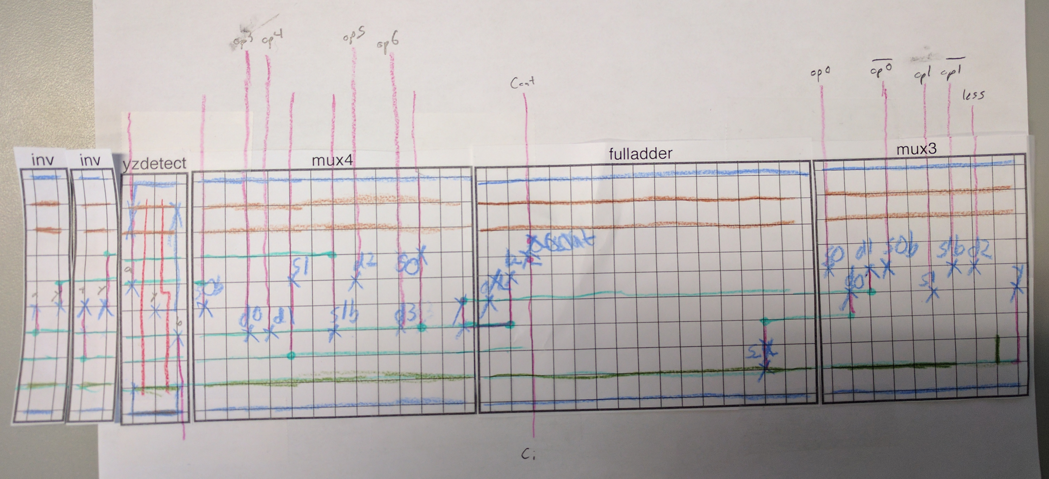
Note: In the final version, yzdetect has been swapped with the inverters.
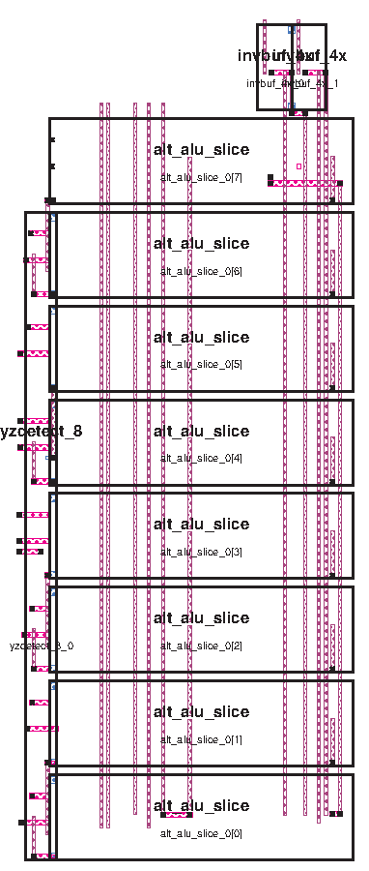
Fig. 2: Unexpanded ALU Design

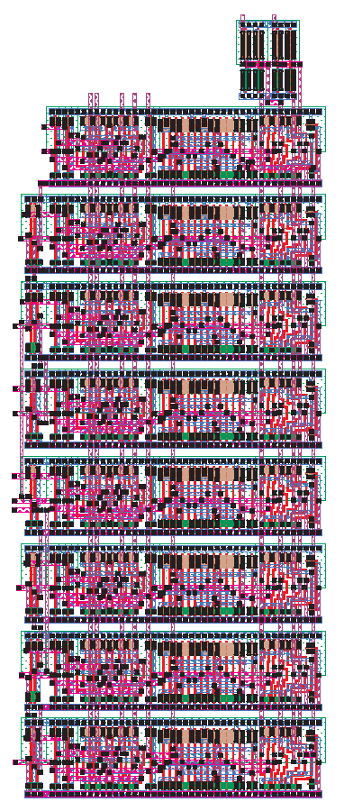
Fig. 3: Expanded ALU Design
The new ALU is 397x987 lambda, (or 119.1x296.1 um), while the old ALU was 410x986 lambda (123x295.9 um). Therefore, the new ALU has decreased in size by 12,421 labmda² (a 3% decrease). This isn’t all that much, but the new ALU also introduced additional capabilities and opcodes, so it is impressive that we now have a device which has increased features at lower cost.

Testing

Our test python script (see Appendix A) generates a bunch of testvectors automatically. For every opcode, the ‘a’ input is run through every possible input (0x00 through 0xff). For each ‘a’ input, b is tested with values from 0x00 through 0xff, but increasing by 0x11 each time (a total of 16 tests). Therefore, each function was tested 3364 times. Increasing by 0x11 for b makes sure that at some point all bits will be one, which assures that all carry channels will be tested, and all functions will all be tested over a wide range of inputs. The test also only takes about a minute to run, which is much more efficient than running a completely exhaustive test.

Prepended to this file is some test code which simply sets up the testvector definitions and dumps things to a logfile.

Time to Complete Lab
This lab took about 8 hours to complete (2 lab periods and a couple hours outside of lab). Most of the time was taken up by dealing with Magic itself, as well as in debbugging.

Appendix A: testgen.py

oplist = [0b0001001, 0b0111001, 0b1000001, 0b0110001, 0b0101000, 0b1010100, 0b1010110]

f = open('tb.cmd', 'w')

index = 0
for op in oplist:
f.write("setvector op "+format(op, '07b')+"\n")
for a in range(0,0b11111111):
f.write("setvector a "+format(a, '08b')+"\n")
for b in range(0,0b11111111, 0b00010001):
f.write("setvector b "+format(b, '08b')+"\n")
if index == 0:
result = a&b
elif index == 1:
result = a|b
elif index == 2:
#nor
result = (a|b)^0b11111111
elif index == 3:
result = a^b
elif index == 4:
result = (a+b) % (1<<8)
elif index == 5:
result = (a-b) % (1<<8)
elif index == 6:
if (a<b):
result = 0b1
else:
result = 0b0
else:
#this is bad
print "ahhhhhhh"

f.write("s\n")
f.write("assert result "+format(result, '08b')+"\n")
if (result == 0):
f.write("assert zero 1\n")
else:
f.write("assert zero 0\n")

index += 1

f.close()

