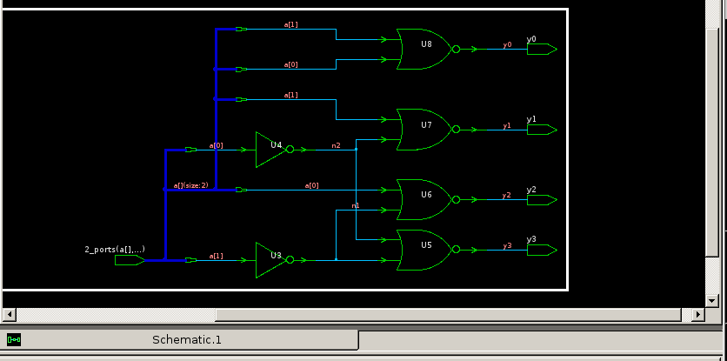Figure 1: Schematic of Example Decoder
Christer Hoeflinger
Ian Miller
ECE: 425
2/28/2017
Lab 5

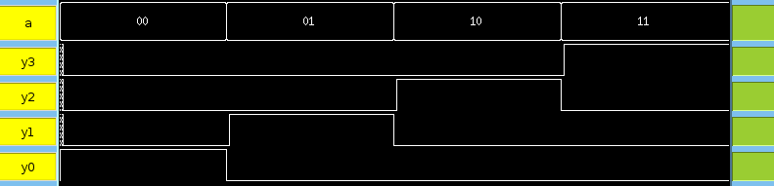Figure 2: Waveform of Example Decoder

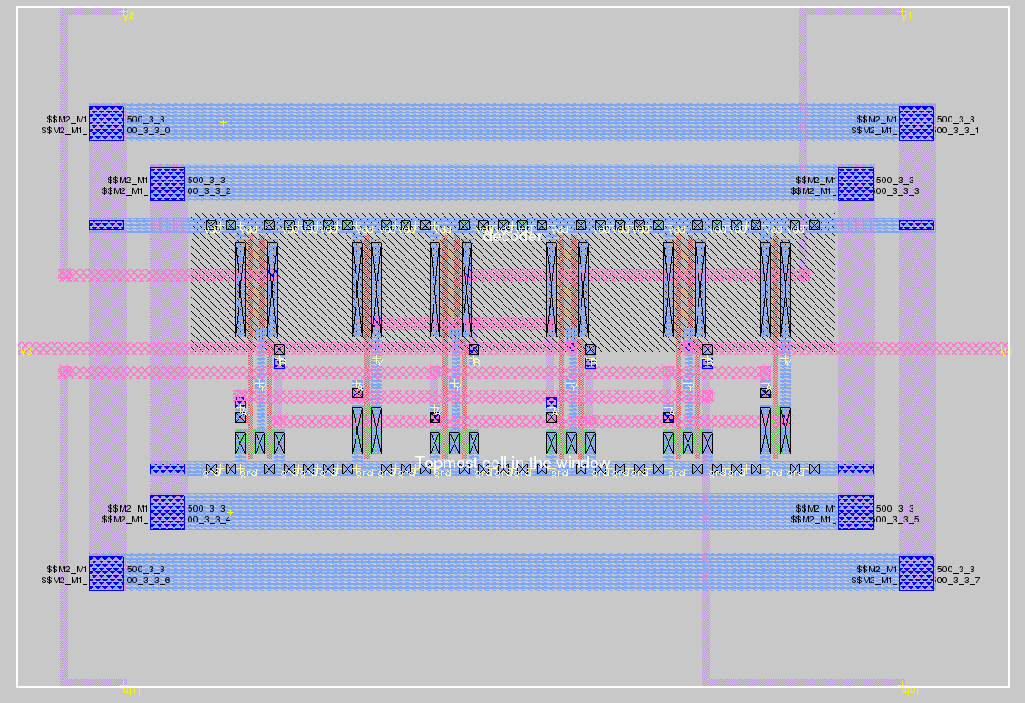Figure 3: Magic Layout of Example Decoder

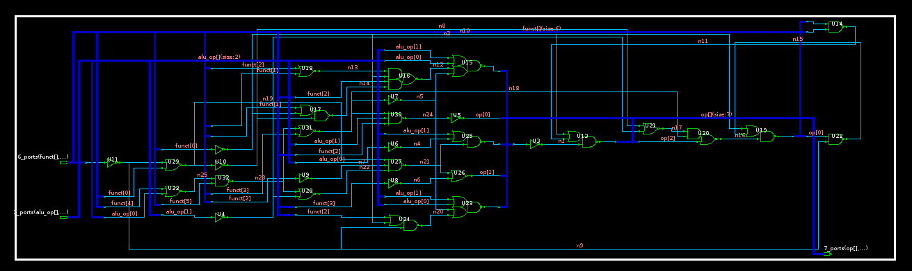Figure 4: Schematic of ALU_Op Decoder

Figure 5: Waveform of ALU_Op Decoder

Simulation of ALU_Op Decoder is not included here. The command files for testing this system is aludec_test.cmd.

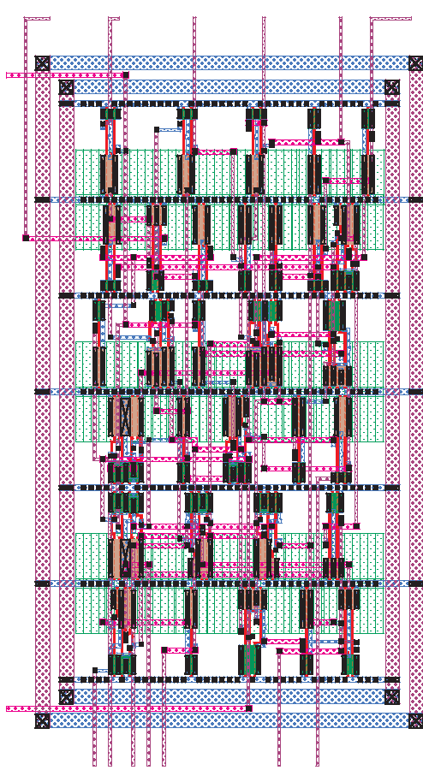Figure 6: Magic Layout of ALU_Op Decoder called aludecoder.mag

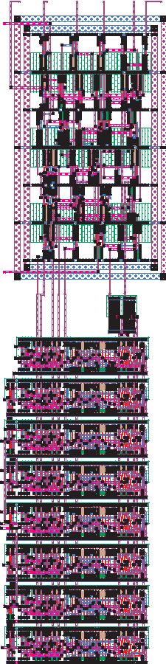Figure 7: Magic Layout of ALU_Op Decoder with Alt_ALU called alu_top.mag

The simulation of the integration of the two systems is not included. To run our tests, the testgen.py was edited from last lab to run off of a 2-bit op code and a 6-bit function code. The first command file to run is alu_setup.cmd followed by tb.cmd generated by testgen.py. The results from this test were stored in log.txt. Upon inspection of the logfile, no errors can be found.

