Ian D. Miller and Christer Hoeflinger
ECE 425 Lab 2

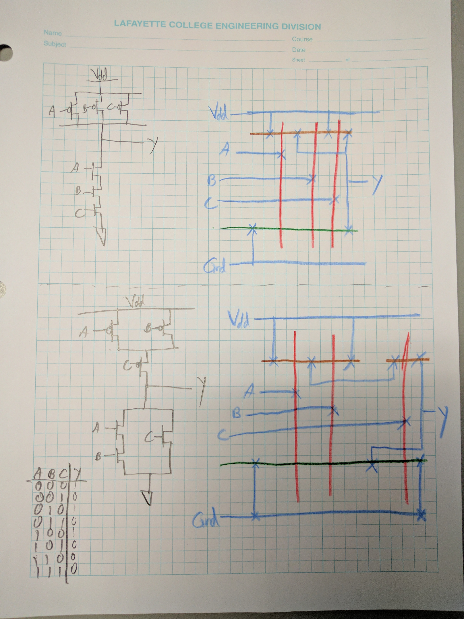
NAND
AOI21

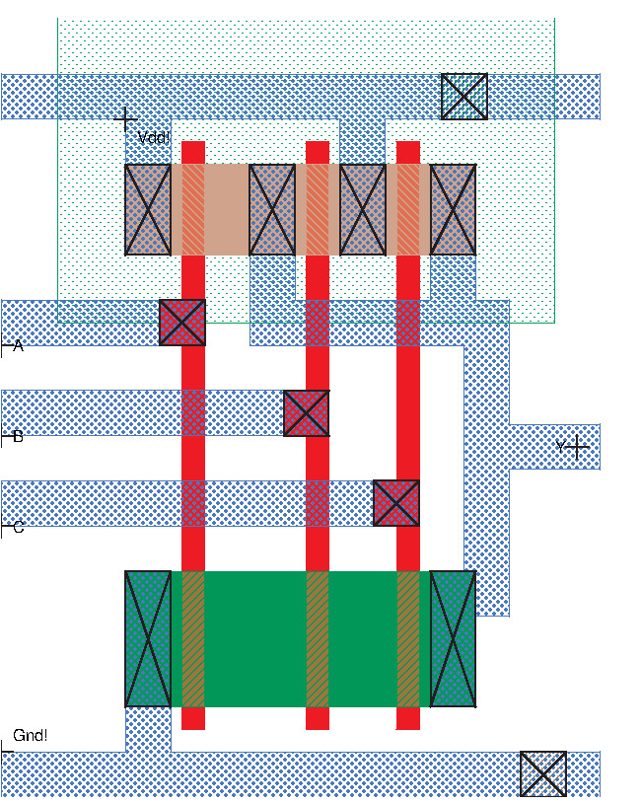
NAND3 Magic Layout

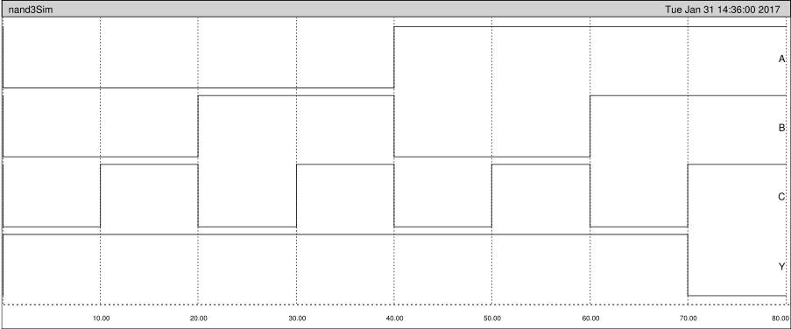
NAND3 Simulation Waveform
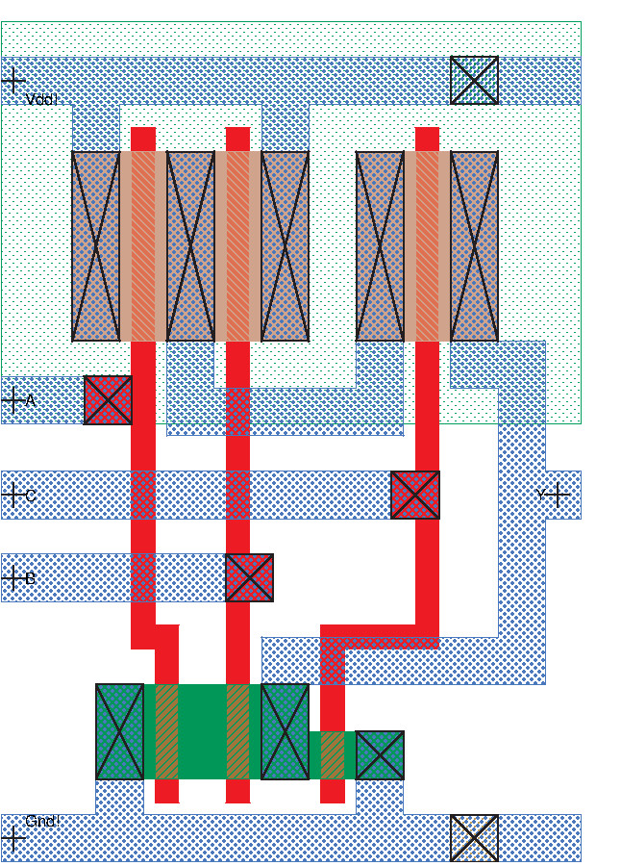
AOI21 Magic Layout

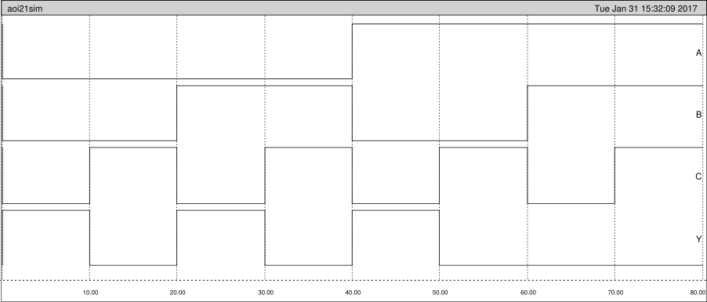
AOI21 Simulation Waveform

Cell Sizes and Area

Nand3 Dimensions: 53x69 lambda, 15.90x20.70 microns
Area: 3657 lambda², 329.13 microns²

AOI21 Dimensions: 49x71 lambda, 14.70x21.30 microns
Area: 3479 lambda², 313.11 microns²

Problems Encountered
The main problem we experienced was dealing with problems in the UI of Magic. We often used the wrong combination of macros, colons, and window selection to make the command window get into various weird states of lock up. When laying out the AOI21 circuit, we encountered problems in trying to minimize the cell area while not violating the DRC rules.

The Lab took a total of ~3hrs.

