ECE 425
Lab 1
Christer Hoeflinger and Ian Miller

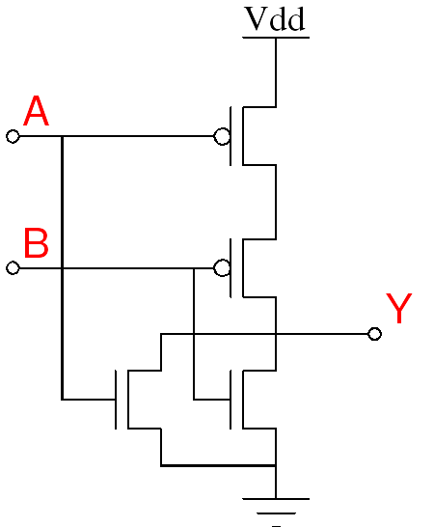
Fig. 1: 2 Input CMOS NOR Gate

This circuit (fig. 1) was simulated in IRSIM to obtain the following waveform (fig. 2):

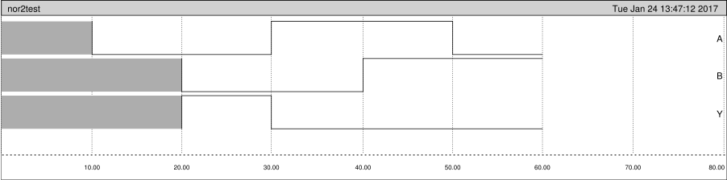
Fig. 2: Simulation Waveform for 2 Input NOR Gate

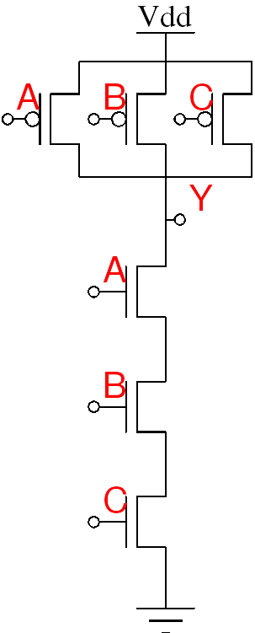
Fig. 3: 3 Input CMOS NAND Gate

This circuit (fig. 3) was simulated using the following IRSIM command file:

h Vdd
l GND
vector in A B C
setvector in 000
s
setvector in 001
s
setvector in 010
s
setvector in 011
s
setvector in 100
s
setvector in 101
s
setvector in 110
s
setvector in 111
s

The simulation results are shown in fig. 4.
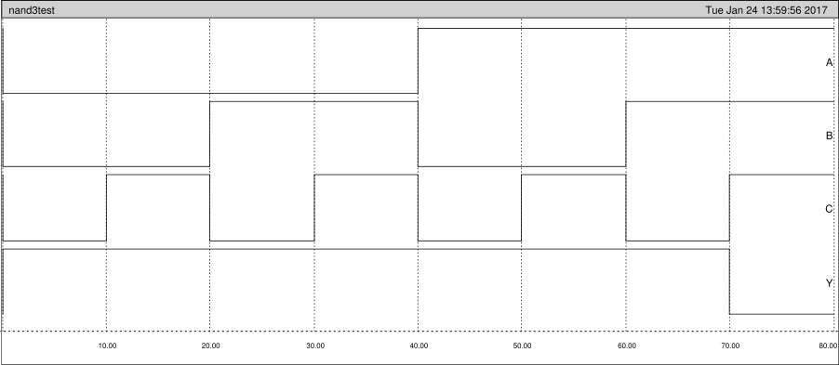
Fig. 4: Simulation waveform for 3 Input NAND gate

As can be seen, the logical behavior of the gate is consistent with expected NAND behavior (high except when all the inputs are high).

