# **IMPLICIT LEARNING OF VISUAL ENSEMBLES DURING VISUAL SEARCH IN CHILDREN WITH ASD**

Lisa Lemmens, Sander Van de Cruys, Andrey Chetverikov, Laurie-Anne Sapey-Triomphe, Ilse Noens, Johan Wagemans

KU LEUVEN

Word count: xxx/5000

**Background:**

**Methods:**

**Results:** Results show that, overall, both groups performed similarly on the odd-one-out visual search task. A repetition effect took place in both participant groups and role-reversal effects revealed that both groups learned the distractor distribution to the same extend.

**Conclusions:** These findings indicate that both TD children and children with ASD implicitly represent sets low-level stimuli by its statistical properties to improve their performance in an odd-one-out visual search task.

**Keywords:** ASD, ensemble encoding, perceptual learning, visual search, predictive coding

In our daily lives, we are continuously confronted with a tremendous amount of visual information, exceeding the amount of information our visual brain can represent at each moment in time. To deal with these capacity limitations, the visual system makes full use of the structure and redundancy available in our visual environment and can represent chunks of information by its summary statistics such as the average or the variance. This phenomenon is often referred to as ensemble perception or summary representation and appears to be a fundamental heuristic of the visual brain (Whitney & Leib, 2018). The most studied form of ensemble perception is the perceived average of sets of similar stimuli and has been found to occur across a variety of features including low-level features such as orientation or size as well as higher level features such as face identity and emotional facial expressions. Representing a set of stimuli by its average often happens without being able to recognize each individual item of the set and is even present under conditions of reduced attention.

The ability to extract statistical properties from sets of stimuli is present early in development, as Sweeny and colleagues (2015) found evidence for ensemble perception in children as young as four to five years old. The children in this study were able to represent sets of oranges of different sizes by its average size. However, based on an ideal observer analysis, the children pooled over a lower number of items compared to adults to get to the estimate of the average size. In line with these results, another study found evidence for younger children (5- and 7-year-olds) to be able to perceive the average motion direction of sets of moving dots, but they integrated over a lower number of dots compared to older children and adults (Manning, Dakin, Tibber, & Pellicano, 2014).

Besides perceiving the average of a certain feature, representing sets of similar items by other statistical properties such as its perceived diversity or variance has gained attention. To find an item that does not belong to a group, which is necessary to be able to detect outliers, it is an important prerequisite to know the diversity or variability of the items that do belong to the group (Haberman & Whitney, 2012; Rosenholtz, 2001). Moreover, an estimate of the variance of groups of stimuli can learn an observer something about the reliability of the average of the set. Ensemble variance has been found to be extracted for size and orientation (Norman, Heywood, & Kentridge, 2015; Solomon, 2010), but has been studied less compared to the average of sets of stimuli.

The vast majority of studies on ensemble perception used explicit measures, inspired by the first seminal study on ensemble perception performed by Ariely (2001) with a mean discrimination and member identification paradigm. In the mean discrimination task, participants were asked to explicitly compare the size of a dot with the average size of a previously shown set of dots. In the member identification task, participants are asked to indicate whether a dot was a member of the previously shown set of dots. Better performance on the mean discrimination task and at chance performance on the member identification task is considered evidence for ensemble perception. More recently, Chetverikov and colleagues developed a method to measure ensemble perception in an implicit way (Chetverikov, Hansmann-Roth, Tanrıkulu, & Kristjánsson, 2019) and found evidence for our visual brain to not only extract and represent the first order statistics such as the average, but all the properties of the distributions including variance, type and skewness. To measure this in an implicit way, they based their paradigm on findings of priming of pop out in odd-one-out visual search tasks. Priming of pop out is a phenomenon that occurs when an odd-one-out target has the same features over different visual search trials, leading to deceased reaction times. Priming of pop out has also been found when distractors have the same features over different trials. Making use of these two priming effects, role reversal effects were included to measure the representations.

In the current study, we investigated whether children with autism spectrum disorder (ASD) implicitly extract and exploit the statistical properties of sets of differently oriented lines to improve their visual search performance with the odd-one-out visual search task developed by Chetverikov and colleagues (2016, 2017b, 2017c, 2017a; 2019). Atypical sensory processing has long been considered as an associated characteristic of autism spectrum disorder (ASD), but is estimated to occur in approximately 95% of children with ASD (Tomchek & Dunn, 2007) and is currently included as a diagnostic sub-criterion in the DSM-5 (American Psychiatric Association, 2013). These sensory symptoms include hyper- or hyposensitivity to sensory input or unusual interests in the sensory aspects of the environment. They are reported for all different modalities, with differences in visual perception being the most studied modality. Two main theoretical accounts have been proposed to explain the differences in visual perception in individuals with ASD. The weak central coherence (WCC) account emphasized the inability to extract “the global picture” in persons with ASD, with more recent versions of WCC describing a preference for a more locally oriented processing style instead of an inability. In contrast, Enhanced Perceptual Functioning (EPF) emphasized superior local processing in individuals with ASD. Empirical studies that tried to disentangle these two frameworks yielded mixed results and have led to a change in the view on perceptual atypicalities in ASD (Evers, Van der Hallen, Noens, & Wagemans, 2018). Scholars have moved away from describing perception in ASD as an impairment towards describing it as a difference in processing style, with an increased preference for local processing and a decreased preference for global processing in individuals with ASD. What comes along with this updated view on perception in ASD is the need for implicit measures of local versus global processing. Recently, theories based on the Predictive Processing framework have proposed an atypical processing style to be at the base of the spectrum of symptoms present in ASD. These theories propose individuals with ASD to show differences in the way they implicitly predict incoming sensory information based on previously learned associations and statistical regularities. Some researchers hypothesize individuals with ASD to have difficulties with making predictions, or with the flexible updating of predictions or with inference of the stability of the environment.

Previous research on ensemble perception in ASD yielded mixed results. Two studies found evidence for children (Van der Hallen, Lemmens, Steyaert, Noens, & Wagemans, 2017) and adults (Corbett, Venuti, & Melcher, 2016) to be able to represent sets of dots by its mean size. In the study with children (Van der Hallen et al., 2017), the children with ASD even outperformed the TD children when the sets of dots were characterized by a higher variability in terms of range (difference between smallest and largest dot) and in terms of heterogeneity (number of different sizes within a set). Explained by weighting all different items as high, which is helpful in this task, but not in other tasks. Here in this study it would not be helpful or would it be helpful? Another study by Maule, Stanworth, Pellicano, & Franklin (2017) found evidence for difficulties in ensemble perception of colour of sets of similarly coloured circles when the sets consisted of four dots. However, performance of adults with ASD was the same as NT adults when sets comprised eight to sixteen dots. Manning, Tibber, Charman, Dakin, & Pellicano (2015) found evidence for children with ASD to be able to tolerate more noise in moving dots stimuli when discriminating between two average motion directions. This was not replicated for average orientation of lines, due to small sample size (Manning, Tibber, & Dakin, 2017). Studies on ensemble perception of high-level stimuli in ASD revealed decreased ensemble perception of face identity in children and adolescents with ASD (Rhodes, Neumann, Ewing, & Palermo, 2015) and no difference in the ability to represent the average emotion of faces between adults with and without ASD (Karaminis et al., 2017).

Only one study investigated and found evidence for the implicit ability to average over sets of stimuli by studying adaptation to mean size in high-functioning adults with ASD. In a study with NT adults, the level of autistic traits was negatively correlated with the level to which a remembered size of each individual item in a display is biased toward the mean size of the set of items in the same color (Lowe, Stevenson, Barense, Cant, & Ferber, 2018).

In the current study, we administered the odd-one-out visual search task developed by Chetverikov and colleagues to assess whether children with and without ASD implicitly extract the statistical properties of sets of differently oriented lines and whether they exploit these ensemble representations to improve their performance on an odd-one-out visual search task.

In addition, we will test whether children with ASD show a role-reversal effect when the target suddenly falls within the previously learned distractor distribution range. We will try to look at their representation of the implicitly learned distributions by plotting their reaction times on test trials over the difference between the target orientation and the previous distractor distribution mean. We expect children with ASD to show a larger role-reversal effect due to a higher precision of PE.

Visual search advantage – maybe in 5° SD condition – less need for forming a global percept of the distractor set.

Difference between mean orientation and target ori. Difference between mean ori and range edge of ori.

Influence of structural priors? Easier to find outlier when distribution mean is cardinal vs oblique orientation. Difference in children with ASD as well? Or less pronounced?

## Methods

### Participants

Two groups of children between 10 and 14 years old participated in this study (N = 48). The mean age of the participants is 11.94 years (SD = 1.39, age range: 10 - 14 years). Intelligence of the participants was estimated with an abbreviated version (Sattler, 2001) of the Wechsler Intelligence Scale, Third edition (WISC-III-NL; Wechsler 1992), which consists of 4 subtests (Vocabulary, Block design, Picture completion, and Similarities). Out of this abbreviated version, a performance intelligence quotient (PIQ), a verbal intelligence quotient (VIQ) and a full scale IQ is derived. Based on these results, none of the participants had an intellectual disability (FIQ ≤ 70). Moreover, all participants reported a normal or corrected-to-normal vision and none of them reported taking any neuroleptics.

The ASD group consisted of 24 children diagnosed with ASD by a child psychiatrist or a multidisciplinary team, based on the DSM-IV-TR criteria (American Psychiatric Association, 2000). Participants were recruited via the Autism Expertise Centre of the University Hospital in Leuven. In proportion with the gender ratio described in the literature (Lai et al., 2015), the ASD group comprised 8 girls and 17 boys. The ASD diagnosis was re-evaluated using the Autism Diagnostic Observation Schedule 2, Module 3 (ADOS-2; Gotham, Risi, Pickles, & Lord, 2007), conducted by a trained psychologist. Eighteen participants scored an ADOS severity score above the cut-off criterion and 6 participants scored an ADOS score below the cut-off criterion (Mean = 8.76, SD = 4.17). Moreover, ASD traits were measured with the Dutch version of the Social Responsiveness Scale (SRS-2; Roeyers, Thys, Druart, De Schryver, & Schittekatte, 2012). In addition, the Dutch version of the Sensory Profile questionnaire (SP-NL; Dunn & Rietman, 2006) was administered to measure how the children process sensory information in everyday situations. We measured the level of attention problems by administering the Child Behavior Checklist (Achenbach, 2001) parent report to control for the influence of attention problems on task behavior. The TD group consisted of 25 children recruited through mainstream schools. The TD participants did not have a known diagnosis of a child psychiatric disorder nor they did have a first-degree family member diagnosed with ASD. In line with the ASD group, the Dutch version of the SRS and the Dutch version of the SP were conducted. Demographic details and p-values of a two sided t test for the comparison of the ASD group and the matched TD group are shown in Table 1.

### Procedure

This study was approved by the ethical committee of the university hospitals of Leuven and incorporated within a larger series of studies on visual perception in children with ASD. Parent consent and child assent was given before the start of the test session. The tests were administered in a quiet and darkened room and viewing distance was approximately 57 cm. A book voucher was given to each participant and transportation costs were reimbursed.

The odd-one-out visual search task was presented to the children as a space game in which they could discover a new planet by following the stars falling in the most odd direction. The participants had to search for the odd-one-out in a 6 x 6 grid of 36 lines subtending 16° x 16° at the center of a display. Each line represented a falling star and the length of each line was 1.41°. All line positions were jittered by randomly adding a value of + - 0.5° to both vertical and horizontal coordinates. The participants had to press the “upward arrow” key if the target was located in the upper half of the search array (i.e. the upper three rows) and the “downward arrow” key when the target was located in the lower half of the search array (i.e. the lower three rows). A little dot was added on both sides of the search array between the third and the fourth row to make it easier for the children to distinguish between the lower and upper half of the search array.

The children were encouraged to respond as fast and accurate as possible and received a score after each response, presented in the top left corner of the display. The higher the score, the closer they got to the undiscovered planet in space. The score increased with every correct response and increased more for faster responses (score = + 10 – reaction time in seconds). For every incorrect response, the score decreased with 10 points. The children were told that there was another competing team of astronauts, also looking for the undiscovered planet. Every 10 blocks (+- 70 trials), a screen was presented with their own score as well as the score of the competing team of astronauts. The score of the competing team was always a random number of points lower compared to the participants score. When this screen was shown, the children could take a self-paced break (12 breaks in total).

Prior to starting with the actual test trials, the participants completed an extensive step-by-step practice protocol with 10 practice trials. Feedback was provided during these practice trials, on both correct (i.e. “Well done! We’re going into the right direction”) and incorrect trials (i.e. “Woops, the wrong direction!). During the actual experiment, feedback was only provided for incorrect trials.

### Apparatus and stimuli

Trials were organized in blocks consisting of a prime streak and a test streak. A prime streak consisted of 5 or 6 trials with distractor orientations sampled from the same distractor distribution with a constant mean and standard deviation (SD). Trial number was varied to prevent participants of learning the regularities in changes from prime streaks to test streaks throughout the experiment. The distractor distribution in trials in prime streaks was always a Gaussian distribution, with a distractor standard deviation (DSD) of 10°. The mean of the distractor distribution was set randomly for each prime streak. The target orientation was set randomly for each trial within the prime streaks, so that the difference between the target orientation and the mean of the distractor distribution could range from 60° to 120°. During the prime streaks, the mean of the distractor distribution and the DSD (always 10°) remained constant, whereas the target orientation and location differed at every trial.

Each prime streak was followed by a test streak consisting of 1 to 2 trials with the distractor orientations sampled from the same distractor distribution. The test streak distractor distribution was a Gaussian distribution with a DSD of 5°. The target orientation in the test trials differed -90° to 90° from the distractor distribution mean of the previous prime streak. The difference between the current target orientation in the test trials and the previous distractor distribution mean (CT-PD) was randomly chosen out of 13 bins with different bin sizes (i.e. smaller bin sizes closer to zero). The different CT-PD bins were [-90° to -70°], [-70° to -50°],[-50° to -35°], [-35° to -25°],[-25° to -15°], [-15° to -5°], [-5° to +5°], [+5° to +15°], [15° to 25°], [25° to 35°], [35° to 50°], [50° to 70°], [70° to 90°]. Bin sizes were smaller where the target orientation was closer to the previous distribution mean (i.e. small CT-PDs), to have a higher precision for our reaction times plotted as a function of CT-PD in the area around the previous distribution mean.

For each prime streak length (5 or 6 trials), a prime streak was combined with a test streak with a target orientation chosen based on a CT-PD sampled from each CT-PD bin (13 different bins) into a block consisting of 6 to 8 trials. These combinations were repeated 5 times per participant resulting in 130 blocks per test session, with an approximate total trial number of 910 per test session. Total test session duration was between 20 and 40 minutes, depending on the length of the self-paced breaks of the participants.

### Analysis

Data analysis was conducted in R (R Core Team, 2017). In the analysis, reaction times were predicted in linear mixed models using the lme4 package (Bates, Mächler, Bolker, & Walker, 2015), specifying a random intercept and random slope for each participant. P-values were obtained by using the LmerTest package (Kuznetsova, Brockhoff, & Christensen, 2017). For all analyses, reaction time data were log transformed to reduces skewness. In all analyses, only reaction times on correct trials are included. For dichotomous outcomes (correct/incorrect responses), we used generalized linear mixed models with a binomial link function of the lme4 package (Bates et al., 2015). For model comparison based on Bayes factors, the BayesFactor package was used (Rouder, Morey, Speckman, & Province, 2012).

Reaction times of 3 standard deviations higher compared to the overall mean reaction time and reaction times lower than 100 ms were removed from the analysis. Based on these outlier criteria, 1.03 % of all trials were removed for the ASD group and 1.57 % of all trials were removed for the TD group.

## Results

### Average task performance

A linear mixed model (random intercept and random slope model) with *Distractor distribution standard deviation (DSD), Group* and *Group x DSD* as predictors, revealed a significant effect of *DSD* on search times, with lower search times in the test streaks with a *DSD* of 5° (*B*= -0.7 (.01), *t* = -5.07, *p* < .0001) compared to search times in the test streaks with a *DSD* of 10°. Neither a significant effect of *Group* (*B* = -.01 (.04), *t* = -.02, *p* = .98)or a significant interaction effect between *Group* and *DSD* (*B* = .01 (.02), *t* = .70, *p* = .49)on search times was found (Figure 2a) . These results indicate that, on average, reaction times were lower (*M* = 1114.96 , *SD* =.194.69) in trials of the test streaks with a *DSD* of 5° compared to reaction times (M = 1222.20, *SD* = *195*.39) on trials in prime streaks with a *DSD* of 10°.

A generalized linear mixed model with a binomial link function with *DSD, Group* and *Group x DSD* as predictors, revealed a significant effect of *DSD* on accuracy, with higher accuracy on trials of the test streaks with a *DSD* of 5° (*B*=0.72(.09), *t*=8.4, *p*<.0001) compared to accuracy on trials of the prime streaks with a *DSD* of 10°. No significant effect of *Group* (*B* = -0.02(.19), *z* =-.12, *p* =.90)or a significant interaction effect between *Group* and *DSD* (*B* = -0.14 (.12), *z* = -1.25, *p* =.21)on accuracy was found (Figure 2b). These results indicate that, on average, accuracy was higher (*M* = .93, *SD* =.05) in trials in the test streaks with a *DSD* of 5° compared to accuracy (*M* = .88, *SD* =.06) on trials in the prime streaks with a *DSD* of 10°.

The results of the Bayesian analysis are in line with the results of the (generalized) linear mixed models reported above. Both for search times and for accuracy as an outcome variable, the strongest support was found for a model with only a main effect of *DSD*. In Table 2, Bayes factors are reported for the model with only *DSD* as a predictor compared to all other possible models. Bayes factor is 9.04 for this model compared to a model including a main effect of Group, indicating substantial evidence for a model without *Group* as a predictor, given our sample size.

### Repetition effect within prime streaks

We assessed repetition effects by analyzing reaction times and accuracy over trial number within prime streaks, in which the distractors at each trial were sampled from the same Gaussian distribution. Average search times and average accuracy over trial number within prime streaks are shown for each group and for each individual participant in Figure 2. A linear mixed model with *Trial Number, Group* and *Group x Trial Number* as predictors with Helmert contrasts for *Trial Number* (comparing average reaction time on each trial with the average reaction time on all subsequent trials) revealed significantly higher reaction times on the first trial compared to reaction times on the later trials for both groups (*B* = .02 (.01), *t* = 9.38, *p <* .0001). On the second trial, reaction times were not higher or lower compared to reaction times on later trials (*B* = -.01 (.01), *t* = -.55, *p =* .58). No effect of G*roup* (*B* = .01 (.04), *t* = .28, *p =* .20) or *Group x Trial Number* interaction on reaction times was found. For accuracy, no repetition effect was found as no significant difference in accuracy over trial number was found for both groups. These results indicate a quick decrease in reaction times after one trial with distractors sampled from the same Gaussian distribution in both groups and no change in average accuracy over trial number.

### Inter-trial priming by target orientation within prime streaks

During each prime streak, the distribution from which the distractors were sampled remained the same. However, target orientation switched randomly within each prime streak. Therefore, we can assess inter-trial priming by the previous target orientation by analyzing reaction times on a trial as a function of the difference between the current target orientation and the previous target orientation (*CT-PT)* (Figure 3). A linear mixed model with *CT-PT* as a quadratic predictor, *Group* and a *Group x CT-PT* as linearpredictors of reaction time, revealed a significant quadratic effect of *CT-PT* (*B* = .05 (.01), *t* =4.04, *p* < .001)on reaction time in both groups. No effect of *Group* (*B* = .01 (.05), *t* =.03, *p* = .98) or a *Group x CT-PT* effect (*B* = -.01 (.02), *t* = -.53, *p* = .61) was found on reaction times. These results indicate that when the global characteristics remain constant within prime streaks, inter-trial priming effects of the previous target orientation (local characteristic) emerge.

### Role-reversal effect in test streaks

To test the role-reversal effects in test streaks, we analyzed reaction times on correct first trials of test streaks as a function of the distance between the current target orientation and the mean of the previous distractor distribution (*CT – PD*) (Figure 4a). If a distractor distribution is learned and therefore inhibited during repetitions in prime streaks, reaction times should increase when a target falls within that prime distribution in a test streak. Fig. 4b and fig. 4c show that role-reversals have a strong effect in both groups, as reaction times gradually decrease with the increase of absolute CT-PD. A linear mixed model with *absolute CT-PD*, *Group* and *Group x absolute CT-PD* as predictors and reaction time as an outcome variable revealed a significantly negative effect (*B* = -.05 (.01), *t* = -5.47, *p <* .0001) *of* *absolute CT-PD* on reaction time. No effect of Group (B = .03(.05), t = .58, p = .56) or interaction effect of Group x absolute CT-PD (*B* = .01 (.01), *t* = .19, *p* =.85) was found. We controlled for the effect of the difference between the current distribution and the previous distractor distribution mean and the difference between the current target orientation and the previous target orientation.

Per bin.. No group difference and no interaction effect. Only two last bins have a significant negative slope. So significantly lower RTs compared to average RTs in previous bins. Uniform distribution?

In Fig. 4d, average reaction times for trials where the current target orientation fell within the range of the previous distractor distribution (*CT-PD* < 30°) are compared with reaction times on test trials where the current target orientation fell outside the range of the previous distractor distribution (*CT-PD* > 30°). A linear mixed model with *In range, Group* and *In range* x *Group* interaction as predictors revealed a significant effect of *In range* (*B* = -.10 (.02), *t* = 5.91, *p <* .0001) on reaction times, with lower reaction times (*M =*) for trials where the target orientation fell outside the previous distractor distribution range compared to reaction times (*M =)* on trials where the target orientation fell inside the previous distractor distribution range. No significant effect of Group or *Group* x *In range* interaction effect was found. These results confirm our previous results and the fact that there is no difference between the two participant groups.

## Discussion

### Implicit learning of perceptual distributions

* Both groups implicitly learn the perceptual distributions: first evidence for implicit learning of visual ensembles in both groups.

In line with findings by Manning regarding average orientation

### Role-reversal effects

## Conclusion

## Acknowledgements

The authors would like to thank all participants and their families for their time and contribution to this research. We would also like to thank Christophe Bossens for his help with programming the experiment, as well as Lise Raymaekers for her help with the data collection. This work has been funded by a personal fellowship awarded to Lisa Lemmens by the Research Foundation Flanders (1171717N) and by a Methusalem grant awarded to Johan Wagemans by the Flemish Government (METH/14/02). Conflict of interest statement: No conflicts declared

## References

Achenbach, T. M. (2001). *Manual for the ASEBA School-age Forms & Profiles: An Integrated System of Multi-informant Assessment*. ASEBA.

American Psychiatric Association. (2013). *Diagnostic and Statistical Manual of Mental Disorders (5th ed.)*. Retrieved from http://dsm.psychiatryonline.org/doi/book/10.1176/appi.books.9780890425596

Ariely, D. (2001). Seeing sets: representation by statistical properties. *Psychological Science*, *12*(2), 157–162.

Bates, D., Mächler, M., Bolker, B., & Walker, S. (2015). Fitting Linear Mixed-Effects Models Using lme4. *Journal of Statistical Software*, *67*(1), 1–48. https://doi.org/10.18637/jss.v067.i01

Chetverikov, A., Campana, G., & Kristjánsson, Á. (2016). Building ensemble representations: How the shape of preceding distractor distributions affects visual search. *Cognition*, *153*(Supplement C), 196–210. https://doi.org/10.1016/j.cognition.2016.04.018

Chetverikov, A., Campana, G., & Kristjánsson, Á. (2017a). Learning features in a complex and changing environment: A distribution-based framework for visual attention and vision in general. In *Progress in Brain Research*. https://doi.org/10.1016/bs.pbr.2017.07.001

Chetverikov, A., Campana, G., & Kristjánsson, Á. (2017b). Rapid learning of visual ensembles. *Journal of Vision*, *17*(2), 21–21. https://doi.org/10.1167/17.2.21

Chetverikov, A., Campana, G., & Kristjánsson, Á. (2017c). Set size manipulations reveal the boundary conditions of perceptual ensemble learning. *Vision Research*, *140*, 144–156. https://doi.org/10.1016/j.visres.2017.08.003

Chetverikov, A., Hansmann-Roth, S., Tanrıkulu, Ö. D., & Kristjánsson, Á. (2019). *Feature Distribution Learning (FDL): A New Method for Studying Visual Ensembles Perception with Priming of Attention Shifts*. 1–21. https://doi.org/10.1007/7657_2019_20

Corbett, J. E., Venuti, P., & Melcher, D. (2016). Perceptual Averaging in Individuals with Autism Spectrum Disorder. *Frontiers in Psychology*, *7*. https://doi.org/10.3389/fpsyg.2016.01735

Evers, K., Van der Hallen, R., Noens, I., & Wagemans, J. (2018). Perceptual Organization in Individuals With Autism Spectrum Disorder. *Child Development Perspectives*, *0*(0). https://doi.org/10.1111/cdep.12280

Haberman, J., & Whitney, D. (2012). *Ensemble perception: Summarizing the scene and broadening the limits of visual processing*. https://doi.org/10.1093/acprof:osobl/9780199734337.003.0030

Karaminis, T., Neil, L., Manning, C., Turi, M., Fiorentini, C., Burr, D., & Pellicano, E. (2017). Ensemble perception of emotions in autistic and typical children and adolescents. *Developmental Cognitive Neuroscience*, *24*(Supplement C), 51–62. https://doi.org/10.1016/j.dcn.2017.01.005

Kuznetsova, A., Brockhoff, P. B., & Christensen, R. H. B. (2017). lmerTest Package: Tests in Linear Mixed Effects Models. *Journal of Statistical Software*, *82*(1), 1–26. https://doi.org/10.18637/jss.v082.i13

Manning, C., Dakin, S. C., Tibber, M. S., & Pellicano, E. (2014). Averaging, not internal noise, limits the development of coherent motion processing. *Developmental Cognitive Neuroscience*, *10*, 44–56. https://doi.org/10.1016/j.dcn.2014.07.004

Manning, C., Tibber, M. S., Charman, T., Dakin, S. C., & Pellicano, E. (2015). Enhanced Integration of Motion Information in Children With Autism. *Journal of Neuroscience*, *35*(18), 6979–6986. https://doi.org/10.1523/JNEUROSCI.4645-14.2015

Manning, C., Tibber, M. S., & Dakin, S. C. (2017). Visual integration of direction and orientation information in autistic children. *Autism & Developmental Language Impairments*, *2*, 2396941517694626. https://doi.org/10.1177/2396941517694626

Maule, J., Stanworth, K., Pellicano, E., & Franklin, A. (2017). Ensemble perception of color in autistic adults. *Autism Research*, *10*(5), 839–851. https://doi.org/10.1002/aur.1725

Norman, L. J., Heywood, C. A., & Kentridge, R. W. (2015). Direct encoding of orientation variance in the visual system. *Journal of Vision*, *15*(4), 3. https://doi.org/10.1167/15.4.3

R Core Team. (2017). *R: A language and environment for statistical computing*. Retrieved from https://www.r-project.org/

Rhodes, G., Neumann, M. F., Ewing, L., & Palermo, R. (2015). Reduced set averaging of face identity in children and adolescents with autism. *The Quarterly Journal of Experimental Psychology*, *68*(7), 1391–1403. https://doi.org/10.1080/17470218.2014.981554

Rosenholtz, R. (2001). Visual search for orientation among heterogeneous distractors: experimental results and implications for signal-detection theory models of search. *Journal of Experimental Psychology. Human Perception and Performance*, *27*(4), 985–999.

Rouder, J. N., Morey, R. D., Speckman, P. L., & Province, J. M. (2012). Default Bayes factors for ANOVA designs. *Journal of Mathematical Psychology*, *56*(5), 356–374. https://doi.org/10.1016/j.jmp.2012.08.001

Solomon, J. A. (2010). Visual discrimination of orientation statistics in crowded and uncrowded arrays. *Journal of Vision*, *10*(14), 19–19. https://doi.org/10.1167/10.14.19

Sweeny, T. D., Wurnitsch, N., Gopnik, A., & Whitney, D. (2015). Ensemble perception of size in 4–5-year-old children. *Developmental Science*, *18*(4), 556–568. https://doi.org/10.1111/desc.12239

Tomchek, S. D., & Dunn, W. (2007). Sensory Processing in Children With and Without Autism: A Comparative Study Using the Short Sensory Profile. *The American Journal of Occupational Therapy; Bethesda*, *61*(2), 190–200.

Van der Hallen, R., Lemmens, L., Steyaert, J., Noens, I., & Wagemans, J. (2017). Ensemble perception in autism spectrum disorder: Member-identification versus mean-discrimination. *Autism Research: Official Journal of the International Society for Autism Research*. https://doi.org/10.1002/aur.1767

Whitney, D., & Leib, A. Y. (2018). Ensemble Perception. *Annual Review of Psychology*, *69*(1), null. https://doi.org/10.1146/annurev-psych-010416-044232

## Table 1

Table 2. *Participant Characteristics*

|  |  |  |  |  |  |
| --- | --- | --- | --- | --- | --- |
|  | ASD  (17M:4F) | | TD  (13M:8F) | | Two-sided  *t* test |
|  | M | SD | M | SD | *p*-value |
| Age | 12 | 1.30 | 11.80 | 1.51 | .61 |
| Verbal IQ | 105 | 17.70 | 106 | 11.10 | .92 |
| Performance IQ | 106 | 17.20 | 107 | 14 | .70 |
| CBCL attention | 57.60 | 7.62 | 54 | 5.29 | .010 |
| SRS | 90 | 17.10 | 48.20 | 8.10 | <.0001 |
| ADOS | 8.76 | 4.17 |  |  |  |

*\*Note.* SRS data of x participant with ASD and of x TD participants is missing.

## Table 2

Table 3. *Result summary of linear mixed models*

|  |  |  |  |  |  |  |  |  |  |
| --- | --- | --- | --- | --- | --- | --- | --- | --- | --- |
|  | Reaction Time | | | |  | Accuracy | | | |
|  | β | SE | *t* | *p* |  | β | SE | z | *p* |
| Intercept | 6.99 | .03 | 220.84 | <.0001 |  | 2.19 | .13 | 16.45 | <.0001 |
| Distractor SD (5°) | **-.07** | **.01** | **-5.07** | **<.0001** |  | **0.72** | **.09** | **8.4** | **<.0001** |
| Group | -.01 | .04 | -.02 | .98 |  | -0.02 | .19 | -.12 | .90 |
| Group x Distractor SD | .01 | .02 | .70 | .49 |  | -0.14 | .12 | -1.25 | .21 |

## Table 3

Table 3.*Result summary of Bayesian tests*

|  |  |  |  |
| --- | --- | --- | --- |
|  | Reaction Time |  | Accuracy |
|  | Bayes factor |  | Bayes factor |
| 1. DSD + participant | 1 |  | 1 |
| 1. Group + DSD + Participant | 9.04 |  | 12.79 |
| 1. Group + DSD + Group*Participant + Participant | 88 |  | 423.31 |
| 1. Participant | 5.15 * 10^35 |  | 2.50 * 10^41 |
| 1. Group + Participant | 4.65* 10^36 |  | 3.20 * 10^42 |

## Figure 1

## 

*Figure 1*. Example search array for a prime trial and example search array for a test trial. In the prime trial, the distractors are sampled from a Gaussian distribution with a DSD of 10°. In this example, the mean orientation of the distribution is 109° and the target orientation differs 85° from the distractor distribution mean. In the test trial, the distractors are sampled from a Gaussian distribution with a DSD of 5°. In this example the difference between the current target orientation and the previous distractor distribution mean (CT-PD) is 13°. The target differs 61° from the current distractor distribution mean (M = 157°).

## Figure 2

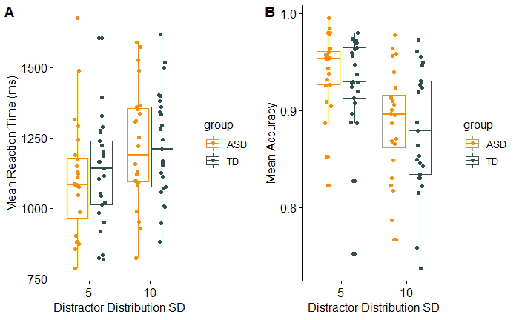

*Figure 2.*(a) Mean reaction times for the two distractor distribution conditions for both groups (b) Mean accuracy scores for the two distractor distribution conditions for both groups.

## Figure 3



*Figure 3.*(a) Mean reaction times for each trial within prime streaks for both groups. Grey points and lines represent average reaction times for each participant. (b) Mean accuracy for each trial number within prime streaks for both groups. Grey points and lines represent average reaction times for each participant. Error bars show +- 1 SEM.

## Figure 4

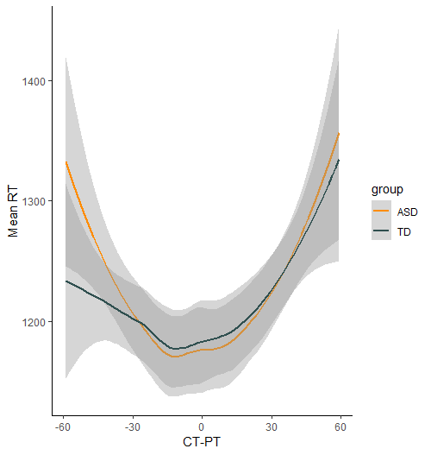

*Figure 4.*Mean reaction times in prime trials over the difference between the current target orientation and the target orientation in the previous trial (CT-PT) for both groups, when distractor distributions remained constant.

## Figure 5

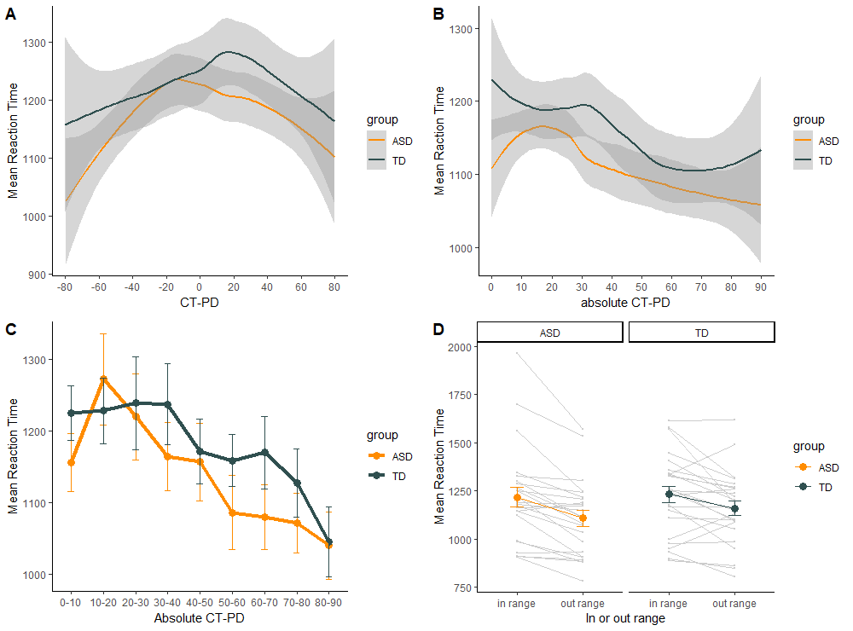

*Figure 5.* (a) Mean reaction times on first and correct trials of test streaks over the difference between the current target orientation and the previous distractor distribution mean (CT-PD). (b) Mean reaction times on first and correct trials of test streaks over the difference between the current target orientation and the target orientation in the previous trial (CT-PT). (c) Mean reaction times on first and correct trials of test streaks over the difference between the current target orientation and the previous distractor distribution mean (CT-PD). Gray areas show 95% confidence intervals of the fitted function. Error bars show +- 1 SEM.

## Key points