Supplementary Materials

|  |  |  |  |  |
| --- | --- | --- | --- | --- |
| Variables | TD participants | ASD participants | TD vs ASD | Group-level difference? |
| Agea | 14.38 (1.28) | 14.04 (1.49) | t45= -.82, p= .42 | No |
| Full scale IQa | 105.96 (8.69) | 104.33 (8.74) | t45= -.64, p= .52 | No |
| Verbal IQa | 105.83 (7.60) | 102.87 (15.39) | t45= -.84, p= .40 | No |
| Performal IQa | 106.00 (12.29) | 108.09 (14.40) | t45= .54, p= .60 | No |
| SRS (overall)b | 49.46 (9.11) | 80.26 (11.45) | t,45= 10.23, p< .001 | ASD > TD |

*Table 1*: Overview of the average group-level scores on descriptive measures. All tests are two-sample two-tailed t-tests (comparison ASD group and matched TD group). **a** No group differences on age or IQ, given that groups (ASD and TD) were matched on these variables. **b** We found an expected significant main effect of Group on overall SRS score and subscale scores, with higher scores in the ASD group compared to the TD group.

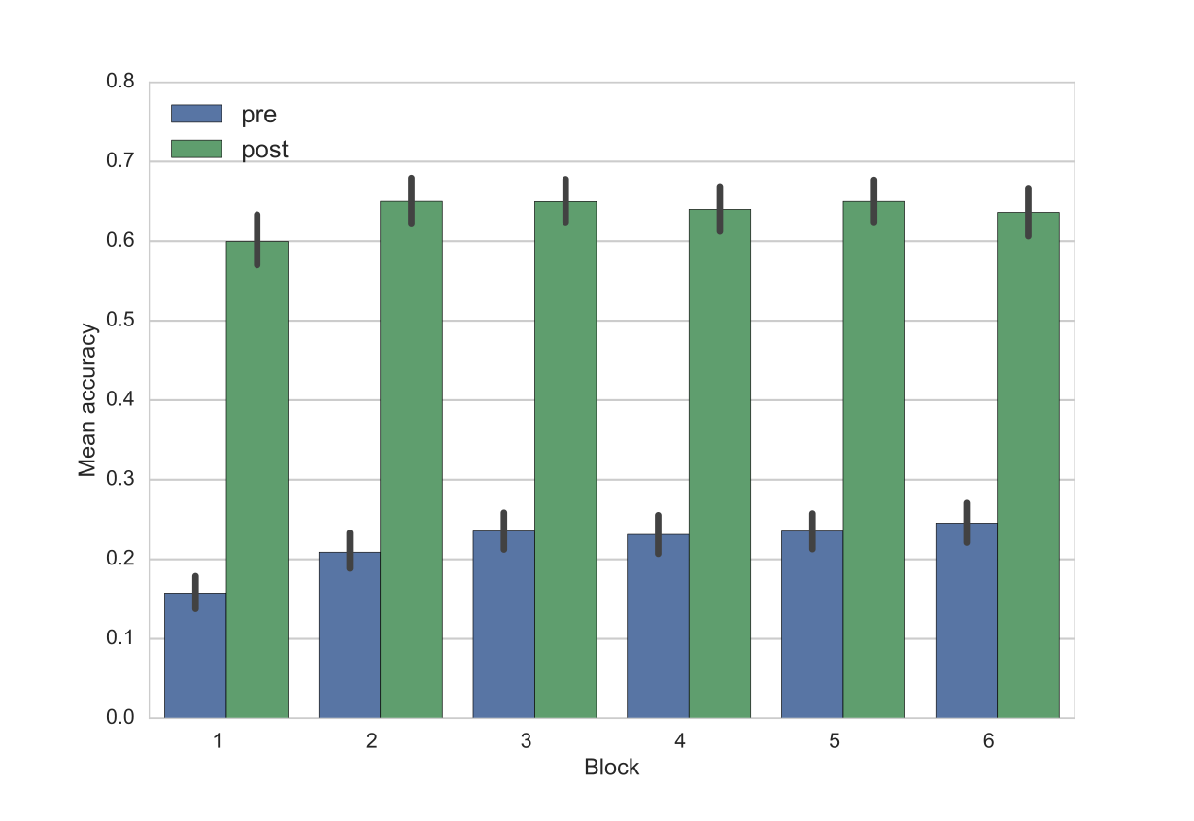

*Figure 1*: Overview of the average accuracies in pre (blue) and post (green) phase across the 6 blocks for study 1.

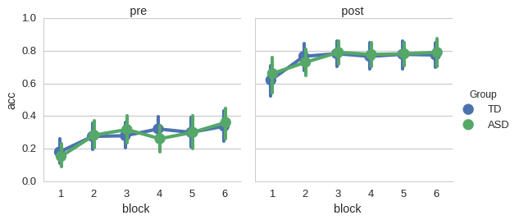

*Figure 2*: Overview of the average group-wise accuracies in pre and post phase across the 6 blocks for study 2 for the ASD (green) and the TD (blue) group.