1. Create a repository in the github

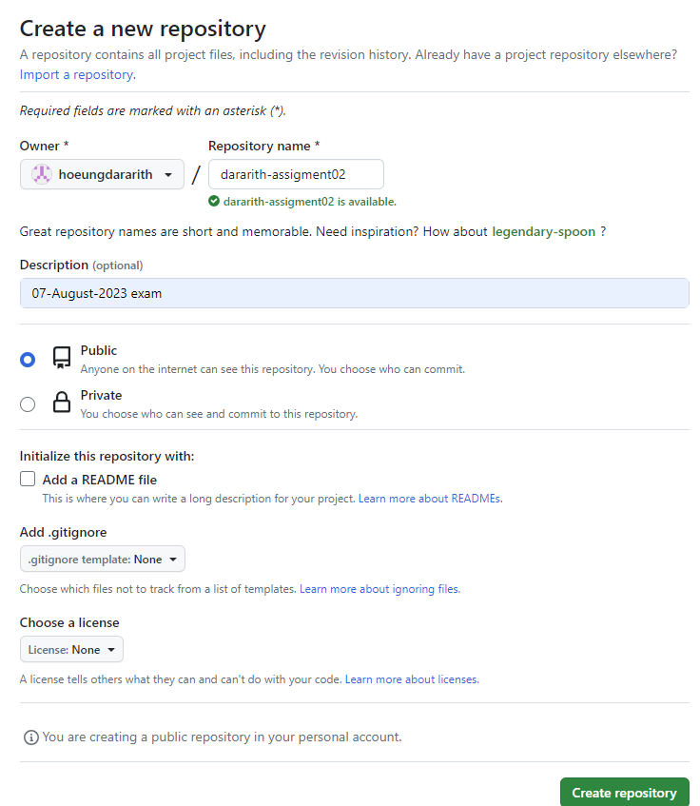

1. Clone the repository at local system

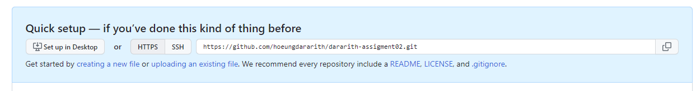

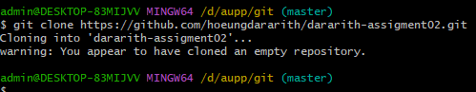

1. Upload 2 text files in github repo

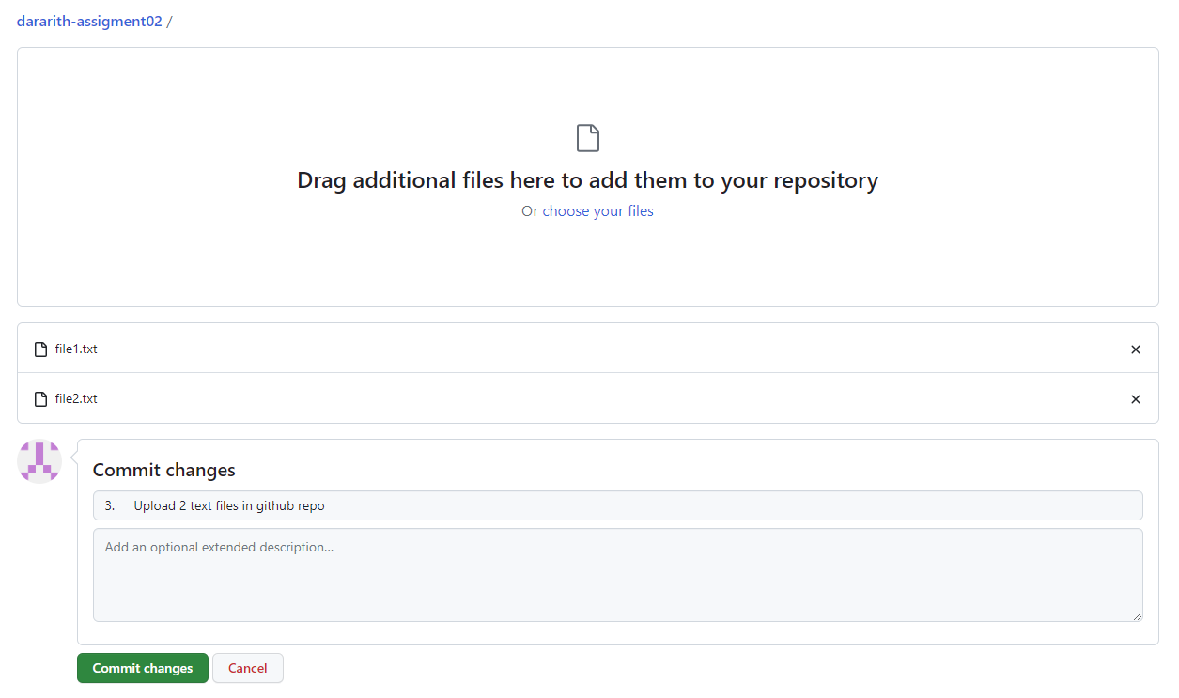

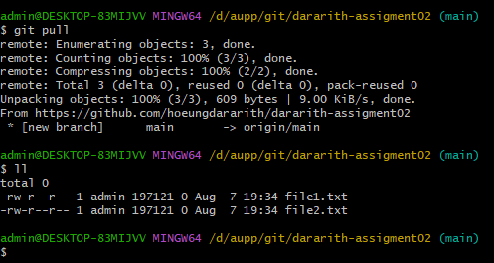

1. In the 1st text file add some text in the line no 3 in your uploaded github repo file

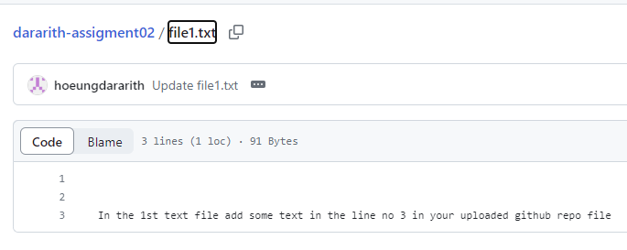

1. In the 2nd text file add some text in the line no 3 in your uploaded github repo file

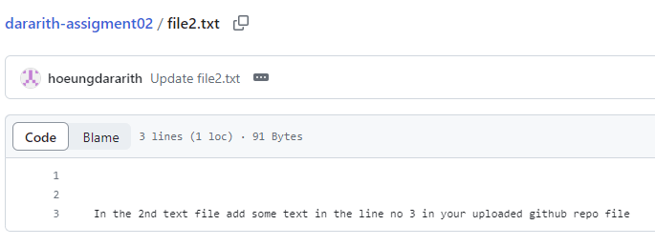

1. In the 1st text file add different text in the line no 3 in your local repository

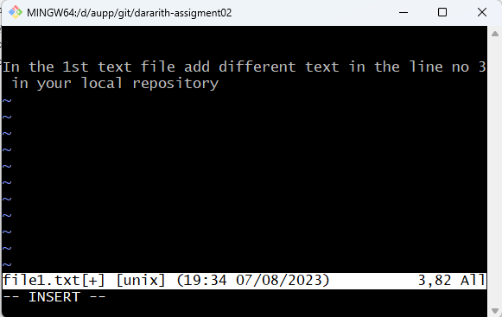

1. In the 2nd text file add same text in the line no 3 in your local repository

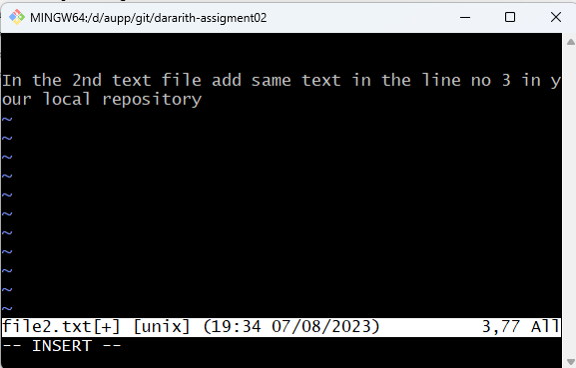

1. Use git add to add that file to the local repository

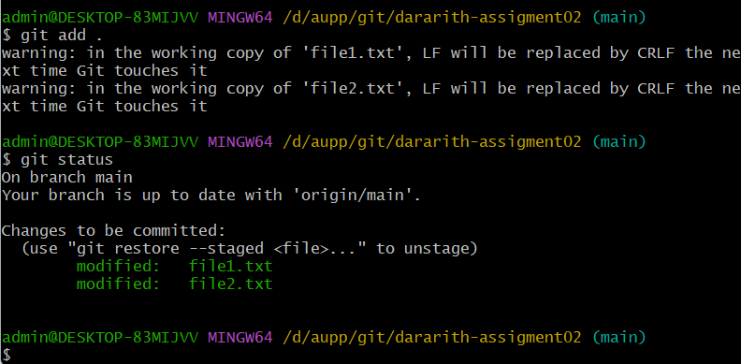

1. Use git commit to commit your change. Use a meaningful message

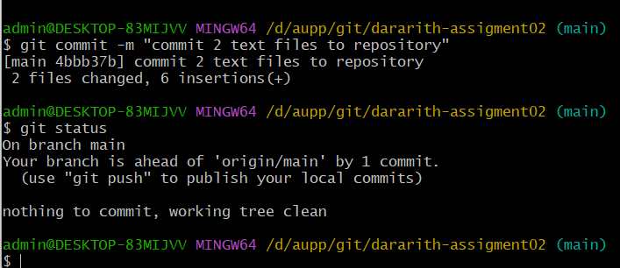

Commit will occur in local or github repository? “yes”

1. Use git push to send your change to the github repository

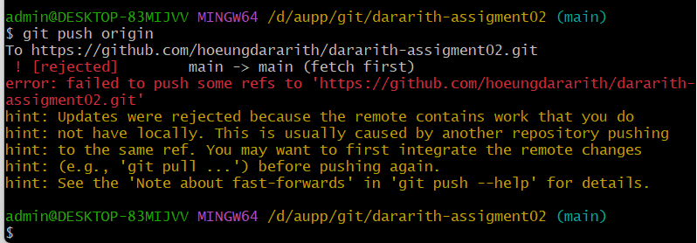

IS it works? or you will get any error. “It not work. Push was rejected”

1. If you will get the error how to resolve it?

Get error 🡪 need to fetch 🡪 use git pull command

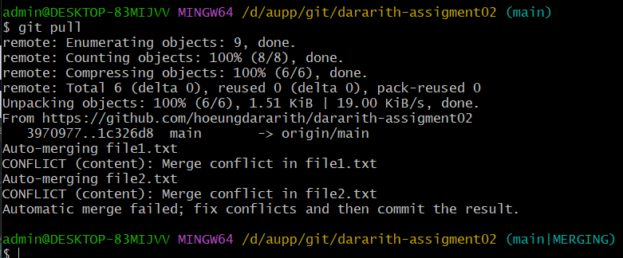

Edit conflict file by command code + filename



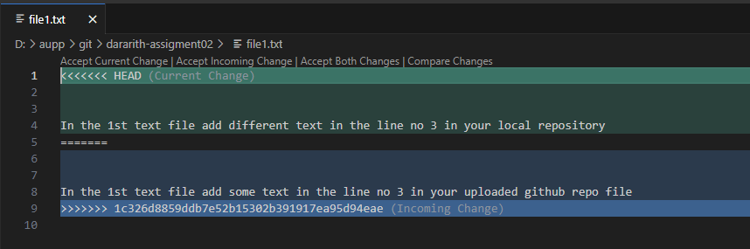

Edit file and save it.

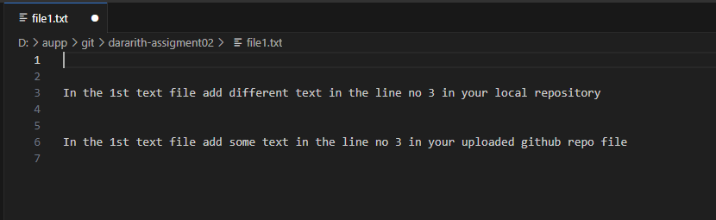

Use command git status to check status

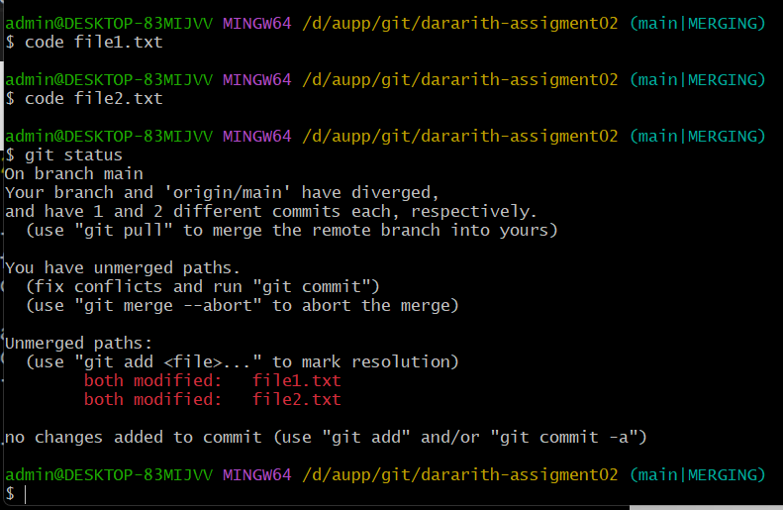

All both file has been modified.

1. ADD it

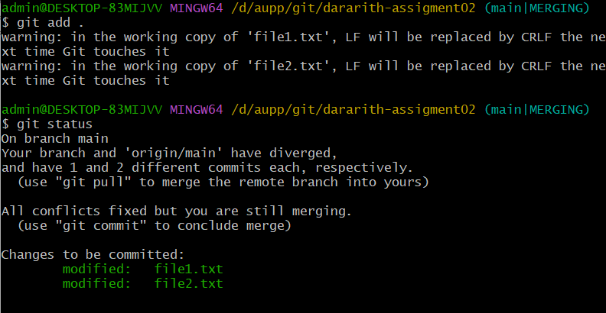

1. Commit it

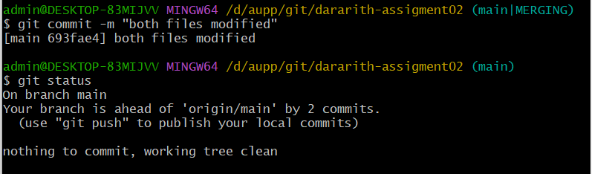

1. PUSH IT IN THE GITHUB

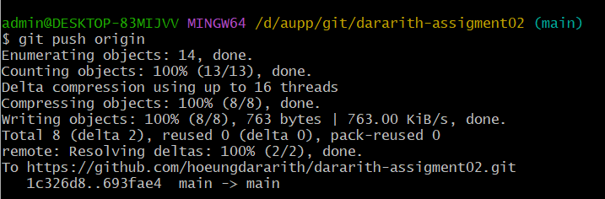

1. Check in the github

