Holly Hoffman-Glover

02/17/2018

LIB2024

LIB2024: Assignment 2 Prototyping

Additional Webpage content

The third page I will be creating for my website will be a brief overview of basic information concerning the Quokka. This page occupies the “Information” section of the website, and will contain information on the basics of what the endangered animal is, their diet and habitat, as well as current threats to their survival, both predatory and environmental. This page will reflect similar pages found on other animal conservation websites such as <https://rhinos.org/> and <https://www.savingcranes.org> , though both of these examples are much more complex than this webpage will be.

Rhinos.org

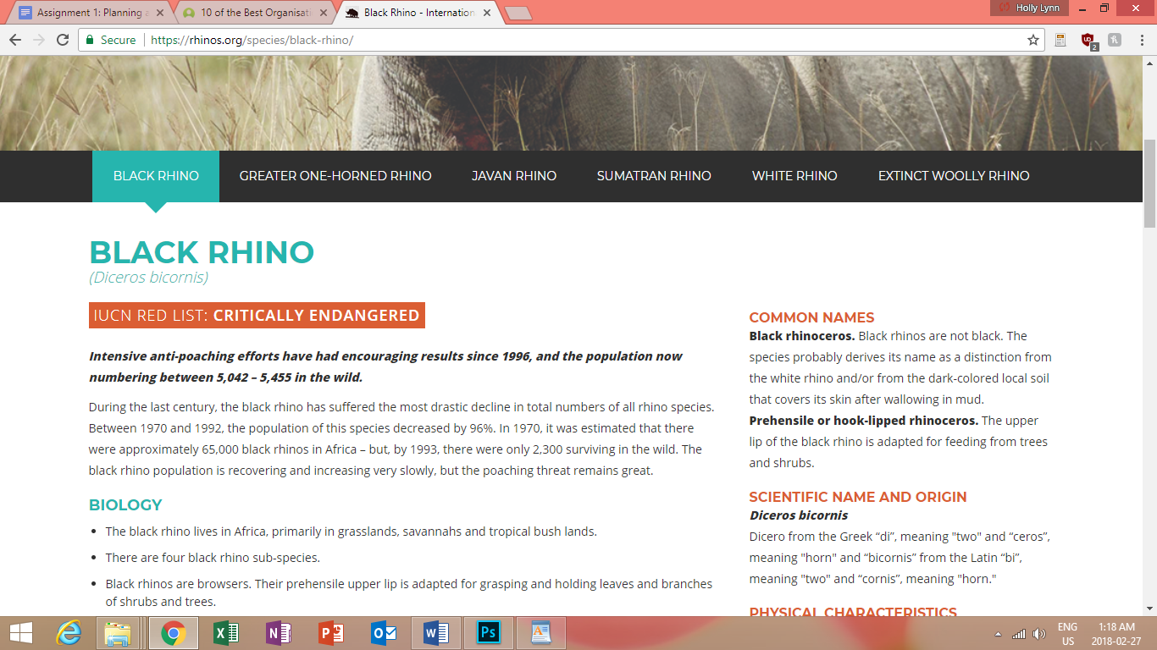

Saving Cranes

